January 13, 2009

Nadia E. Dombrowski
7515 W. Hunterhil Street
Dunnellon, FL 34433

Dear Ms. Dombrowski;

Our office is in receipt of your email to Governor Crist dated January 7, 2009 concerning Progress Energy Florida’s Application for a proposed Levy County Power Plant and its associated transmission line corridors. Your concerns involve the necessity of more power lines in your neighborhood.

Whereas these are valid concerns, the Public Service Commission (PSC) is the sole forum for the determination of need for new nuclear power plants and associated facilities. In making their determination, the PSC must take into account the need for electric system reliability and integrity, the need for fuel diversity and supply reliability, the need for base-load generating capacity, the need for adequate electricity at a reasonable cost, and whether the proposed plant is the most cost-effective alternative available. The PSC must also expressly consider whether renewable energy sources or conservation measures taken by or reasonably available to the utility might mitigate the need for the proposed plant (403.519, F.S.).

The PSC issued its need determination on August 12, 2008. You may read the document from this web site http://www.psc.state.fl.us/library/filings/08/07126-08/07126-08.pdf

The application for this project was filed on June 2, 2008. You may review that application as well as its schedule and the manner in which the project follows the statutory requirements of the Power Plant Siting Act at this web site: http://www.dep.state.fl.us/siting/Highlights/applications.htm#Progress_Energy_Levy_County_Nuclear. Progress Energy has a website which shows aerial maps of the proposed transmission line corridors at: http://www.progress-energy.com/aboutenergy/transmission/florida/energyplanning/maps.asp

There are numerous opportunities for public involvement. You may wish to familiarize yourself with those here: http://www.dep.state.fl.us/siting/Information/Public%20Interaction.htm

One opportunity will be available to you at the public hearing the Administrative Law Judge will schedule during the certification hearing. For the Citrus lines, public testimony will be taken from 3:00pm to 8:00pm on March 16, 2009, at Crystal River National Guard Armory, 8551 West Venable Street, Crystal River, Florida.

You may also wish to petition the Administrative Law Judge at the Division of Administrative Hearings to intervene pursuant to 403.508(3)(e), Florida Statutes, which states:

(3)(a) Parties to the proceeding shall include:

e) Other parties may include any person, including those persons enumerated in paragraph (c) who have failed to timely file a notice of intent to be a party, whose substantial interests are affected and being determined by the proceeding and who timely file a motion to intervene pursuant to chapter 120 and applicable rules. Intervention pursuant to this paragraph may be granted at the discretion of the designated administrative law judge and upon such conditions as he or she may prescribe any time prior to 30 days before the commencement of the certification hearing.

For further questions on this topic, you may contact either Ann Seiler or me at 850/245-2007. Thank you again for your interest and concern.

Sincerely,
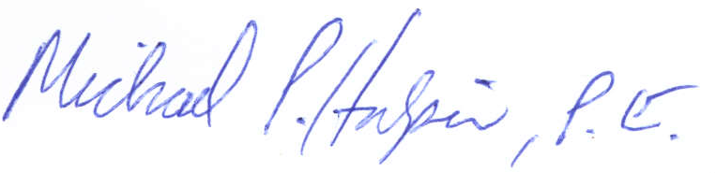
Michael P. Halpin, P.E.
Administrator, Siting Coordination Office

