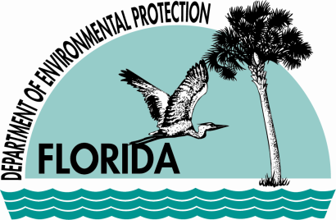 | Florida Department of  Environmental Protection  Marjory Stoneman Douglas Building  3900 Commonwealth Boulevard  Tallahassee, Florida 32399-3000 | Rick Scott  Governor  Jennifer Carroll  Lt. Governor  Herschel T. Vinyard Jr.  Secretary

June 30, 2011

Randy Barnes, Deputy
Tangible Personal Property Dept.
Polk County Property Appraiser's
255 N. Wilson Ave.
Bartow, FL 33830

Re: Oldcastle Lawn and Garden, Inc.
Dear Mr. Barnes:
In accordance with Section 193.621, Florida Statutes (F.S.), if it becomes necessary for a manufacturing or industrial plant or installation to install or construct a facility in order to eliminate or reduce industrial air or water pollution, those facilities shall be deemed to have value, for purposes of assessment for ad valorem property taxes, no greater than their market value as salvage. Only those facilities specifically installed to eliminate or reduce air or water pollution are eligible for this type of assessment.
I have reviewed the material attached to your email dated June 22, 2011 concerning pollution control devices at Oldcastle Lawn and Garden, Inc. (Oldcastle) located in Lakeland. In my opinion, the equipment listed under line item 21 (Asset No. 668) of the 2010 Tangible Personal Property Tax Return submitted by Oldcastle is not “primarily for the purpose of pollution control” and is not eligible for full assessment as a pollution control device pursuant to §193.621, Florida Statutes.
Oldcastle indicated the reduction of air pollution emissions with the conversion from a fuel operated grinder to an electric grinder. However, the primary function of the equipment is grinding the materials and not to control air pollution emissions. The conversion from a diesel to an electric grinder will reduce the facility’s annual emissions, but the electric grinder in itself is not a control device.
I am unable to make a determination on the fuel and fuel oil depot (Asset No. 506). I recommend asking Oldcastle to submit a more detailed description of the fuel and oil depot and how its operation, or reduced operation with the removal of the diesel grinder, will control and reduce air or water pollution.
Additionally, certification from a Professional Engineer is not included. In accordance with 62-8.040, F.A.C., a current evaluation of their equipment by a registered Professional Engineer in the State of Florida must also be submitted.
If you have any questions regarding this determination, please contact Bobby Bull at (850) 245-2001 or me at (850) 245-2175.

Sincerely,
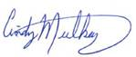
Cindy Mulkey
Administrator, Siting Office

