Table of Contents

Purpose and contents 1
Background 2
What is a TMDL? 2
Description of the 34th Street Basin WBID 2
Fecal Coliform Impairment of the 34th Street Basin 3
walk the wbid exercise 3
Participants 3
Cost 3
Initial Steps 3
Maps on the Table Session 4
Field Event 4
Results 6
southern 34th street basin boundaries 6
commercial entities within the wbid 23
Residential Neighborhoods within the wbid 28
Section 2.1 #
Section 2.2 #
Subsection 2.2.a #
Subsection 2.2.b #
Subsection 2.2.c #
Section 2.3 #
Chapter 3 #
Section 3.1 #
Section 3.2 #
Section 3.3 #
Subsection 3.3.a #
Subsection 3.3.b #
Subsection 3.3.c #

Table of Figures
Figure 1: 34th Street Basin 2
Figure 2: 34th Street Basin of WBID 1716A southern boundary 6
Figure 3: Doug Jamerson Elementary School damaged control structure 6
Figure 7: A duck observed wading in the open ditch. 8
Figure 8: Hydrilla in the waters of the open ditch. 9
Figure 9: Erosion was noted along the banks of the open ditch at the Pinellas County Technical Education Center, PTEC. Action Item: Banks will be stabilized by the PCSB. 9
Figure 10: Upstream view of the open ditch at PTEC. 10
Figure 11: I-275 & 22nd Avenue South 10
Figure 12: I-275 Landscape Area 11
Figure 13: I-275 Landscape Area By the Overpass. 11
Figure 14: Team WTW inspects a manhole26th Avenue South at Kingston Street South for evidence of infiltration. 12
Figure 15: Close–up of Manhole on 26th Avenue South at Kingston Street South 12
Figure 16: Several dogs were observed during the exercise. 13
Figure 17: Discarded trash and pollutions left on the side of the road. 13
Figure 18: Box Culvert and drainage ditch. 14
Figure 19: Ditch with pollutants. 14
Figure 20: WTW Team Member Anita Nash, FDEP inspects an "exposed “sewer pipe. 15
Figure 21: The sewer pipe shows signs of deterioration. 15
Figure 22: Illegal dumping in a vacant lot. 16
Figure 23: Illegal dumping in a vacant lot. 16
Figure 24: Evidence of not practicing good pet waste disposal at vet business. 17
Figure 25: Veterinary clinic had evidence of not properly disposing of pet waste. Action item: City to advise business of requirements to remove dog waste from property. 17
Figure 26: An open garbage container. This can be a source of pollutants getting into the water. 18
Figure 27: Port-O-Potty at a construction site. 18
Figure 28: WTW Team inspecting the manhole before taking a water sample. 19
Figure 29: The WTW Team about to inspect a manhole. 19
Figure 30: WTW Team member taking a water sample. Action Item: Results from sampling showed 9,900 CFU/100 mL. 19
Figure 33: WTW Team member taking a water sample from the standing water to insure there are no pollutants. Action Item: Results of sampling indicated no fecal coliform in excess of 400 CFU/100mL. 20
Figure 31: Observed algae growing in the water of the parking lot. 20
Figure 32: Abandoned Warehouse with stagnant water in the parking lot. 20
Figure 34: Evidence of some leakage at a sea food plant. Action Item: Advise company to repair leak. 21
Figure 35: The WTW Team inspected a nearby manhole for evidence of infiltration from the plant. 21
Figure 36: WTW Team members inspect the manhole outside of the seafood plant compound. 21
Figure 38: Action Item completed. Seafood processing company with repair around discharge pipe of sump. 22
Figure 39: The Wildwood Heights section of the 34th Street Basin. 23
Figure 41: WTW Team members walking the Wildwood Heights Neighborhood. 24
Figure 42: WTW Team member, Anita Nash (FDEP), finds evidence of residents not practicing proper pet clean up. 24
Figure 44 a & b: Harshaw Lake – N of 18th A/N and W of 34th S. Sample from lake indicated elevated fecal coliform. Lake has at least one family of mascovy ducks. West side of lake on 38th S/N had various areas of dog wastes. 25
Figure 45: Sign Installed to clean up pet waste as per city code as per action item. 25
Figure 43: Harshaw Lake 25
Figure 46: Resident walking his dog. No evidence of a cleanup bag. 26
Figure 47: Resident walk two dogs, no evidence of a cleanup bag. 26
Figure 48: 1st A/S and 34th S – Trash Dumpster and grease storage needs to be maintained at business located at 14 A/N and 34th S. 27
Figure 49: : 1st A/S and 34th S – Area behind the businesses needs to be maintained located at SW corner of 14 A/N and 34th S. Request the Grease Management Program to review maintenance records of site. 27
Figure 50: Central Avenue and 34th S – Signs of Homeless in area 28
Figure 51: 1st A/S and 34th S – Business is closed is and being remodeled. Trash exists in and around dumpster in parking lot. 28
Figure 52: 1st A/S and 34th S – Trash Dumpster and grease storage needs to be maintained. Additionally, a sewer cleanout has no cap. S/N. 29
Figure 53: Trash Compactor enclosure with grease storage bin at shopping center located at Central Avenue and 34th S/N. 29

Purpose and Contents
This report summarizes the results of the Walk the WBID exercise for the 34th Street Basin watershed, located in Pinellas County in south St. Petersburg, on July 11, 2013. This field reconnaissance and source elimination effort was carried out to gain a better understanding of conditions within the watershed, including the hydrology of the creek and its contributing ditches and branches, flood-prone areas, the locations of sewer and stormwater infrastructure, and potential sources that are contributing fecal coliform bacteria to the creek.
The Walk the WBID exercise is a low-cost, effective alternative to begin addressing fecal coliform pollution in 34th Street Basin watershed so that it meets state water quality standards. This common-sense first step allows stakeholders to identify the location of suspected sources, establish a sampling plan to fill in knowledge gaps, carry out easy-to-implement management actions for the creek using existing programs and ongoing activities, and follow up on those actions to assess the degree of success and the additional effort needed. The exercise allows stakeholders to identify uncertainties and future options for more effective adaptive management. It also contributes to improved communication between and within agencies, and provides opportunities to increase public awareness.
The lead entity for the Walk the WBID exercise is the City of St. Petersburg, no other participants took part in the event.
This report includes the following information:
Identification of the WBID;
Results of any preliminary investigation or issues identified;
- List of entities and staff participating in the field efforts or other operations;
Sources and potential sources observed;
Immediate next steps and follow-up actions taken;
Follow-up actions still needed;
Sources eliminated or investigated;
Water quality results from samples taken in the field;
Monitoring sites identified or proposed; and
Any other pertinent information.

Background

What is a TMDL?
A Total Maximum Daily Load, TMDL, is a scientific determination of the maximum amount of a given pollutant that a water body can absorb and fall with the required water quality standards that protect human health and aquatic life. Any water body that doesn’t meet the current required standards is identified as impaired. The primary pollutants of concern are: nutrients, bacteria, mercury, and nitrogen.
The threshold limits on pollutants in surface waters--Florida's surface water quality standards on which TMDLs are based--are set forth primarily in rule 62-302, Florida Administrative Code, and the associated table of water quality criteria. TMDLs have been developed, adopted and implemented to reduce pollutants and clean up the impaired water body. A TMDL represents the maximum amount of a given pollutant that a waterbody can assimilate and still meet water quality standards, including its applicable water quality criteria and its designated uses. TMDLs are developed for waterbodies that are verified as not meeting their water quality standards. They are a critical step in the watershed restoration process because they provide the targets for measuring progress in subsequent water quality restoration efforts. The fecal coliform TMDL calls for a 98 percent reduction in in-stream concentrations for 34th Street Basin Watershed to meet state water quality standards.

Description of the 34th Street Basin WBID
The 34th Street Basin Watershed is located in the southern portion of Pinellas County in south St. Petersburg. It is unique in that it is comprised of both commercial and residential entities. The topography of the 34th Street Basin within the Clam Bayou Watershed WBID 1716A encompasses approximately 2.1 square miles. The water flows mostly underground through stormwater culverts with approximately 2000 linear feet in an aboveground ditch through Pinellas County School Board (PCSB) properties.
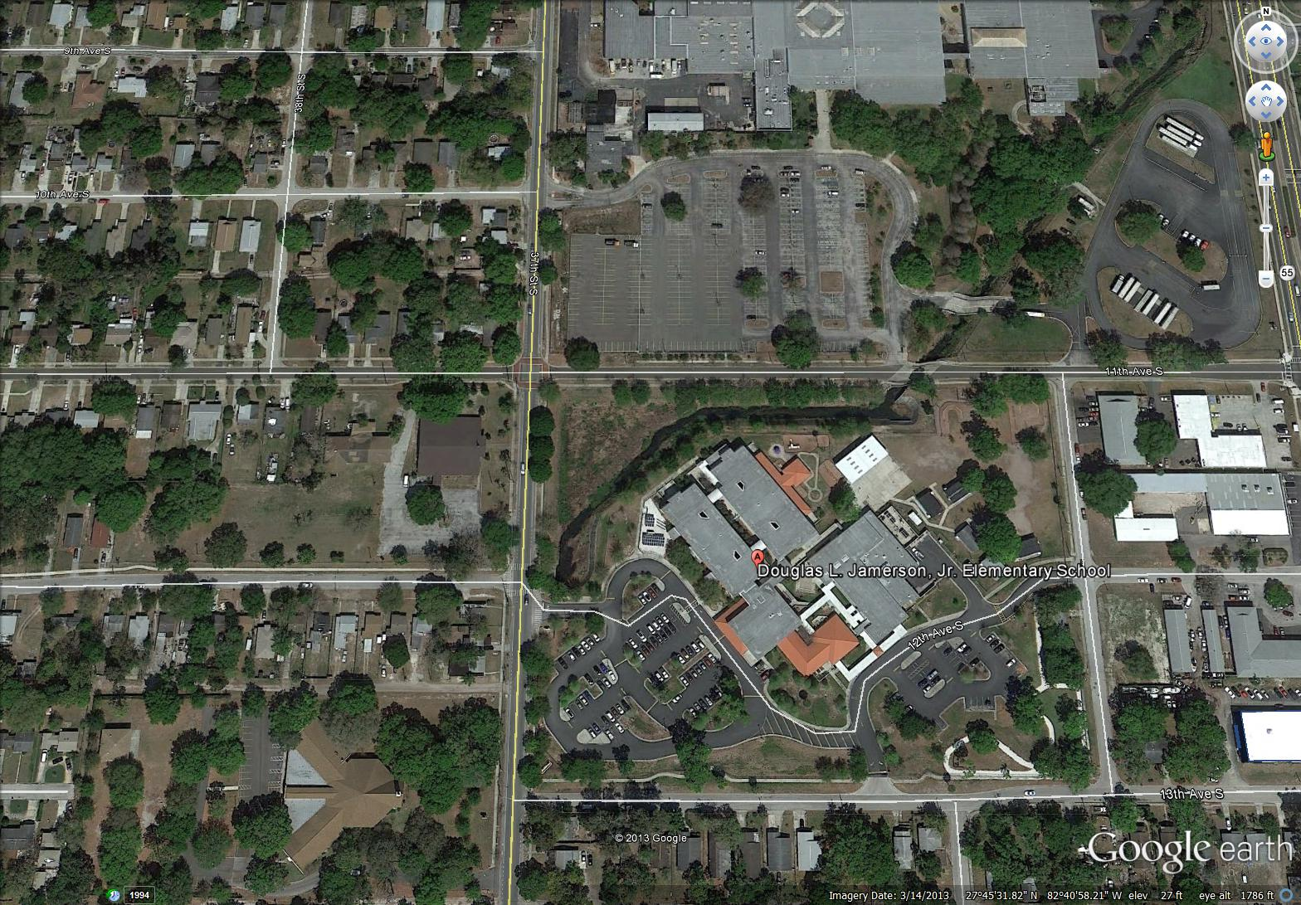

Figure 1: 34th Street Basin

Fecal Coliform Impairment of the 34th Street Basin
The 34th Street Basin, WBID 1716A, was assessed as being impaired for fecal coliform bacteria during the Cycle 2, Basin 5 review of the watershed by FDEP. In February, 2012, the verified impaired list was adopted by FDEP which included this impairment. Based on the state’s Impaired Surface Waters Rule (IWR), a Total Maximum Daily Load (TMDL) was finalized for fecal coliform in September, 2012.

Walk the WBID Exercise

Participants
Members from the City of St. Petersburg’s Water Resources , Code Compliance Assistance, Legal and Engineering & Capital Improvements took part in the exercise along with representatives from the Florida Department of Environmental Protection, FDEP. A representative with the Pinellas County School Board (PCSB) met the team at the first stops which included PCSB schools.

Costs
The only costs to the participants in the Walk the WBID exercise were staff time and potential management actions. The water samples taken were processed by the City’s Water Resources Department.
Follow-up for action items noted during the exercise will be done by the appropriate city department. Examples of follow-up activities that may result in additional costs include system maintenance, repair, and investigation; however, it is important to note that these activities generally correspond with jurisdictional missions and already-established programs.

Initial Steps
Before going into the field, the City employees from various departments met and exchanged information through a collaborative meeting organized by the City of St. Petersburg and the FDEP.
In preparation for these meetings, information was provided digitally in advance to FDEP. Engineering & Capital Improvement, created multiple copies of large-format maps for use in the maps on the table exercise and the field event. The information that was collected and assimilated included the following:
- Geographic information system (GIS) data;
- Stormwater infrastructure maps showing the locations of inlets and outfalls, ponds, ditches, and underground conveyances;
- Stormwater best management practices (BMPs) being implemented;
- Maps of public sewer infrastructure showing the locations of pump stations and force and gravity main;,
- Additional fecal coliform water quality sampling locations and results.

Maps on the Table Session
Team members held the Maps on the Table session to identify areas of concern to visit during the Walk the WBID event, based on field knowledge from staff and a synthesis of the available information. The team members marked areas of concern on their maps and elected field representatives with infrastructure knowledge and access to facilities, and who were familiar with sampling equipment and standard operating procedures (SOPs). Locations of additional sampling points were selected at the conclusion of the session by Water Resources, Engineering and FDEP.

Field Event
The Walk the WBID team used the large-format maps while conducting the field investigations. A documentation team was designated, with a team member assigned to record areas on the map, another person to take pictures, and a primary note taker to record the information. Water quality sampling equipment was used to collect water quality information about potential fecal coliform sources or concentrations identified in the field.
The team explored a large representative portion of the watershed while in the field, referring to the maps to follow the open ditch and below ground. Team members looked at 34th Street Basin Watershed banks and in the vicinity of the waterbody for potential sources. Canals/ditches that intersected the waterbody were also walked to ensure that the waterbody and its associated branches were all included within the WBID boundary. Care was taken to ensure that only appropriate entity representatives accessed private property, unless the property owner had granted access to the entire team. Potential sources that were investigated included the following:
- Potential illicit connections (PICs) or discharges;
- Public and private sanitary sewer infrastructure (such as manholes and pump stations);
- Signs of recent SSOs, or areas with multiple SSOs;
- Wastewater infrastructure located close to surface waters and/or stormwater inlets, including pump stations, manholes, and air release valves (ARVs);
- Evidence of homeless populations;
- MS4 conveyances requiring cleaning;
- Accumulated trash and debris on streets and parking lots;
- Accumulated trash and debris near to or inside stormwater drains and catch basins;
- Clogged or broken stormwater grates;
- Stormwater drains undergoing repairs;
- Stormwater outfalls discharging from underground conveyances or into ponds;
- Sewage smell from stormwater drains, indicating possible cross-connections;
- Unusual odors;
- Evidence of illegal dumping or discharge of liquids;
- Signs of oil and grease;
- Excessive sediments and signs of erosion or wash out;
- Stagnant water;
- Debris in inlets, or inlets located near wastewater infrastructure;
- Exposed pipes of unknown origin;
- Flood-prone areas;
- Pet waste or evidence of high-traffic pet areas;
- Evidence of wildlife such as raccoons, coyotes and waterfowl;
- Areas with heavy tree cover and vegetated ditches preventing ultraviolet (UV) light penetration.

Any discharges that were observed were sampled both downstream and upstream. Potential sources or other issues identified while in the field were reported to the proper jurisdiction and cataloged while in the field. A record was kept of major findings, including observations about the waterbody, potential sources, followed-up items and the responsible entity, and any areas that should be added to the monitoring plan or that required additional investigation.
Results
Figures 2 through 52 summarize the water quality issues and potential fecal coliform sources that the team observed during the Walk the WBID exercise on July 10, 2013.

Southern 34th Street Basin Boundaries
The only major above ground section of the WBID is between 34th Street South and 37th S/S and between 8th A/S and 12 A/S. The culveted section of the main flowway of the storm system enters the ditch and travels about 2000 feet before entering box culverts and traveling underground towards Clam Bayou. This ditch is on the property of the Pinellas County School Board’s(PCSB) Pinellas Technical Education Center (PTEC) and Doug Jamerson Elementary School. It collects stormwater runoff from the residential neighborhood as well as from the grounds of the schools. Birds were observed in the ditch at the time of the inspection. A section of the flowway was modified by the PCSB as mitigation. The ditch was fairly well maintained; open to UV light; low velocity except during significant rainfall events.
Figure 2: 34th Street Basin of WBID 1716A southern boundary
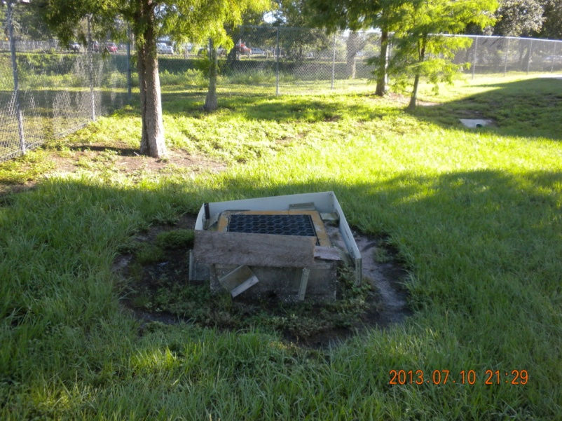
Theditch had small amounts of debris deposited in it. PCSB Maintenance Department is responsible for maintaining the area, particularly the mitigation site. They maintain it quarterly in order to keep the system working and free of permanent deposits of debris and pollution that may wash into the area.

Figure 3: Doug Jamerson Elementary School damaged control structure
Action Item: The structure was repaired by the Pinellas County School Board Maintenance division in September, 2013.
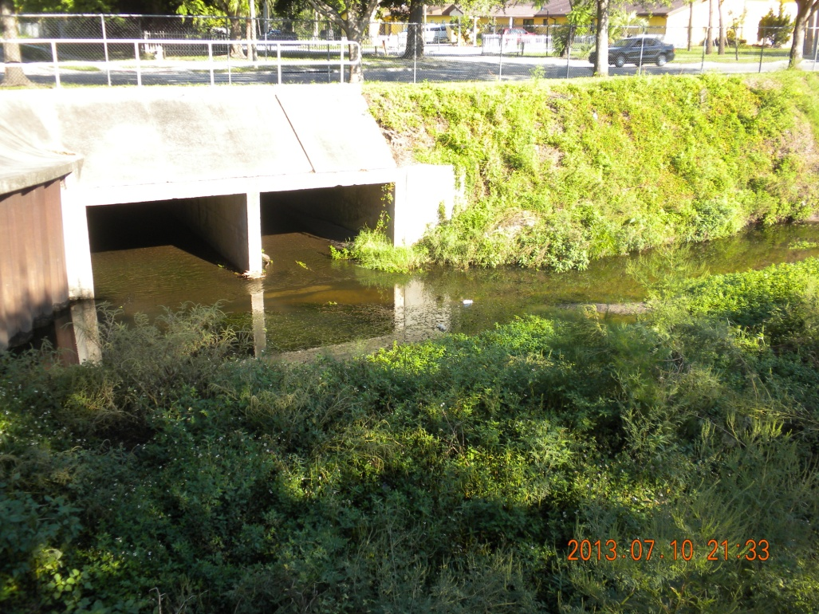
Figure 4: Open Ditch - downstream box culverts

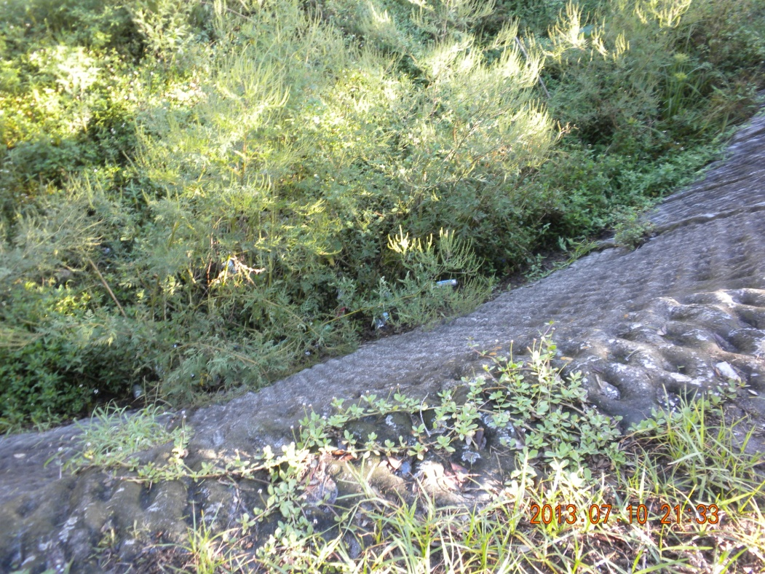
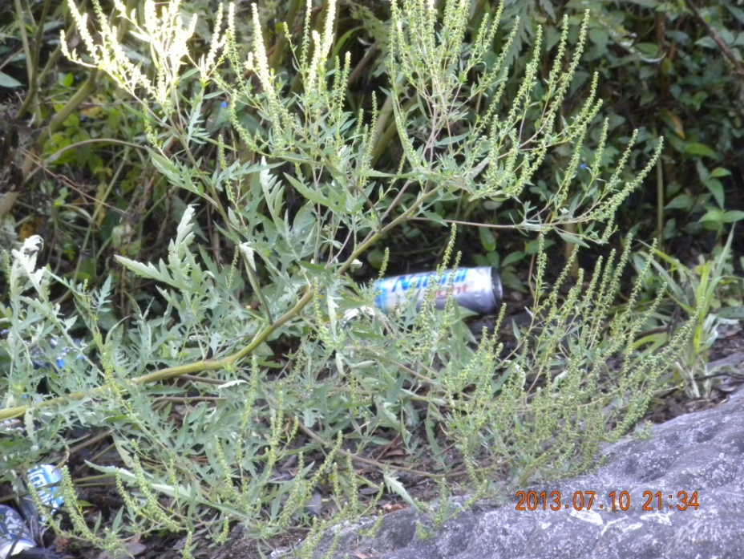
Figure 5: Open ditch walls and litter

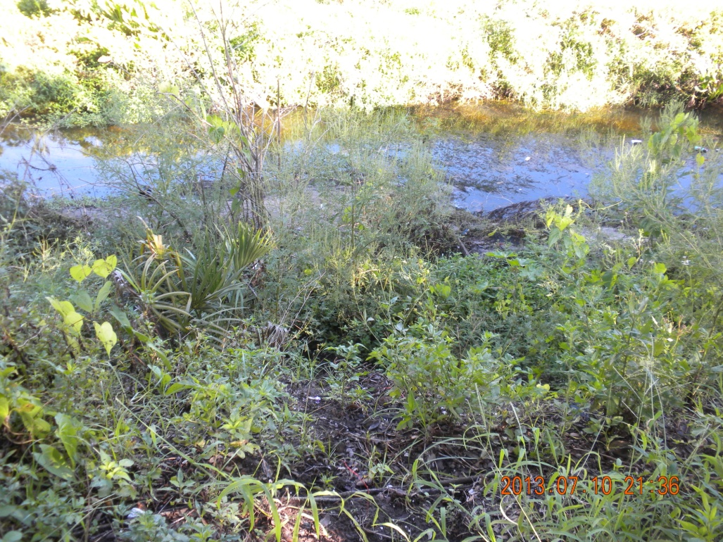
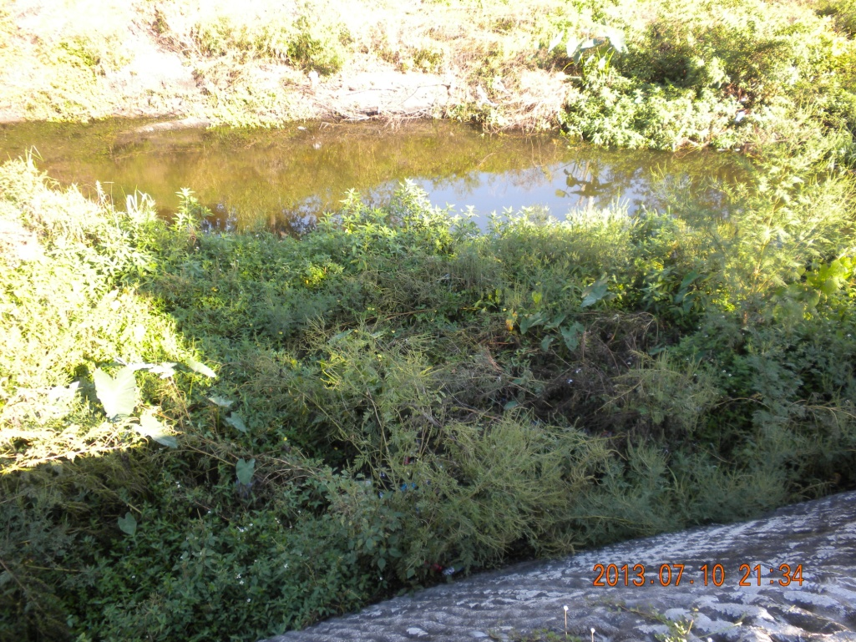
Figure 6: Open Ditch at Jamerson Elementary
Action Item: Maintain the vegetation and debris to keep the system functioning.

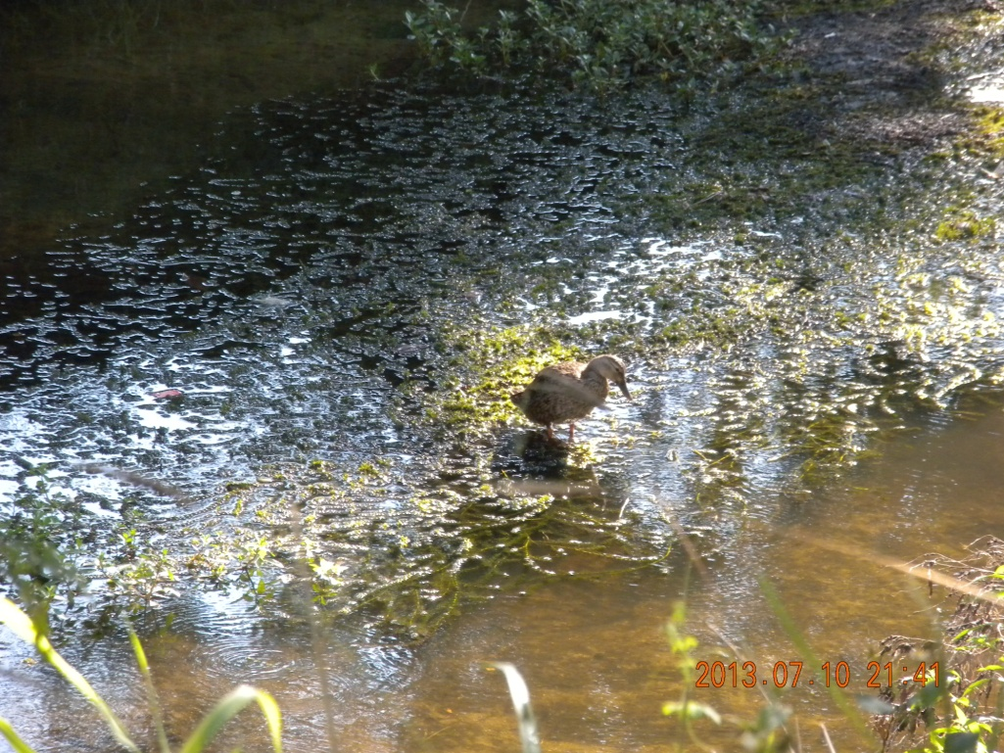
Figure 7: A duck observed wading in the open ditch.
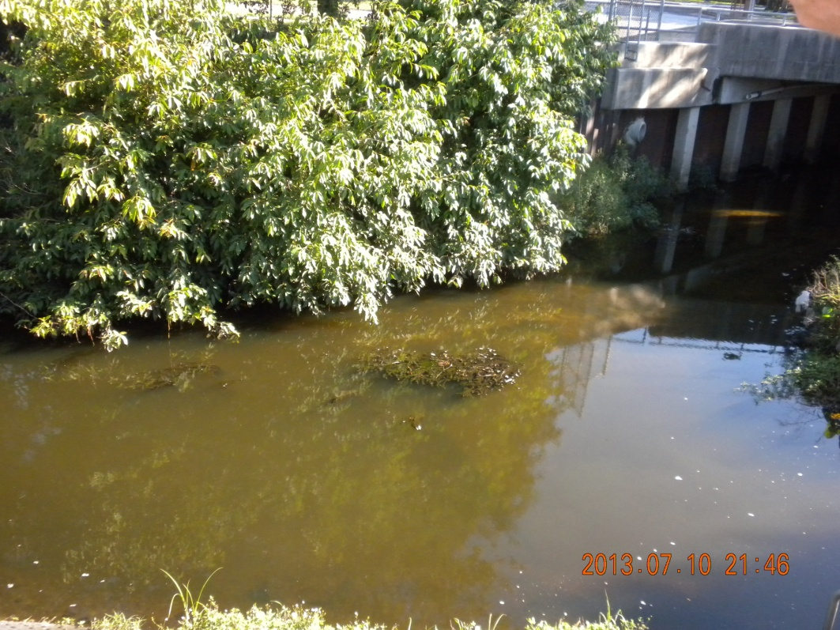
Figure 8: Hydrilla in the waters of the open ditch. Hydrilla is an invasive exotic which when uncontrolled will grow in abundance and shade out the UV rays which kill bacteria and pathogens. Suspended turbidity which could indicate suspension of sediments. Bacteria cling to particulates, and may be coming from the sediments via regrowth.

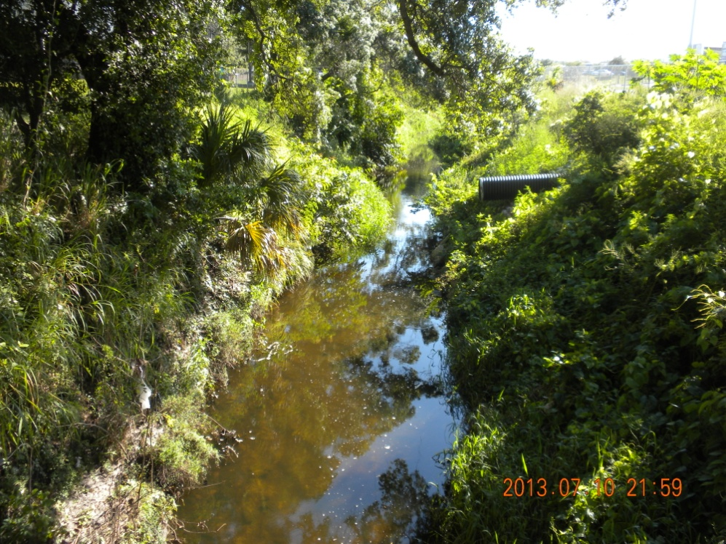
Figure 9: Erosion was noted along the banks of the open ditch at the Pinellas County Technical Education Center, PTEC. Action Item: Banks will be stabilized by the PCSB.

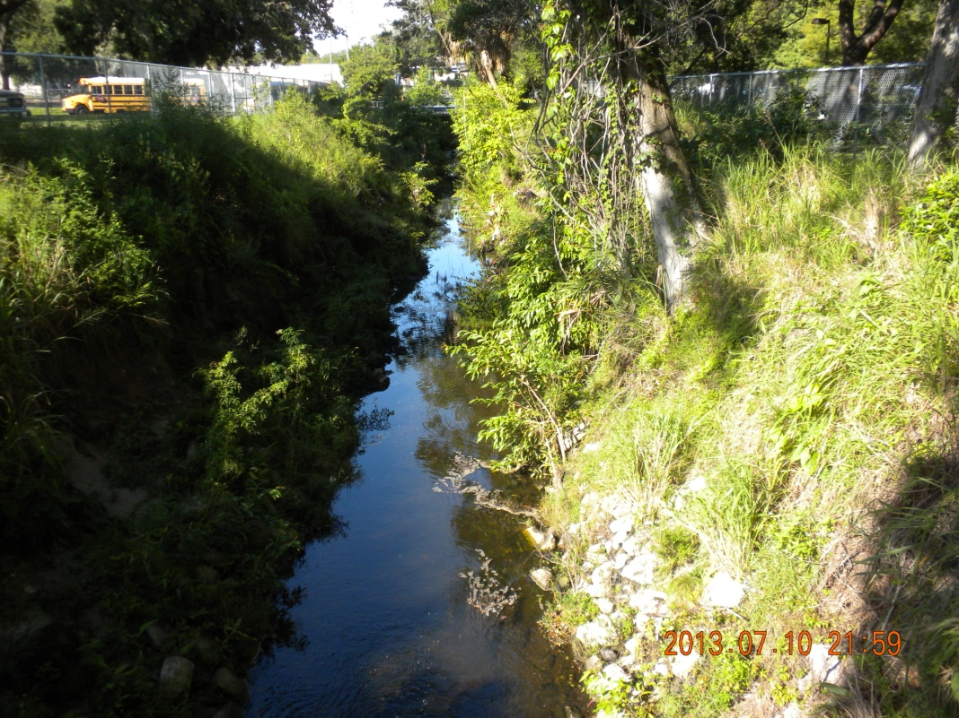
Figure 10: Upstream view of the open ditch at PTEC. The water column is getting some UV penetration here.

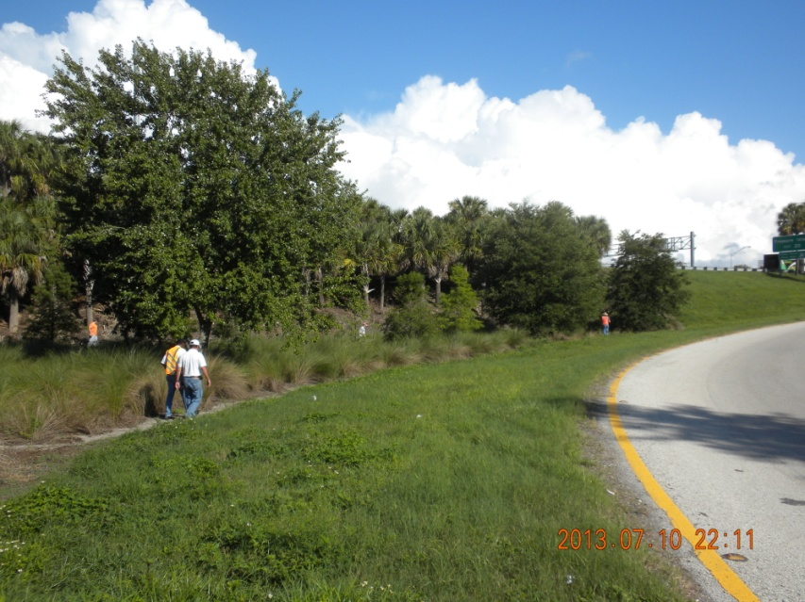
Figure 11: I-275 & 22nd Avenue South, no signs of homless camps here, just litter from the roadway.
Figure 12: I-275 Landscape Area, sediment erosion may be entering the ditches and streams.
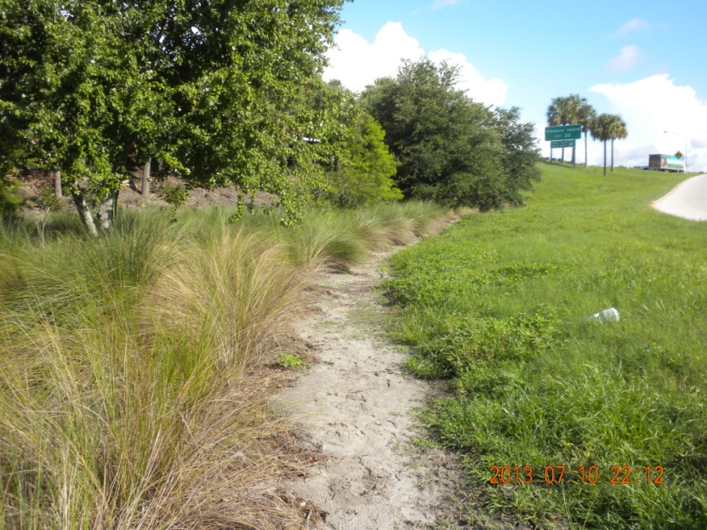

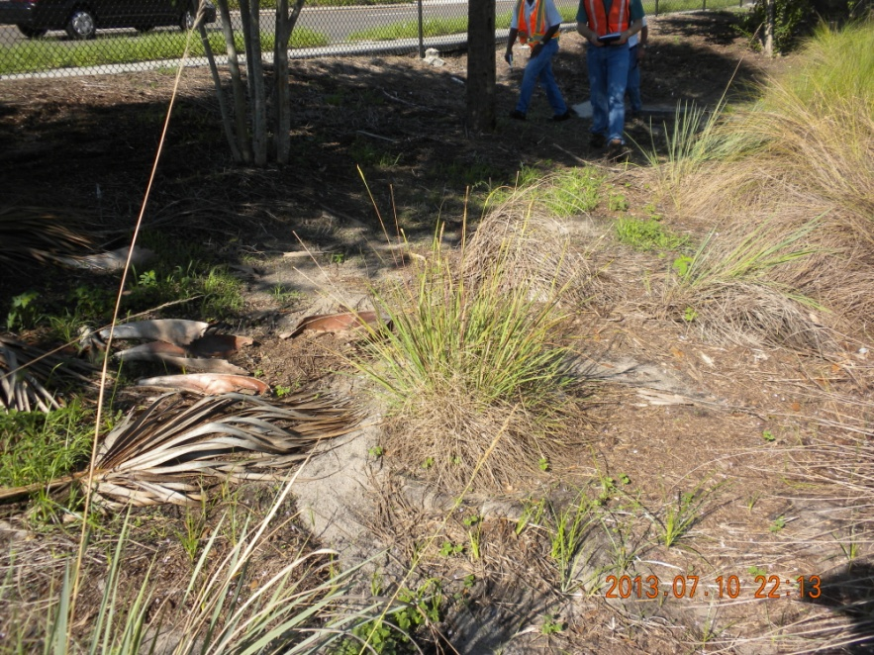

Figure 13: I-275 Landscape Area by the Overpass, more erosion abserved.
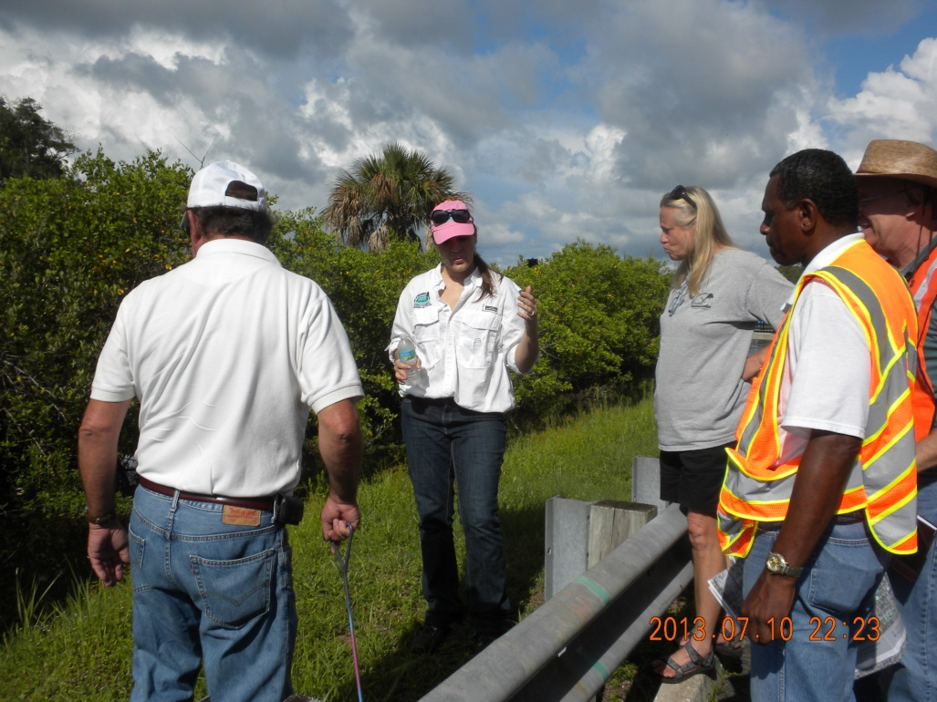
Figure 14: Team WTW inspects a manhole26th Avenue South at Kingston Street South for evidence of infiltration. No evidence observed.

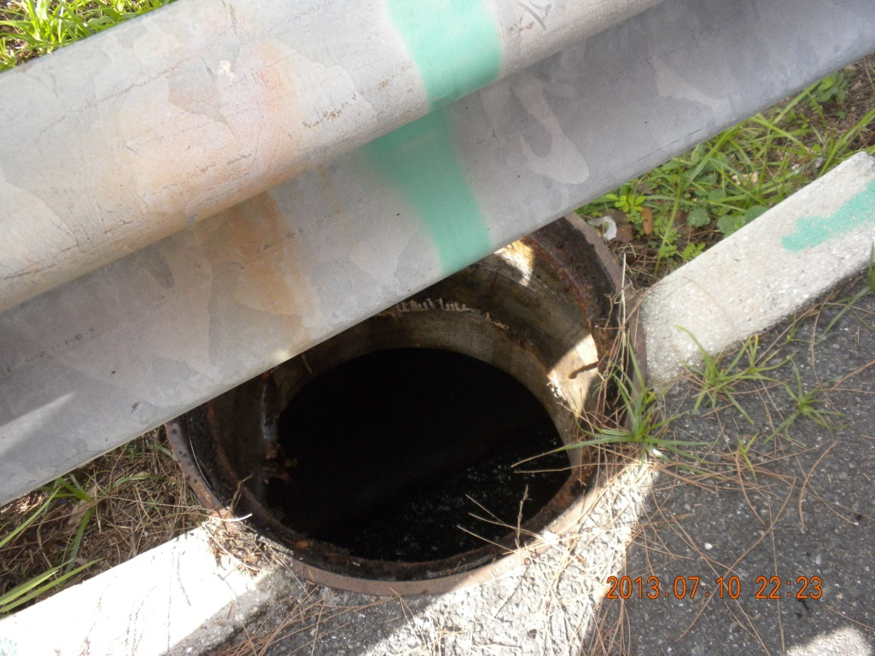
Figure 15: Close–up of Manhole on 26th Avenue South at Kingston Street South flowing freely.

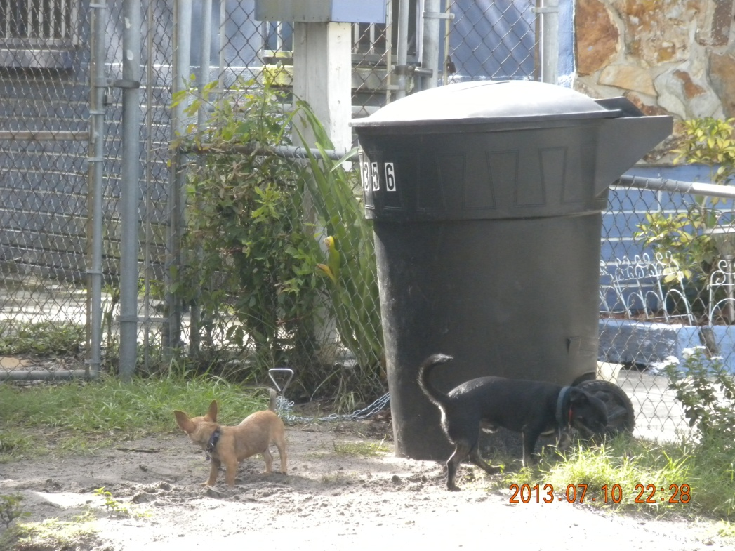
Figure 16: Several dogs were observed during the exercise. Lawns of pet owners contained dog waste which could wash into the storm drains during rain events. Waste from free roaming dogs is expected to be washed by rain into the stormdrains as well.

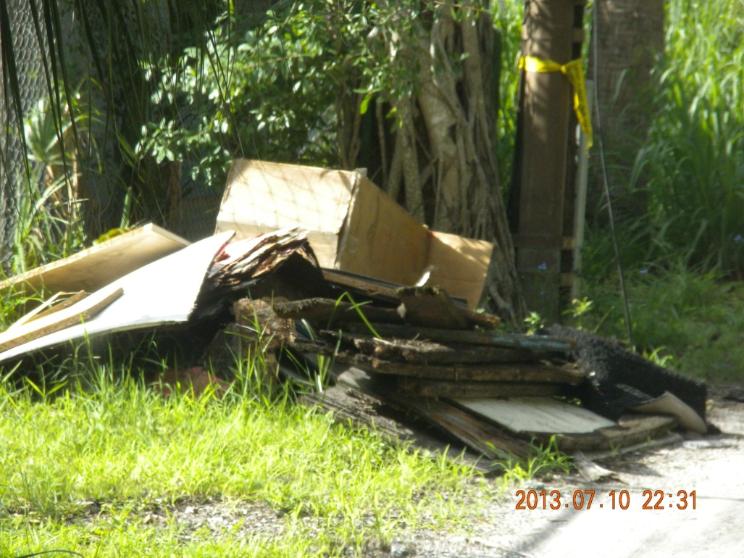

Figure 17: Discarded trash and pollutions left on the side of the road.
Action Item: City forces to remove the pile.
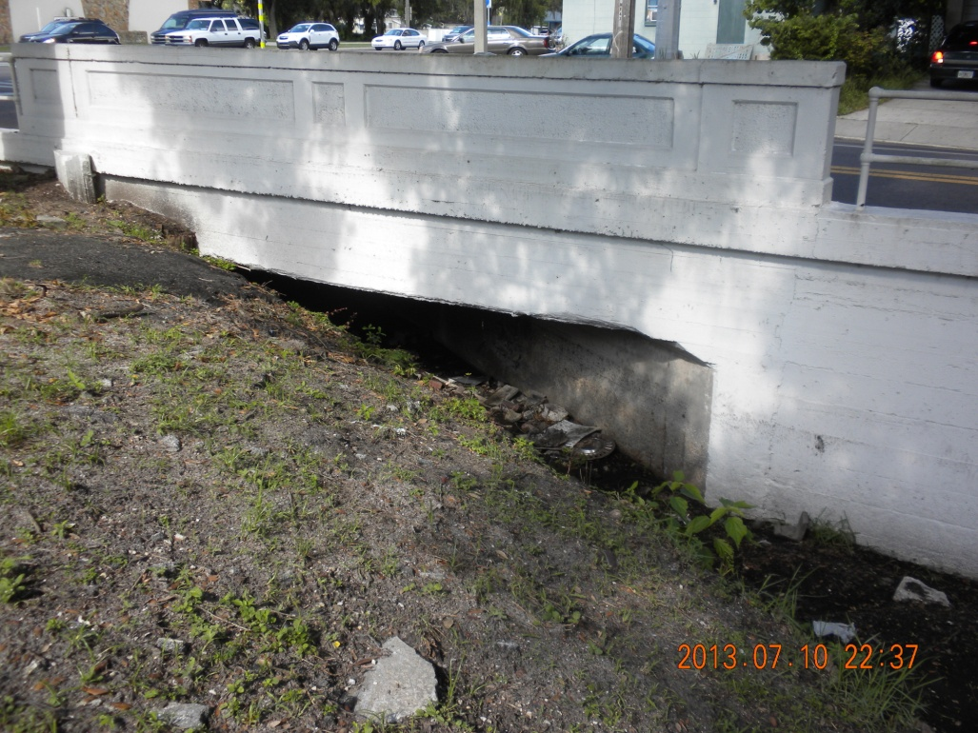
Figure 18: Box Culvert and drainage ditch. Action Item, determine schedule of trash and sediment clean out at this location, then increase frequency.

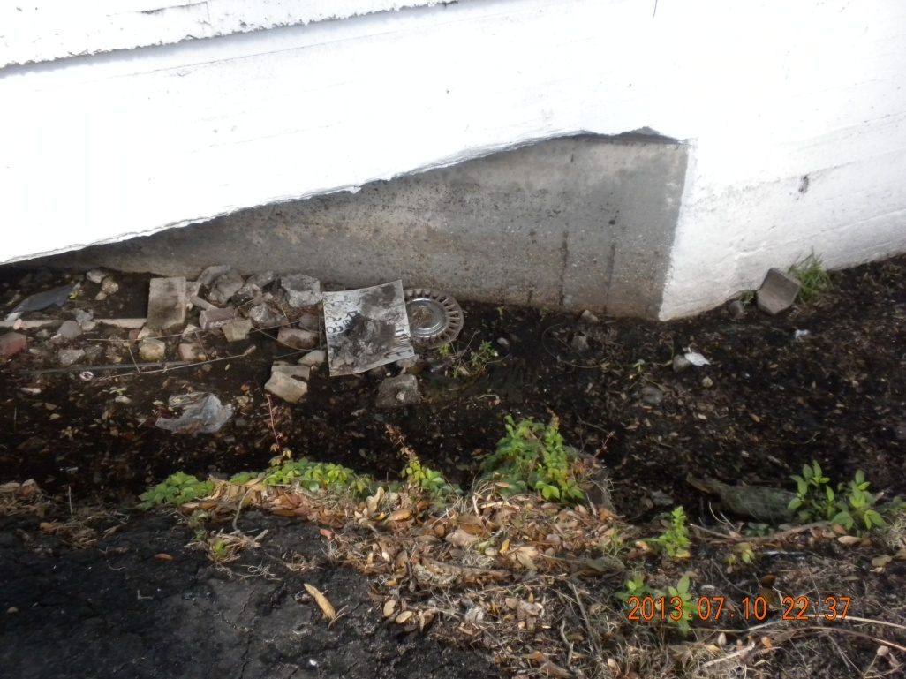
Figure 19: Ditch with litter.
Action Item: City forces removed the debris allowing the ditch to drain properly.
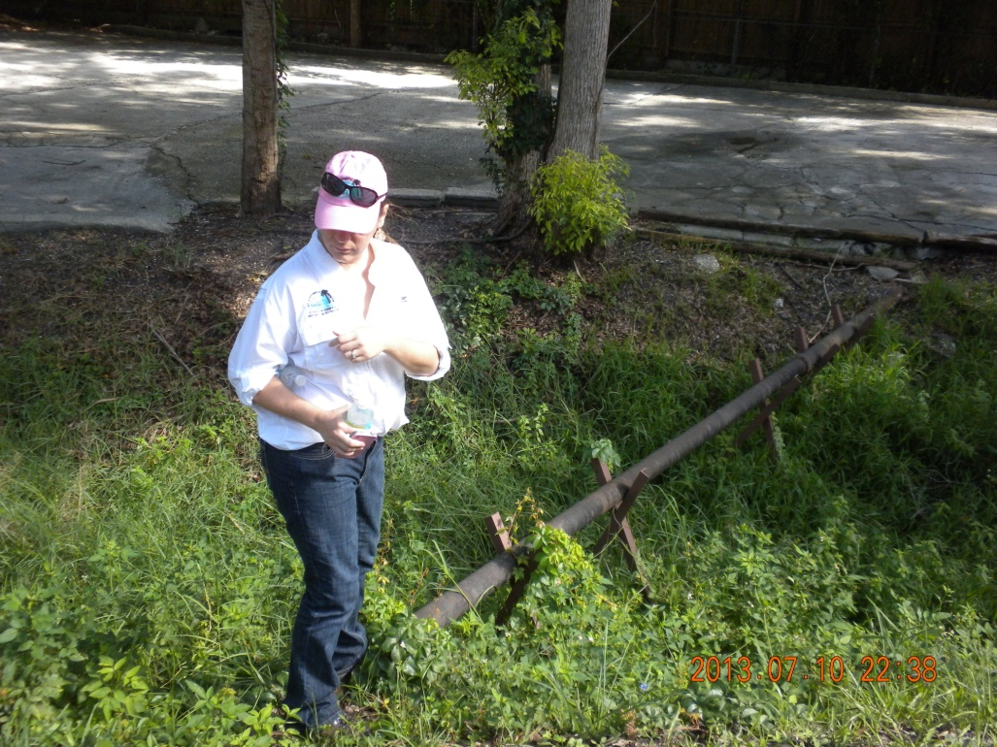
Figure 20: WTW Team Member Anita Nash, FDEP inspects an "exposed “sewer pipe.

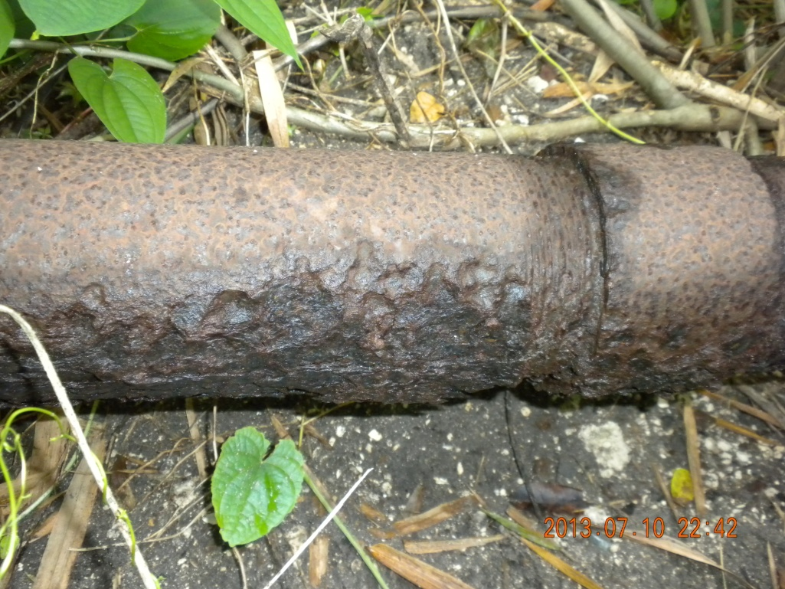
Figure 21: The sewer pipe shows pitting, signs of deterioration.
Action Item: Water Resources representatives to review status of pipe and fix if necessary.

Figure 22: Illegal dumping in a vacant lot.

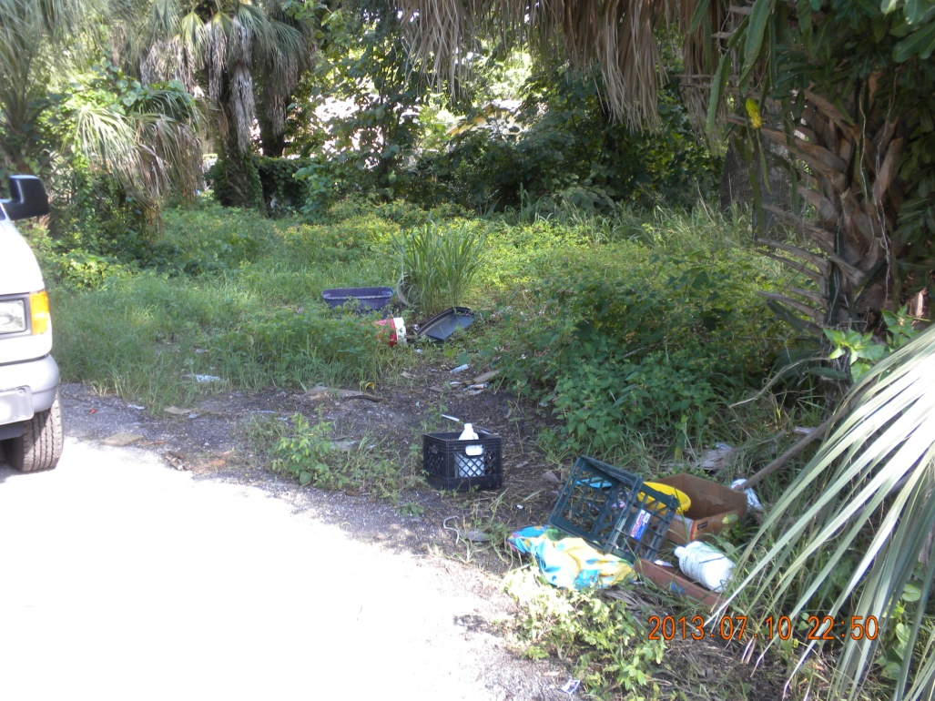
Figure 23: Illegal dumping in a vacant lot.
Action Item: City forces will clean up and notify owner to maintain the lot and keep it free of trash.
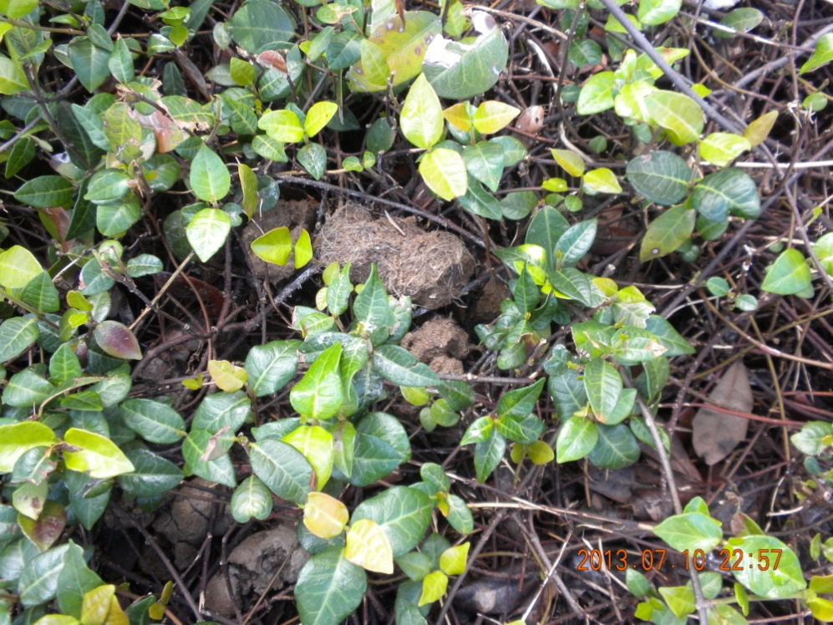
Figure 24: Evidence of not practicing good pet waste disposal at vet business Action Item: Speak with veterinary business about cleaning up their outdoor property daily. Consider possibility of using this as a site for public education via signage outside, brochures in the clinic, or possibly a poster in the clinic. City code enforcement staff to check vet clinic property weekly for compliance with waste pick up request.

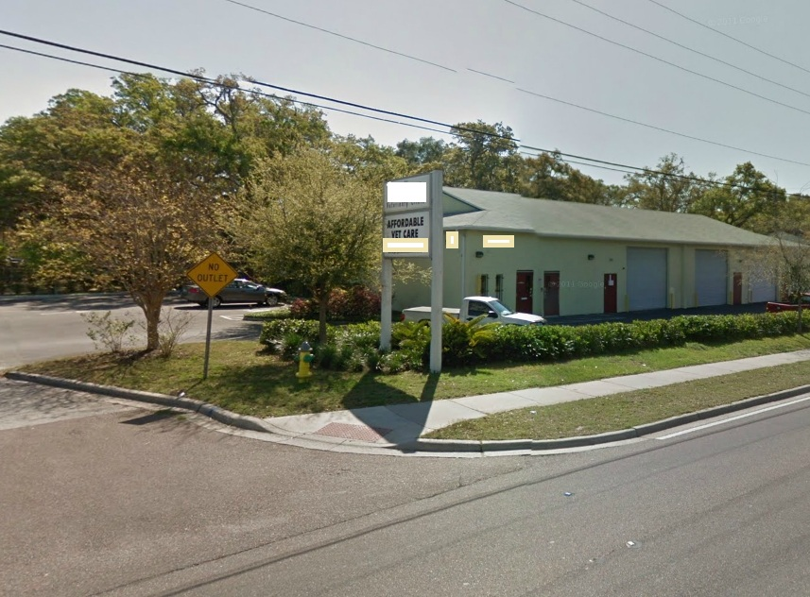
Figure 25: Veterinary clinic had evidence of not properly disposing of pet waste. Action item: City to advise business of requirements to remove dog waste from property.

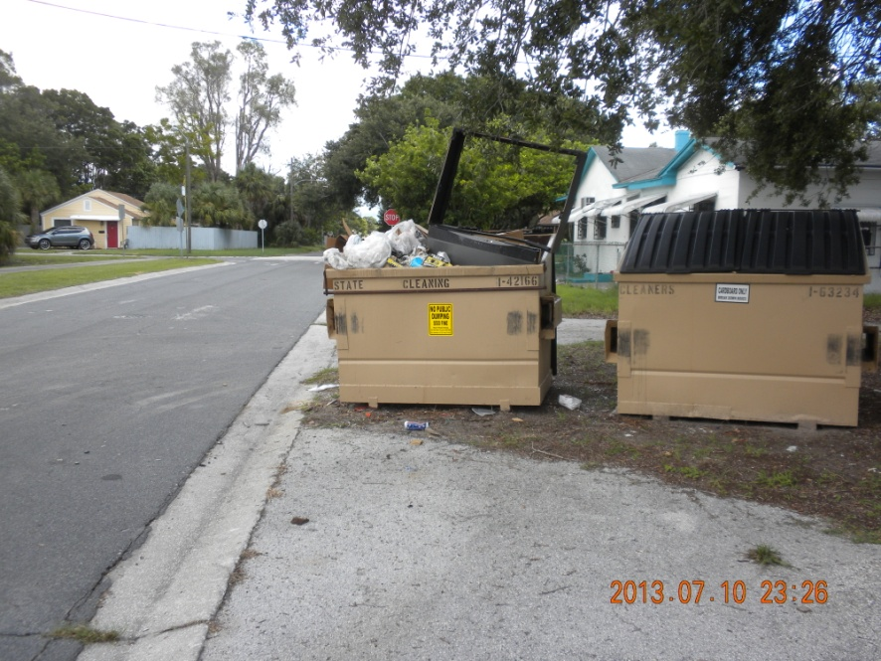

Figure 26: An open garbage container. This can be a source of pollutants getting into the water as rain washes over trash gathering pathogens and bacteria and flows out of the trash bin into the stormwater system.
Action Item: City staff to replace dumpster if needed and to advise business to keep lids closed not to overfill dumpster. City to come by monthly to see if new practice remains.

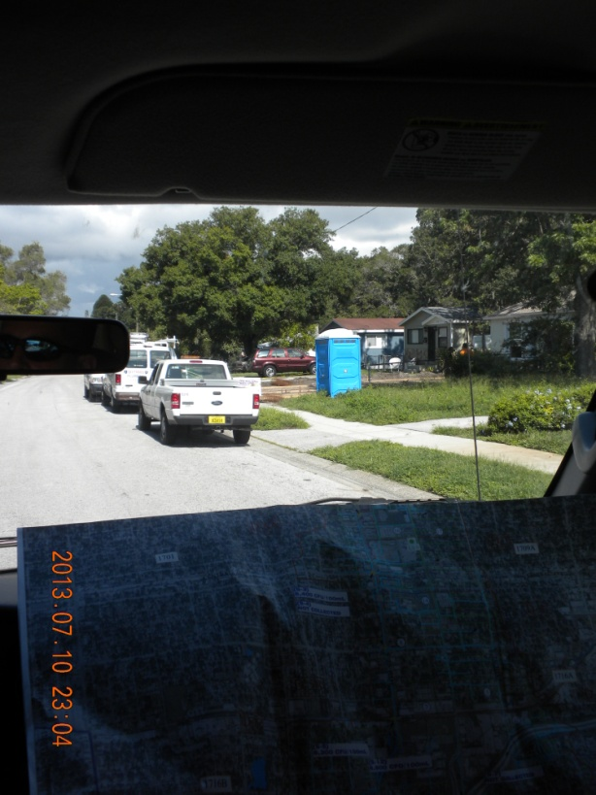

Figure 27: Port-O-Potty at a construction site.
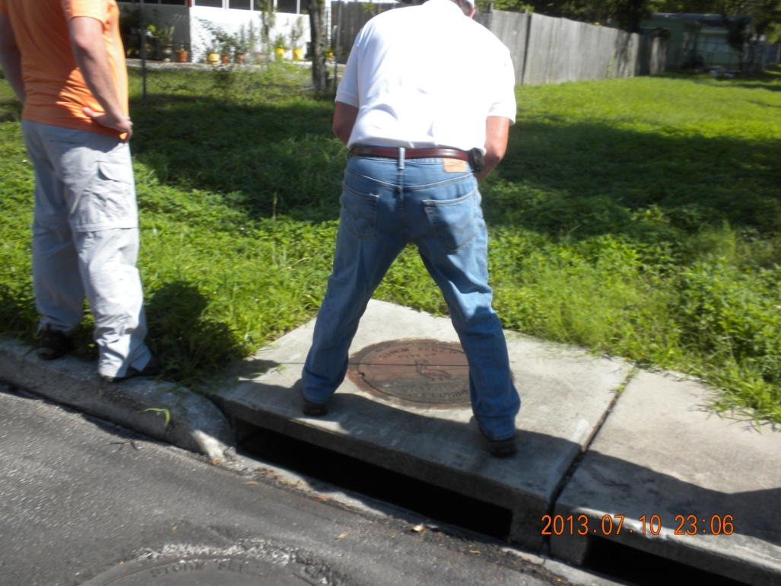
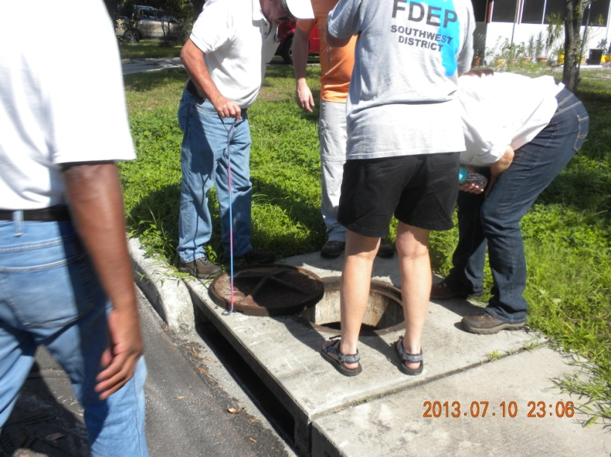
Figure 28: WTW Team inspecting the stormwater manhole before taking a water sample. Shallow flowing water in the stormdrain.
Figure 29: The WTW Team about to inspect a stormwater manhole.

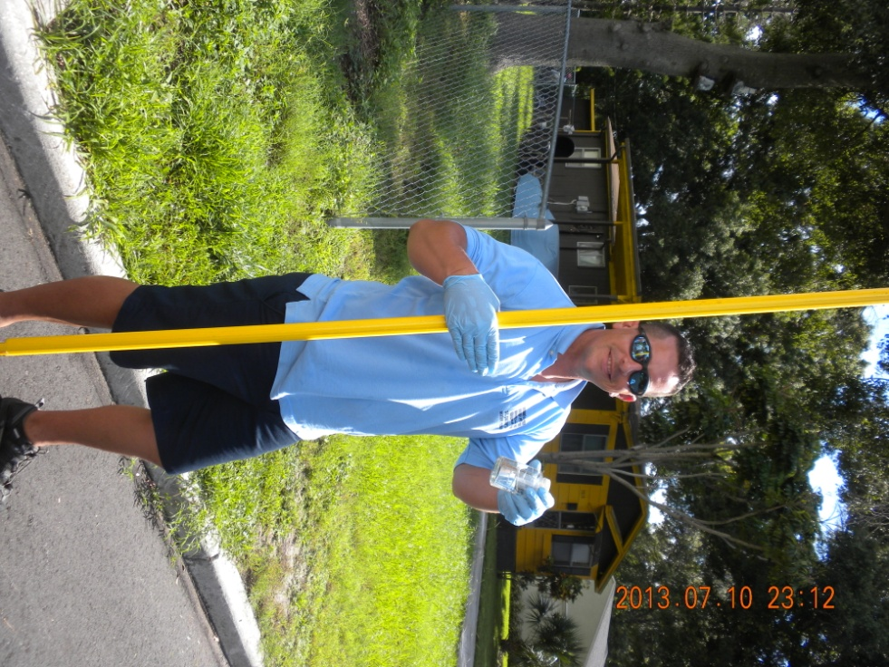

Figure 30: WTW Team member taking a water sample. Action Item: Results from sampling showed 9,900 CFU/100 mL.
NewAction Item: Follow up sampling to determine what part of the stormdrains contain these high Fecal Coliform loads. Sucralose sampling recommended to determine if human waste water is in the stormdrain.

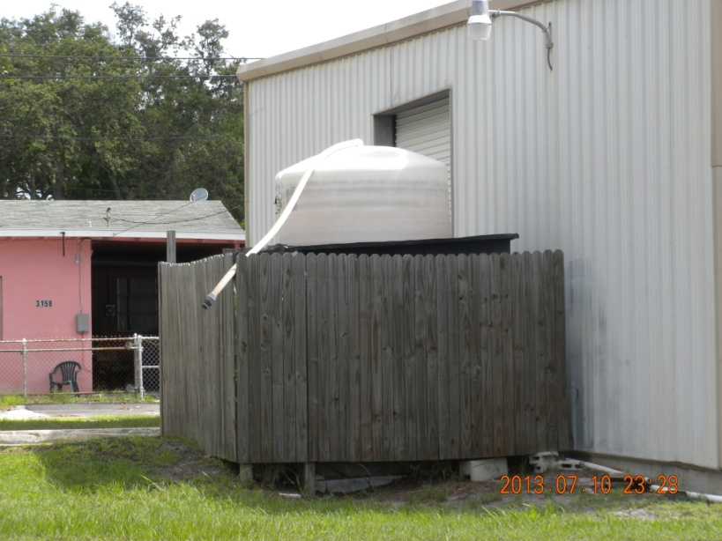
Figure 31: Cleaning services company with tank over flow discharging on ground. Action Item: City to advise company that open discharge to ground is not authorized.

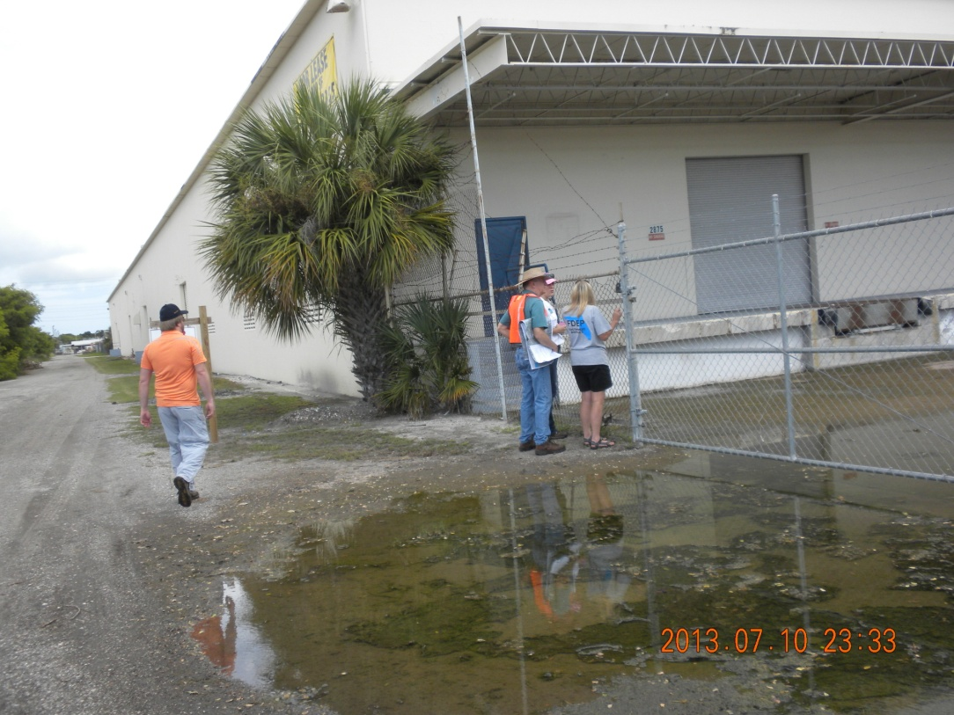

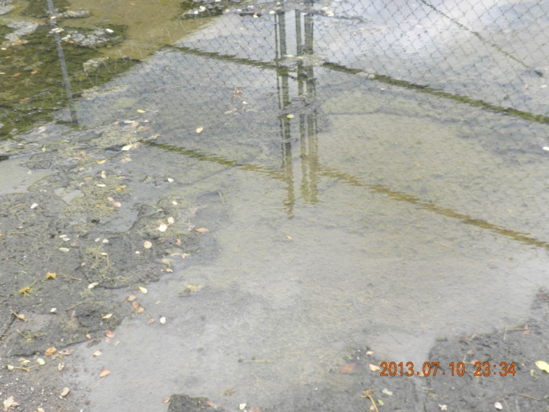
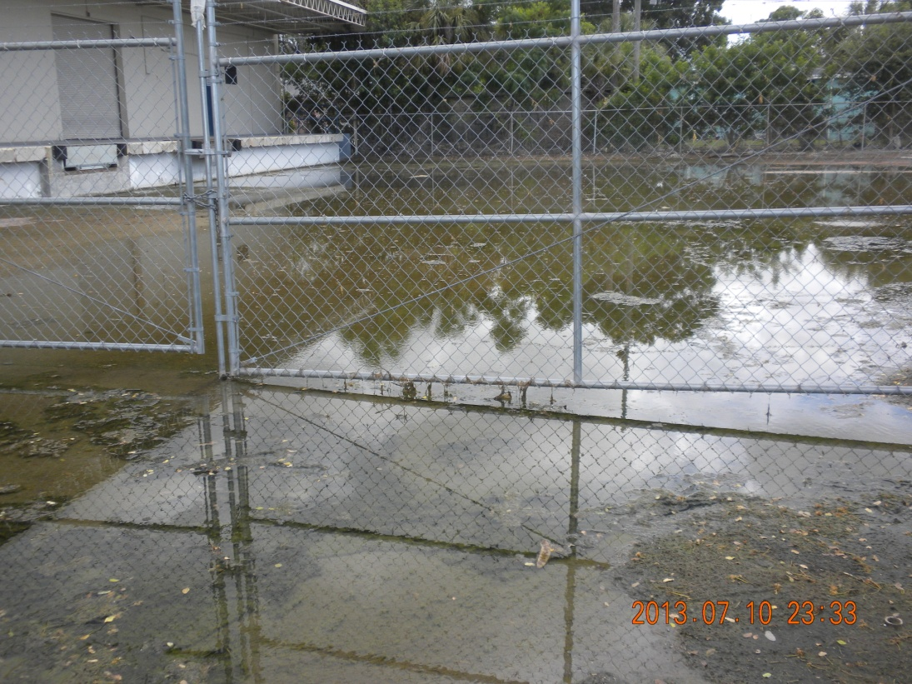
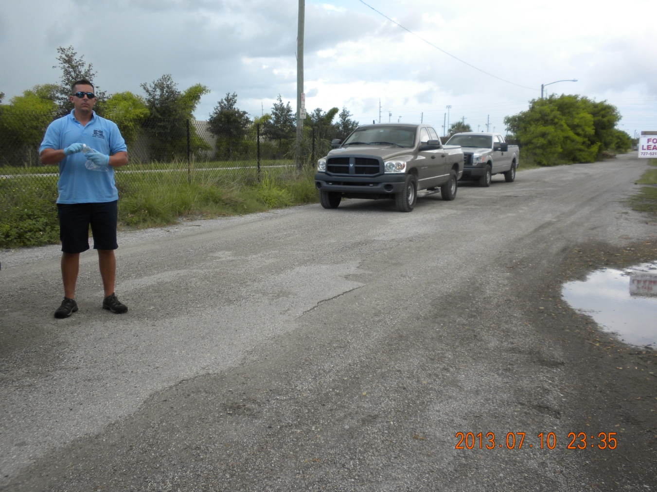
Figure 31: Observed algae growing in the water of the parking lot indicating the pool has been here for a week or more. Appears stormwater drainage vent in the bottom of the truck dock is clogged. Action Item: City to contact property owners for maintenance of stormdrain.
Figure 32: Abandoned Warehouse with stagnant water pooling in the parking lot.
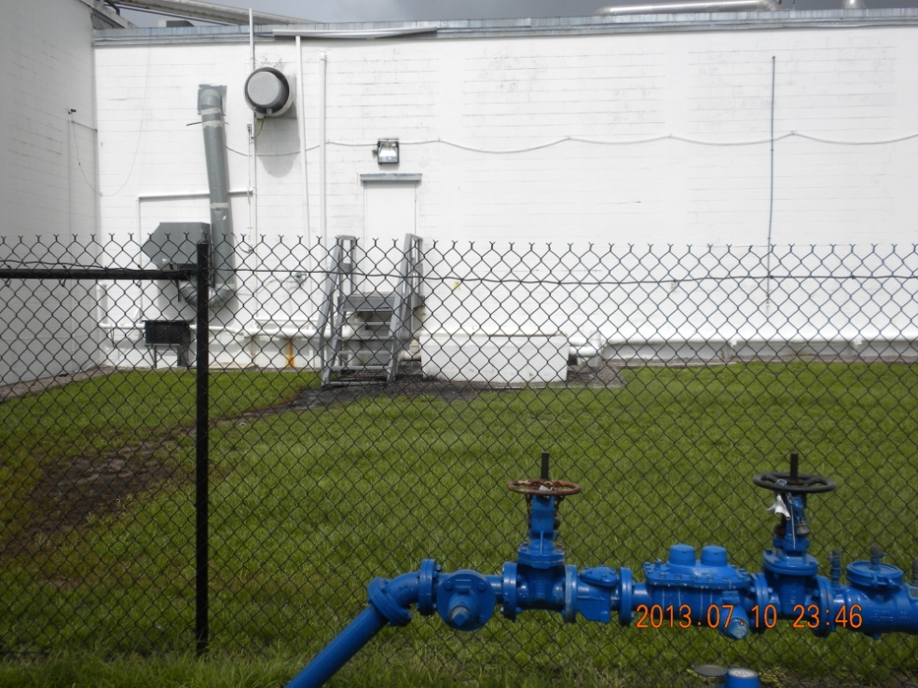
Commercial

Figure 33: WTW Team member taking a water sample from the standing water to insure there are no pollutants. Action Item: Results of sampling indicated no fecal coliform in excess of 400 CFU/100mL.

Entities Within the WBID:
The main commercial areas of the WBID are along 34th Street. It is a mixture of fast food, hotels/motels, restaurants, department stores, strip centers and other commercial businesses typically found along heavy traffic corridors. Additionally, the WBID has a formal rail line that is now a bicycle trail. Commercial/industrial businesses along the trail include, lumber, manufacturing, a variety of active and closed small warehouses as well as other businesses. One business along the trail is a seafood processing business. Florida’s sea food industry is a billion dollar per year business. It is not uncommon to find sea food processing plants in every city. Fish waste or fish paste is commonly discharged from the processing plants is an organic material consisting of fish oils and other fish by products that are high in nutrients. If not disposed of properly, when discharged from commercial facilities into environments where these nutrients are not naturally found, such as infiltration into a storm drain, it can cause higher than normal levels of pollutants and nutrients.
Figure 34: Evidence of some leakage at a sea food plant. Action Item: Advise company to repair leak.
The WTW Team explored the boundaries of the area sea food processing plant to ensure BMPs were in place to protect the environment.
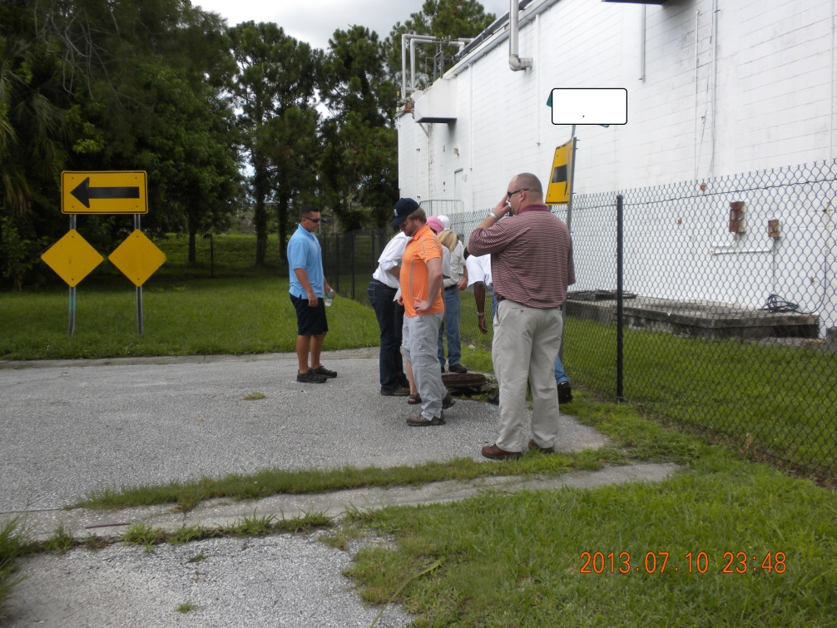

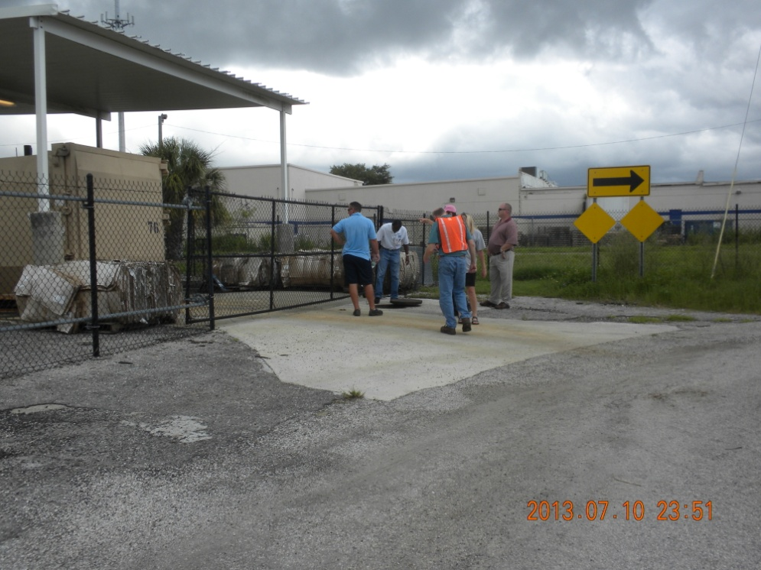

Figure 35: The WTW Team inspected a nearby manhole for evidence of infiltration from the plant.

Figure 36: WTW Team members inspect the manhole outside of the seafood plant compound. There was an strong bacterialogical smell and hundreds of flies near the dumpsters to the left in the picture.
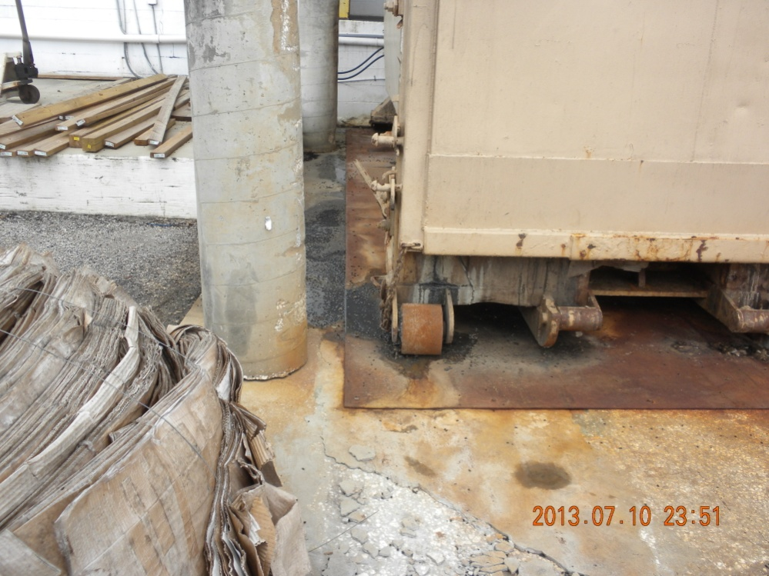
Figure 37: Seafood processing company with dumpster leaking. Action item: Advise company to stop leaks from flowing to MS4 .

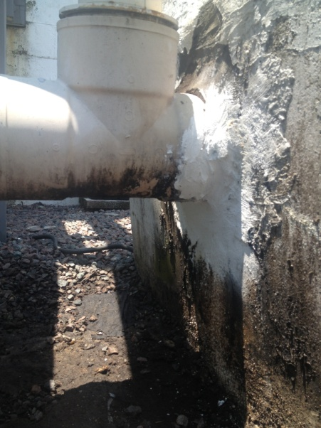
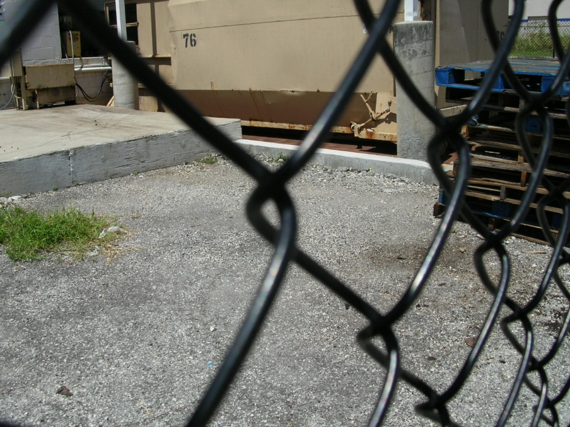
Figure 39: Action item completed. Seafood processing company with new curb installed.
Figure 38: Action Item completed. Seafood processing company with repair around discharge pipe of sump.

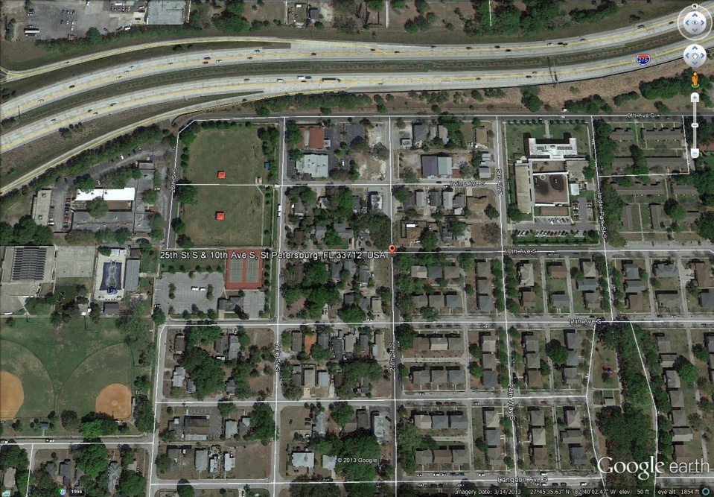
Residential Neighborhoods Within The WBID:
Many urban areas have issues with high levels of fecal coliform bacteria, which create water quality problems. Storm drains and street gutters are prime receptacles for pollutants to create water quality issues. The 34th Street Basin is a blend of residential and commercial properties. For this Walk the Watershed exercise, the WTW Team visited the Wildwood Heights section of the basin. The neighborhood is approximately 0.18 square miles, and is densely populated.
Figure 39: The Wildwood Heights section of the 34th Street Basin.

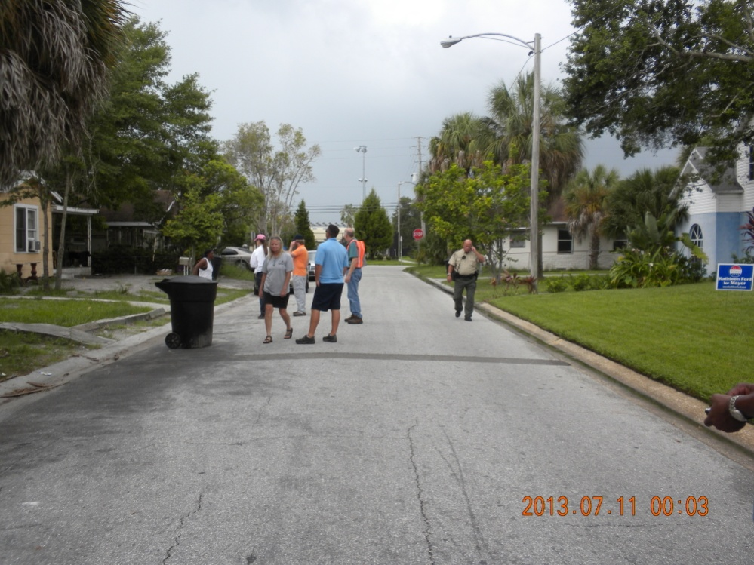
Figure 41: WTW Team members walking the Wildwood Heights Neighborhood.
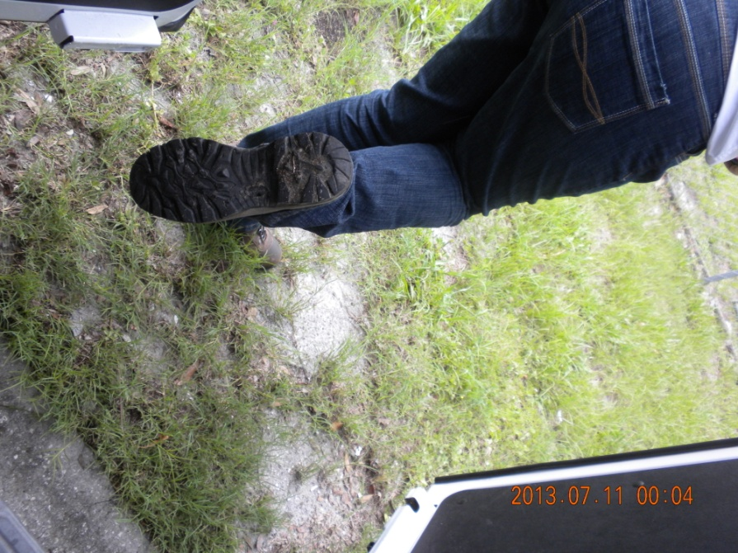
Figure 42: WTW Team member, Anita Nash (FDEP), finds evidence of residents not practicing proper pet clean up.
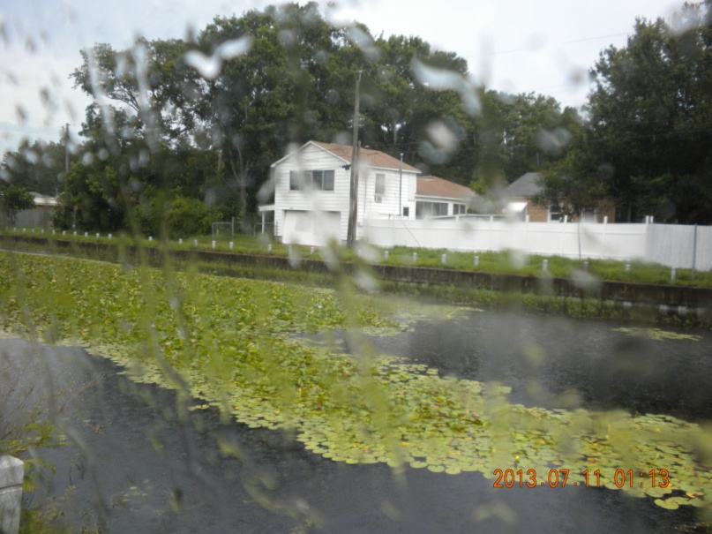
Further north, in the North Kenwood Association, is Lake Floral, a 0.89 acre lake that has hardened shoreline surrounding the entire lake. The lake is a stormwater pond that is maintained by the city and has desirable wetland emergent plants in the center. The lake discharges to the storm sewer through a small 12” diameter culvert at the southwest area of the lake. The surrounding watershed is dense residential. Action items for this lake is to sample downstream of the lake to determine if the lake has had an impact on the storm sewer and based on the results, provide education through the HOA.
Figure 40: Floral Lake – Samples collected in lake exhibited high fecal coliform levels. However, lake was not discharging at time of sampling. Action item: Sample in storm sewer system downstream of lake and provide education to the residents.

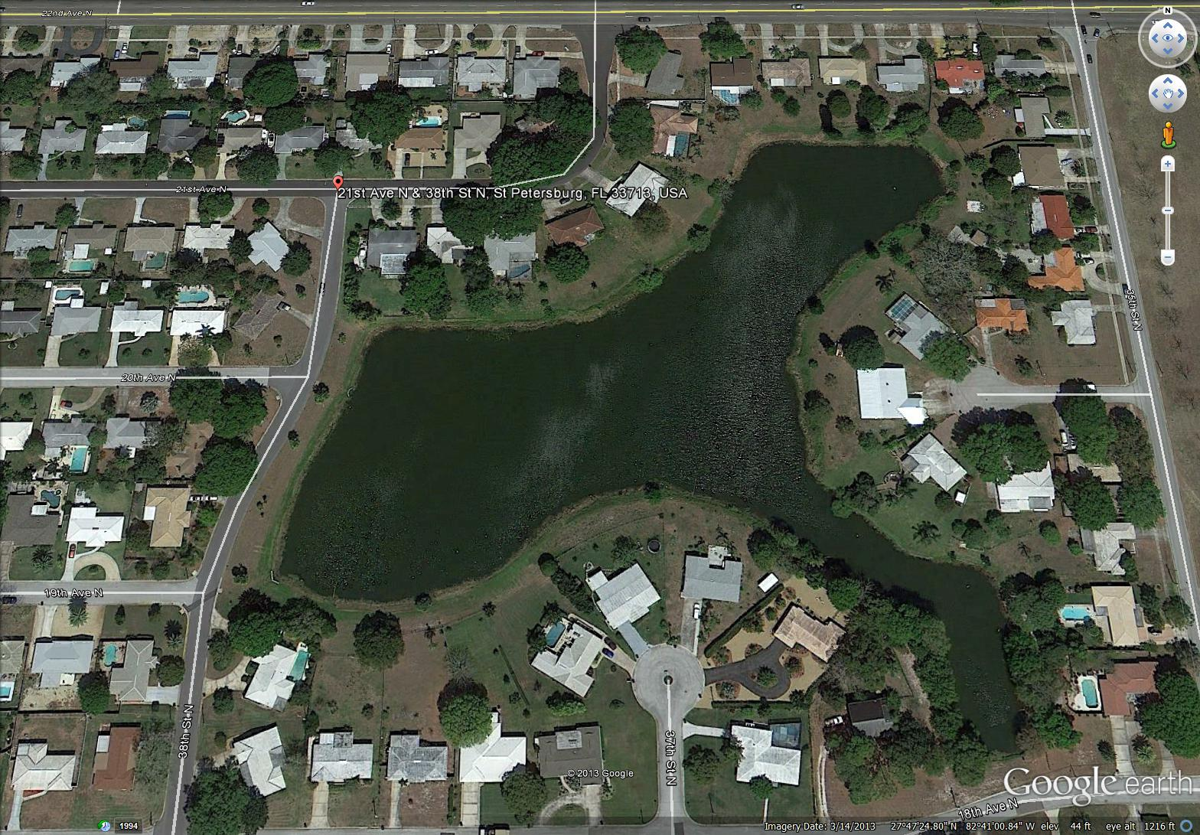
East of 34th Street, WTW Team members visited the Harshaw Lake No. 2 located at the intersection 19th Avenue North and 38th Street North. The team explored the western banks of the lake where there is known activity of residents walking their dogs and a population of Muscovy Ducks.
Figure 43: Harshaw Lake with surrounding residential neighborhood

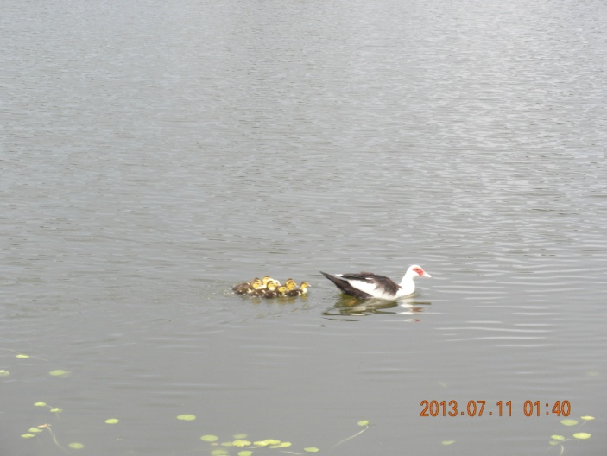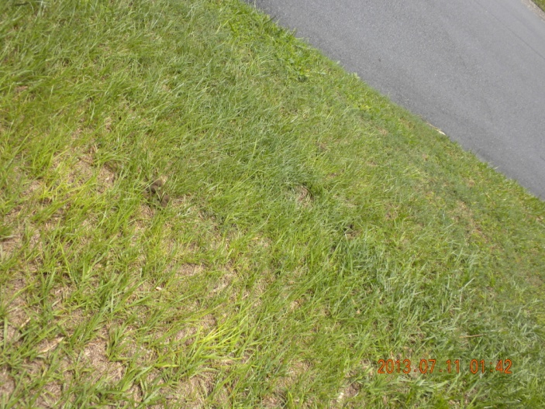
Figure 44 a & b: Harshaw Lake – N of 18th A/N and W of 34th S. Sample from lake indicated elevated fecal coliform. Lake has at least one family of mascovy ducks. Muscovy ducks are not native to FL and contribute feces to the water and edges of waterbodies. It is recommended these exotics are not encouraged to reproduce where feces are contributed to ambient waters. West side of lake on 38th S/N had numeroous areas with dog waste piles.
Action Item: Place sign advising dog owners that they are required to pick up after dogs as per city code. Additionally, get with HOA to provide educational material.

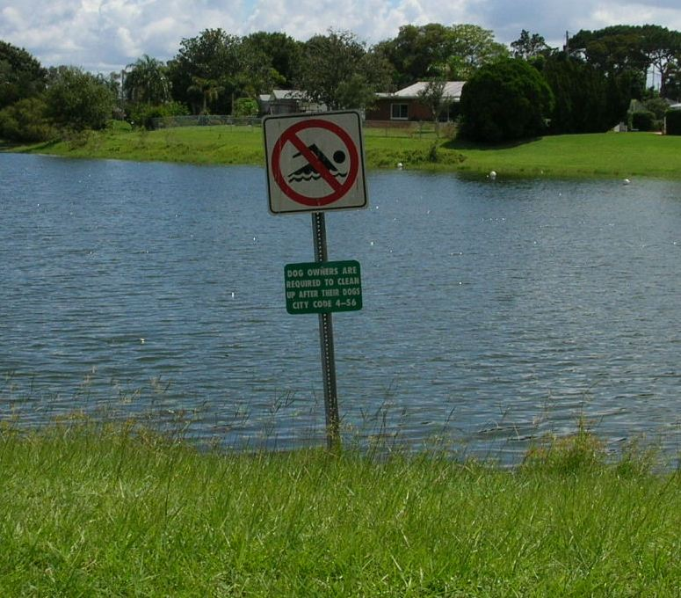
Figure 45: Action Item completed: Sign Installed to clean up pet waste as per city code as per action item.
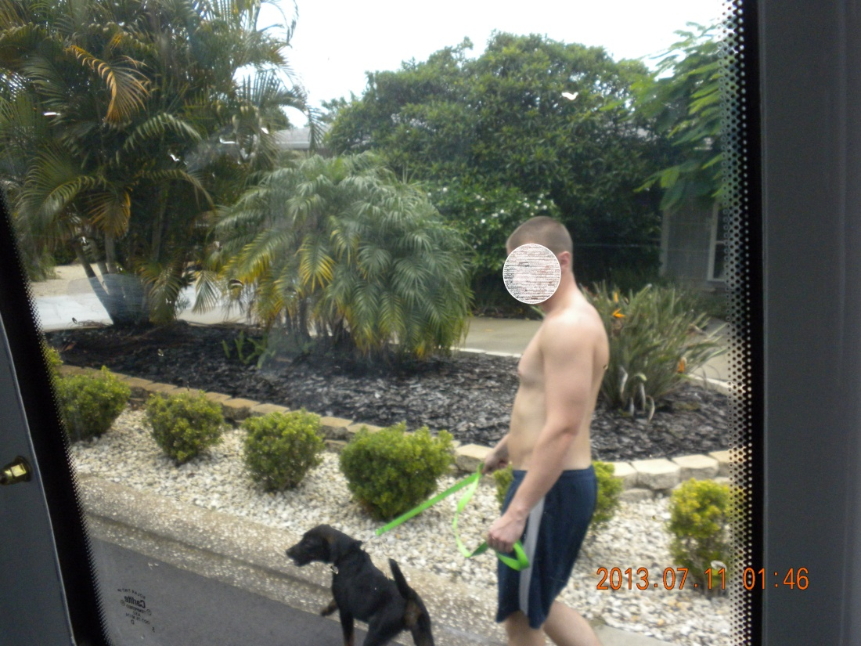
Figure 46: Resident walking his dog. No evidence of a cleanup bag.
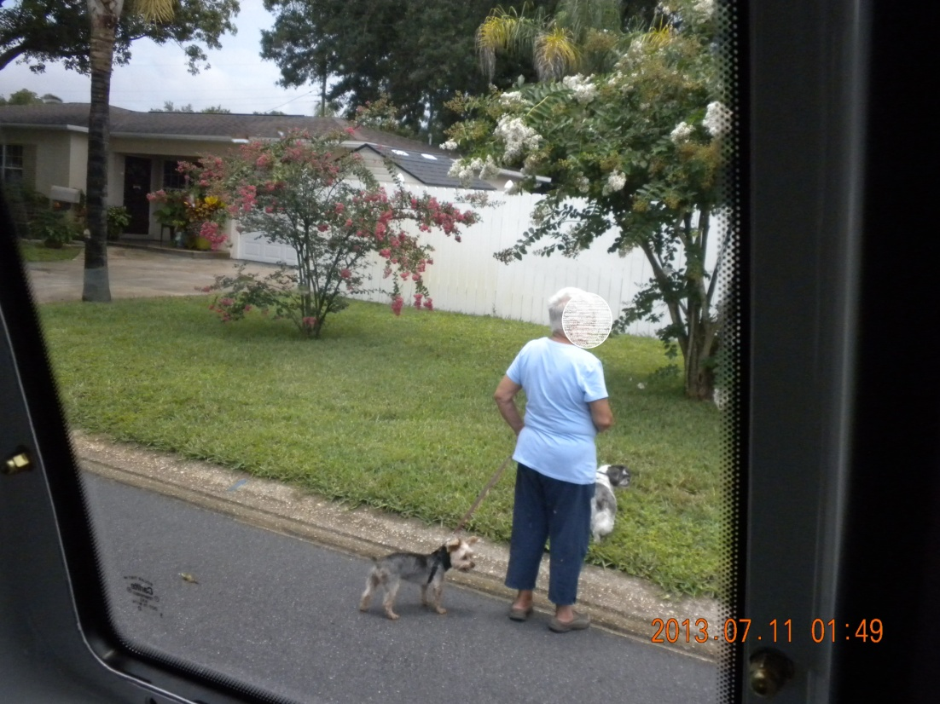
Figure 47: Resident walk two dogs, no evidence of a cleanup bag.
Action Item: Education needed through HOA on need for pet owners to clean-up after their dogs.

Commercial Areas of WBID

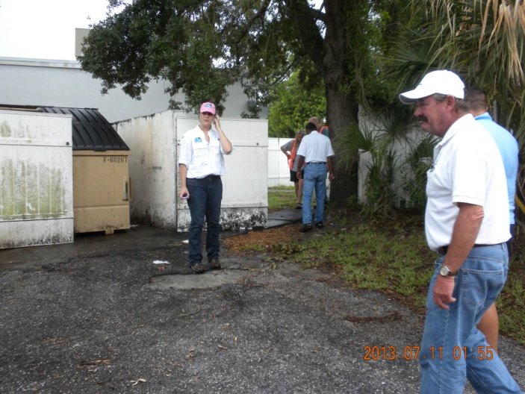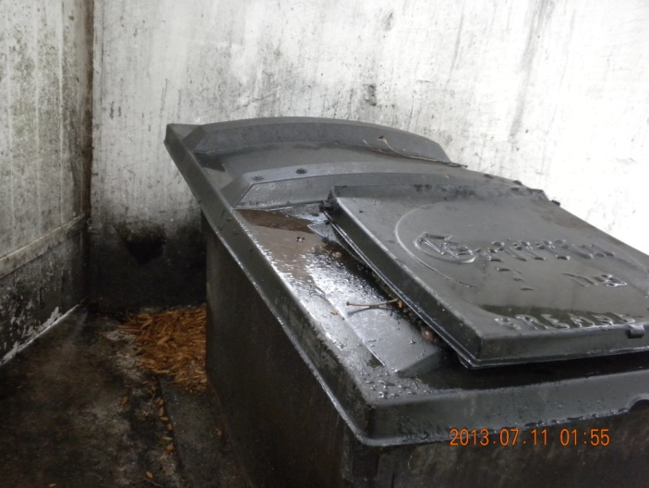

Figure 48: 1st A/S and 34th S – Trash Dumpster and grease storage needs to be maintained at business located at 14 A/N and 34th S.
Action Item: Advise property owner and businesses to maintain area.

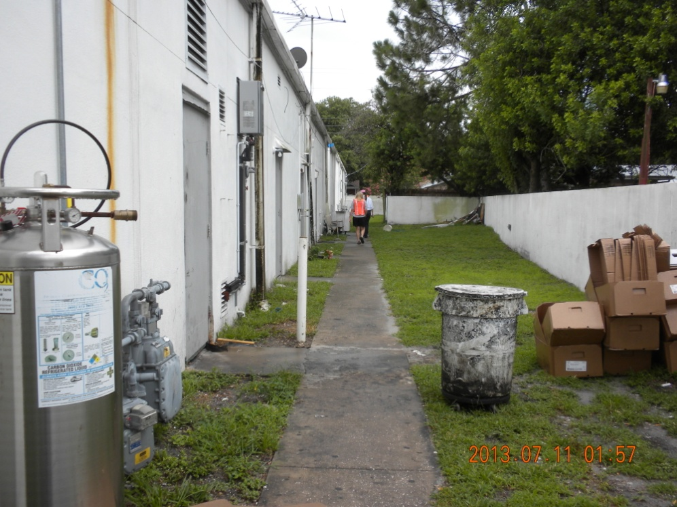
Figure 49: : 1st A/S and 34th S – Area behind the businesses needs to be maintained located at SW corner of 14 A/N and 34th S. Request the Grease Management Program to review maintenance records of site.
Action Item: Advise property owner and businesses to maintain area.

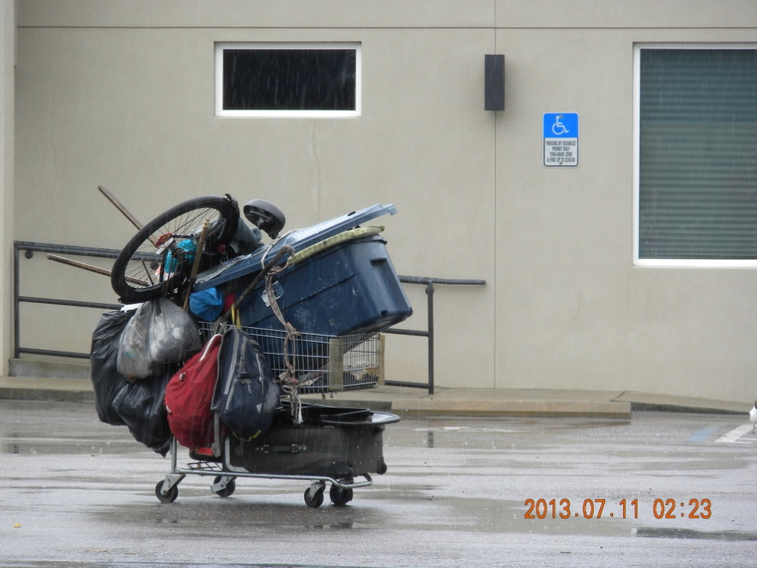
Figure 50: Central Avenue and 34th S – Signs of homeless in area

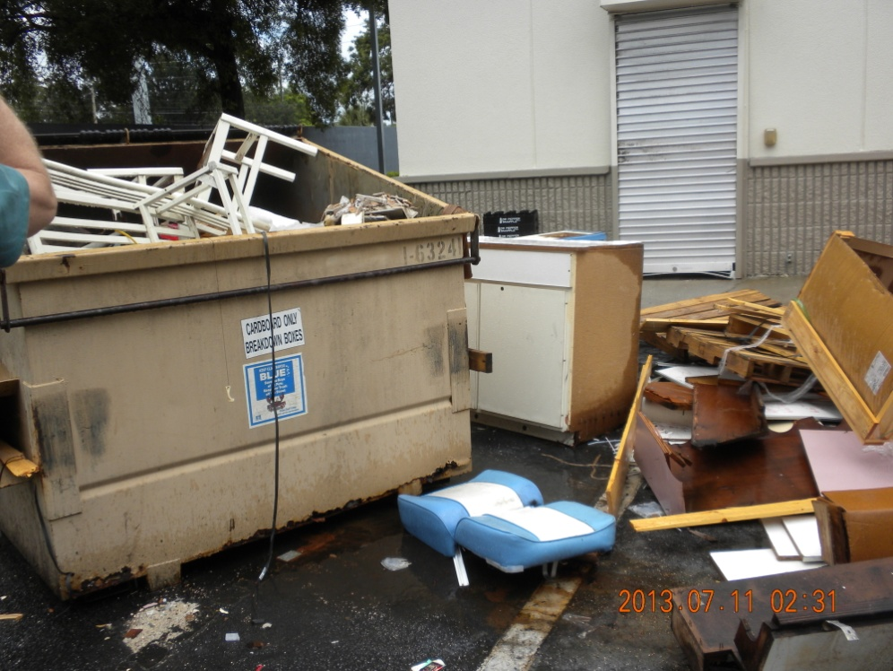
Figure 51: 1st A/S and 34th S – Business is closed is and being remodeled. Trash exists in and around dumpster in parking lot.
Action Item: Complete- Dumpster and trash have been removed and business reopened.

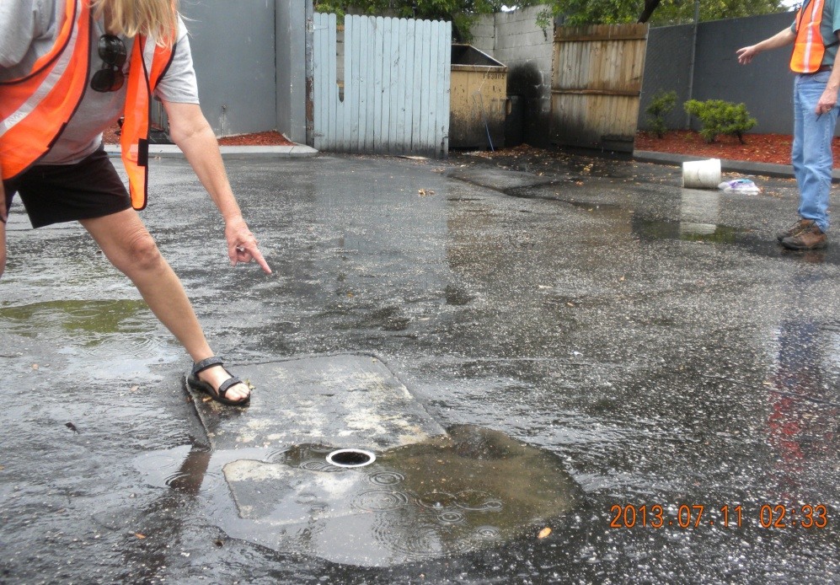
Figure 52: 1st A/S and 34th S – Trash Dumpster and grease storage needs to be maintained. Additionally, a sewer cleanout has no cap. S/N.
Action Item: Advise property owner and business to maintain dumpster area and provide cap for cleanout line.
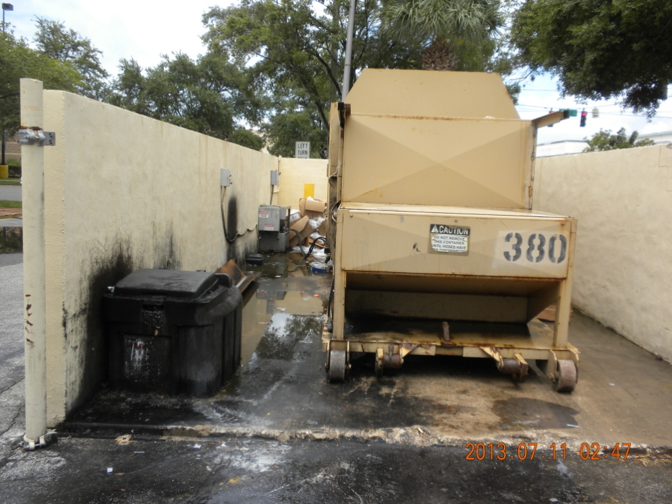
Figure 53: Trash Compactor enclosure with grease storage bin at shopping center located at Central Avenue and 34th S/N.
Action Item: Advise property owner and businesses to maintain area.

Next Steps and Follow-up Actions

Intractable Contributions and Natural Conditions
- Figures 7, 9, 29, and 54 show evidence of wildlife in close proximity to the Turkey Creek watercourse, including: raccoon prints, waterfowl, and feces.
- Citrobacter grows on rotting fruit and can cause false positives for fecal coliform tests. Citrus grows wild and in residential yards throughout the watershed. See Figure 52.
- Bacterial re-growth is probable in ditches and natural watercourses given the sediments observed. See Figures 9, 19, 29, and 54.
- Natural canopy cover is not a contributor, but does prevent UV rays from reaching the water column. UV rays kill pathogens and fecal coliforms. See Figures 14, 21, 25, 42, 48, and 53.
- Natural tannins from decomposing plant material in the water also shade out UV rays. See Figures 21 and 52.

Action Item List
Location | Suggested Action | Responsible Entity | Date Completed | Results
Figure 6 | Determine frequency and magnitude of coliform discharges from Valrico AWTF. | FDEP | 01/20/2012 | Effluent from Valrico AWTF currently receives a high level of treatment. Sampling history shows effluent concentrations meet and exceed permit requirements.
Figure 10 | Contact landowner for BMP enrollment. | FDACS  IFAS
Figure 14 | Supersaturated drain field at migrant housing. | EPC |  | Inspection conducted 12/15/2011. Re-inspect for compliance and proper functionality.
Figure 19 | Follow up inspection to verify problem persists and identify potential sources. | HCPW | 01/24/2012 | Follow up inspection showed improved conditions. Runoff appears to be entirely from a strawberry field and anthropogenic sources of coliforms are unlikely.
Figure 20 | Contact landowner for BMP enrollment and reduce animal waste in close proximity to watercourse. | FDACS  IFAS
Figure 21 | Investigate other nearby land uses along this tributary because of repeated hits. | HCPW | 01/24/2012 | Follow up investigation elicited several possible sources. These have been added as action items directly below [Figure 22].
Figure 22 | Investigate resident complaint of potential chronic septic failures. | DOH | 02/14/2012 | DOH complaint inspection showed no evidence of sanitary nuisance.
Figure 22 | Contact owner of sheep farm and provide educational information on Small Farm BMPs. | FDACS
Figures 23 | Investigate unknown pipes for potential illicit connections. | EPC |  | EPC investigation found discharge is composed entirely of stormwater and, therefore, a legal connection.
Figure 24 | Investigate unknown pipes for potential illicit connections. | Hillsborough County |  | Illicit connections discharging to the MS4 should be removed according to Hillsborough County’s Stormwater Ordinance.
Figures 26 & 34 | Distribute education materials to residents in order to reduce possible pet waste contamination. | HCPW
Figure 27 | Inspect unknown pipes observed during the Walk. | DOH | 12/21/2012 | Contact with landowner was made during the Walk. Subsequent DOH inspection revealed pipes had been removed and no sanitary nuisance observed.
Figure 28 | Contact landowner for agricultural BMP enrollment at strawberry farm. | FDACS  IFAS |  | Landowner has been enrolled in the agricultural BMP program.
Figures 31, 32, & 33 | Investigate pipes crossing the ditch to ensure proper functionality. | EPC |  | Starlite MHP is in receivership as of the date of the Walk; however, continued efforts will be made with the future owners.
Figure 35 | Direct owner of Starlite MHP to properly secure lids to wastewater clean outs. | EPC |  | Starlite MHP is in receivership as of the date of the Walk; however, continued efforts will be made with the future owners.
Figures 36 & 37 | Determine functionality of unknown pipes in Starlite MHP. | EPC  Code Enforc. |  | Starlite MHP is in receivership as of the date of the Walk; however, continued efforts will be made with the future owners.
Figures 38 & 39 | Follow up visits to investigate source of saturation at Starlite MHP. | HCPW  EPC | 01/25/2012 | EPC investigation determined saturation was the result of an underground potable water leak. Owner was notified. Subsequent inspection showed no evidence of saturation.
Figures 40, 41, 42, 46, 47, & 48 | Direct owner of Starlite MHP to perform trash removal. | Code Enforc. FDLE |  | Active complaint with Hillsborough County Code Enforcement. Resolution to be determined.
Figures 43 & 49 | Direct landowner to maintain vegetation throughout effluent pond and conveyances within Starlite MHP. | EPC |  | Starlite MHP is in receivership as of the date of the Walk; however, continued efforts will be made with the future owners.
Figures 44 & 45 | Investigate source and magnitude of potential coliform contamination to resolve hazard. | EPC |  | Water sampling conducted on 01/25/12 revealed significant coliform contamination [>200,000. CFU/100mL]. Owner was immediately notified. Subsequent inspection showed no evidence of sanitary nuisance.
Figure 51 | Investigate potential illicit connections. | FDLE |  | Active complaint with Hillsborough County Code Enforcement. Resolution to be determined.
Figure 52 | Contact landowner to determine function and legality of building which spans the tributary. | FDLE |  | Active complaint with Hillsborough County Code Enforcement. Resolution to be determined.
Figure 53 | Investigate PIC which appears to be in line with septic mound. | HCPW |  | DOH inspection indicated no evidence of sanitary nuisance. Pipe will be inspected during wet weather and any discharge will be sampled.
Figure 55 | Remove trash and discarded tire. | HCPW | Ongoing | Trash is regularly removed by Hillsborough County Public Works during ROW mowing. The major thoroughfares in the Turkey Creek area, including: Dover, Sydney Washer, Sydney, and Forbes Roads, are currently scheduled for mowing [04/15/12].
Figure 57 | Investigate PVC pipe running from camper into the ground. | DOH |  | DOH inspection indicated no evidence of sanitary nuisance.
Figure 58 | Inform Robinson Elementary of potential water quality hazard and request dumpster lids remain secured. | HCPW | 12/14/2011 | Informed Principal Wilkerson of the potential water quality hazard and requested the lids remain secured. Subsequent visit found lids secured.
Figure 59 | Re-inspect drain field at Crawford 3B’s Mobile Home Park to ensure proper function. | EPC |  | Owner was notified of the violation during the Walk. Follow up inspection will be scheduled to ensure compliance.
Watershed Wide | Trash and debris can provide a medium for bacterial growth. More frequent ditch maintenance should be conducted, where feasible. | HCPW  EPC |  | Opportunities to expand ditch maintenance through alteration of the County’s wetland regulations will be explored.
Watershed Wide | Exotic vegetation can block sunlight and provide a medium for bacterial growth. Additional vegetation maintenance should be explored, where feasible. | HCPW  EPC |  | Opportunities to expand areal extent of vegetation maintenance through alteration of the County’s wetland regulations will be explored.
Watershed Wide | Livestock in close proximity to watercourses and excess sedimentation were observed. Continue agricultural BMP enrollment within impacted areas. | FDACS  IFAS
Watershed Wide | Increase water quality monitoring within the impacted areas to facilitate future assessment and pollutant removal activities. | HCPW  EPC | Begun:  01/01/2012 | Hillsborough County and EPC have arranged for additional water quality monitoring in the Turkey Creek watershed. Two quarterly sampling locations have been added north of SR 60; one located at S. Forbes Rd and another at Sydney Rd.
Watershed Wide | Increase awareness of coliform impairment within County maintenance staff. | HCPW | Begun:  03/06/12 | Emphasis on communication & awareness in Hillsborough County Public Works East Service Unit, which conducts maintenance in the Turkey Creek WBID. Annual education program trains all maintenance staff regarding stormwater pollution and illicit discharge detection.
Watershed | Poor quality migrant housing has potential to contribute to coliform contamination. Increase inspection of migrant housing, if necessary, and resolve any known sanitary issues. | DOH | Existing | DOH Farm Worker Housing Program inspects all migrant housing facilities two times a quarter during residency, i.e. housing occupied year round would receive eight inspections.

Additional questions on this event should be directed toward:
Anita Nash
Environmental Consultant
Division of Environmental Assessment and Restoration
Florida Department of Environmental Protection
Office: (850) 245-8545
Email: anita.nash@dep.state.fl.us

Carlos Frey,P.E.
City of St. Petersburg
Engineering & Capital Improvements
P.O. 2842
St. Petersburg, Florida
Office (727) 892-5380
Email: carlos.frey@stpete.org

List of Acronyms and Abbreviations
List the acronyms used in the table of follow up actions and in text, especially those that pertain to departments within a county or city. Delete those below which do not apply to this document and add as appropriate.
BMP Best Management Practice
BMAP Basin Management Action Plan
CFU Colony Forming Units
FDEP Florida Department of Environmental Protection
FDLE Florida Department of Law Enforcement
FDOT Florida Department of Transportation
GIS Geographic Information System
GPS Global Positioning System
IFAS University of Florida Institute of Food and Agricultural Sciences
IWR Impaired Waters Rule
MF Membrane Filter
MGD Million Gallons per Day
mL Milliliters
MPN Most Probable Number
MS4 Municipal Separate Storm Sewer System
OSTDS Onsite Sewage Treatment and Disposal System
PIC Potential Illicit Connection
PVC Polyvinyl Chloride
ROW Right of Way
SOP Standard Operating Procedure
SR State Road
SSO Sanitary Sewer Overflow
TMDL Total Maximum Daily Load
UV Ultra-Violet
WBID Waterbody Identification
WTW Walk the Waterbody
WWTP Wastewater Treatment Plant

More information regarding the adoption of the IWR can be found at http://www.dep.state.fl.us/water/watersheds/assessment/iwr.htm.

