Cocohatchee River
Class II Marine Waterbody
** Fecal Coliform Criteria: The Most Probable Number (MPN) shall not exceed a median value of 14 with not more than 10% of the samples exceeding 43, nor exceed 800 on any one day
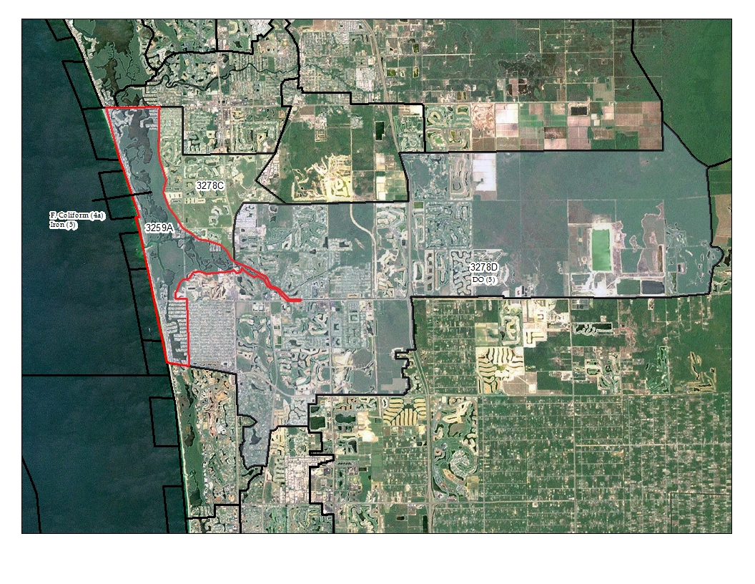
Current Impairments – Cycle 3
3259A – Cocohatchee River
Fecal Coliform (4a) – TMDL (August 19, 2008)
Counts per Day: 43 / 100ml
Percent Reduction: 65
Iron (5)
Biochemical Oxygen Demand (4c)
Dissolved Oxygen (4c)
3259D – Cocohatchee (Inland Segment)
Biochemical Oxygen Demand (5)
Dissolved Oxygen (5)
3278C – Cocohatchee Golf Course Discharge
Dissolved Oxygen (4d)

Walk the WBID 3259A
The year it was verified impaired in Cycle 2 (2008?)
Notes by Rhonda Watkins:
- Tightness/leak testing of all county sewer lines in the area
- Septic tank surveys by DOH and extensive sampling by Rhonda Watkins (Collier County)
- No source tracked down
- No leaks in system

Point Sources
- No NPDES wastewater facilities authorized to discharge into the Cocohatchee River.
- Several wastewater facilities within WBIDS surrounding the Cocohatchee River Estuary watershed have NPDES discharge permits.
- Stormwater: Collier County Phase II MS4 permit (FLR04E037)

Nonpoint Sources
- Surface runoff, wildlife, pets, leaking and overflowing sewage lines, leaking septic tanks
- Land use (1999 SFWMD): > 70% is wetland or water, 22% urban and built-up; 75% of urban/built up land is medium to high-density residential
- Population (2006): 3000 to 4000 in Cocohatchee River Estuary watershed mostly in southeast area known as Vanderbilt Beach Estates
- Septic tanks present
- No Agricultural land = no livestock contribution
- 780 Dogs Owned; 876 Cats Owned

Areas of Concern
Email from Rhonda Watkins (Collier County) to Chris Nappi (FDEP). April 15, 2009.
1. There is still a problem at the “Remington Reserve Canal @ Powerlines (EVRGWC0077FTM)” in North Naples canal as the upstream site has minimal fecal. However the upstream site would only impact this one if the weir was open. Regardless, the fecal count oddly seems to drop out pretty quickly by the time it gets ~400 yards downstream to Dimock (EVRGWC0076FTM). My concern here is the dramatic change in salinity which suggests there was significant tide change between the sites Remington and Dimock and maybe you are capturing tidal inflow instead of outflow from the canal. The fecal may be dying because the salinity is changing drastically. When the spec. cond. is closer, you see that Dimock is as high as Remington. When the spec. cond. is higher at Dimock, the fecal is lower than Remington, suggesting die-off.
2. East Branch of the Cocohatchee River (ECOCORV) appears to be another source. Fecal is high there and it appears high downstream at the Collier’s Reserve cart path to the Clubhouse. Since the other inputs from Coconut Palm River aren’t as high, they probably aren’t adding to the fecal at the cart path site. As far as the otters go, they wouldn’t have any more impact than birds or raccoons in the area. Only DNA testing would tell.
3. Since the Dimock site empties in downstream of the Collier’s Reserve cart path site (Site #?), then the bigger problem lies between the cart path site and the East Branch of the Cocohatchee. Do you not when you take your sample if the weir is open here? If it’s not open then it’s not really contributing downstream at all.

Cocohatchee Fecal Results: 2008 – 2011
Site Name | Remington Reserve Canal @ Powerlines | Cocohatchee River @ SR 856A | Cocohatchee River @ US 41 | Cocohatchee Rvr @ Collier Reserve Cart Bridge | Collier Reserve @ Dimock Ln | Canal @ Creekside Rd., S of Immokalee | E. Branch Coco Rvr @ SR 846 | Immokalee Rd Canal @ Palm River Blvd | Canal @ Palm River Blvd. Bridge | Coconut Palm Rvr Bridge @ Ibis Way
STORET # | EVRGWC0077FTM | 28030009 | 28030036 | EVRGWC0081FTM | EVRGWC0076FTM | EVRGWC0079FTM | ECOCORIV | BC14 | COCPALM | COC@IBIS
12/22/2008 | 65 | 68 | 240 | 427 | 15 | 14 | 137 | 139 | 44 | 160
12/29/2008 | 1 | 77 | 124 | 112 | 2 | 1 | 105 | 4 | 8 | 80
1/7/2009 | 13 | 127 | 81 | 134 | 15 | 13 | 192 | 12 | 354 | 39
1/14/2009 | 1 | 68 | 132 | 99 | 30 | 9 | 450 | 4 | 1 | 80
1/21/2009 | 2 | 99 | 105 | 141 | 26 | 4 | 280 | 2 | 22 | 50
1/28/2009 | 20 | 44 | 350 | 280 | 94 | 84 | 340 | 107 | 2 | 90
2/4/2009 | 58 | 16 | 118 | 179 | 30 | 16 | 500 | 60 | 8 | 58
2/11/2009 | 700 | 76 | 117 | 153 | 46 | 7 | 390 | 2 | 15 | 46
2/18/2009 | 142 | 64 | 25 | 78 | 100 | 2 | 718 | 116 | 370 | 56
2/25/2009 | 90 | 3 | 30 | 390 | 48 | 23 | 106 | 48 | 34 | 736
3/4/2009 | 3 | 3 | 68 | 39 | 5 | 2 | 13 | 210 | 2 | 94
3/11/2009 | 62 | 320 | 133 | 117 | 25 | 2 | 2000 | 280 | 16 | 44
3/18/2009 | 30 | 28 | 275 | 125 | 5800 | 76 | 372 | 430 | 12 | 33
3/25/2009 | 86 | 62 | 260 | 132 | 339 | 90 | 3600 | 23 | 48 | 300
4/1/2009 | 88 | 5 | 66 | 72 | 50 | 2 | 782 | 2 | 23 | 62
4/8/2009 | 18 | 5 | 42 | 18 | 23 | 2 | 82 | 2 | 74 | 62
4/15/2009 | 8500 | 7 | 102 | 305 | 250 | 636 | 4500 | 460 | 873 | 430
5/19/2009 | 4900 | 44 | 78 | 102 | 4400 | 157 | 240 | 92 | 490 | 3400
6/3/2009 | 440 | 2 | 76 | 62 | 480 | 70 | 106 | 2 | 110 | 580
6/17/2009 | 134 | 7 | 44 | 260 | 132 | 104 | 33 | 50 | 179 | 1400
7/1/2009 | 1030 | 390 | 290 | 44 | 163 | 40 | 380 | 390 | 270 | 5300
7/15/2009 | 164 | 54 | 390 | 114 | 1240 | 2200 | 42 | 25 | 56 | 4600
7/29/2009 | 89 | 15 | 530 | 3000 | 4600 | 66 | 580 | 118 | 560 | 4800
8/12/2009 | 480 | 5700 | 573 | 123 | 480 | 2100 | 260 | 76 | 290 | 818
8/26/2009 | 270 | 340 | 3000 | 360 | 280 | 320 | 330 | 2100 | 2000 | 3600
9/9/2009 | 330 | 34 | 430 | 64 | 78 | 114 | 48 | 108 | 470 | 170
9/23/2009 | 664 | 108 | 1190 | 320 | 3100 | 380 | 2200 | 1140 | 290 | 280
10/7/2009 | 50 | 93 | 140 | 654 | 13 | 290 | 54 | 213 | 220 | 50
11/10/2009 | 62 | 36 | 98 | 76 | 44 | 11 | 34 | 23 | 5 | 26
12/2/2009 | 290 | 370 | 62 | 133 | 84 | 166 | 86 | 23 | 44 | 147
1/13/2010 | 3 | 52 | 66 | 86 | 10 | 44 | 54 | 5 | 25 | 33
2/10/2010 | 10 | 95 | 122 | 94 | 20 | 10 | 540 | 33 | 20 | 54
3/10/2010 | 198 | 54 | 210 | 92 | 120 | 96 | 68 | 11 | 103 | 7
4/7/2010 | 202 | 18 | 600 | 246 | 56 | 26 | 480 | 40 | 148 | 25
5/19/2010 | 220 | did not take | did not take | did not take | did not take | 240 | did not take | did not take | 74 | 64
6/23/2010 | 2900 | did not take | did not take | did not take | did not take | 2600 | did not take | did not take |  | 2000
7/19/2010 | 9200 | did not take | did not take | did not take | did not take | 1300 | did not take | did not take |  | 2600
Average | 852 | 250 | 299 | 254 | 653 | 306 | 651 | 187 | 207 | 875

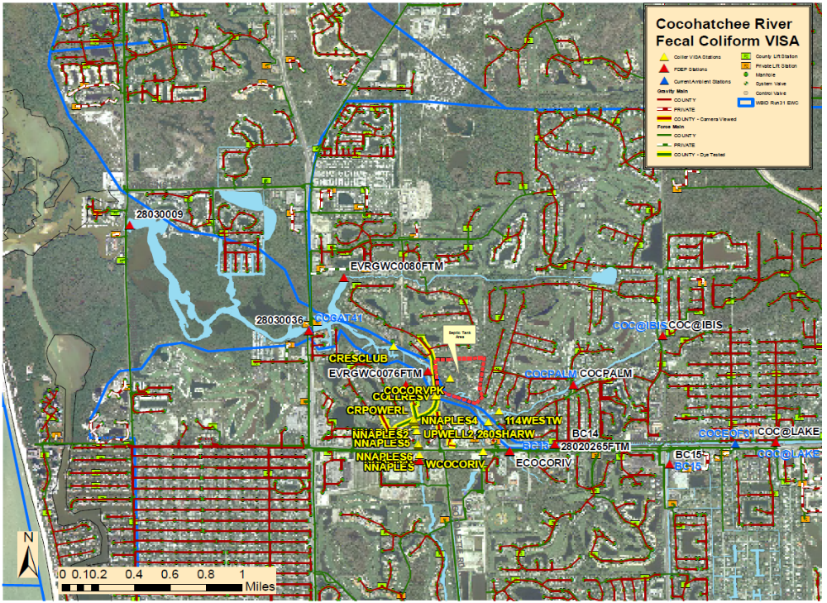
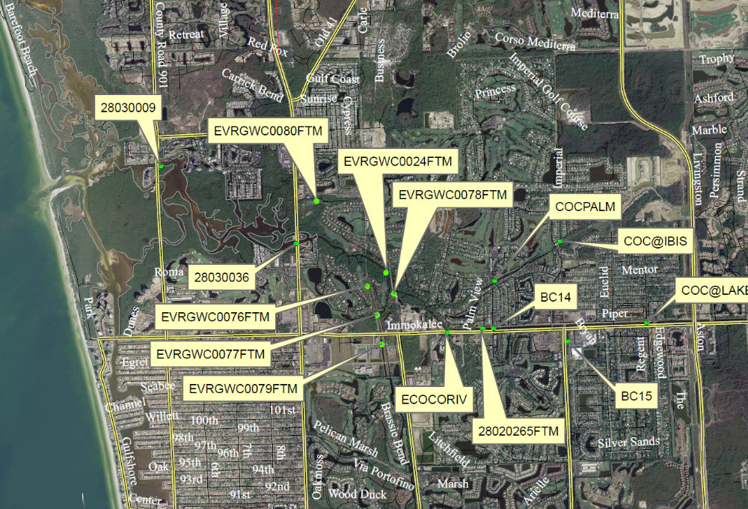Stage 1 Map
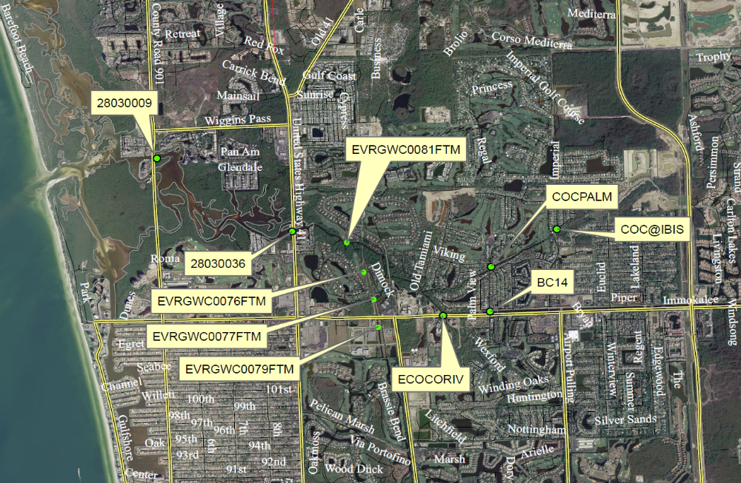
Stage 2 Map

