Summary of Results

Walk the Waterbody Exercise for
Hopkins Creek (WBID 2266)
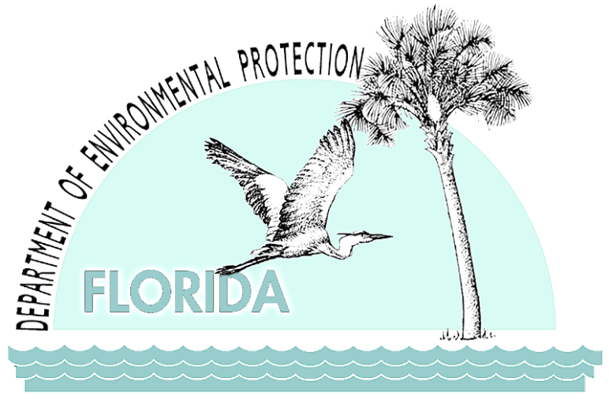

Florida Department of Environmental Protection
Division of Environmental Assessment and Restoration
Bureau of Watershed Restoration
Tallahassee, FL 32399

August 2011

Contents
Purpose and Contents 1
Background 2
Description of the Hopkins Creek Watershed 2
Fecal Coliform Impairment of Hopkins Creek 4
Walk the Waterbody Exercise 5
Participants 5
Costs 5
Initial Steps 5
Maps on the Table Session 6
Field Event 6
Results 9
Next Steps and Follow-up Actions 63

List of Tables
Table 1. Next steps and follow-up actions for reducing fecal coliform in Hopkins Creek 63

List of Figures
Figure 1. Aerial photo showing the boundary of the Hopkins Creek watershed and major geopolitical and hydrologic features in the area. 3
Figure 2. Walk the Waterbody team members at the end of the field event. 7
Figure 3. Point 24: Neptune Beach, Penman Rd. (FDOT ditch). 10
Figure 4. Point 24: Neptune Beach, Penman Rd. (FDOT ditch). 11
Figure 5. Point 24: Neptune Beach, Penman Rd. (FDOT ditch). 12
Figure 6. Point 24: Neptune Beach, Penman Rd. (FDOT ditch). 13
Figure 7. Point 24: Neptune Beach, Penman Rd. (FDOT ditch). 14
Figure 8. Point 24: Neptune Beach, Penman Rd. (FDOT ditch). 15
Figure 9. Point 51: Neptune Beach, Kings Rd. Bridge. 18
Figure 10. Point 29: Neptune Beach, Jarboe Park. 2
Figure 11. Point 26: Neptune Beach, Davis St. Ditch. 3
Figure 12. Point 23: Neptune Beach, private hotel and grocery store dumpsters. 4
Figure 13. Point 23: Neptune Beach, private hotel. The Days Inn has cleaned up the landscape debris around the lift station. Error! Bookmark not defined.
Figure 14. Point 23: Neptune Beach, private hotel. The Days Inn has cleaned up the landscape debris around the lift station. Error! Bookmark not defined.
Figure 15. Point 23: Neptune Beach, private hotel. 6
Figure 16. Points 35 and 37: Border of Jacksonville and Neptune Beach, FDOT ditch at Seagate Ave. The aerial photo shows the vicinity of Points 35 and 37. 7
Figure 17. Point 35: Border of Jacksonville and Neptune Beach, FDOT ditch at Seagate Ave. 8
Figure 18. Point 35: Border of Jacksonville and Neptune Beach, FDOT ditch at Seagate Ave. 8
Figure 19. Point 35: Border of Jacksonville and Neptune Beach, FDOT ditch at Seagate Ave. 10
Figure 20. Point 35: Border of Jacksonville and Neptune Beach, FDOT ditch at Seagate Ave. 11
Figure 21. Point 35: Border of Jacksonville and Neptune Beach, FDOT ditch at Seagate Ave. 13
Figure 22. Point 37: Jacksonville Beach, Boys and Girls Club. 14
Figure 23. Point 41: Jacksonville Beach at 15th Ave. N., “8th St. N. SW Ditch” (FDOT ditch). The aerial photo shows the vicinity of Point 41. 16
Figure 24. Point 41: Jacksonville Beach at 15th Ave. N. (FDOT ditch). 17
Figure 25. Point 41: Jacksonville Beach at 15th Ave. N. (FDOT ditch). 18
Figure 26. Point 41: Jacksonville Beach at 15th Ave. N. (FDOT ditch). 19
Figure 27. Point 41: Jacksonville Beach at 15th Ave. N. (FDOT ditch). 20
Figure 28. The team parked near 12th Ave. N. and 20th St. N. at Point 59 and walked to Point 38, Pinewood Ditch, in Jacksonville Beach. The aerial photo shows the original point map. 21
Figure 29. The team parked near 12th Ave. N. and 20th St. N. at Pt. 59 and walked to Point 38, Pinewood Ditch, in Jacksonville Beach. The aerial photo shows the field notes taken by Neptune Beach during the walk. 22
Figure 30. Point 59: Jacksonville Beach. 23
Figure 31. Jacksonville Beach, just downstream of Point 59. 24
Figure 32. Point 39: Jacksonville Beach, upstream from Pinewood Rd. 27
Figure 33. Near Point 40: Jacksonville Beach, near Oakwood. 28
Figure 34. Near Point 40: Jacksonville Beach, downstream of Pinewood Rd. 29
Figure 35. Near Point 40: Jacksonville Beach, downstream of Pinewood Rd. 30
Figure 36. Point 40: Jacksonville Beach, south of Pinewood Rd. 31
Figure 37. Near Point 40: Jacksonville Beach, downstream from Pinewood Rd. 32
Figure 38. Near Point 40: Jacksonville Beach, downstream from Pinewood Rd. 33
Figure 39. Point 38: Jacksonville Beach. 34
Figure 40. Near Point 40: Jacksonville Beach, downstream from Pinewood Rd. 36
Figure 41. Between Points 39 and 40: Jacksonville Beach, downstream from Pinewood Rd. 37
Figure 42. Point 38: Jacksonville Beach, Tallwood Rd. crossing. 38
Figure 43. Point 38: Jacksonville Beach, Tallwood Rd. crossing. 39
Figure 44. Point 46: Jacksonville Beach, Arden Way. 40
Figure 45. Point 46: Jacksonville Beach, Arden Way. 41
Figure 46. Point 52: Atlantic Beach, Mayport Rd. and Saratoga Ditch (FDOT ditch). This is an aerial photo of the vicinity of Point 52. 42
Figure 47. Point 52: Atlantic Beach, Mayport Rd. and Saratoga Ditch (FDOT ditch). 43
Figure 48. Point 52: Atlantic Beach, Mayport Rd. and Saratoga Ditch (FDOT ditch). 44
Figure 49. Point 12: Atlantic Beach, at the end of Stanley Rd. The aerial photo shows the vicinity of Point 12. 46
Figure 50. Point 12: Atlantic Beach, at the end of Stanley Rd. 47
Figure 51. Point 12: Atlantic Beach, at the end of Stanley Rd. 48
Figure 52. Point 12: Atlantic Beach, at the end of Stanley Rd. 49
Figure 53. Point 6: Atlantic Beach. The aerial photo shows the field notes taken during the walk. The team parked on the north end of this stretch near Point 6 and walked south. 50
Figure 54. Point 6: Atlantic Beach. 51
Figure 55. Point 6: Atlantic Beach. 52
Figure 56. Point 6: Atlantic Beach. 53
Figure 57. Point 6: Atlantic Beach. 54
Figure 58. Point 6: Atlantic Beach. 55
Figure 59. Point 49: Atlantic Beach. The aerial photo shows the field notes taken during the walk. There is a sewer crossing below grade. 56
Figure 60. Point 8: Atlantic Beach. The photo shows the field notes taken during the walk. 57
Figure 61. Point 8: Atlantic Beach. 58
Figure 62. Point 8: Atlantic Beach. 59
Figure 63. Point 8: Atlantic Beach. 60
Figure 64. Point 1: Atlantic Beach. The aerial photo shows the vicinity of Point 1, the dog park. 61
Figure 65. Point 1: Atlantic Beach, Dog Park. 62

Purpose and Contents
This report summarizes the results of the Walk the Waterbody exercise for the Hopkins Creek watershed (WBID 2266), located in the Lower St. Johns Basin in northeast Florida, on April 15, 2011. (WBID is the abbreviation for WaterBody IDentification number.) This field reconnaissance and source elimination effort was carried out to gain a better understanding of conditions within the watershed, including the hydrology of the creek and its contributing ditches and branches, flood-prone areas, the locations of sewer and stormwater infrastructure, and potential sources that are contributing fecal coliform bacteria to the creek.
Basin Management Action Plans (BMAPs) to address sources may be appropriate for some watersheds; however, they are both time and resource intensive. The Walk the Waterbody exercise is a low-cost, effective alternative to begin addressing fecal coliform pollution in Hopkins Creek so that it meets state water quality standards. This common-sense first step allows stakeholders to identify the location of suspected sources, establish a sampling plan to fill in knowledge gaps, carry out easy-to-implement management actions for the creek using existing programs and ongoing activities, and follow up on those actions to assess the degree of success and the additional effort needed. The exercise allows stakeholders to identify uncertainties and future options for more effective adaptive management. It also contributes to improved communication between and within agencies, and provides opportunities to increase public awareness.
The lead entity for the Walk the Waterbody exercise is the city of Neptune Beach. Other participants include the cities of Jacksonville Beach, Atlantic Beach, and Jacksonville; Florida Department of Transportation (FDOT); Florida Department of Health (FDOH); and Florida Department of Environmental Protection (FDEP).
This report includes the following information:
- Identification of the watershed or waterbody identification (WBID);
- Results of any preliminary investigation or issues identified;
- List of entities and staff participating in the field efforts or other operations;
- Sources and potential sources observed;
- Immediate next steps and follow-up actions taken;
- Follow-up actions still needed;
- Sources eliminated or investigated;
- Water quality results from samples taken in the field;
- Monitoring sites identified or proposed; and
- Any other pertinent information.

Background

Description of the Hopkins Creek Watershed
Hopkins Creek is located along the southeastern coastal portion of Duval County, in northeast Florida (Figure 1). Portions of the creek also flow through the cities of Atlantic Beach, Neptune Beach, and Jacksonville Beach. The creek is situated roughly 0.1 miles from the Atlantic Ocean and 5 miles south of the mouth of the St. Johns River. It flows south for approximately 1.6 miles before turning west and flowing about 0.6 miles before discharging into Pablo Creek (Intracoastal Waterway). Within the WBID boundary, a number of branches and ditches contribute to Hopkins Creek (Figure 2). The drainage area within the Hopkins Creek WBID boundary is approximately 3.7 square miles (mi²) and is highly urbanized.

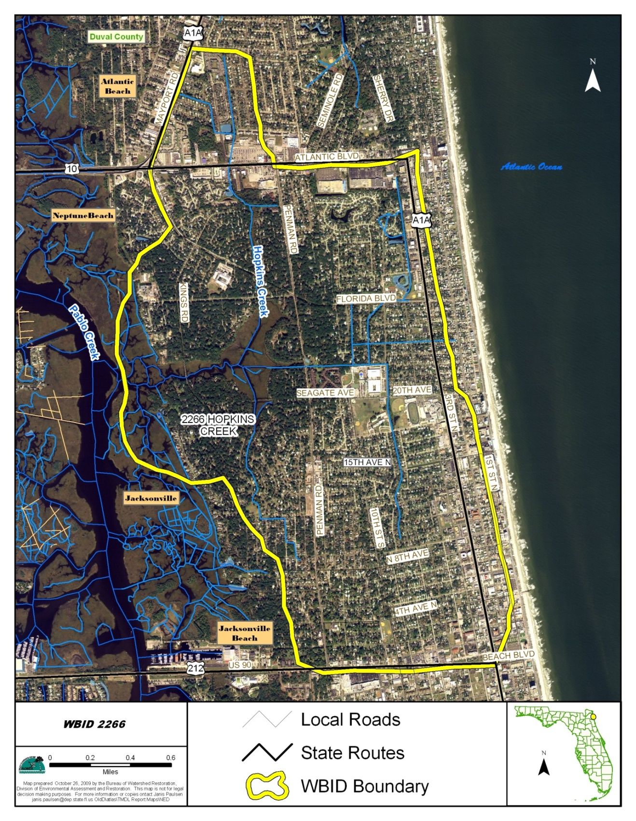
Figure 1. Aerial photo showing the boundary of the Hopkins Creek watershed and major geopolitical and hydrologic features in the area.

Fecal Coliform Impairment of Hopkins Creek
The creek was first verified impaired during FDEP’s Cycle 1 assessment (January 1, 1996, through June 30, 2003), and the impairment was confirmed based on the result of the Cycle 2 assessment (January 1, 2001, through June 30, 2008. The determination of impairment was based on the state’s Impaired Surface Waters Rule (IWR) (see box at right). Hopkins Creek was included on the Verified List of impaired waters for the Lower St. Johns Basin that was adopted by Secretarial Order on May 27, 2004, and the TMDL was adopted in July 2010.
Florida Water Quality Standard for Fecal Coliform
For determining impairment for fecal coliform bacteria, the IWR states that the most probable number (MPN) or membrane filter (MF) counts per 100 milliliters (mL) of fecal coliform bacteria shall not exceed a monthly average of 200, nor exceed 400 in 10 percent of the samples, nor exceed 800 on any one day. The criteria state that monthly averages shall be expressed as geometric means based on a minimum of 10 samples taken over a 30-day period. However, there were insufficient data (fewer than 10 samples in a given month) available to evaluate the geometric mean criterion for fecal coliform bacteria. Therefore, the criterion selected for the TMDL was not to exceed 400.
A TMDL represents the maximum amount of a given pollutant that a waterbody can assimilate and still meet water quality standards, including its applicable water quality criteria and its designated uses. TMDLs are developed for waterbodies that are verified as not meeting their water quality standards. They are a critical step in the watershed restoration process because they provide the targets for measuring progress in subsequent water quality restoration efforts.
The fecal coliform TMDL calls for a 67 percent reduction in in-stream concentrations for Hopkins Creek to meet state water quality standards. Although one domestic wastewater facility is physically located within the WBID boundary and other domestic and industrial wastewater facilities are located near the WBID, none of the facilities is permitted to discharge within the Hopkins Creek WBID boundary, and should therefore have no impact on fecal coliform concentrations in the creek.
Two Phase I National Pollutant Discharge Elimination System (NPDES) municipal separate storm sewer system (MS4) permits cover Hopkins Creek. The cities of Jacksonville, Atlantic Beach, and Neptune Beach, and the Florida Department of Transportation (FDOT) District 2 are copermittees for Permit Number FLS000012, which includes the northern portions of Hopkins Creek. The city of Jacksonville Beach is the permittee for Permit Number FLS000013, which includes most of the southern portion of Hopkins Creek.

Walk the Waterbody Exercise

Participants
All agencies with jurisdictional authority collaborated before, during, and after the event. Team members included representatives from the cities of Neptune Beach, Jacksonville Beach, Atlantic Beach, and Jacksonville; FDOT, FDEP, and the Florida Department of Health (FDOH).

Costs
The only costs to the participants in the Walk the Waterbody exercise were staff time and potential management actions. Processing the water quality samples associated with this effort was funded cooperatively among participating entities.
Future management actions associated with existing city and county programs will require scheduling, coordination, and follow-up on behalf of the participating agencies. Examples of follow-up activities that may result in additional costs include system maintenance, repair, and investigation; however, it is important to note that these activities generally correspond with jurisdictional missions and already-established programs.

Initial Steps
Before going into the field, the stakeholders met and exchanged information through meetings organized by the city of Neptune Beach; these included the cities of Jacksonville Beach, Atlantic Beach, and Jacksonville; FDOT, FDEP, and FDOH. In preparation for these meetings, each entity provided information about Hopkins Creek to better acquaint themselves with the conditions in the watershed. The information was provided in advance to FDEP, which created multiple copies of large-format maps for use in the maps on the table exercise and the field event. The information that was collected and assimilated included the following:
- Geographic information system (GIS) data;
- Stormwater infrastructure maps showing the locations of inlets and outfalls, ponds, ditches, and underground conveyances;
- Stormwater best management practices (BMPs) being implemented;
- Maps of private and public sewer infrastructure showing the locations of pump stations and force and gravity mains, as well as the location and number of sanitary sewer overflows (SSOs);
- Locations of septic tanks and repair permits issued;
- Locations of specialty farms, kennels, and other animal operations;
- Water quality sampling information such as sampling stations, frequency, and results;
- Hydrology, including wetlands, streams, and ponds; and
- Locations of known issues or areas of special concern such as homeless populations, dog parks, landfills, and transfer stations.

Maps on the Table Session
With a representative present from each participating agency, team members held the Maps on the Table session to identify areas of concern to visit during the Walk the Waterbody event, based on field knowledge from staff and a synthesis of the available information. The team members marked areas of concern on their maps and elected field representatives with infrastructure knowledge and access to facilities, and who were familiar with sampling equipment and standard operating procedures (SOPs).
During the Maps on the Table exercise, notes were assigned a number and the same number was placed on the map in the general location the note was about. This created the points referenced in this document. The numbered points were referred to during the field exercise and throughout the follow-up.
Subsequently, the city of Neptune Beach carried out a preliminary field reconnaissance to identify areas of focus, determine appropriate routes for the participants, and identify any access issues and safety concerns requiring coordination with local law enforcement.

Field Event
The Walk the Waterbody team used the large-format maps while conducting the field investigations. A documentation team was designated, with team members assigned to record global positioning system (GPS) points with the coordinates of potential sources, persons to take pictures, and four primary note takers to record the information. Water quality sampling equipment was used to collect water quality information about potential sources identified in the field. Figure 2 shows the team members at the conclusion of the event.
The team explored the majority of the waterbody while in the field, referring to the maps to follow the creek above and below ground. Team members looked at the banks of Hopkins Creek and in the vicinity of the waterbody for potential sources. Canals/ditches that intersected the waterbody were also walked to ensure that the waterbody and its associated branches were all included within the WBID boundary. Care was taken to ensure that only appropriate entity representatives accessed private property, unless the property owner had granted access to the entire team. Potential sources that were investigated or looked for included the following:
- Potential illicit connections (PICs) or discharges;
- Public and private sanitary sewer infrastructure (such as manholes and pump stations);
- Package plants;

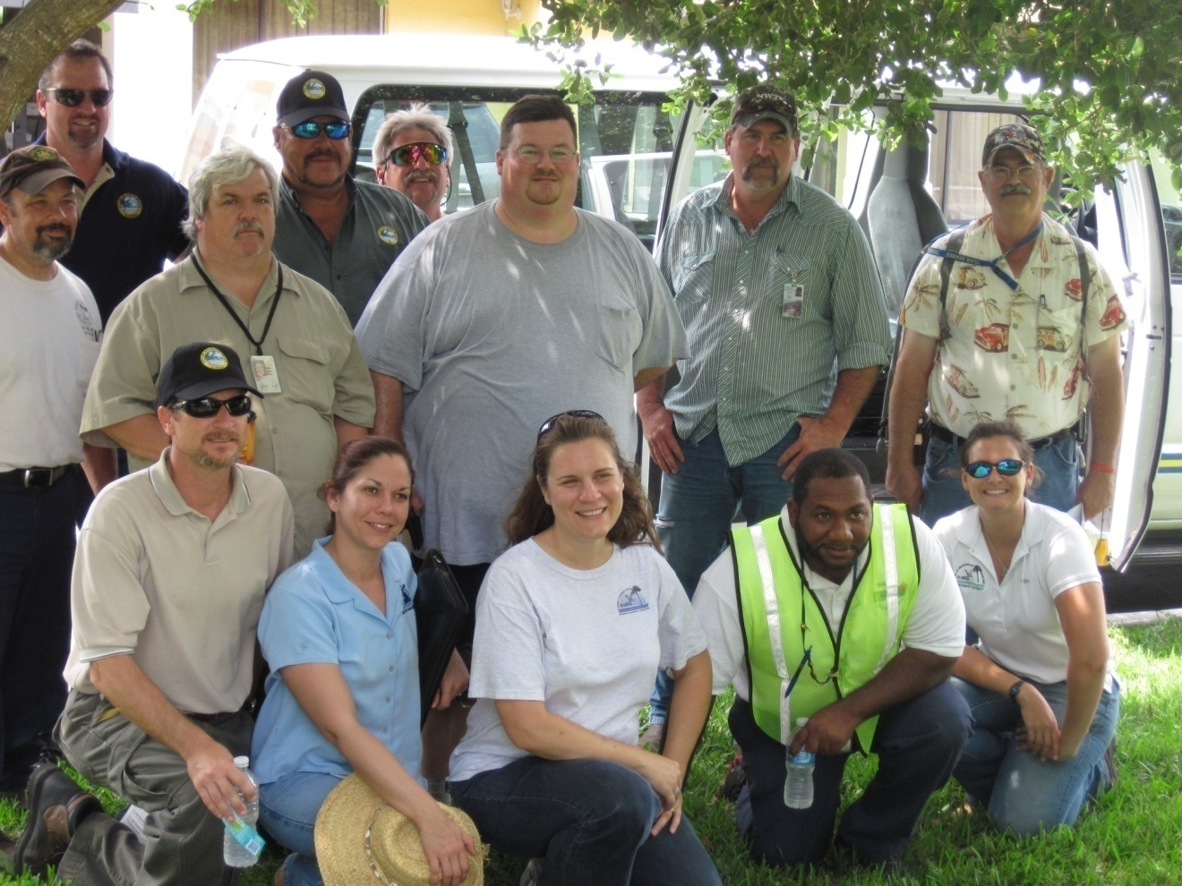
Figure 2. Walk the Waterbody team members at the end of the field event.

- Signs of recent SSOs, or areas with multiple SSOs;
- Wastewater infrastructure located close to surface waters and/or stormwater inlets, including pump stations, manholes, and air release valves (ARVs);
- Septic tanks located close to surface waters and/or stormwater inlets;
- Failing septic tanks (as indicated by ponding and a strong smell of sewage);
- Evidence of homeless populations;
- MS4 conveyances requiring cleaning;
- Accumulated trash and debris on streets and parking lots;
- Accumulated trash and debris near to or inside stormwater drains and catch basins;
- Clogged or broken stormwater grates;
- Stormwater drains undergoing repairs;
- Stormwater outfalls discharging from underground conveyances or into ponds;
- Sewage smell from stormwater drains, indicating possible cross-connections;
- Unusual odors;
- Evidence of illegal dumping or discharge of liquids;
- Signs of oil and grease;
- Excessive sediments and signs of erosion or wash out;
- Stagnant water;
- Debris in inlets, or inlets located near wastewater infrastructure;
- Exposed pipes of unknown origin;
- Flood-prone areas;
- Pet waste or evidence of high-traffic pet areas;
- Presence of horses, cattle, or other ruminants in the water or close to the water;
- Evidence of wildlife such as raccoons and waterfowl;
- Evidence of chickens or other hobby animals;
- Areas with heavy tree cover and vegetated ditches preventing ultraviolet (UV) light penetration.

Any discharges that would have been observed would have been sampled both downstream and upstream, however none were observed or sampled on this field event. Potential sources or other issues identified while in the field were reported to the proper jurisdiction and cataloged while in the field. A record was kept of major findings, including observations about the waterbody, potential sources, follow-up items and the responsible entity, and any areas that should be added to the monitoring plan or that required additional investigation.
Various potential sources of fecal contamination were observed and were noted during the field event. However, it is not expected that natural or uncontrollable sources would be eliminated or reduced. Wildlife is an example of natural or uncontrollable source of fecal Coliform contamination. Notation of uncontrollable sources and favorable growing conditions help us understand why sample results from some areas may be exceeding the water quality standard despite the lack of man induced sources or conditions. Examples of conditions, which in some cases cannot be controlled, that would allow fecal Coliforms to proliferate are dark water, silty sediment, slow flow or stagnate water, and natural or native in stream UV blocking vegetation. It is important to characterize sources and conditions favorable to fecal Coliform growth in order to fully understand the meaning of water quality test results and source investigations, especially when anthropogenic sources cannot be identified or have previously been removed.

Results
Figures 3 through 65 summarize the water quality issues and potential fecal coliform sources that the team observed during the Walk the Waterbody exercise on April 15, 2011, as well as the results of the water quality sampling that was carried out on that date. Below each figure are the field notes pertaining to the figure and post-field event notes provided by participants.

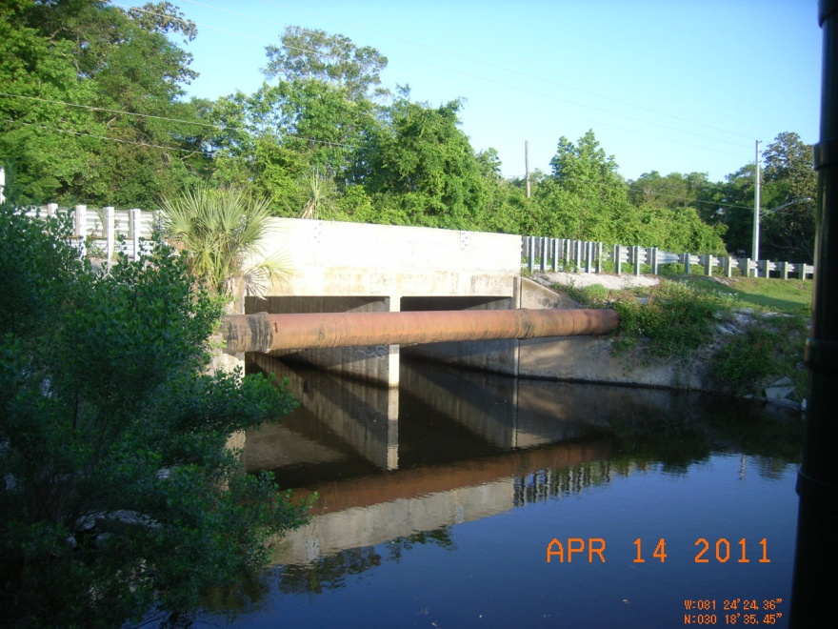
Figure 3. Point 24: Neptune Beach, Penman Rd. (FDOT ditch).
FIELD NOTES: A possible drip witnessed off the WWTP effluent pipe could be from air condensation or a leak. The pipe was thought to belong to the city of Jacksonville Beach, and this needs to be confirmed. Low velocity was observed in the channel.
POST FIELD NOTES: Jacksonville Beach followed the field event with an inspection of the pipe and saw no drip from the pipe.

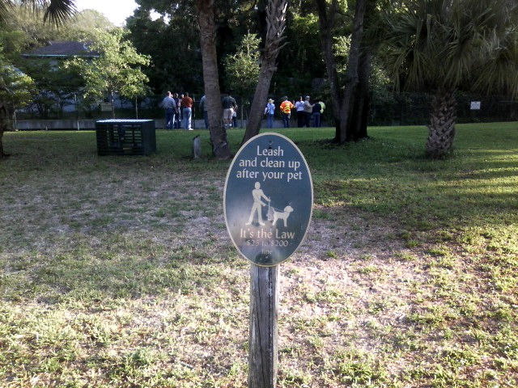
Figure 4. Point 24: Neptune Beach, Penman Rd. (FDOT ditch).
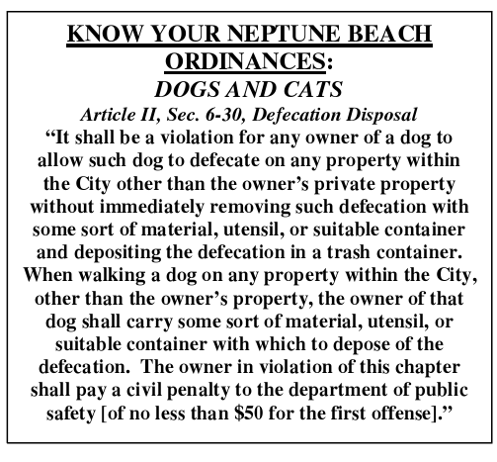
FIELD NOTES: The team observed dog waste in an irrigation area adjacent to the ditch, and a “clean up after pet” sign was posted next to the playground.
POST-FIELD NOTES: The City of Neptune Beach periodically publishes information about their pet waste ordinance and cleaning up after pets in their monthly newsletter entitled Cast-a-Line. Information about the pet waste ordinance was published in the March 2011 Cast-a-Line.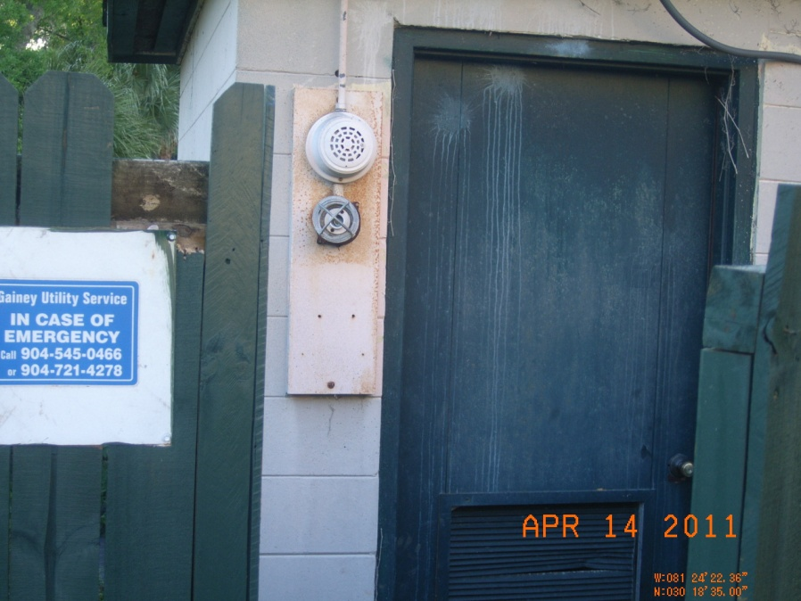

Figure 5. Point 24: Neptune Beach, Penman Rd. (FDOT ditch).
FIELD NOTES: The private lift station at Ocean Oaks Apartments was missing a warning light. The posted emergency contact was Gainey Utility Service at (904) 545–0466. Neptune Beach will pass this information on to the city of Jacksonville for follow-up. Also, there was no lock on the wet well, a bleach bottle was found next to the irrigation well, and irrigation water was observed landing on the nearby pavement.
POST-FIELD NOTES: The City of Jacksonville EQD inspected the lift station on 7-27-11.

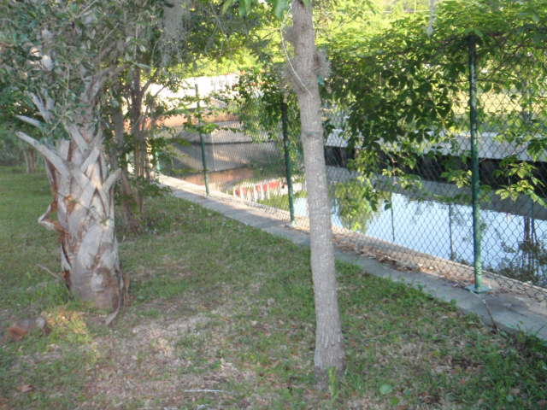

Figure 6. Point 24: Neptune Beach, Penman Rd. (FDOT ditch).

FIELD NOTES: The team observed vegetation covering the fence along this section of the 8th St. Ditch.
POST-FIELD NOTES: FDOT contractors completed clearing this area, August, 2011.

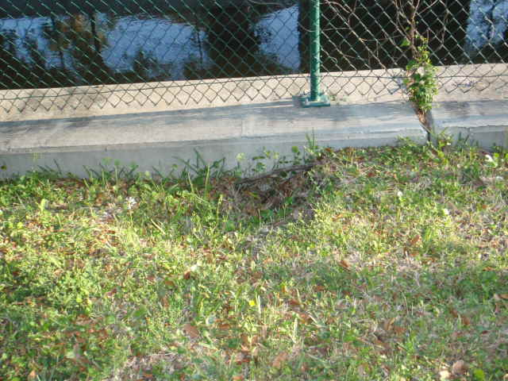
Figure 7. Point 24: Neptune Beach, Penman Rd. (FDOT ditch).
FIELD NOTES: The team observed erosion at the apartment side of the wall.
POST-FIELD NOTES: FDOT contractors August 4th, filled the hole and will look at it the area after the next rain. If the hole does not reappear, they will place sod over the dirt.

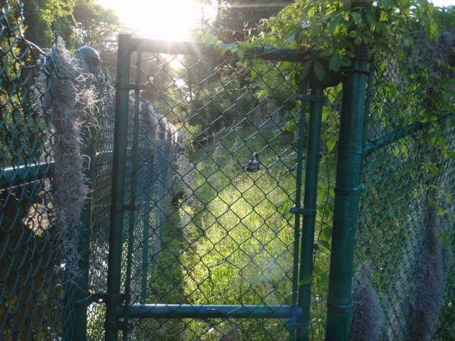

Figure 8. Point 24: Neptune Beach, Penman Rd. (FDOT ditch).
FIELD NOTES: This stretch of the ditch is overgrown.
POST-FIELD NOTES: FDOT asked its contractors to weed-eat the area starting at 8th St next to the High School, secure it, and thin the vegetation along the ditch bank to expose the ditch to sunlight. This area will be maintained on a regular mowing cycle. Expect this to be finished the end of August.

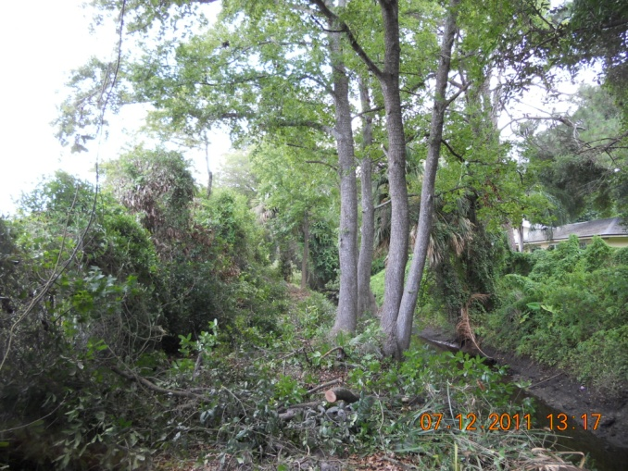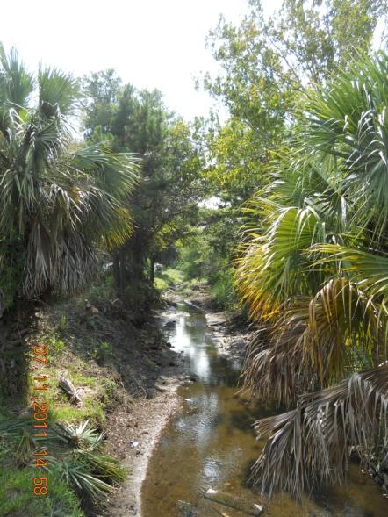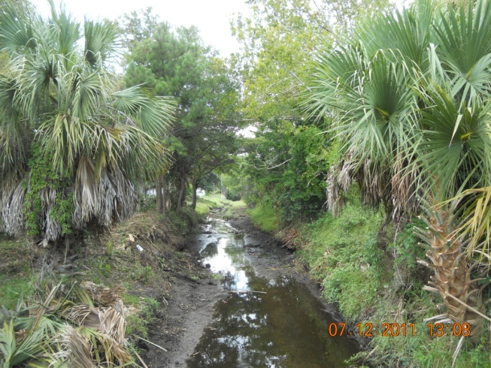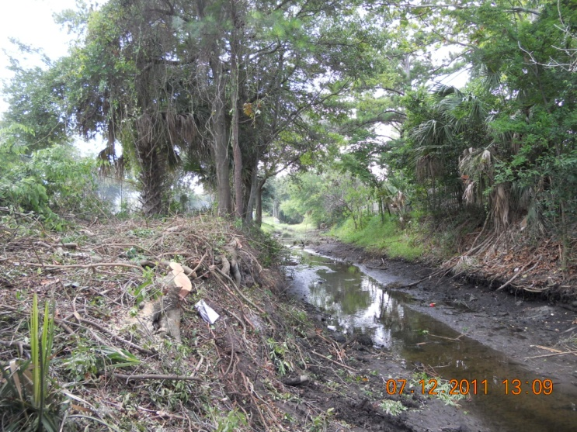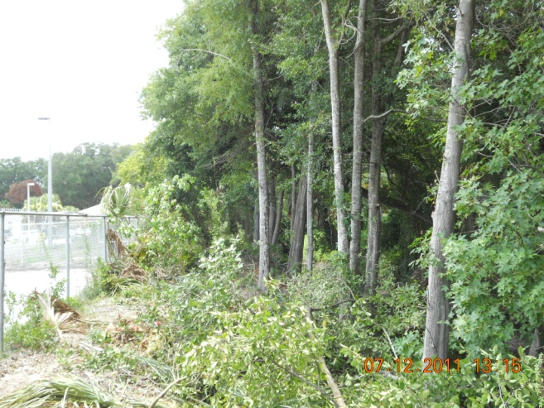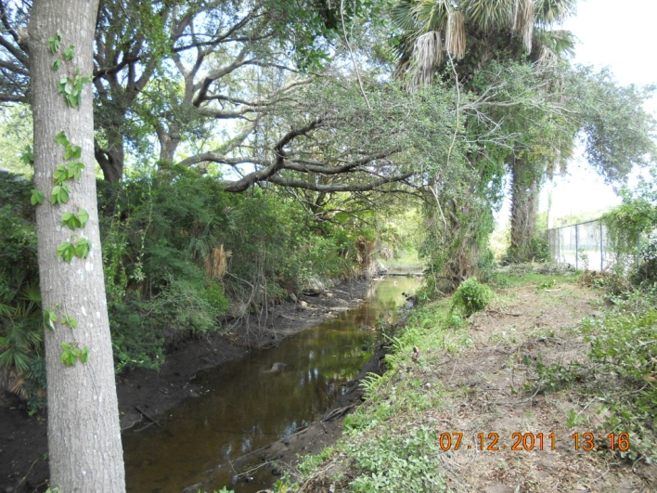
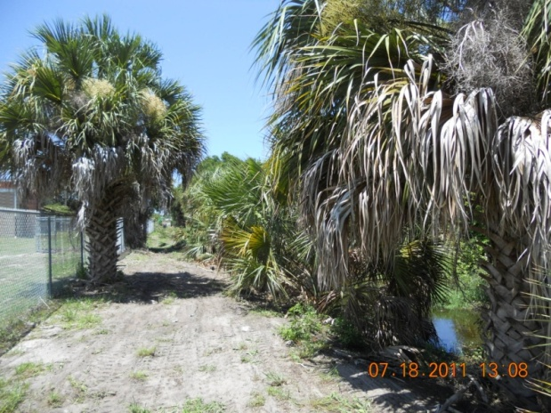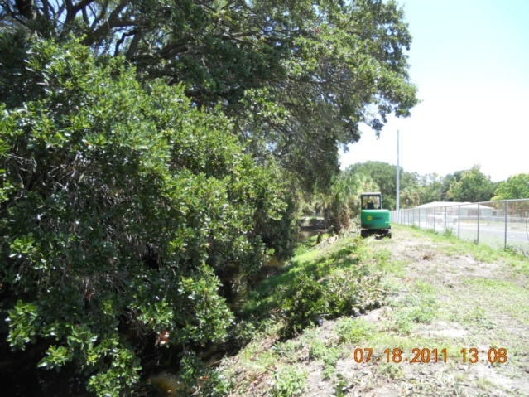
These two pictures are taken adjacent to the High School in Neptune Beach. The brush has been removed and tree trimming has been mostly completed. The contractors will perform additional tree trimming. The vegetation along the ditch has been widened so equipment can return to mow. Invasive plants and trees have been removed, and future inspections will be made to ensure invasive have not returned.

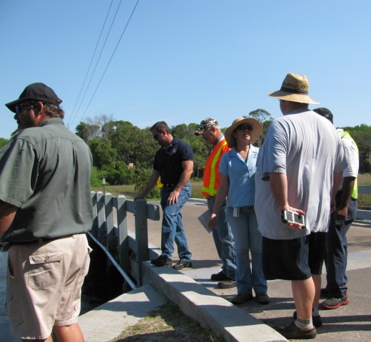
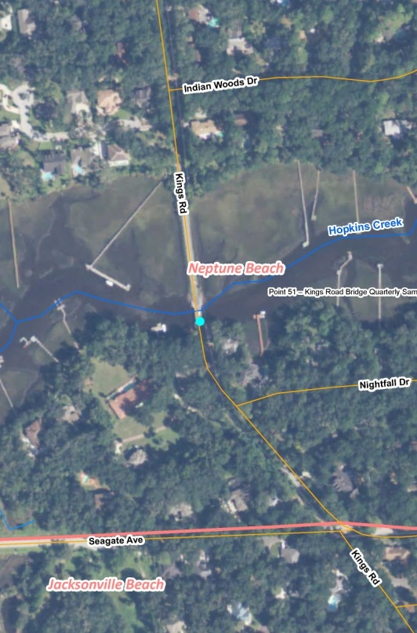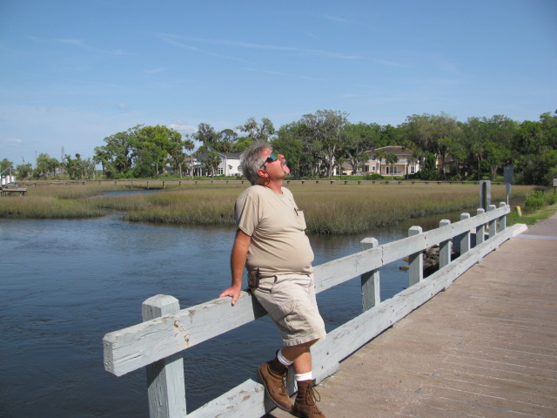

Figure 9. Point 51: Neptune Beach, Kings Rd. Bridge.
FIELD NOTES: The nearby neighborhood is on septic systems and has historically had numerous repair permits. High salinity could cause fecal coliform die off. The dark water and silty bottom could aid the regrowth of fecal coliform. Dog waste was observed by the bridge.

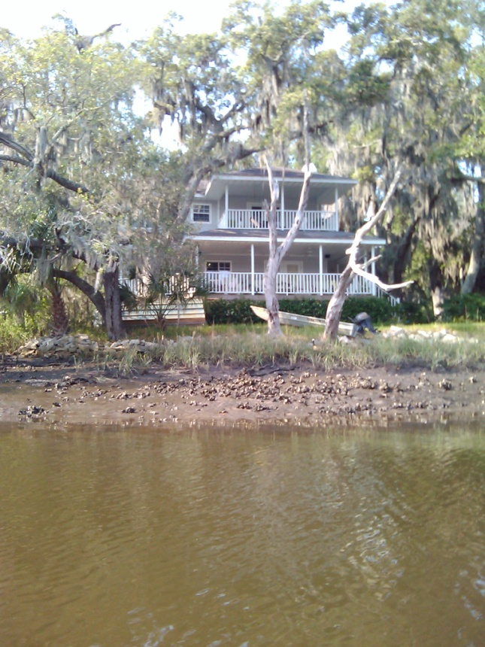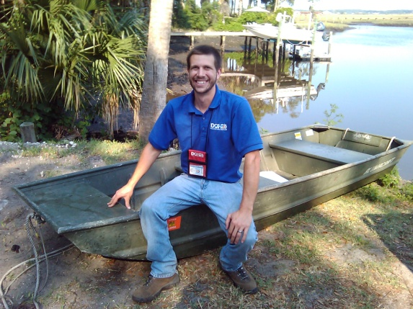
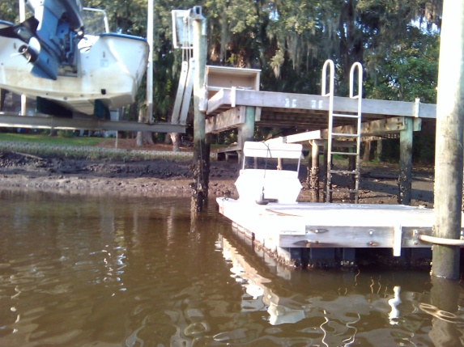

POST-FIELD NOTES: On May 23, 2011,Braden Ward, Florida Department of Health Inspector, met with Neptune Beach Public Works representatives and followed up with a low-tide boat trip to look for PICs in the septic area near the bridge, and no PICs were found. FDOH surveyed 49 properties in the area served by septic systems. One property was found to have a collapsed septic tank lid, which has since been replaced by the homeowner. As a side note, permitting records show 10 permitted repairs of failed septic systems within the 49 properties over the last 16 years.
The City of Neptune Beach periodically publishes information about their pet waste ordinance and cleaning up after pets in their monthly newsletter entitled Cast-a-Line. Information about the pet waste ordinance was published in the March 2011 Cast-a-Line.
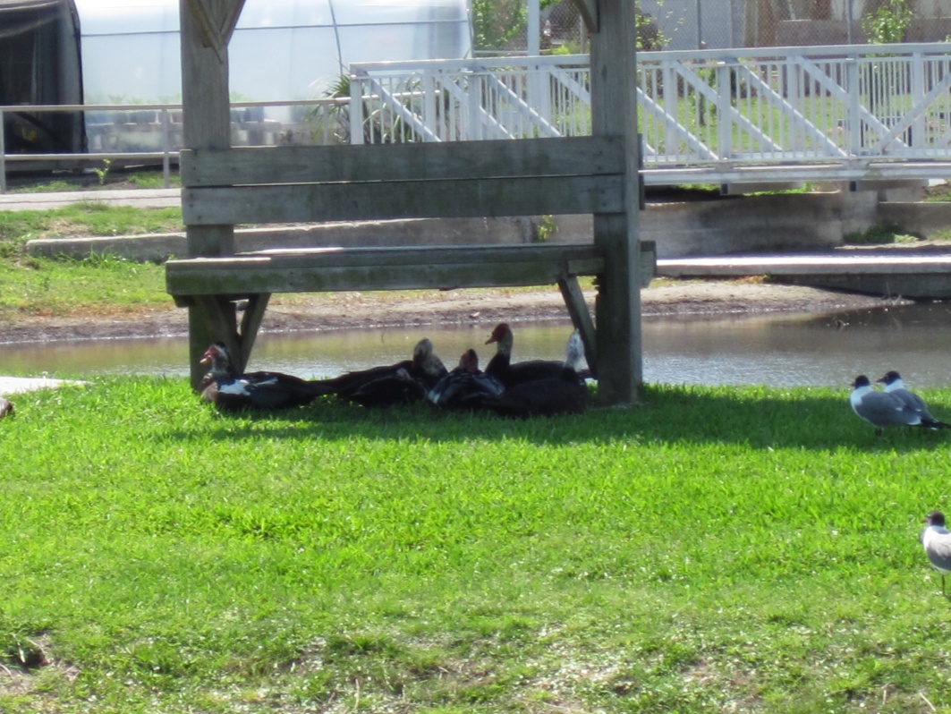
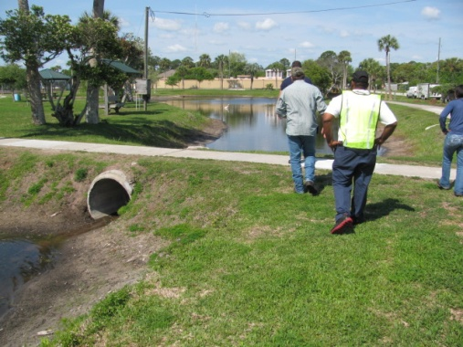
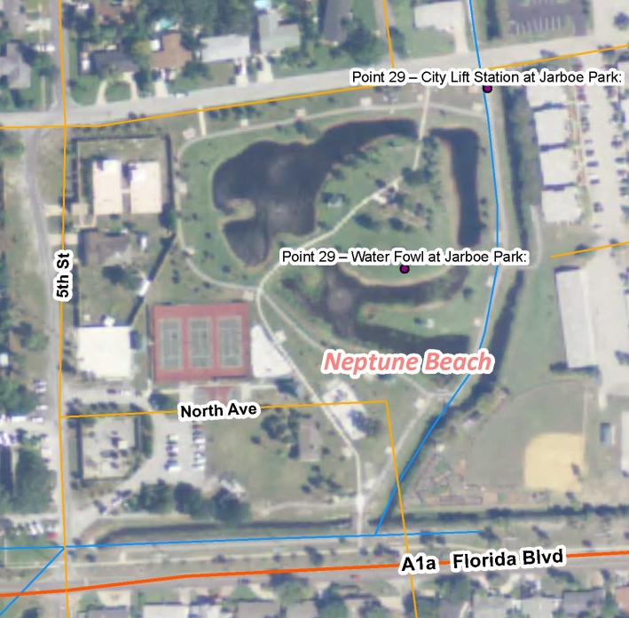

Figure 10. Point 29: Neptune Beach, Jarboe Park.
FIELD NOTES: The aerial photo shows the area of Jarboe Park. The team observed ducks, seagulls, and other waterfowl in the park, as well as fish, tadpoles, and turtles.

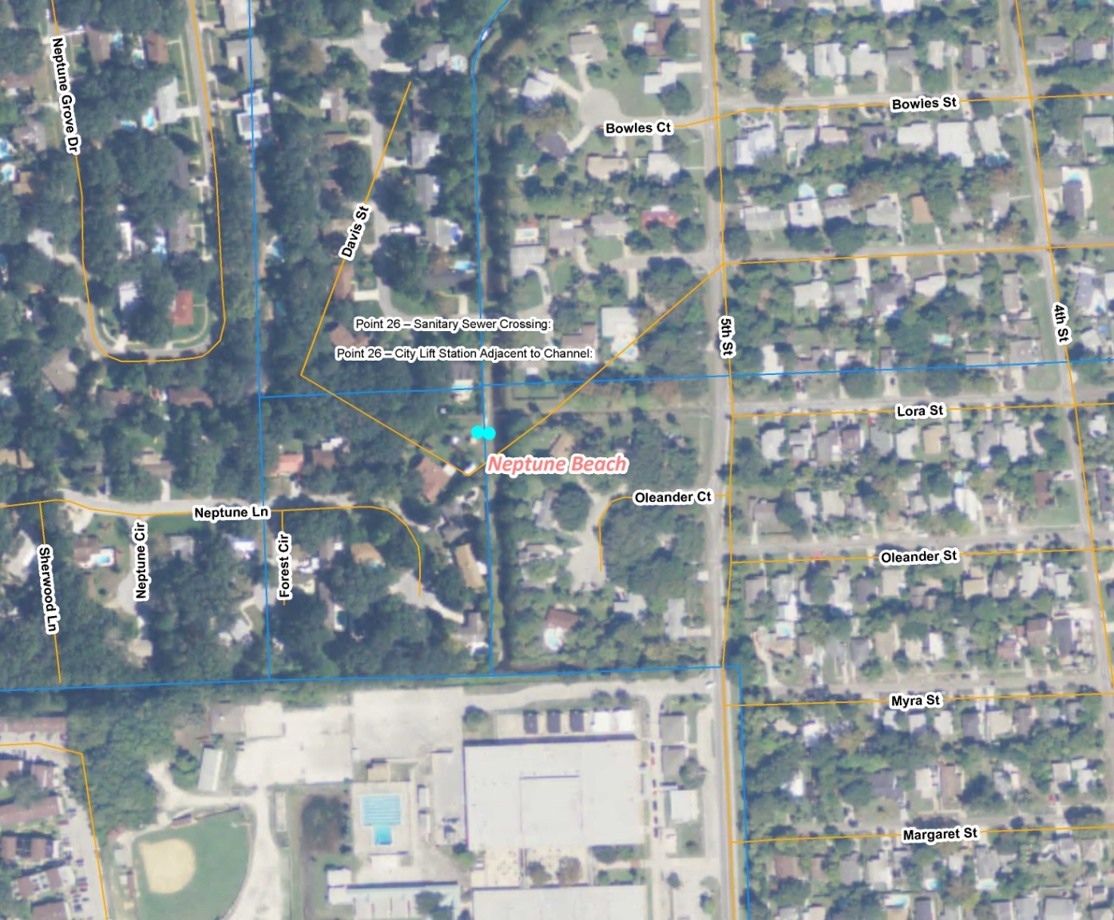
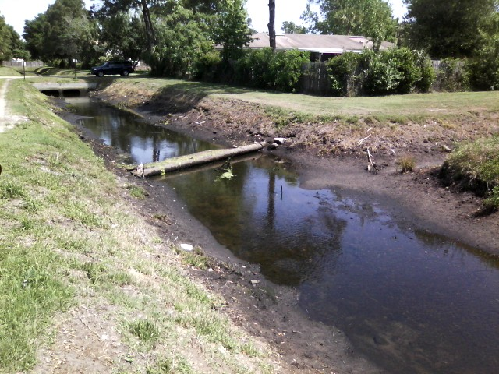

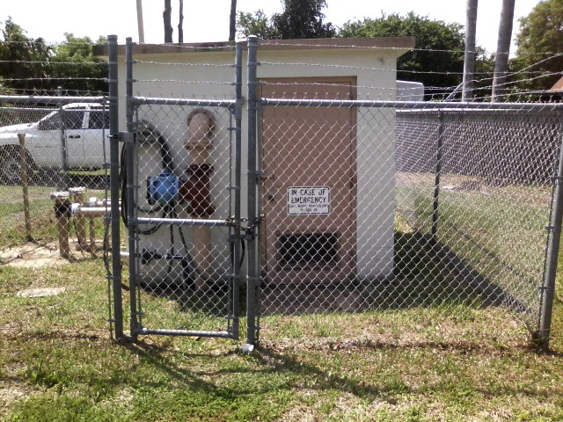

Figure 11. Point 26: Neptune Beach, Davis St. Ditch.
FIELD NOTES: There are 2 gravity sewer lines crossing the creek (top photo), and the overflow to the old Fletcher Lift Station (bottom photo) is plugged. The lift station, which is adjacent to the ditch, was locked. An emergency contact sign was posted. A sample taken at this location showed fecal coliform levels of 72 colony-forming units per 100 milliliters (cfu/100mL).

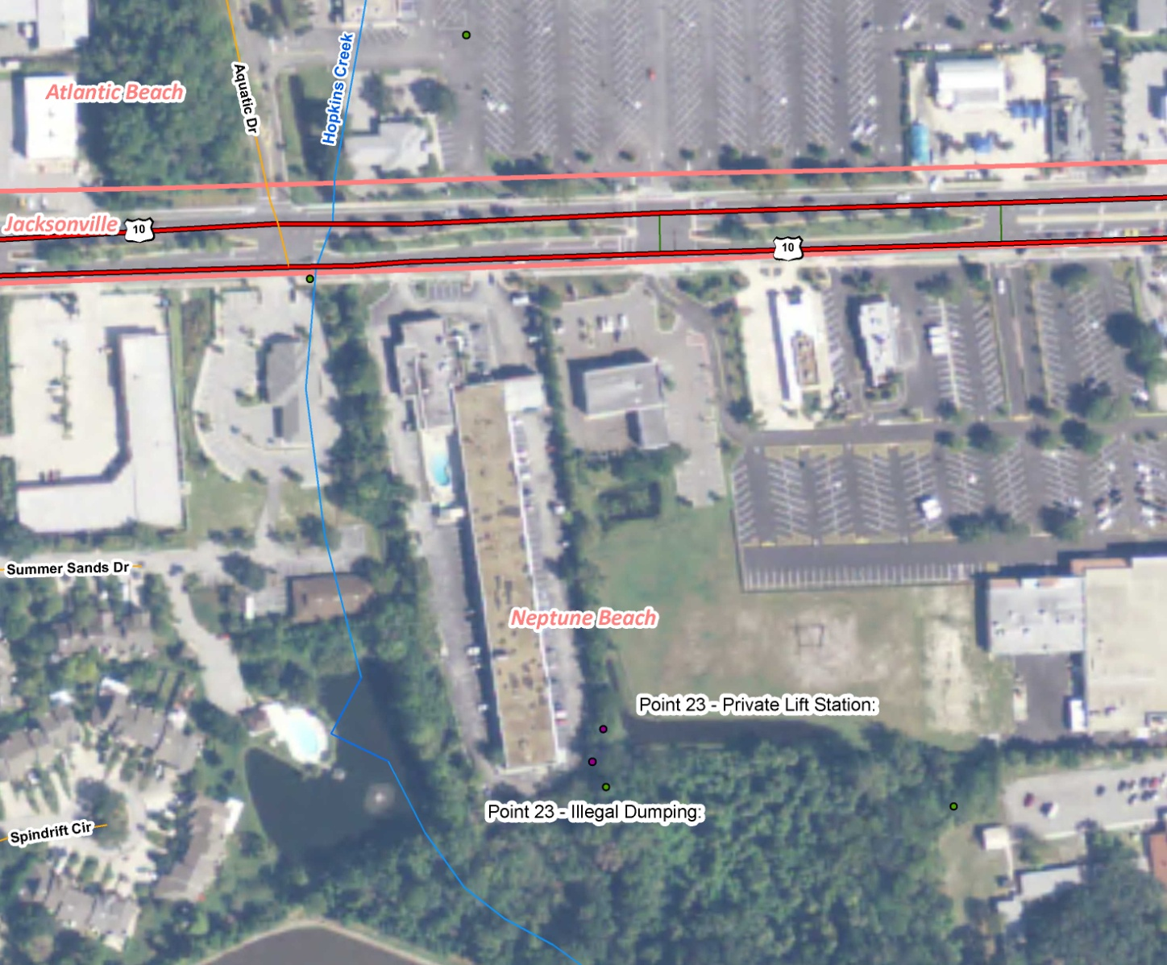

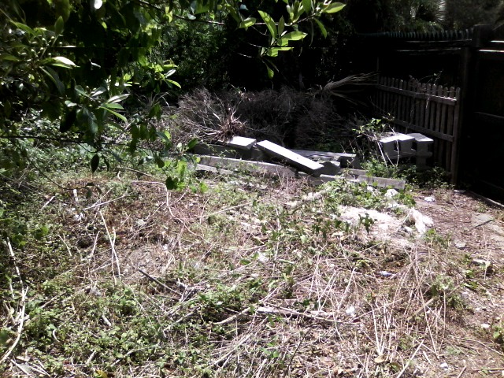
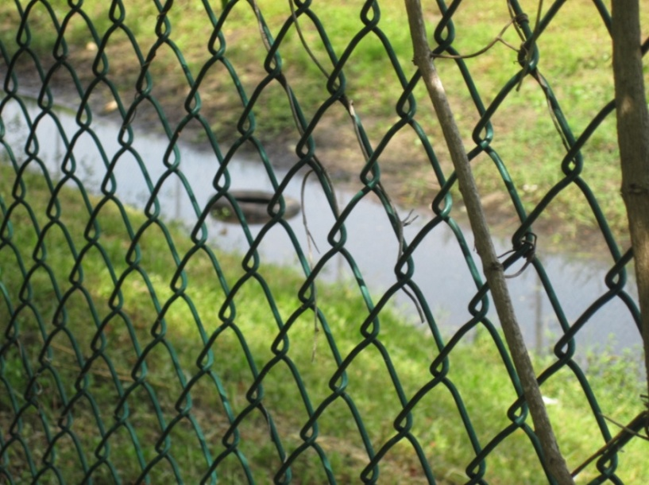

Figure 12. Point 23: Neptune Beach, private hotel and grocery store dumpsters.
FIELD NOTES: A code enforcement issue was observed, with trash piles behind the Days Inn lift station (top photo). Tires were found in the adjacent Winn Dixie stormwater pond (bottom photo).
POST-FIELD NOTES: Neptune Beach Code Enforcement followed up, and the trash and tires were removed in April 2011. The 4 pictures below show the cleaned up areas.

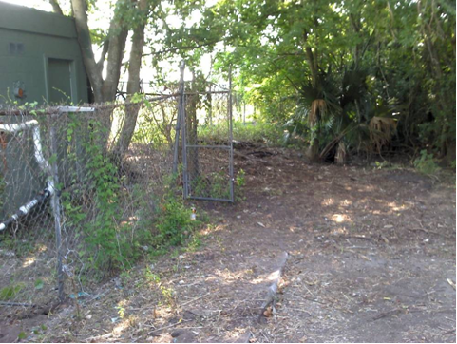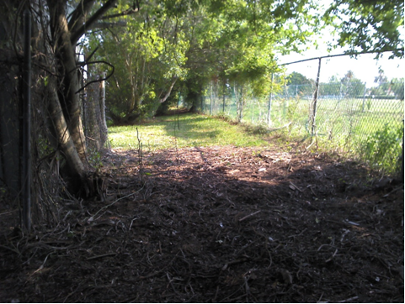

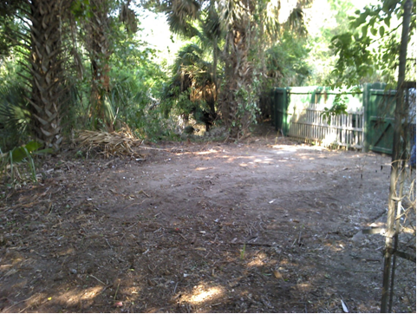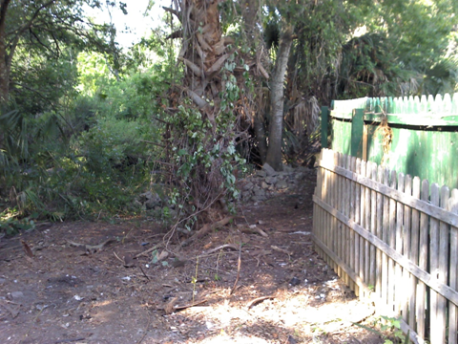


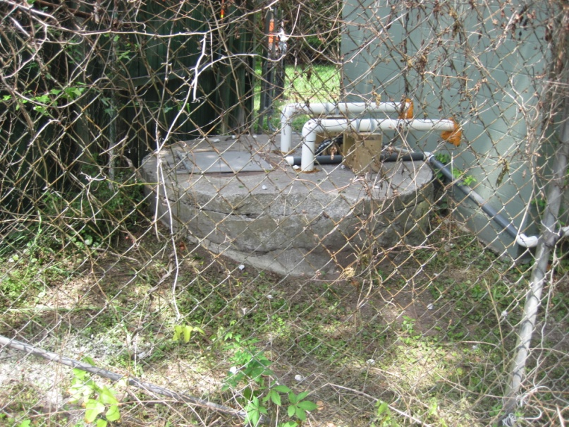

Figure 15. Point 23: Neptune Beach, private hotel.
FIELD NOTES: There was no lock on the wet well at the Days Inn lift station (top photo). An emergency contact was posted (bottom photo).
POST-FIELD NOTES: The city of Jacksonville will followed up on the lock issue and performed an inspection on 7-21-11. Maintenance was recently carried out to rehabilitate the well and install new polyvinyl chloride (PVC) pipe.
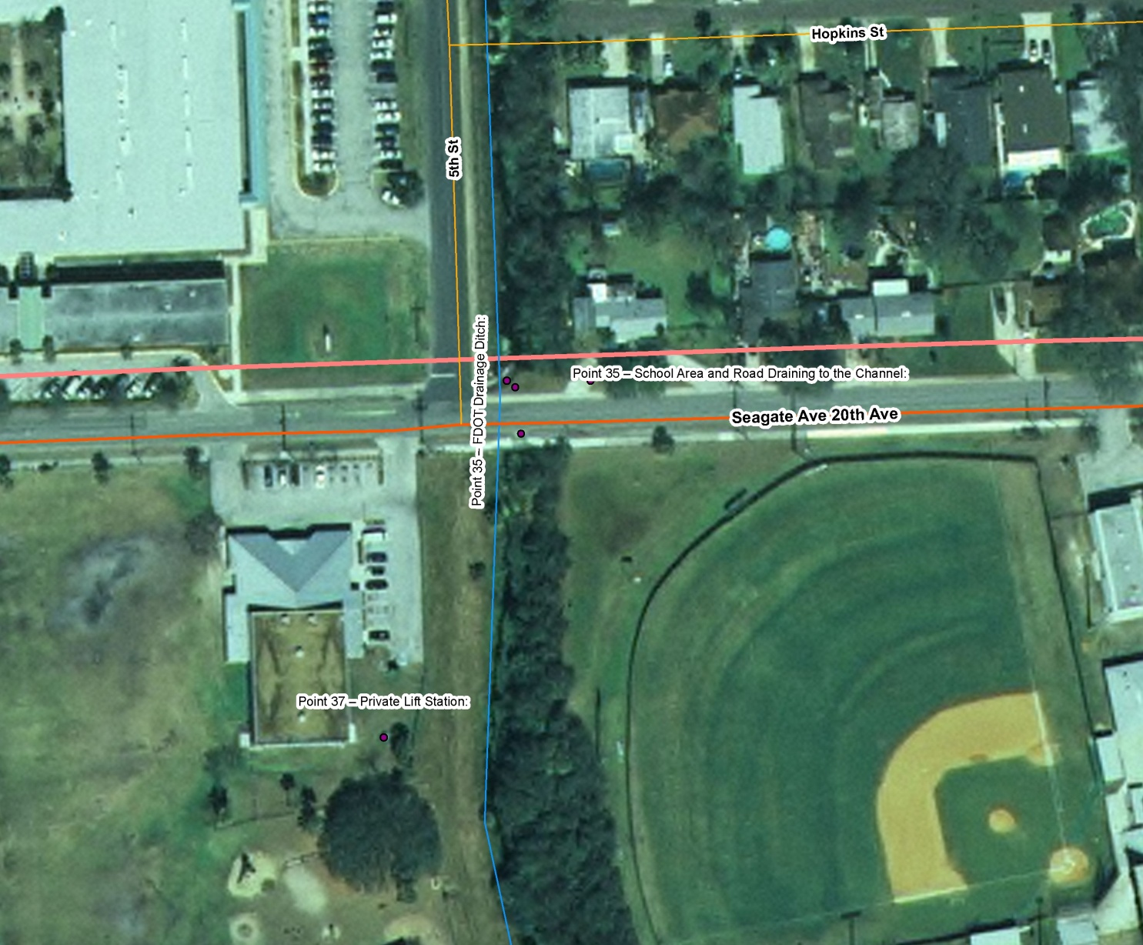
Figure 16. Points 35 and 37: Border of Jacksonville and Neptune Beach, FDOT ditch at Seagate Ave. The aerial photo shows the vicinity of Points 35 and 37.

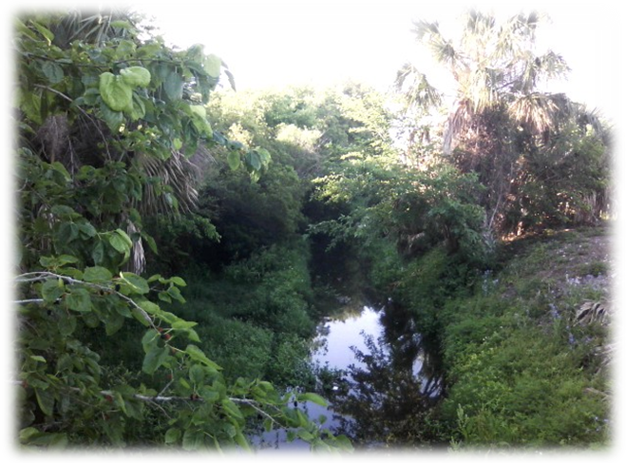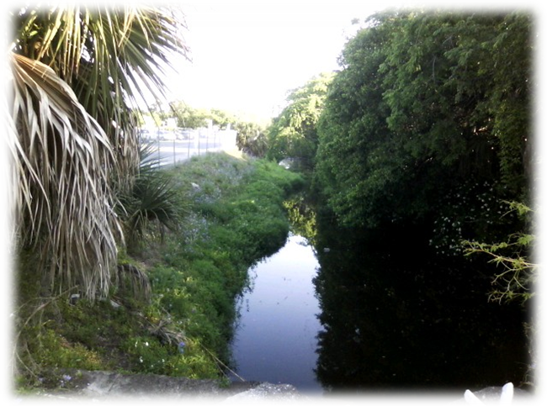

Figure 17. Point 35: Border of Jacksonville and Neptune Beach, FDOT ditch at Seagate Ave.
FIELD NOTES: Canopy cover prevents ultraviolet (UV) light from reaching the ditch. There is slow flow and little flushing unless heavy rainfall occurs. Wildlife live in the ditch, and a turtle was observed. This location is a Jacksonville Beach sampling point (during wet and dry weather).
POST-FIELD NOTES: A sample taken at this point during the field event showed fecal coliform concentrations of 280 cfu/100mL. The first sample of the day was labeled Point 53 on the lab results page, but it appears that the numbers were transposed.
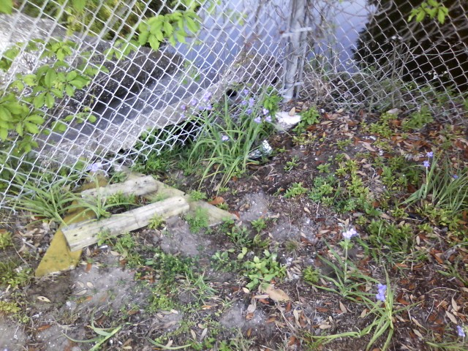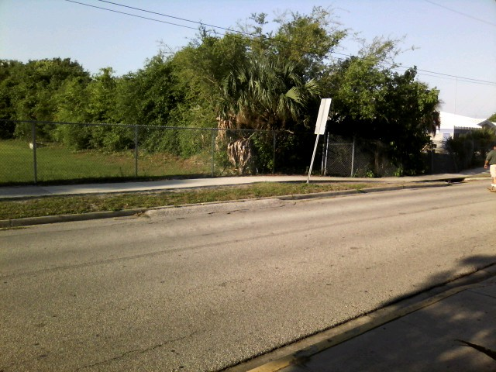
Figure 18. Point 35: Border of Jacksonville and Neptune Beach, FDOT ditch at Seagate Ave.
FIELD NOTES: There is erosion occurring behind the concrete flume belonging to DOT.
This part of the ditch receives discharge from the nearby school grounds. Pedestrian traffic leads to litter, which can provide a breeding ground for fecal coliform.

Date | Time | Fecal Coliform
23-Jun-10 | 9:14 | 540
13-Jul-10 | 13:46 | 940
29-Jul-10 | 12:20 | 2,380
18-Aug-10 | 10:45 | 5,500
25-Aug-10 | 8:37 | 3,600
8-Sep-10 | 10:15 | 7,000
13-Oct-10 | 9:36 | 2,600
10-Nov-10 | 9:32 | 1,300
8-Dec-10 | 9:35 | 850
13-Jan-11 | 9:40 | ND
9-Feb-11 | 12:10 | 700
9-Mar-11 | 12:40 | 660
13-Apr-11 | 10:34 | 2,100
11-May-11 | 10:10 | 1,900
8-Jun-11 | 10:52 | 2,700

POST-FIELD NOTES: Jacksonville Beach provided sample results for review to see if the sampling results fluctuate during school season compared with those of the non-school season. No trend related to the school season is concluded.
DOT plans to repair the flume after vegetation removal is complete. DOT plans to look at all DOT flumes and repair as necessary.

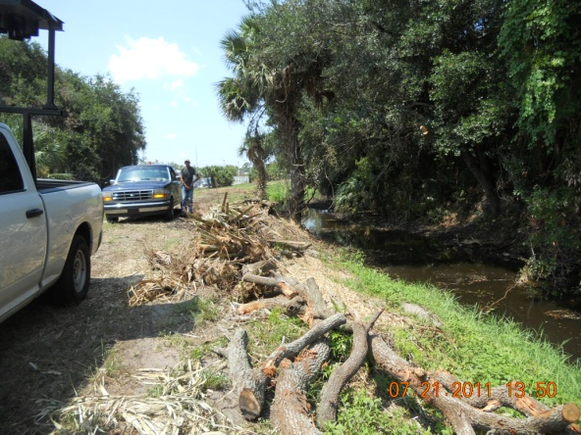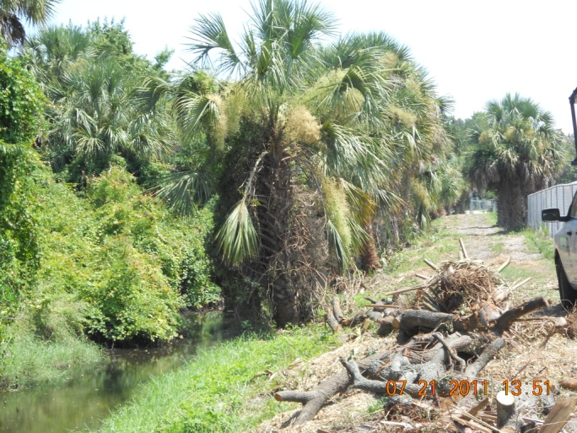
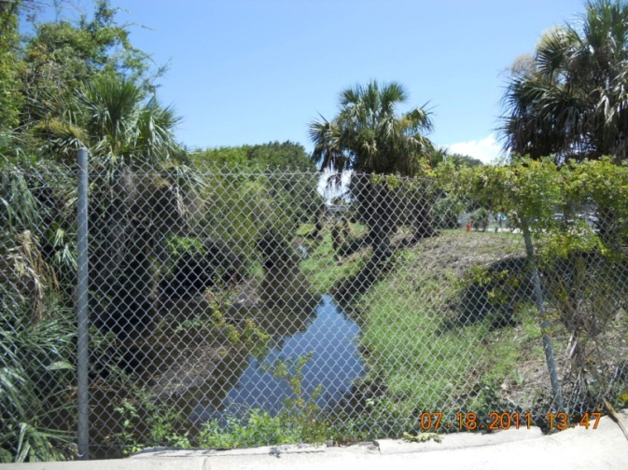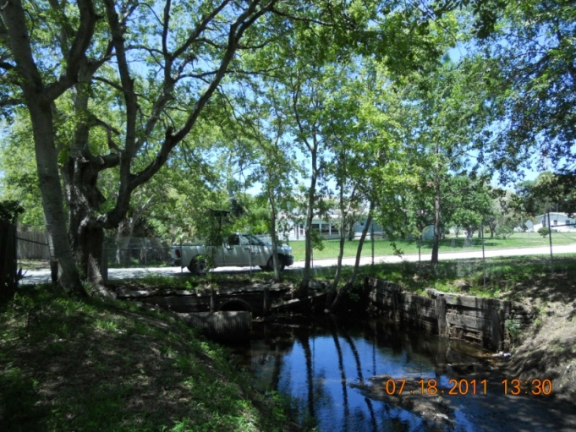
The DOT contractor completed the tree trimming and brush removal 7-18-11.

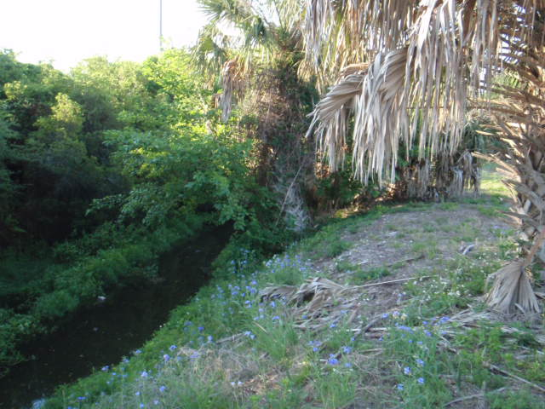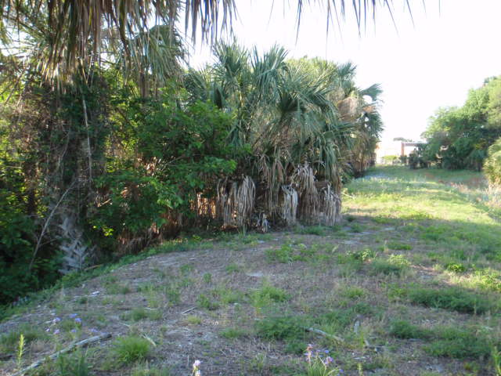
Figure 19. Point 35: Border of Jacksonville and Neptune Beach, FDOT ditch at Seagate Ave.
FIELD NOTES: This area is heavily overgrown, blocking UV penetration to the ditch.
POST-FIELD NOTES: FDOT contractors cleared most of the overhanging vegetation.
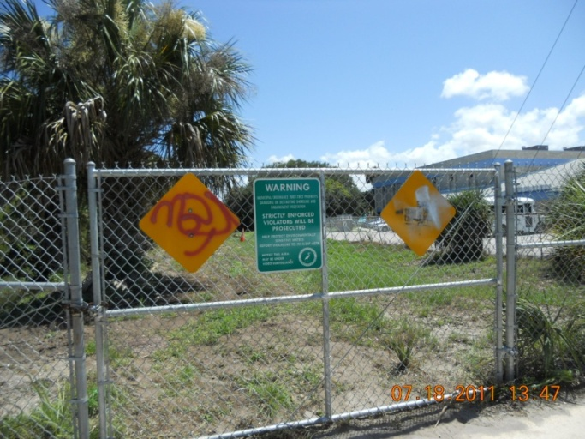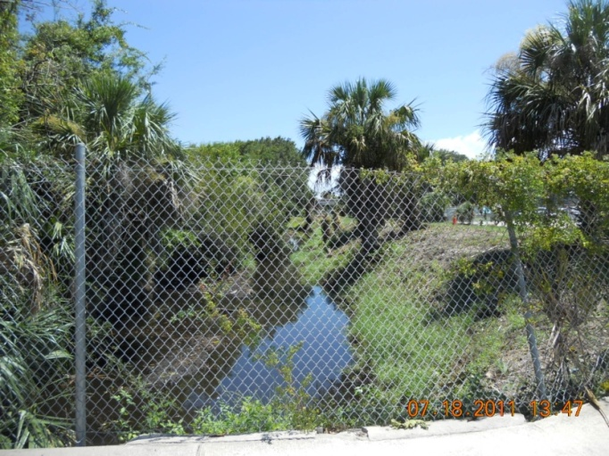
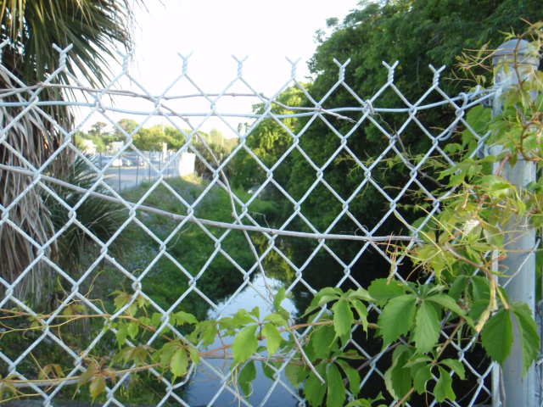
Figure 20. Point 35: Border of Jacksonville and Neptune Beach, FDOT ditch at Seagate Ave.
FIELD NOTES: Vegetation is growing alongside and into the ditch.
POST-FIELD NOTES: FDOT has asked its contractors to remove any vegetation and debris from the flow line of the ditch. This area requires a vast amount of hand work to accomplish clearing the ditch and is taking longer than originally anticipated. Work started in July, 2011 on this portion of the ditch.

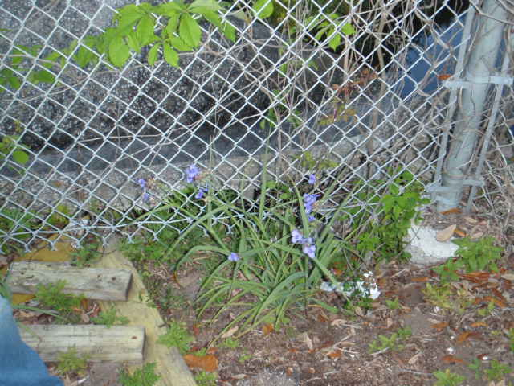
Figure 21. Point 35: Border of Jacksonville and Neptune Beach, FDOT ditch at Seagate Ave.
FIELD NOTES: The team observed erosion along the fence.
POST-FIELD NOTES: FDOT has asked its contractors to repair the eroded area. This will be accomplished once the majority of the tree trimming is complete. Tree trimming began on this ditch in July, 2011.

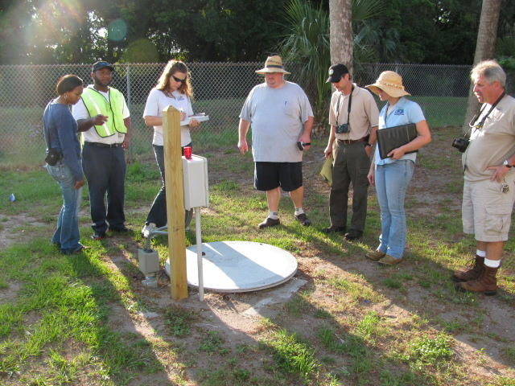
Figure 22. Point 37: Jacksonville Beach, Boys and Girls Club.
FIELD NOTES: The vent was rusted open on the private lift station at the Boys and Girls Club. No emergency contact number was provided.
POST-FIELD NOTES: Reported Tenant Fletcher High School 06/28/2011: Private lift station (point 37 – Boys and Girls club) has been inspected by the City of Jacksonville, FL environmental compliance Dept. See attached PDF copy of email from Mr. Bob Fegan, COJ inspector, and photo.
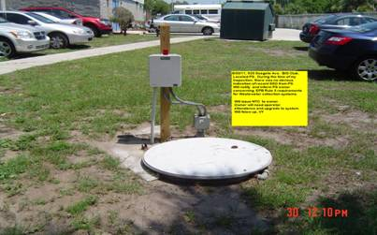
Per Inspector: Vertell Yarbrough - COJ
On 6/30/11, I responded to a complaint concerning possible contamination to Hopkins Creek.
My inspection started with looking for signs of recent overflow. During my inspection, there was no odor, there was no tissue on ground or surrounding area, the area around wetwell did not show wetness to ground surface, nor was there a flow pattern to Creek.

The station will need monthly operator attendance. After contracted with an operator, upgrade to system will be required. We will require a sign posted with operators information and a monthly log of PS activity. Station will be secured and both audible and visable alarms should be activated at high level.

NTC# VY11-34 will start EQD enforcement actions.

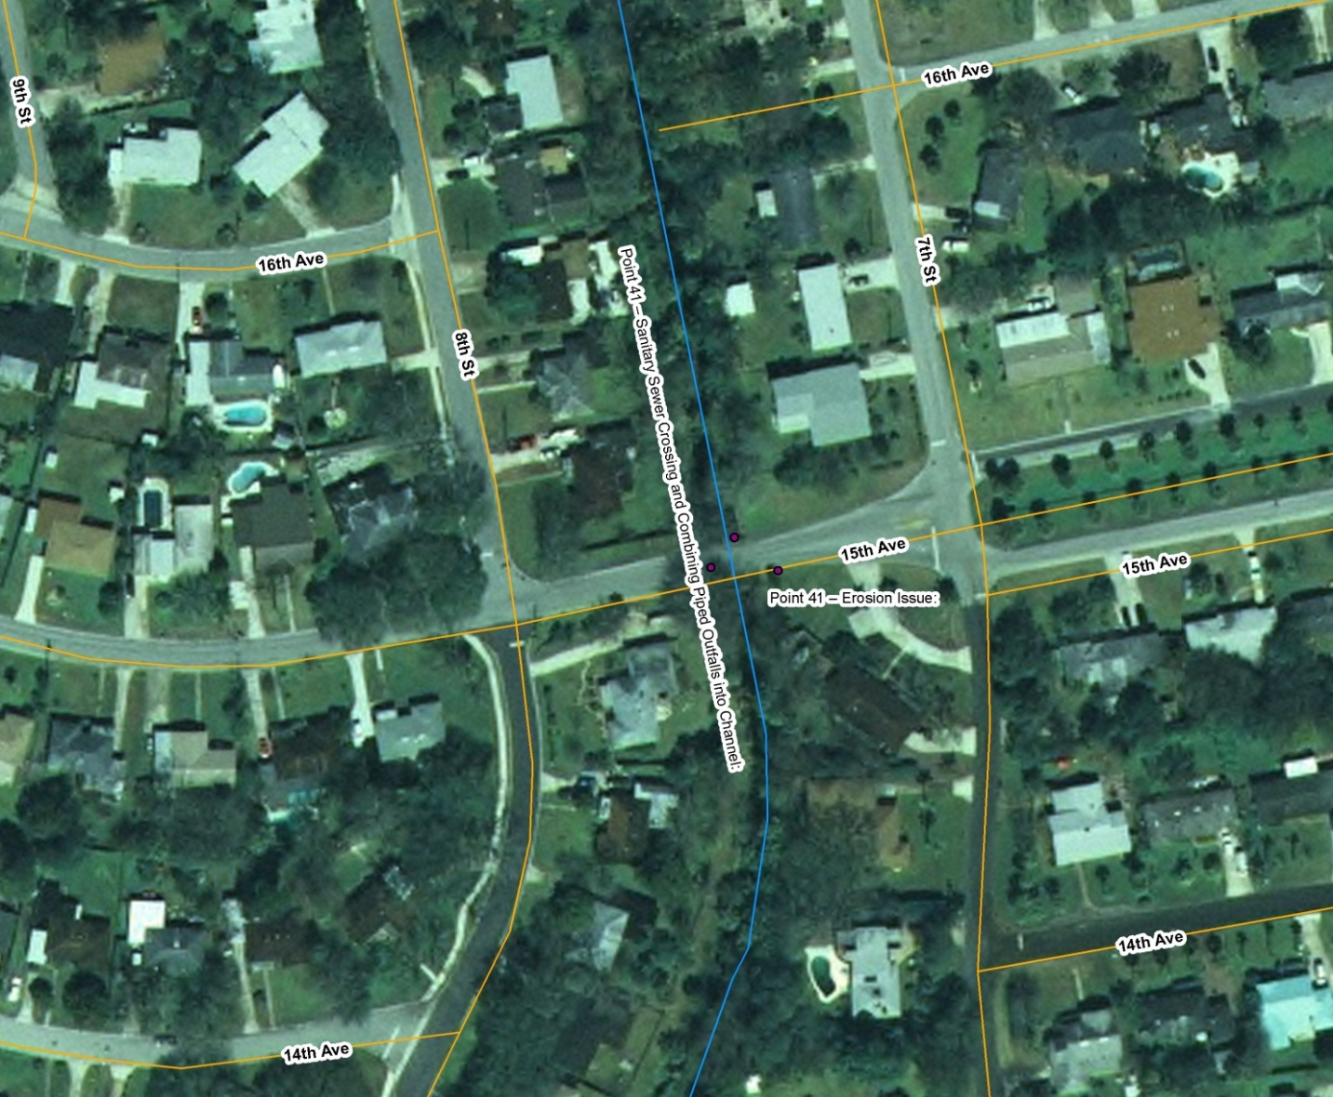
Figure 23. Point 41: Jacksonville Beach at 15th Ave. N., “8th St. N. SW Ditch” (FDOT ditch). The aerial photo shows the vicinity of Point 41.

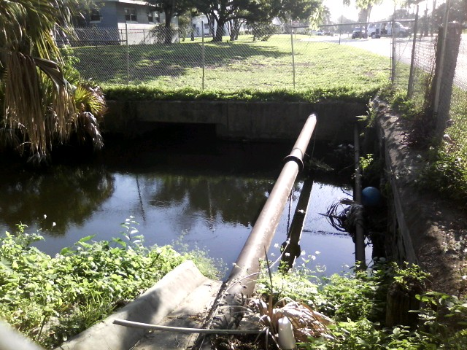
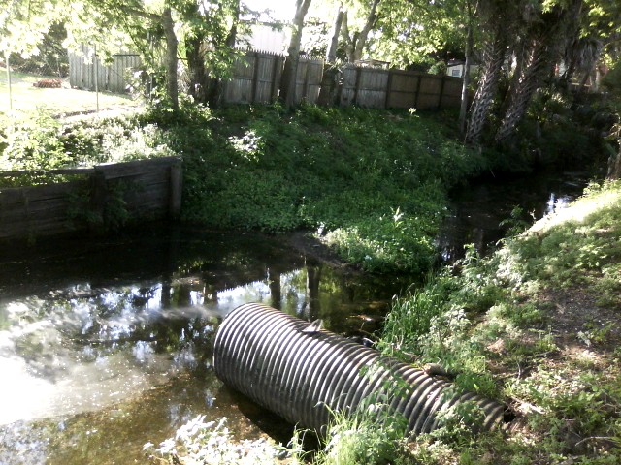
Figure 24. Point 41: Jacksonville Beach at 15th Ave. N. (FDOT ditch).
FIELD NOTES: The top photo faces north, and the bottom photo faces south. A sanitary sewer pipe crossing, outfalls, and a lift station are located nearby. This is a Jacksonville Beach monthly TMDL sampling station during wet and dry weather.
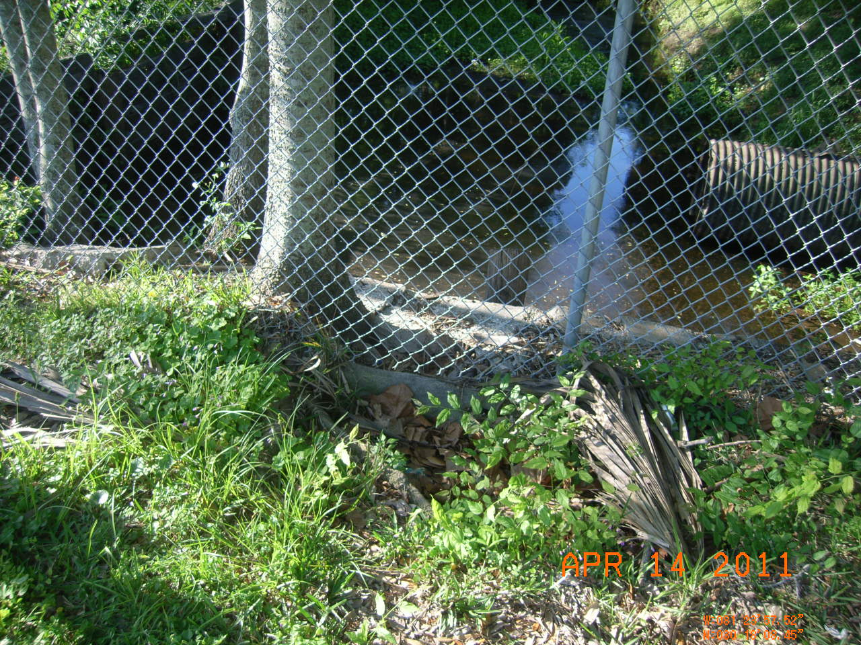
Figure 25. Point 41: Jacksonville Beach at 15th Ave. N. (FDOT ditch).
FIELD NOTES: The overgrowth of vegetation at this location prevents UV penetration. Because the upstream portion of the ditch is piped, UV light cannot penetrate the water. There is slow flow and little flushing unless heavy rainfall occurs.
POST-FIELD NOTES: DOT contractors informed DOT that the 8th St Ditch is subject to rise and fall of about 2 to 3 feet daily during tidal events, slowing progress of clearing vegetation. Work began in July 2011 on this ditch.

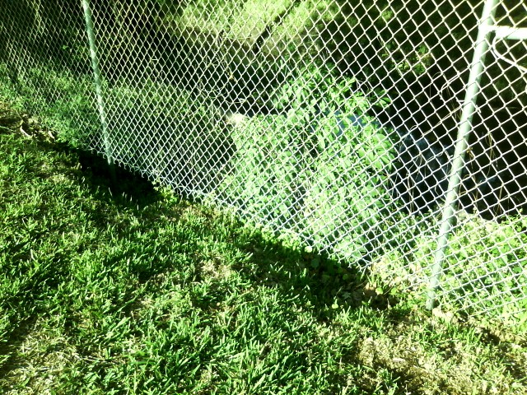

Figure 26. Point 41: Jacksonville Beach at 15th Ave. N. (FDOT ditch).
FIELD NOTES: Erosion has occurred on the south side of the road.
POST-FIELD NOTES: Scheduled to be repaired when tree trimming operation nearing completion. Tree trimming began July 2011.

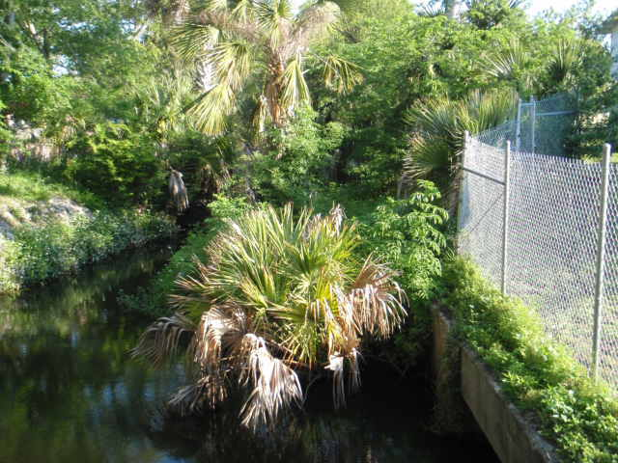
Figure 27. Point 41: Jacksonville Beach at 15th Ave. N. (FDOT ditch).
FIELD NOTES: The area is heavily overgrown.
POST-FIELD NOTES: FDOT has asked its contractors to thin vegetation to expose the ditch to sunlight and remove any debris from the flow line of the ditch. This is one of the challenging areas our DOT Contactor is facing but will accomplish. Scheduled to begin September, 2011.

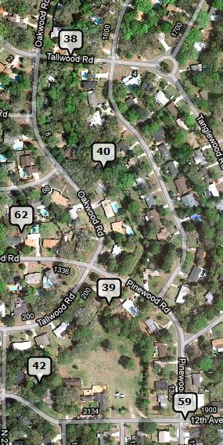
Figure 28. The team parked near 12th Ave. N. and 20th St. N. at Point 59 and walked to Point 38, Pinewood Ditch, in Jacksonville Beach. The aerial photo shows the original MOT point map.

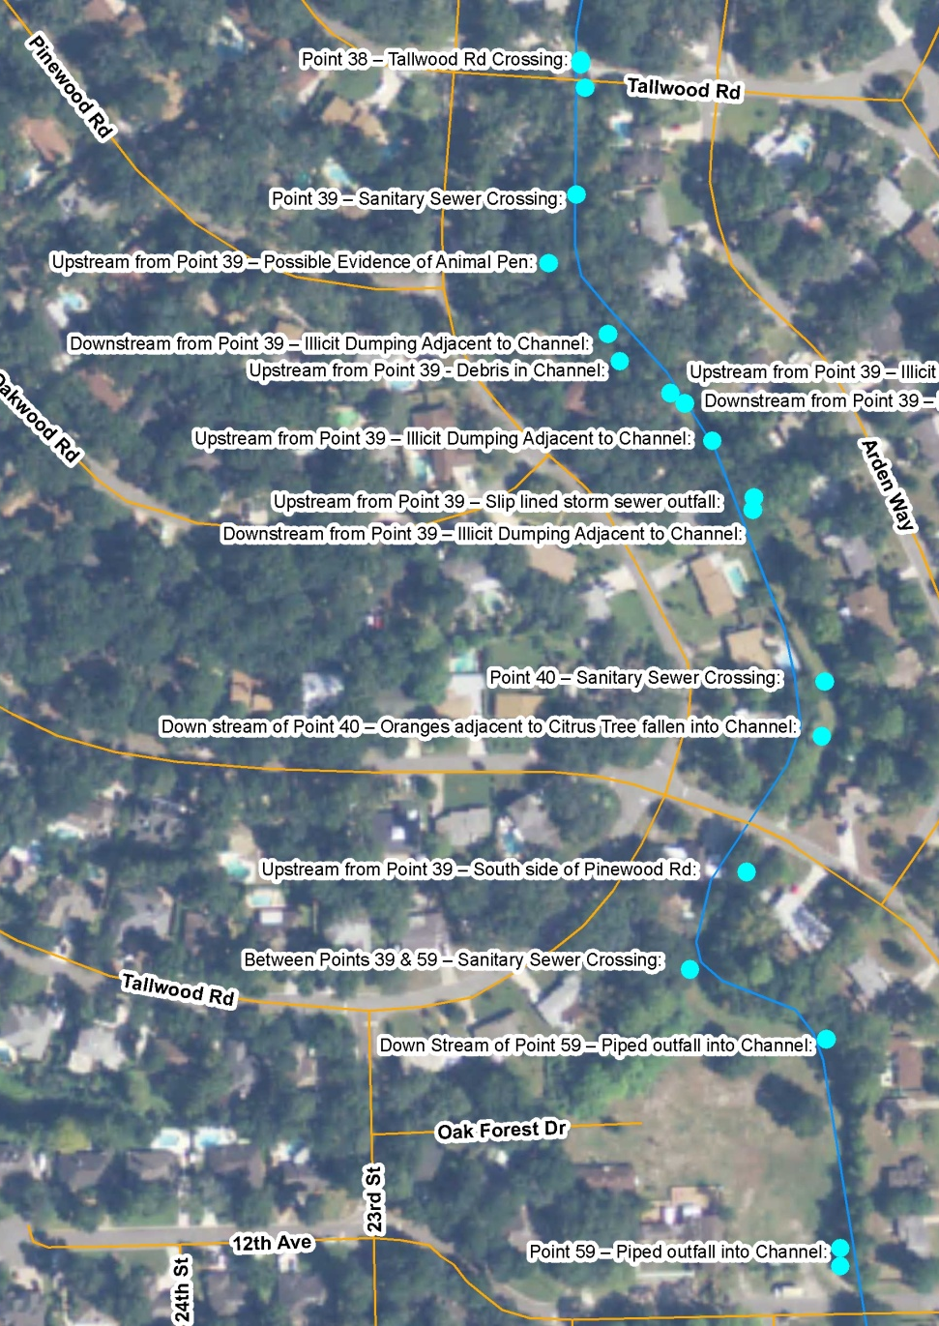
Figure 29. The team parked near 12th Ave. N. and 20th St. N. at Pt. 59 and walked to Point 38, Pinewood Ditch, in Jacksonville Beach. The aerial photo shows the field notes taken by Neptune Beach during the walk.
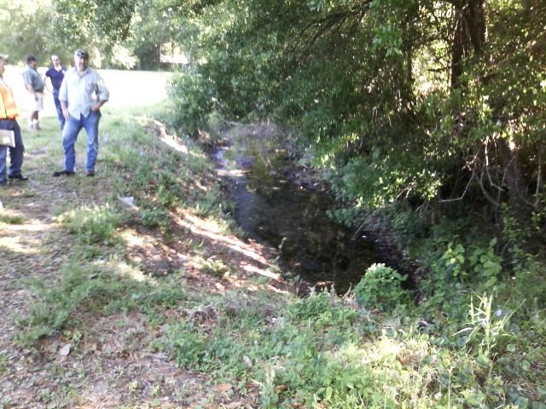
Figure 30. Point 59: Jacksonville Beach.
FIELD NOTES: A sample was taken at 12th Ave. South; the results showed 36 cfu/100mL of fecal coliform. The manhole cover was pulled; no bats were found. Bats have been observed in this manhole in the recent past. This part of the creek has slow velocity and canopy cover, and is piped upstream.

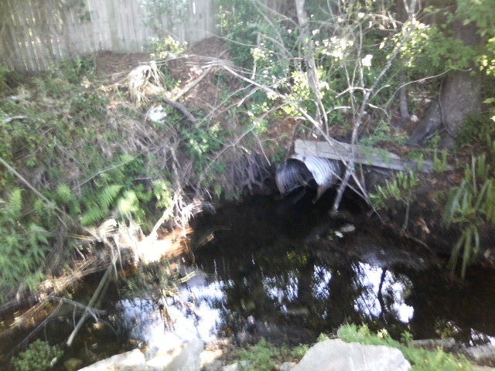
Figure 31. Jacksonville Beach, just downstream of Point 59.
FIELD NOTES: The team observed piles of illicitly dumped yard waste.
POST-FIELD NOTES: Jacksonville Beach Code Enforcement will follow up. Referred week of 06/27/2011 7/1/2011 COJB PW Streets Division employees went door to door to speak with residents about illicit dumping into our storm water system and ditches. They passed out 82 public information and educational materials to the local residents who live near the SW ditch.
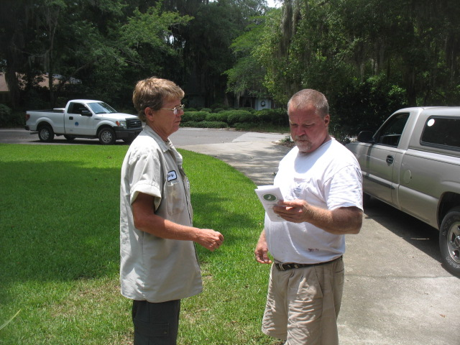

A copy of the double sided trifold handout pictured above is inserted below.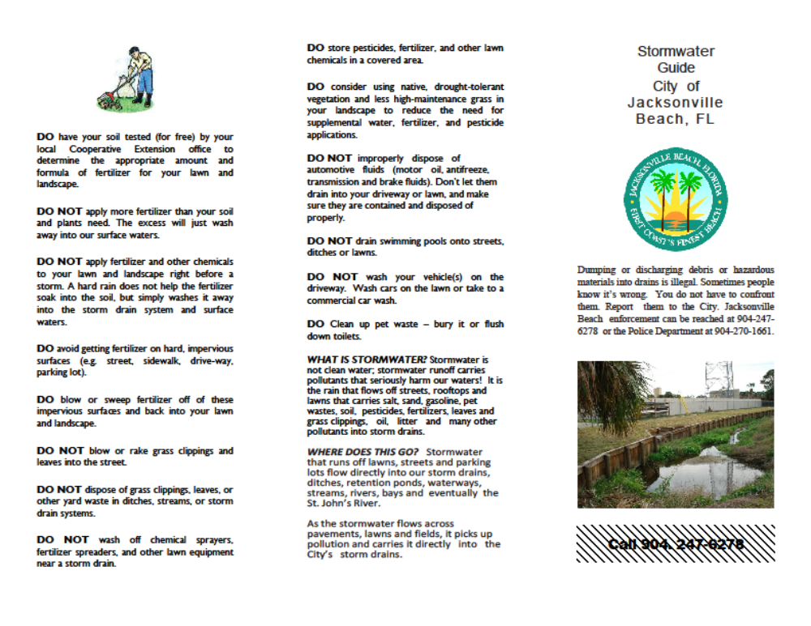
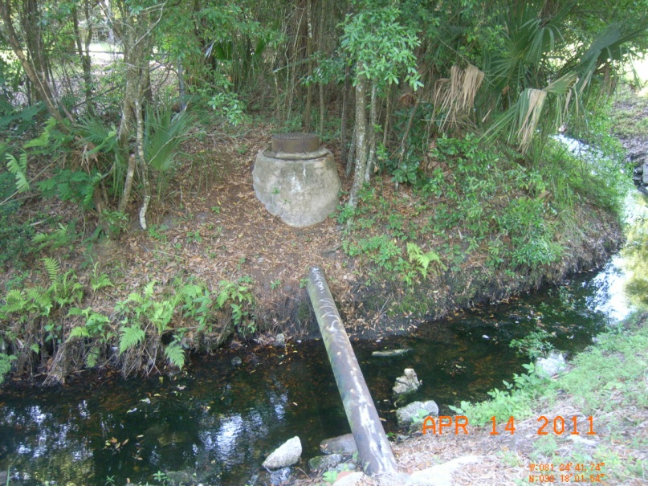
Figure 32. Point 39: Jacksonville Beach, upstream from Pinewood Rd.
FIELD NOTES: There are piped outfalls and sanitary sewer crossings. Some corrosion pitting was observed on the sewer crossing.
POST-FIELD NOTES: Jacksonville Beach inspected the pitting and has stated that the corrosion is not bad enough to take any action at this time.

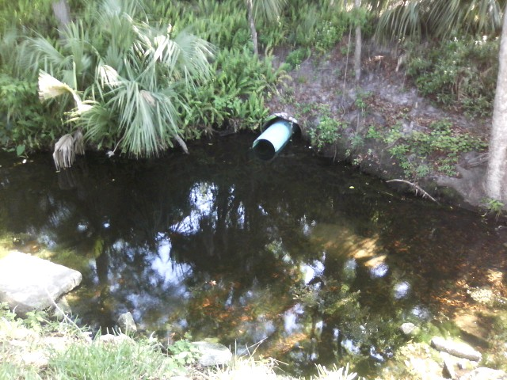

Figure 33. Near Point 40: Jacksonville Beach, near Oakwood.
FIELD NOTES: The crossing collapsed one and a half years ago, and subsequently PVC pipe was inserted inside the old corrugated pipe.

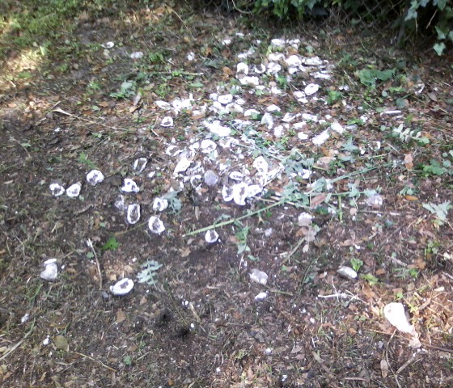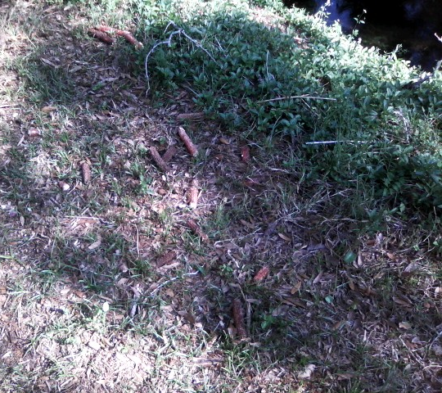

Figure 34. Near Point 40: Jacksonville Beach, downstream of Pinewood Rd.
FIELD NOTES: Yard waste was dumped behind a home above the ditch line, around the corner from, due north of sampling Point 59 at 12th Ave. North (left photo). Cobs of field corn were observed on the bank and may indicate that residents are feeding wildlife (right photo).
POST-FIELD NOTES: Jacksonville Beach try to count cats and raccoons in the area and talk with local residents about the impacts of feeding wildlife and feral cats.
7/10/2011 inspection of the ditch area did not indicate any wild cats or raccoons. There is no new evidence of feeding wild animals.
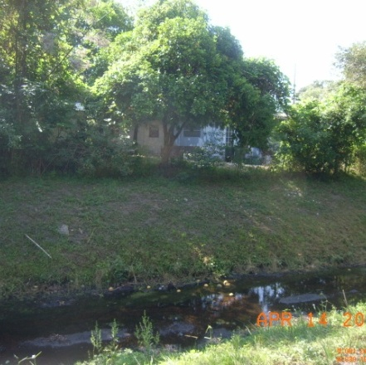
Figure 35. Near Point 40: Jacksonville Beach, downstream of Pinewood Rd.
FIELD NOTES: A fruit tree was dropping fruit into the ditch.
POST-FIELD NOTES: The rotting fruit can host Citrobacter, which can cause a positive lab result for fecal coliform, falsely indicating fecal contamination.

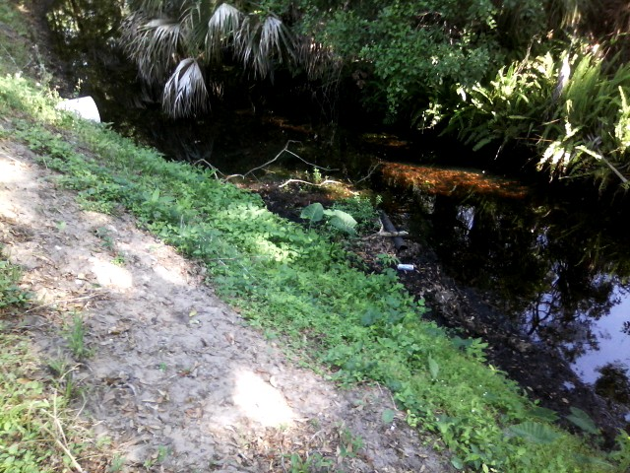
Figure 36. Point 40: Jacksonville Beach, south of Pinewood Rd.
FIELD NOTES: Debris was observed in the ditch, and the city of Jacksonville Beach put in a work order to clean it up.
POST-FIELD NOTES: The trash was picked up 06/21/2011.
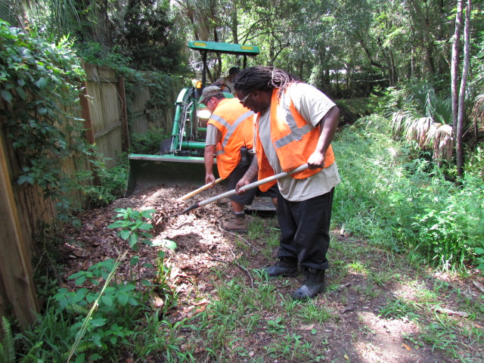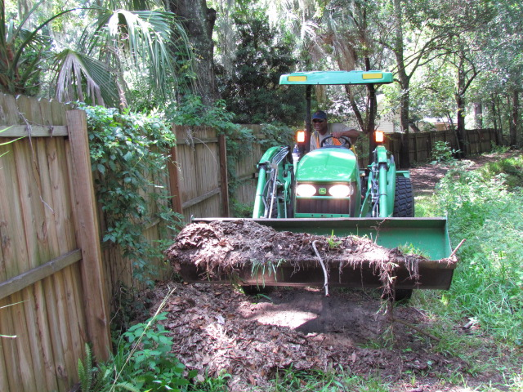
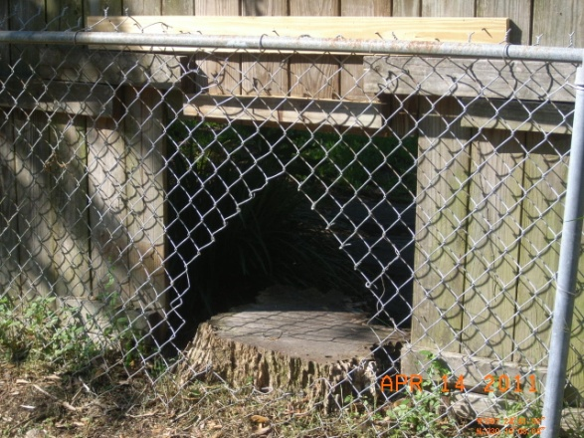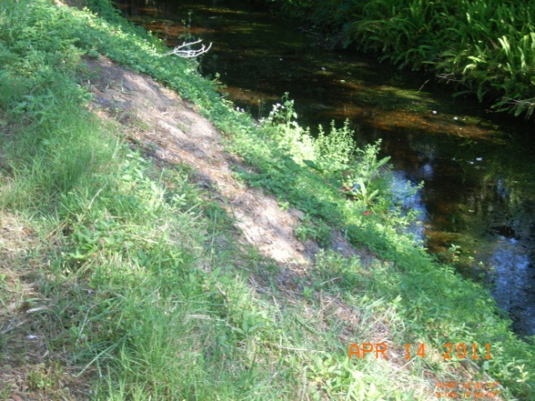
Figure 37. Near Point 40: Jacksonville Beach, downstream from Pinewood Rd.
FIELD NOTES: A “cat entrance” through the fence was observed between private property and the ditch in line with an animal trail to the water.
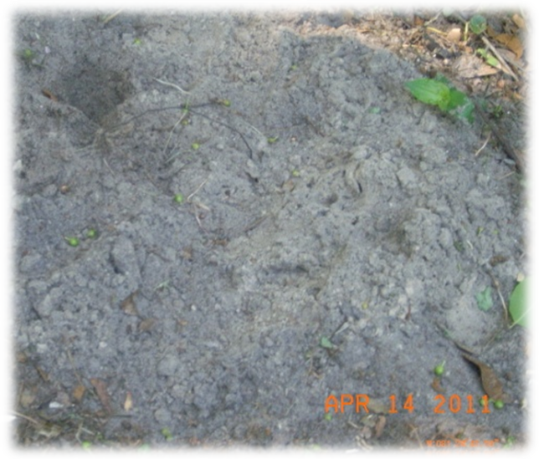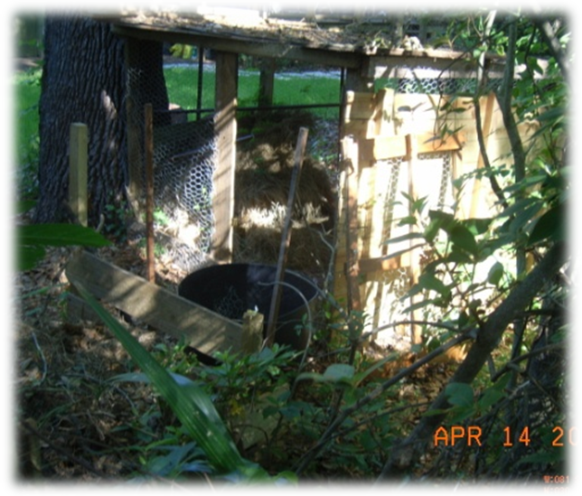
Figure 38. Near Point 40: Jacksonville Beach, downstream from Pinewood Rd.
FIELD NOTES: A large population of cats is running loose in the area, and tracks were observed during the field event. A possible animal cage was located along the fence, but no animals were observed in it during the walk.
POST-FIELD NOTES: Monitoring initiated 10/01/2010 no feral cats indicated north of Beach Blvd and west of Penman Road. Raccoon and Opossum nocturnal traffic is below normal w/1 raccoon and 2 opossum deaths. No indication of feeding today. Observations ongoing.

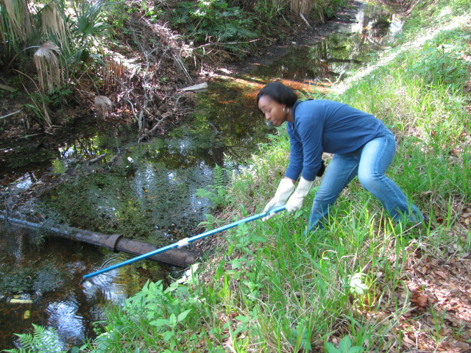
Figure 39. Point 38: Jacksonville Beach.
FIELD NOTES: A sample was taken downstream of the submerged sanitary sewer pipe; the results showed fecal coliform concentrations of 880 cfu/100mL.
POST-FIELD NOTES: Sampling should be carried out upstream and downstream of the pipe to determine the source. Jacksonville Beach went back and took samples above and below the pipe, and the results are forthcoming.

Lab Results:

Hopkins Creek Fecal Coliform samples: | Upstream of pipe  May 11, 2011 | Downstream of pipe May 11, 2011 | April 13, 2011 | Mar 9, 2011 | Feb 9, 2011 | Jan 13, 2011
SW06  Tallwood Road (Pinewood ditch) | 480 | 2100 | 890 | 220 | 460 | ND

From: Michael Taylor [mailto:MTaylor@jaxbchfl.net]
Sent: Thursday, June 23, 2011 10:44 AM
To: Nash, Anita
Cc: David McDonald; John Birch; Ty Edwards; Robert Newman
Subject: SW ditch sampling

Hi Anita, I tried Tuesday (6/21/11) morning to take SW ditch samples (upstream and downstream of submerged sewer pipe) at point 38. The SW ditch was dry. I will wait until after we get some rain and re-schedule another sample time. While the ditch was dry, I inspected the sewer pipe. There were no signs of any leaks or smell from the pipe. The pipe was dry. I will continue to monitor and inspect the sewer piping routinely. I moved some leaves from under the piping for a better visual inspection. I only found a small amount of surface water. Photo’s below.

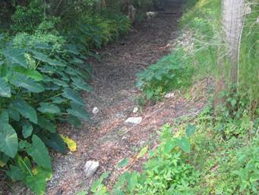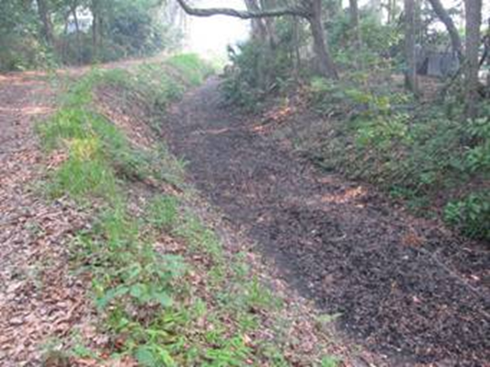
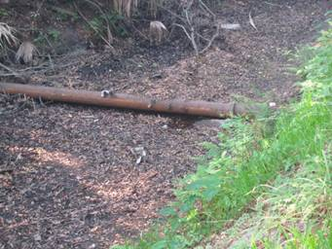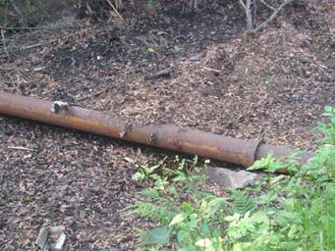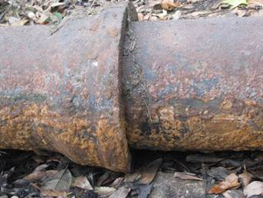
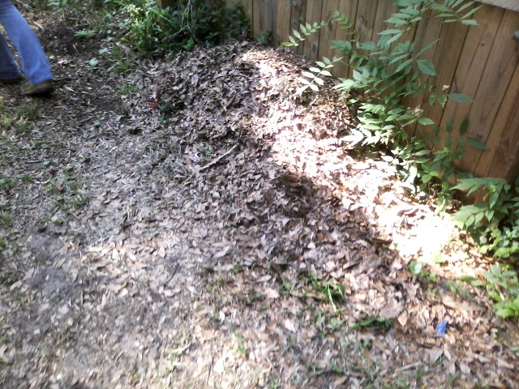
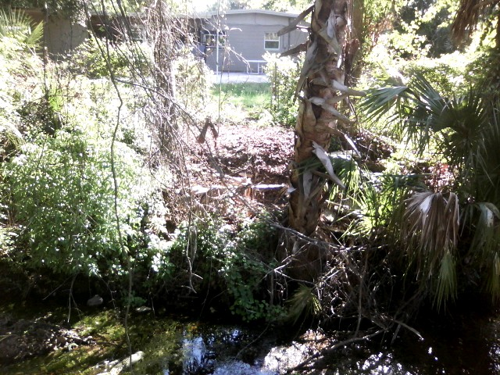

Figure 40. Near Point 40: Jacksonville Beach, downstream from Pinewood Rd.
FIELD NOTES: Piles of illicitly dumped yard waste were observed along the ditch. Jacksonville Beach will follow up.

POST-FIELD NOTES: COJB preformed a complete clean up along the entire Pinewood Ditch
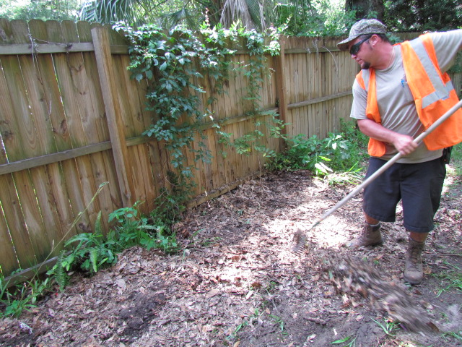
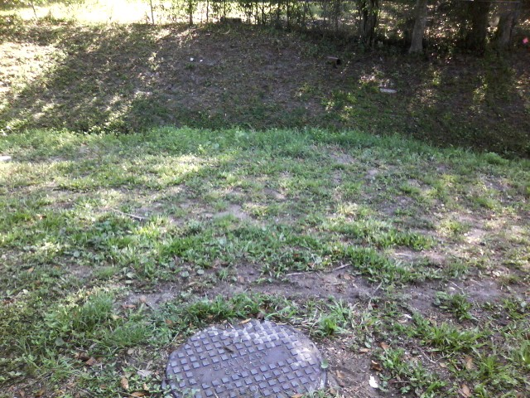
Figure 41. Between Points 39 and 40: Jacksonville Beach, downstream from Pinewood Rd.
FIELD NOTES: There is a sewer crossing below grade.

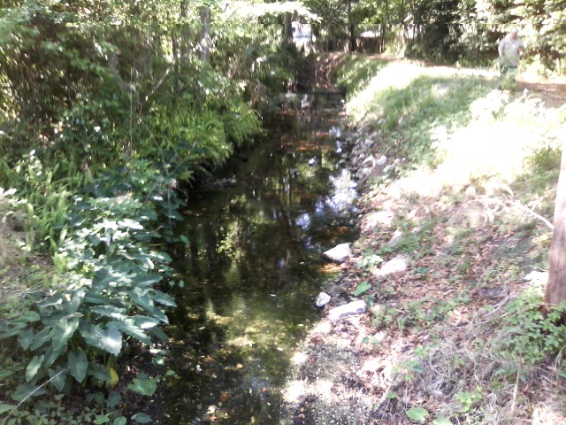
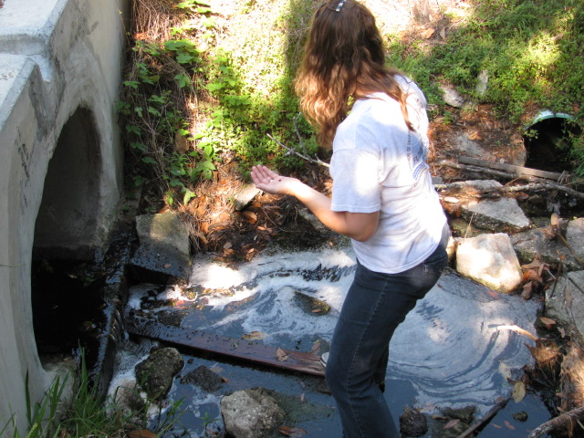
Figure 42. Point 38: Jacksonville Beach, Tallwood Rd. crossing.
FIELD NOTES: The team noticed a slight methane and/or sulfur smell. An abundance of snails were observed at the culvert at Pinewood Rd. There is a canopy cover in this part of the creek, and the water is foamy.
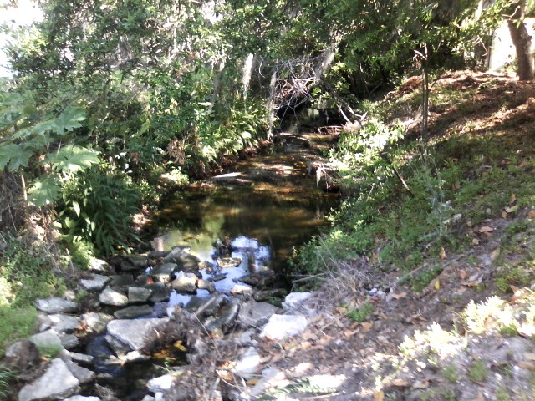

Figure 43. Point 38: Jacksonville Beach, Tallwood Rd. crossing.
FIELD NOTES: There is a dense canopy cover in this stretch of the creek. This is a Jacksonville Beach TMDL sampling station. The station is tidal and flows both directions.

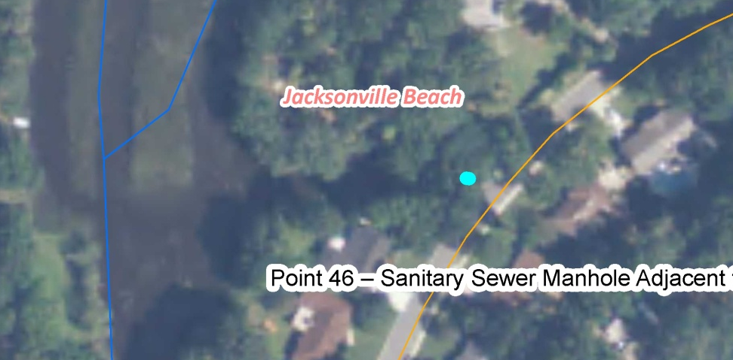
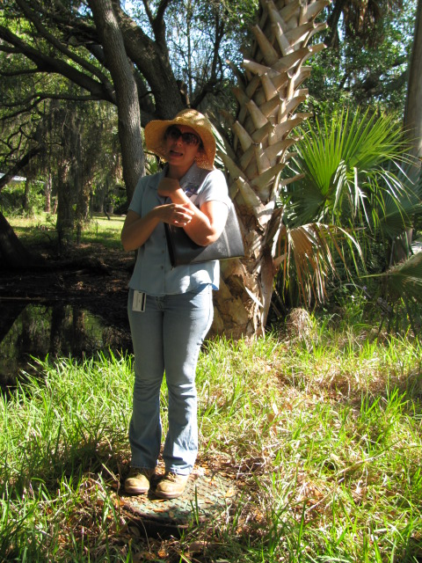

Figure 44. Point 46: Jacksonville Beach, Arden Way.
FIELD NOTES: The top photo shows the field notes taken during the walk. There is a lift station near the creek. Jacksonville Beach will review the history of the manhole near the creek (bottom photo).
POST-FIELD NOTES: The manhole was refurbished, and flow re-routed, pipe lined 2009. Per Distribution & Collection CJB 06/28/2011
Contacted Pam Morgan Supervisor COJB Waste Water Treatment Plant. There have not been any sewer over flows at this location in the history of the outfall.
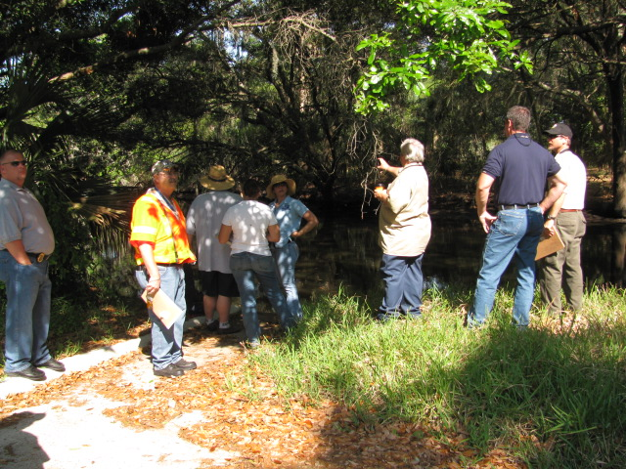

Figure 45. Point 46: Jacksonville Beach, Arden Way.
POST-FIELD NOTES: At this location, the ditch has low to no velocity and heavy canopy cover.

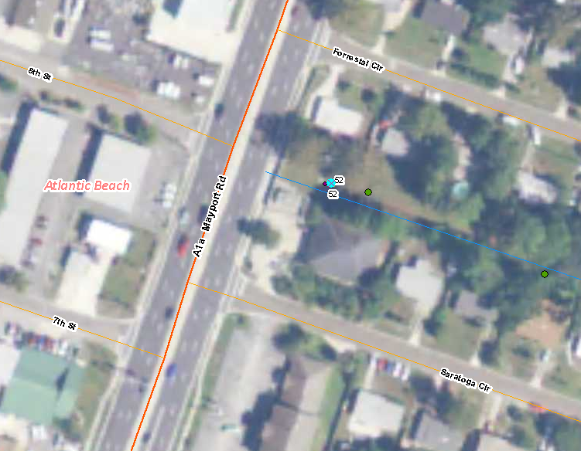
Figure 46. Point 52: Atlantic Beach, Mayport Rd. and Saratoga Ditch (FDOT ditch). This is an aerial photo of the vicinity of Point 52.

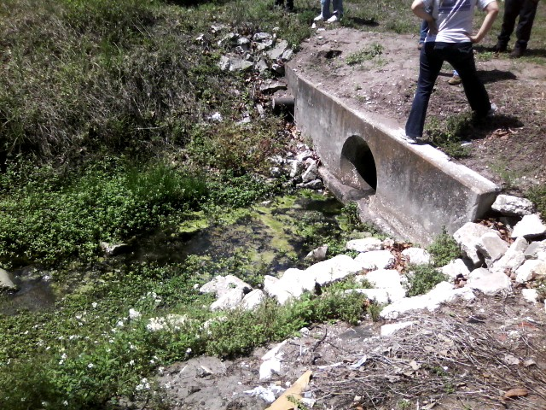
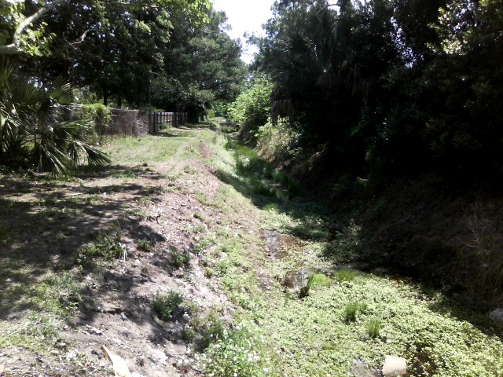
Figure 47. Point 52: Atlantic Beach, Mayport Rd. and Saratoga Ditch (FDOT ditch).
FIELD NOTES: Algae are growing in still water. A city lift station is adjacent to this location. The ductile iron pipe on the far edge of the wall is grouted shut (top photo), and there is heavy canopy cover and vegetation in the ditch (bottom photo).
POST-FIELD NOTES: July 28, 2011, FDOT’s contractors thinned vegetation in the ditch next to the lift station exposing the ditch to sunlight and to repaired erosion and removed debris from the flow line. See photos below.

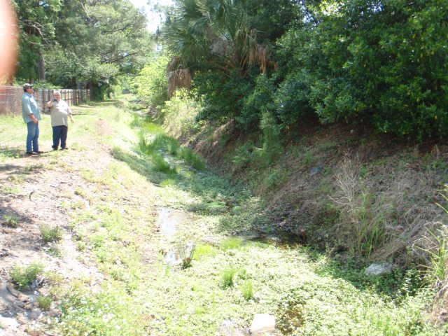
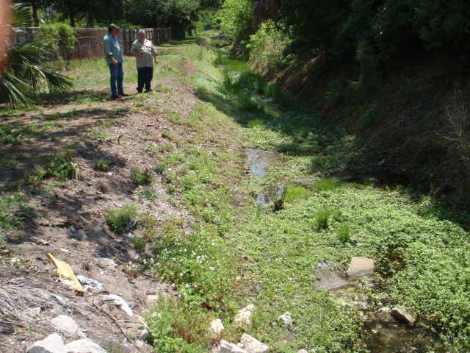
Figure 48. Point 52: Atlantic Beach, Mayport Rd. and Saratoga Ditch (FDOT ditch).
FIELD NOTES: The area is heavily overgrown.
POST-FIELD NOTES: July 28, 2011, FDOT’s contractors thinned vegetation in the ditch next to the lift station exposing the ditch to sunlight and to repaired erosion and removed debris from the flow line. See photos below.

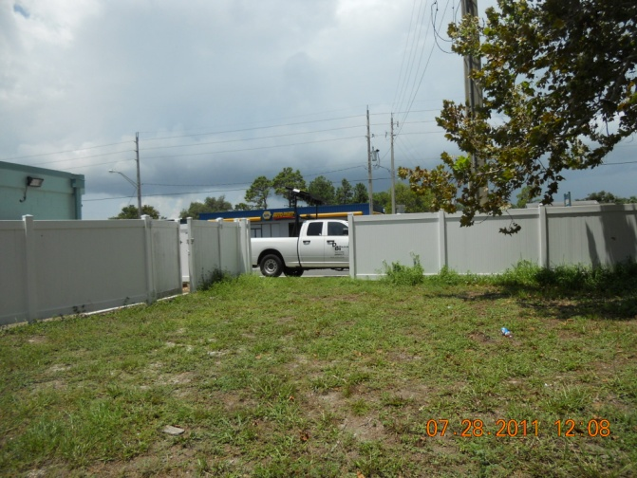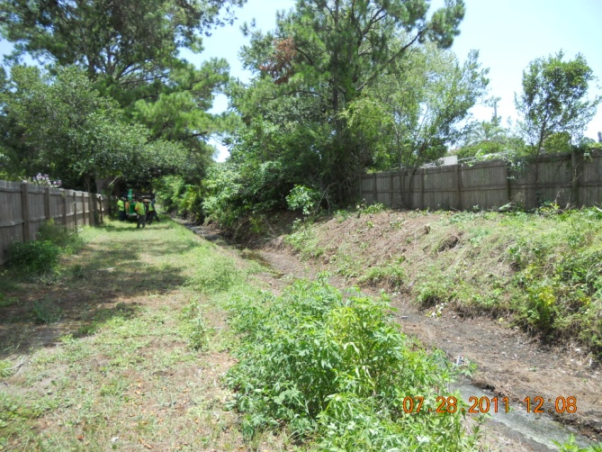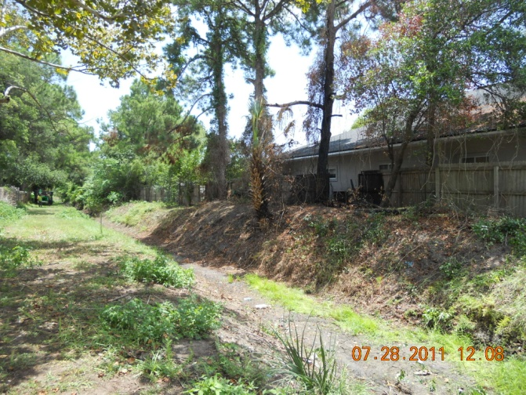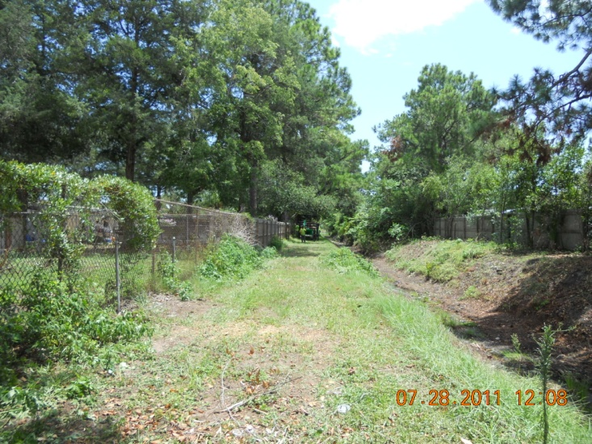
Photos above show the cleared ditch after DOT’s contractors completed vegetation clearing and removal of invasive plants. Started in July, 2011. Planning additional trimming in near future. DOT to inspect areas cleared of vegetation for PICs in areas along the ditch that could not be walked during the field day.
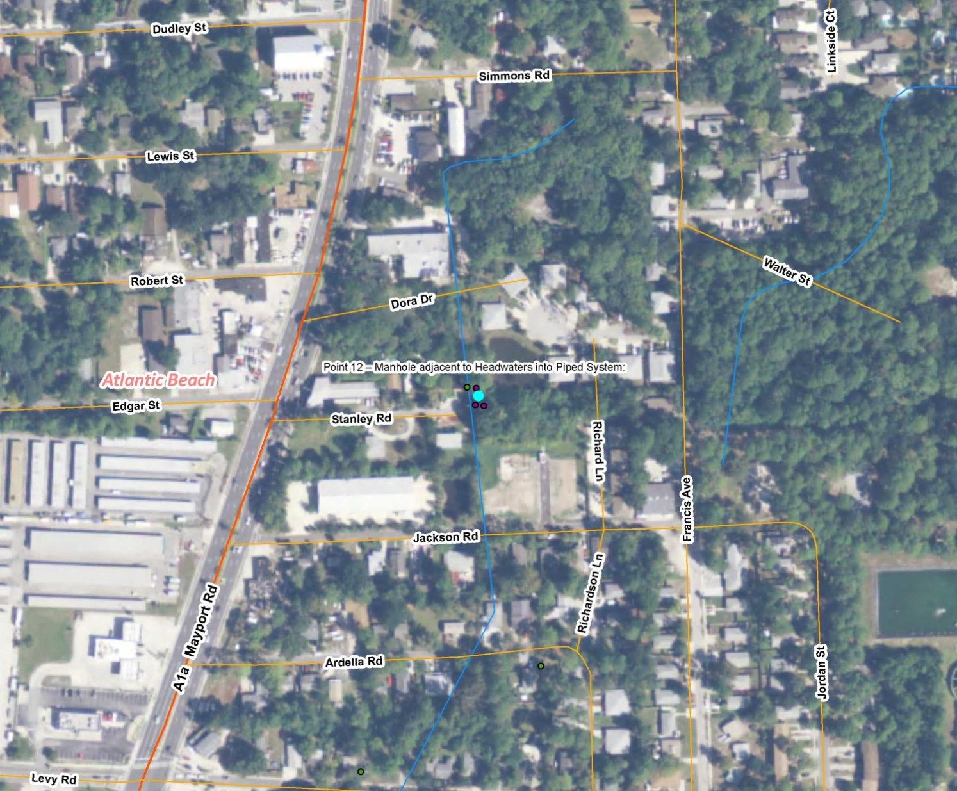
Figure 49. Point 12: Atlantic Beach, at the end of Stanley Rd. The aerial photo shows the vicinity of Point 12.

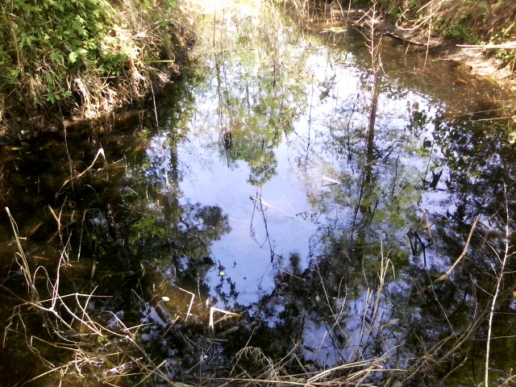
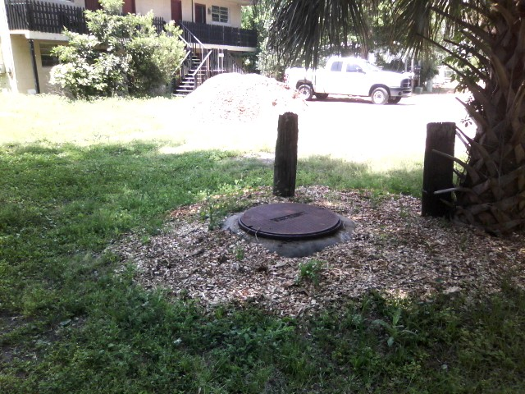

Figure 50. Point 12: Atlantic Beach, at the end of Stanley Rd.
FIELD NOTES: In the headwaters, the team observed a sheen on the surface of the water resembling petroleum product (top photo). This could be pesticides from spraying the previous week. The manhole near the creek has mulch around it near the ditch, possibly indicating overflows (bottom photo).
POST-FIELD NOTES: Atlantic Beach staff went back a few days after the field event and said the sheen was gone. The ditch was checked several times more. However, the ditch was dry due to the drought. Atlantic Beach will check the history of manhole overflows at this location.
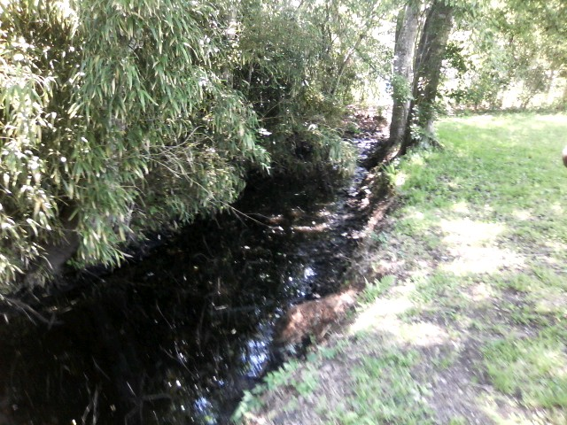
Figure 51. Point 12: Atlantic Beach, at the end of Stanley Rd.
FIELD NOTES: Overgrown vegetation is preventing UV penetration.
POST-FIELD NOTES: The Atlantic Beach Maintenance Department removed the much of the overhanging vegetation and debris.

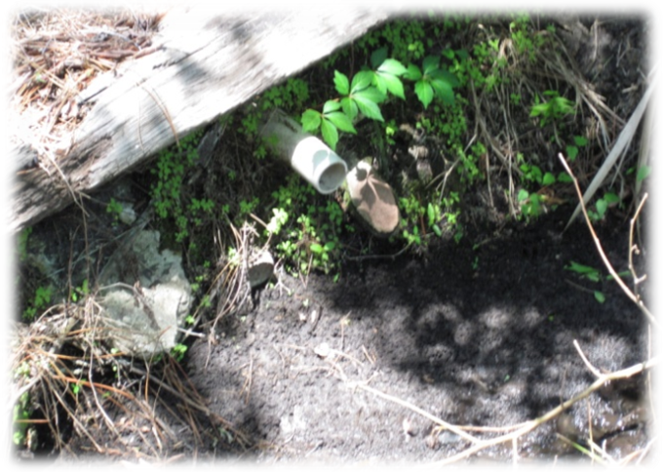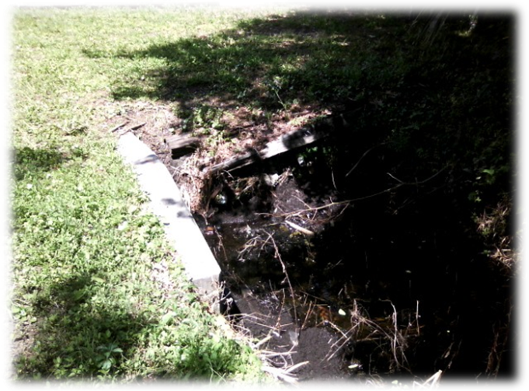
Figure 52. Point 12: Atlantic Beach, at the end of Stanley Rd.
FIELD NOTES: A potential illicit discharge was observed (a 2-inch pipe) (top photo). Although it was stated by AB staff that the pipe was capped at the homeowner’s end years ago. A sample taken during the field event showed fecal coliform concentrations of 27 cfu/100mL. Piles of yard rakings, mainly pine needles, were observed on the bank and in the ditch (bottom photo).
POST-FIELD NOTES: Follow-up by Atlantic Beach indicated that the pipe has been capped at the ditch end and was not connected to anything as was noted in the field. Atlantic beach staffspoke with the land owners about not dumping yard clippings/rakings along the ditch.
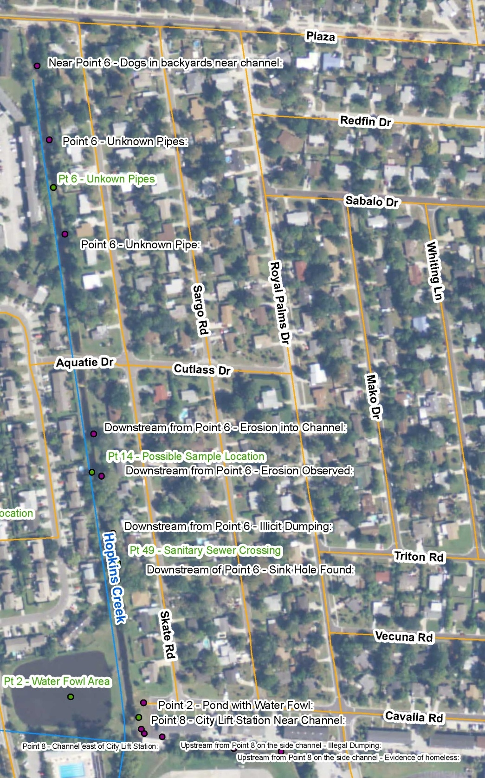
Figure 53. Point 6: Atlantic Beach. The aerial photo shows the field notes taken during the walk. The team parked on the north end of this stretch near Point 6 and walked south.

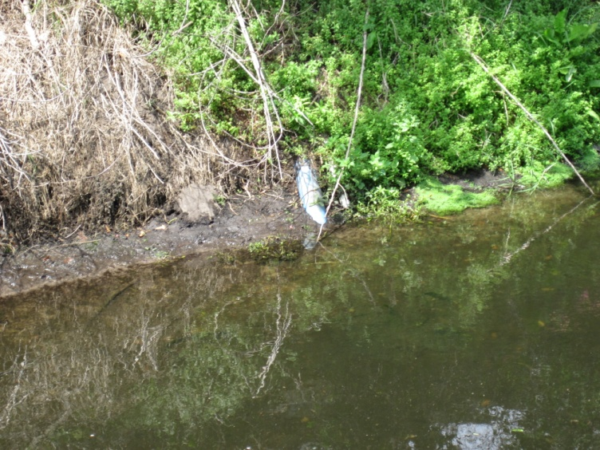
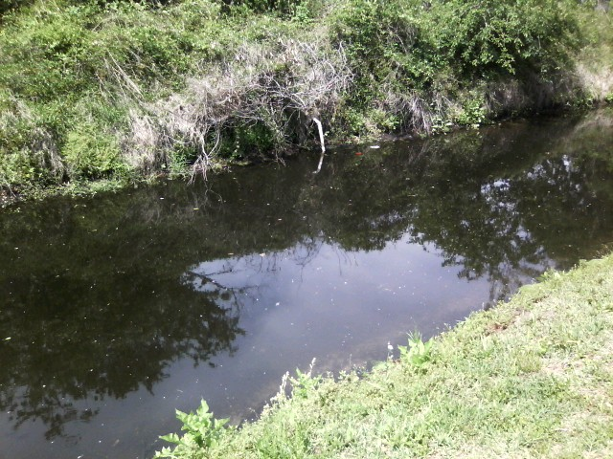
Figure 54. Point 6: Atlantic Beach.
FIELD NOTES: Three PICs were observed at the beginning of this stretch.
POST-FIELD NOTES: Atlantic Beach followed up and determined both the white and blue pipes were scrap pieces of pipe that were pulled up, and they were not connected to anything. It is thought that they were capped on the apartment’s side years ago, but this information is still being confirmed.

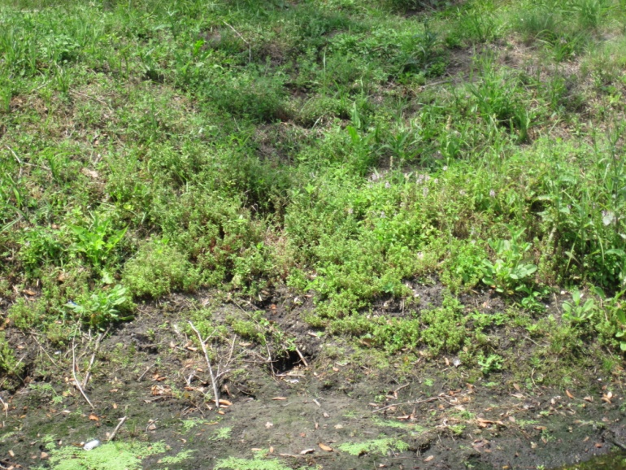
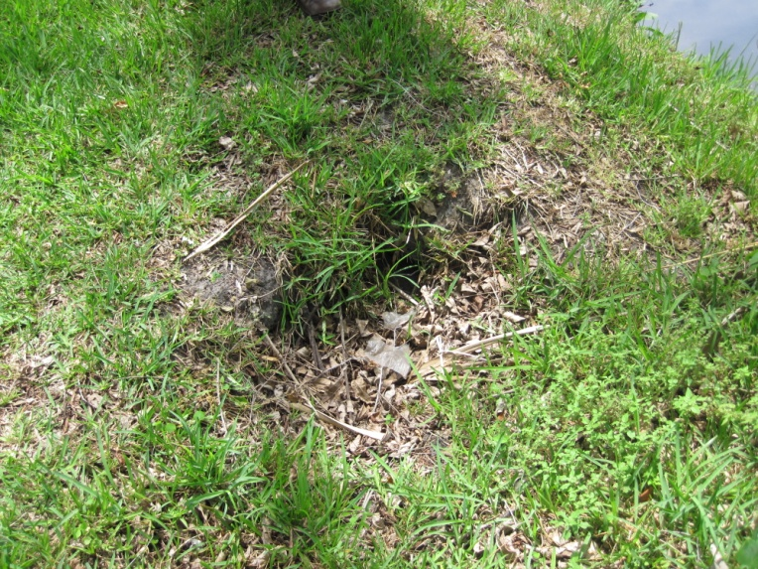
Figure 55. Point 6: Atlantic Beach.
FIELD NOTES: Two more discrete PICs (eroded flow paths) were observed in this stretch. The source was a roof drain on an adjacent building.
POST-FIELD NOTES: Atlantic Beach will investigate whether anything can be done about the roof drain, but this is unlikely.

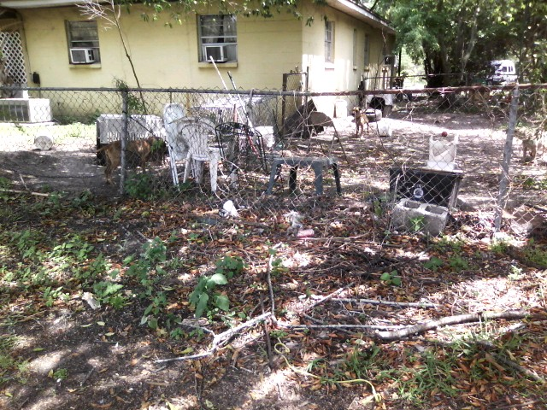

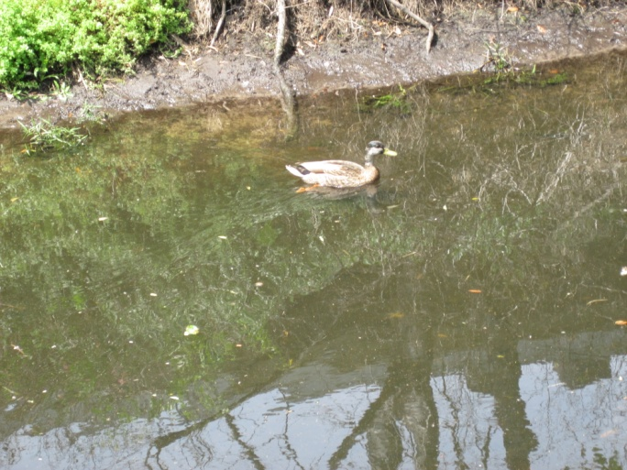
Figure 56. Point 6: Atlantic Beach.
FIELD NOTES: Dog waste was observed in neighboring yards (top photo), as well as waterfowl and turtles in the ditch (bottom photo). There is very low flow in this stretch.
POST-FIELD NOTES: Follow-up fecal coliform samples should be taken. Atlantic Beach will sample the water for fecal coliform slightly downstream of Point 6 and will consider passing out flyers in the neighborhood about the importance of “scoop the poop.”

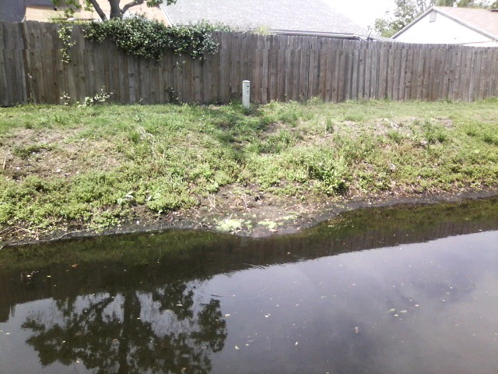
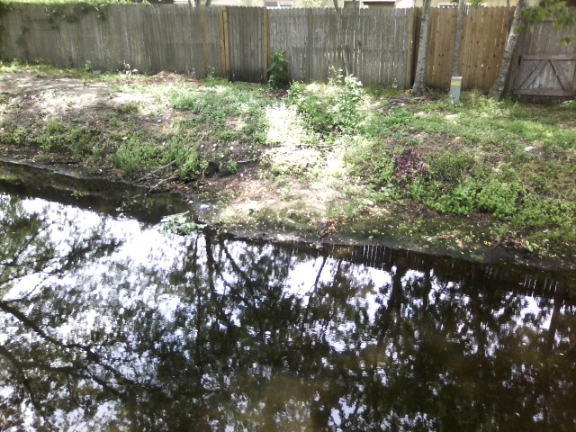
Figure 57. Point 6: Atlantic Beach.
FIELD NOTES: The team observed erosion from backyard runoff, caused by a natural low spot in the adjoining yards.
POST-FIELD NOTES: Atlantic Beach will follow up.
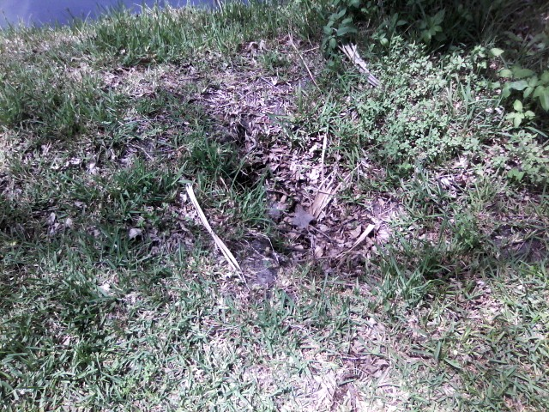
Figure 58. Point 6: Atlantic Beach.
FIELD NOTES: A hole was observed along the ditch.
POST-FIELD NOTES: Atlantic Beach will try to find the source of the hole, and will follow up after filling it to see if it returns.

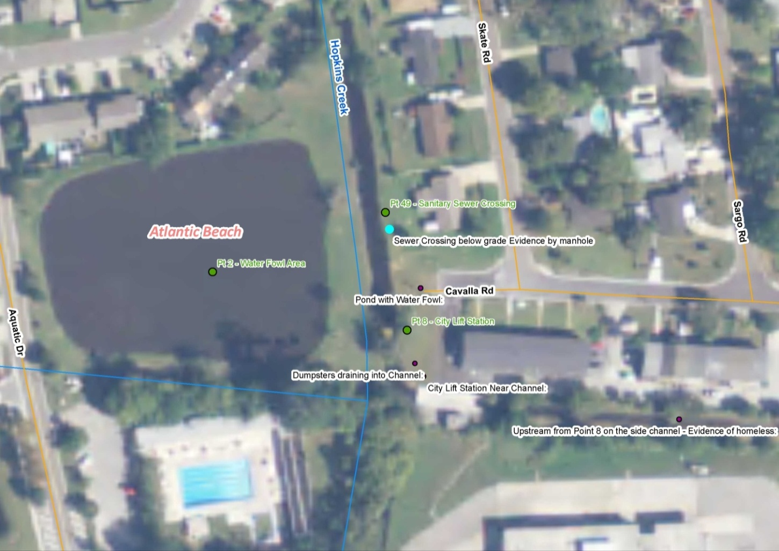
Figure 59. Point 49: Atlantic Beach. The aerial photo shows the field notes taken during the walk. There is a sewer crossing below grade.

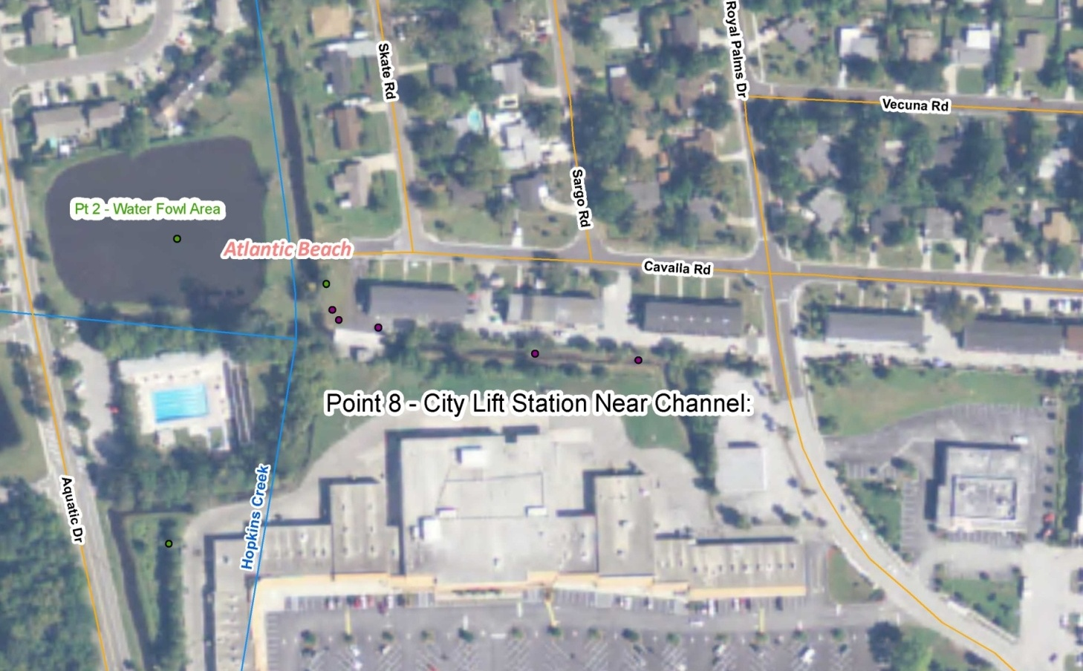
Figure 60. Point 8: Atlantic Beach. The photo shows the field notes taken during the walk.

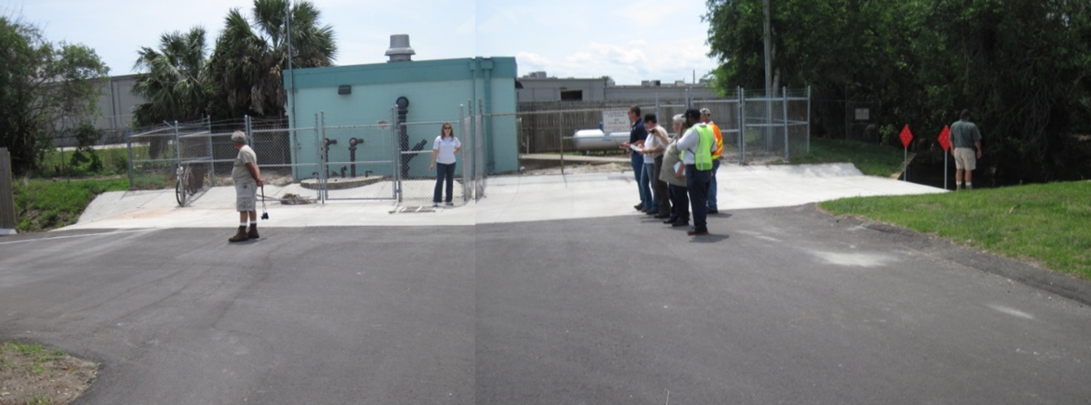
Figure 61. Point 8: Atlantic Beach.
FIELD NOTES: There is a well-maintained lift station on the Skate Road Ditch. Since there is no berm or catchment, an overflow could potentially flow directly into the creek.
POST-FIELD NOTES: Atlantic Beach will investigate whether there is a rule requiring some sort of catchment around the lift station to contain the potential overflow.

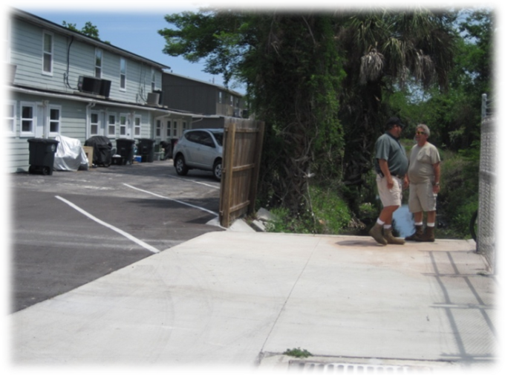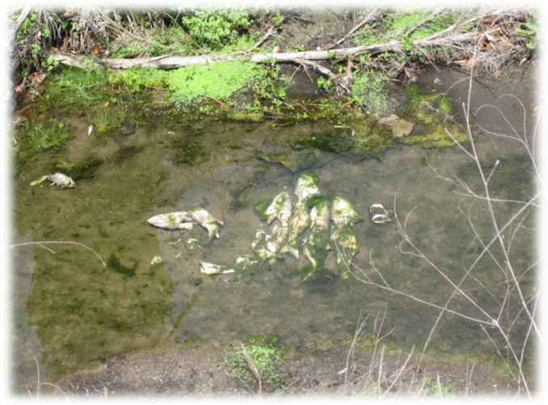
Figure 62. Point 8: Atlantic Beach.
FIELD NOTES: Residential runoff from the Royal Palm complex runs directly to the ditch (top photo). The team observed filleted fish carcasses dumped into the ditch (bottom photo).
POST-FIELD NOTES: Atlantic Beach will consider passing out flyers asking residents to please not dump in the ditch.
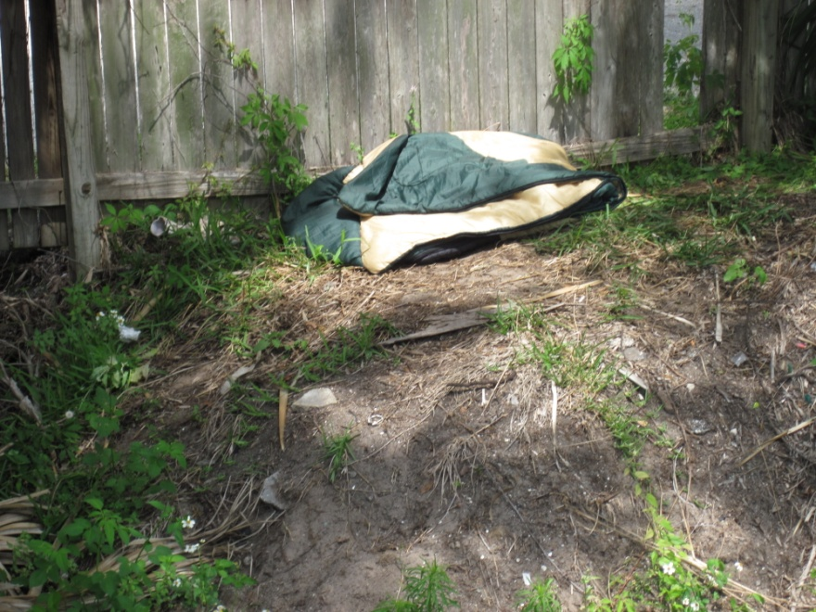
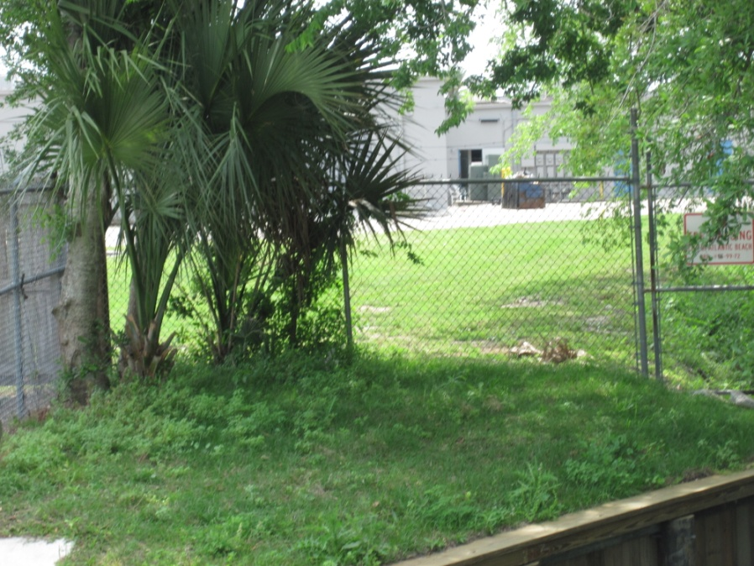
Figure 63. Point 8: Atlantic Beach.
FIELD NOTES: There may be homeless people staying along the ditch. The team noticed a sleeping bag (top photo) and 2 chairs behind the fence on the ditch side. Overflowing dumpsters also drain to the ditch (bottom photo).
POST-FIELD NOTES: Atlantic Beach will follow up to see if the homeless individuals return and will keep an eye on the dumpsters for overflow.
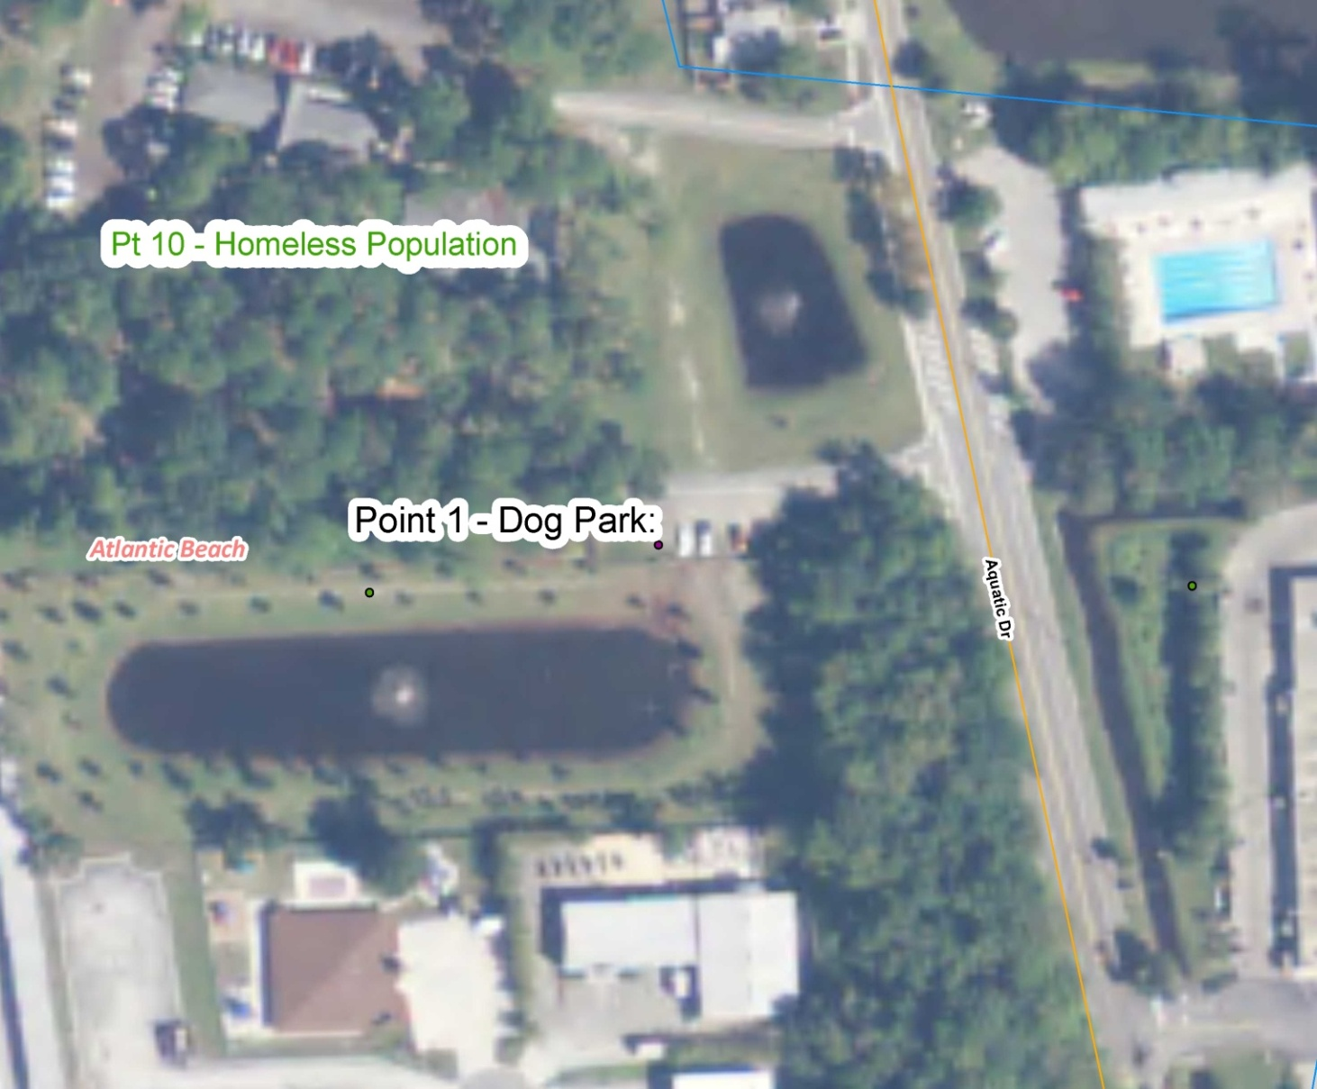

Figure 64. Point 1: Atlantic Beach. The aerial photo shows the vicinity of Point 1, the dog park.

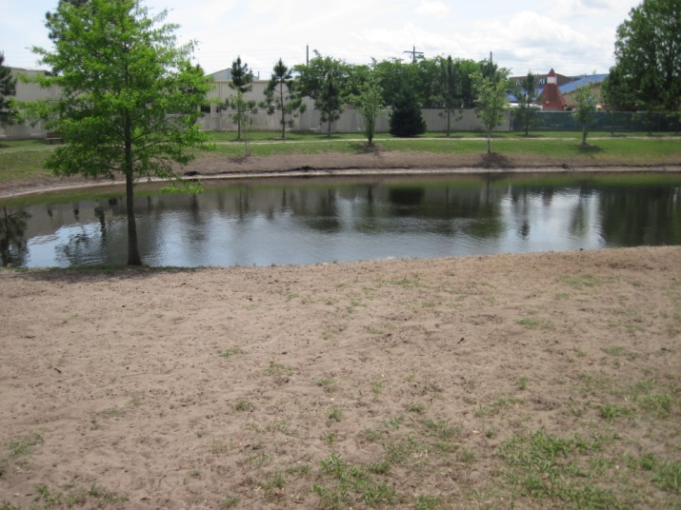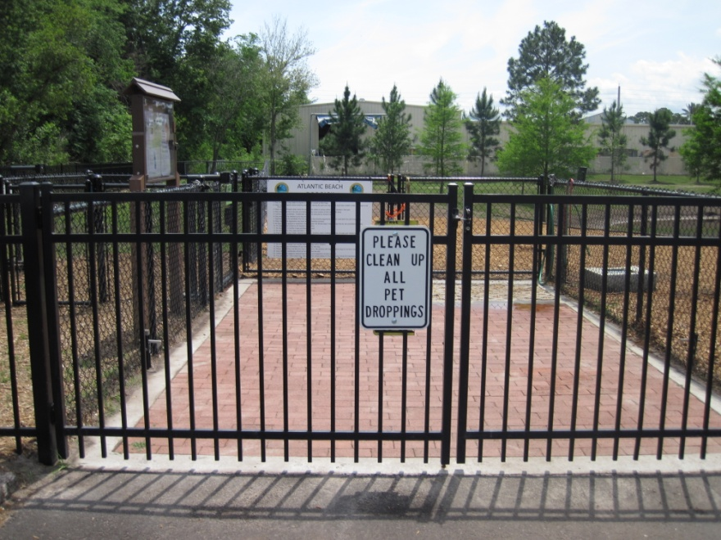

Figure 65. Point 1: Atlantic Beach, Dog Park.
FIELD NOTES: The photos show a dog park around the stormwater pond. An adjacent property, Point 10, has been known to be a homeless camp in the past, but no signs of recent activity were observed.
POST-FIELD NOTES: Atlantic Beach will sample both the stormwater pond and the overflow pond for fecal coliform. Additional future sampling in both ponds should be considered.

Here are the results of Atlantic Beach’s sampling.
Dog Park Pond
Sample 6/14/2011:(the day after first significant rain event in months) 21,000 cfu/100ml
Sample 6/28/2011: Non Detect
Sample 7/19/2011: 90 cfu/100ml

Aquatic Gardens Pond
Sample 6/14/2011:(the day after first significant rain event in months) 3300 cfu/100ml
Sample 6/28/2011: Non Detect
Sample 7/19/2011: 54 cfu/100ml

Next Steps and Follow-up Actions
A follow-up meeting was held on May 16, 2011, to review field day observations; ensure that the documentation was accurate; review the sampling results; determine follow-up actions on issues such as drips, leaks, and PICs; note future sampling needs; and document the progress of action items already being carried out.
Table 1 lists each follow-up action to be taken to reduce fecal coliform levels in Hopkins Creek, the related figure, the entity carrying out the activity, the date of completion or initiation, and the action that was taken. The table serves as a checklist to ensure that all the necessary follow-up actions are taken. The follow-up actions will be completed by June 20, 2011.
Table 1. Next steps and follow-up actions for reducing fecal coliform in Hopkins Creek
Related Figure(s) | Action Item | Entity | Date Initiated/Completed | Outcome
3 | Point 24: Neptune Beach, Penman Rd. (FDOT ditch). Confirm the ownership of the WWTP effluent pipe that is thought to belong to Jacksonville Beach. | Jacksonville Beach | 6/14/2011 | Pam Morgan confirmed this Effluent line belongs to COJB
5 | Point 24: Neptune Beach, Penman Rd. (FDOT ditch). Install a warning light on the private lift station at Ocean Oaks Apartments. The posted emergency contact was Gainey Utility Service at (904) 545–0466. Install a lock on the wet well and fix the irrigation system. Neptune Beach will pass this information to the city of Jacksonville for follow-up. | City of Jacksonville | 7-27-11 | City of Jacksonville EQD inspected the facility.
6, 7, 8 | Point 24: Neptune Beach, Penman Rd. (FDOT ditch). Remove vegetation from the fence at this section of the 8th St. Ditch, repair erosion at the apartment side of the wall, weed-eat the area, secure it, and thin the vegetation along the ditch bank to expose the ditch to sunlight. | FDOT contractor | 6- Completed  7-Scheduled for Aug 4th, 2011  8-Scheduled for end of Aug. 2011. | FDOT has asked its contractors to carry out this work.
9 | Point 51: Neptune Beach, Kings Rd. Bridge. Look for PICs in the septic tank area near the bridge. | DCHD, FDOH | May 23, 2011 | Braden Ward of FDOH took a low-tide boat trip to look for PICs in the septic area near the bridge; nothing was found.
9 | Point 51: Neptune Beach, Kings Rd. Bridge. Carry out a door-to-door check on septic tanks in the summer. | Duval County Health Department (DCHD) | Completed June 2011 | FDOH completed the survey and found 2 broken tank lids in the area.
9 | Point 51: Neptune Beach, Kings Rd. Bridge. Educate residents about the importance of “scoop the poop.” | Neptune Beach | March 2011 | Information about the pet waste ordinance and cleaning up after pets was published in March 2011 Cast-a-Line newsletter.
15 | Point 23: Neptune Beach, private hotel. Follow up on the missing lock at the wet well at the Days Inn lift station. | City of Jacksonville | 7-21-11 | City of Jacksonville EQD inspected the facility.
15 | Point 23: Neptune Beach, private hotel. Anita Nash will call Neptune Beach Code Enforcement to find out if the lift station at this location was leaking. | FDEP | June 2011 | No leaking witnessed, but there was obvious degradation of the lift station. Maintenance was required. Possible evidence of sewage released from the system had been noted, but not confirmed. Code enforcement is satisfied with the repairs.
12 | Point 23: Neptune Beach, private hotel. Remove trash and debris behind the Days Inn. | Neptune Beach Code Enforcement | April 2011 | The trash piles were removed. (Figures 16 and 17 show the cleaned-up area).
12 | Point 23: Neptune Beach, private hotel. Remove tires in Winn Dixie stormwater pond. | Neptune Beach Code Enforcement | April 2011 | The tires were removed (Figures 16 and 17 show the cleaned-up area).
18 | Point 35: Border of Jacksonville and Neptune Beach, FDOT ditch at Seagate Ave. Check to see if the school season sampling results fluctuate compared with those of the non-school season. | Jacksonville Beach | July 2011 | Table of historical results for the last year was added to the document
18 | Repair erosion occurring behind the concrete flume belonging to DOT. | FDOT | Began July 2011 | DOT plans to repair the flume after vegetation removal is complete. DOT plans to look at all DOT flumes and repair as necessary.
17, 19, 20, 21 | Point 35: Border of Jacksonville and Neptune Beach, FDOT ditch at Seagate Ave. Remove palm fronds and thin vegetation to expose the ditch to sunlight, remove any debris from the flow line of the ditch, and repair the eroded area. | FDOT contractor | Began August 2011 | Invasives removed, vegetation trimmed, UV can reach the ditch, walking path to be maintained ~monthly to facilitate inspections by DOT.
22 | Point 37: Jacksonville Beach, Boys and Girls Club. Follow up to ensure that an emergency contact number is posted. Follow up on the vent that is rusted open at the private lift station. | City of Jacksonville | 6-30-11 | City of Jacksonville EQD inspected the facitlity.
26 | Point 41: Jacksonville Beach at 15th Ave. N. (FDOT ditch). Fix erosion on the south side of the road. | FDOT | Trimming began July 2011 | Erosion will be fixed after tree trimming completed.
25, 27 | Point 41: Jacksonville Beach at 15th Ave. N. (FDOT ditch). Thin vegetation to expose the ditch to sunlight and remove any debris from the flow line of the ditch. | FDOT contractor | Work began July 2011. | Invasives removed, vegetation trimmed, UV can reach the ditch, walking path to be maintained ~monthly to facilitate inspections by DOT.
31 | Jacksonville Beach, just downstream of Point 59. Follow up on the illicit dumping of yard waste. | Jacksonville Beach Code Enforcement | 7/1/11 | COJB PW Streets Division employees went door to door to speak with residents about illicit dumping into our sw system. They passed out 82 public information and educational materials to the local residents who live near the SW ditch.
36 | Point 40: Jacksonville Beach, south of Pinewood Rd. Pick up the trash and debris in the ditch. | Jacksonville Beach | 06/21/2011 | The city picked up the trash and debris and will send pictures of the cleaned-up ditch.
34 | Near Point 40: Jacksonville Beach, downstream of Pinewood Rd. Follow up on the yard waste dumped behind a home above the ditch line, around the corner from, due north of sampling Point 59 at 12th Ave. N. | Jacksonville Beach | 06/21/2011 | The city picked up the trash and debris and will send pictures of the cleaned-up ditch.
37, 38 | Near Point 40: Jacksonville Beach, downstream of Pinewood Rd. Obtain numbers for wild cats and raccoons in the area, and talk with local residents about the impacts of feeding wildlife. | Jacksonville Beach | 7/10/11 | Inspection of the ditch area did not indicate any wild cats or raccoons. There is no evidence of feeding wild animals.
39 | Point 38: Jacksonville Beach. Take samples above and below the submerged sanitary sewer pipe. | Jacksonville Beach | 6/21/11 | The SW ditch was dry, and will wait until after we get some rain and re-schedule another sample time. While the ditch was dry, I inspected the sewer pipe. There were no signs of any leaks or smell from the pipe. The pipe was dry. COJB will continue to monitor and inspect the sewer piping routinely. I moved some leaves from under the piping for a better visual inspection. Further results are forthcoming.
40 | Near Point 40: Jacksonville Beach, downstream from Pinewood Rd. Address illicit dumping of yard waste along the ditch. |  | 6/21/11 | The COJB did a complete trash and debris cleaned-up near the ditch.
44 | Point 46: Jacksonville Beach, Arden Way. Review the history of the manhole near the creek. | Jacksonville Beach | July 2011 | No overflows noted. This sewer pipe system has since been taken offline for other reasons.
48 | Point 52: Atlantic Beach, Mayport Rd. and Saratoga Ditch (FDOT ditch). Thin vegetation in the ditch next to the lift station to expose the ditch to sunlight, and repair erosion, and remove debris from the flow line. | FDOT contractor | Work began July 2011. | Invasives removed, vegetation trimmed, UV can reach the ditch, walking path to be maintained ~monthly to facilitate inspections by DOT.
51 | Point 12: Atlantic Beach, at the end of Stanley Rd. Remove overgrown vegetation and debris. | Atlantic Beach Maintenance Department | Last week of May 2011 | The city removed the vegetation and debris.
50 | Point 12: Atlantic Beach, at the end of Stanley Rd. Check again whether the sheen resembling petroleum product is gone and check the history of manhole overflows at this location. | Atlantic Beach | Checked Multiple times in May and June | No sheen nor any water present in ditch
52 | Point 12: Atlantic Beach, at the end of Stanley Rd. Talk to the landowners about not dumping yard clippings/rakings along the ditch. | Atlantic Beach | June | Message given to homeowners.
54 | Point 6: Atlantic Beach. Confirm with the management of the apartment complex whether the two white pipes on the apartment’s side of the ditch have been capped. | Atlantic Beach | June | Confirmed the pipes are capped.
55 | Point 6: Atlantic Beach. Investigate whether anything can be done about the roof drain flowing to the ditch. | Atlantic Beach | Aug. 2011 | No prohibition in Code. Roof runoff is considered stormwater and is expected to be in the MS4 system.
56 | Point 6: Atlantic Beach. Sample the water for fecal coliform slightly downstream of Point 6. | Atlantic Beach | Sampling performed June and July 2011 | Sample 6/14/2011:(the day after first significant rain event in months) Too high to count (>60,000 cfu/ 100ml  Sample 6/28/2011: 450 cfu/100ml  Sample 7/19/2011: 2900 cfu/100ml
56 | Point 6: Atlantic Beach. Pass out flyers in the neighborhood about the importance of “scoop the poop.” | Atlantic Beach | CM to review Aug. 2011 | Letter being crafted and will need COAB CM approval
57 | Point 6: Atlantic Beach. Determine whether the erosion caused by backyard runoff can be addressed. | Atlantic Beach | July 2011 | Maintenance done on eroding spots
58 | Point 6: Atlantic Beach. Try to locate the source of the sinkhole along the ditch and follow up after filling it to see if it returns. | Atlantic Beach | July 2011 | No obvious cause, hole filled
61 | Point 8: Atlantic Beach. Investigate whether there is a rule requiring a catchment around the lift station to contain any potential overflow. | Atlantic Beach | Determination made July 2011. | Determined no rules that require such expensive efforts
62 | Point 8: Atlantic Beach. Pass out flyers to residents at the Royal Palm complex about the importance of not dumping in the ditch. | Atlantic Beach | CM to review Aug. 2011 | Letter being crafted and will need COAB CM approval
63 | Point 8: Atlantic Beach. Follow up to see if the homeless individuals return and keep an eye on the dumpsters for overflow. | Atlantic Beach | None seen July 2011  . | Routine follow up and check for homeless population. Dumpster and parking lot drainage go to separate retention areas located on shopping center site. Retention areas overflow to Hopkins Creek
65 | Point 1: Atlantic Beach. Sample both the stormwater pond and the overflow pond for fecal coliform, and consider additional future sampling in both ponds. | Atlantic Beach | Sampled June and July 2011 | Dog Park Pond  Sample 6/14/2011:(the day after first significant rain event in months) 21,000 cfu/100ml  Sample 6/28/2011: ND  Sample 7/19/2011: 90 cfu/100ml  Aquatic Gardens Pond  Sample 6/14/2011:(the day after first significant rain event in months) 3300 cfu/100ml  Sample 6/28/2011: ND  Sample 7/19/2011: 54 cfu/100ml

We greatly appreciate all who worked to make this a successful evaluation of the potential sources of Fecal Coliforms in the Hopkins Creek watershed!

For information on this summary, contact: John Abendroth at the Florida Department of Environmental Protection, 2600 Blair Stone Rd. Tallahassee, FL 32399 Phone: (850) 245-8555 or E-mail John.Abendroth@dep.state.fl.us

