Review of Programs in Southeast Florida that Generate Pollution and Provide Recommendations to Reduce Land-based Pollution Impacting the Southeast Florida Coral Reefs

Southeast Florida Coral Reef Initiative
Land Based Sources of Pollution (LBSP)
Local Action Strategy Projects 21

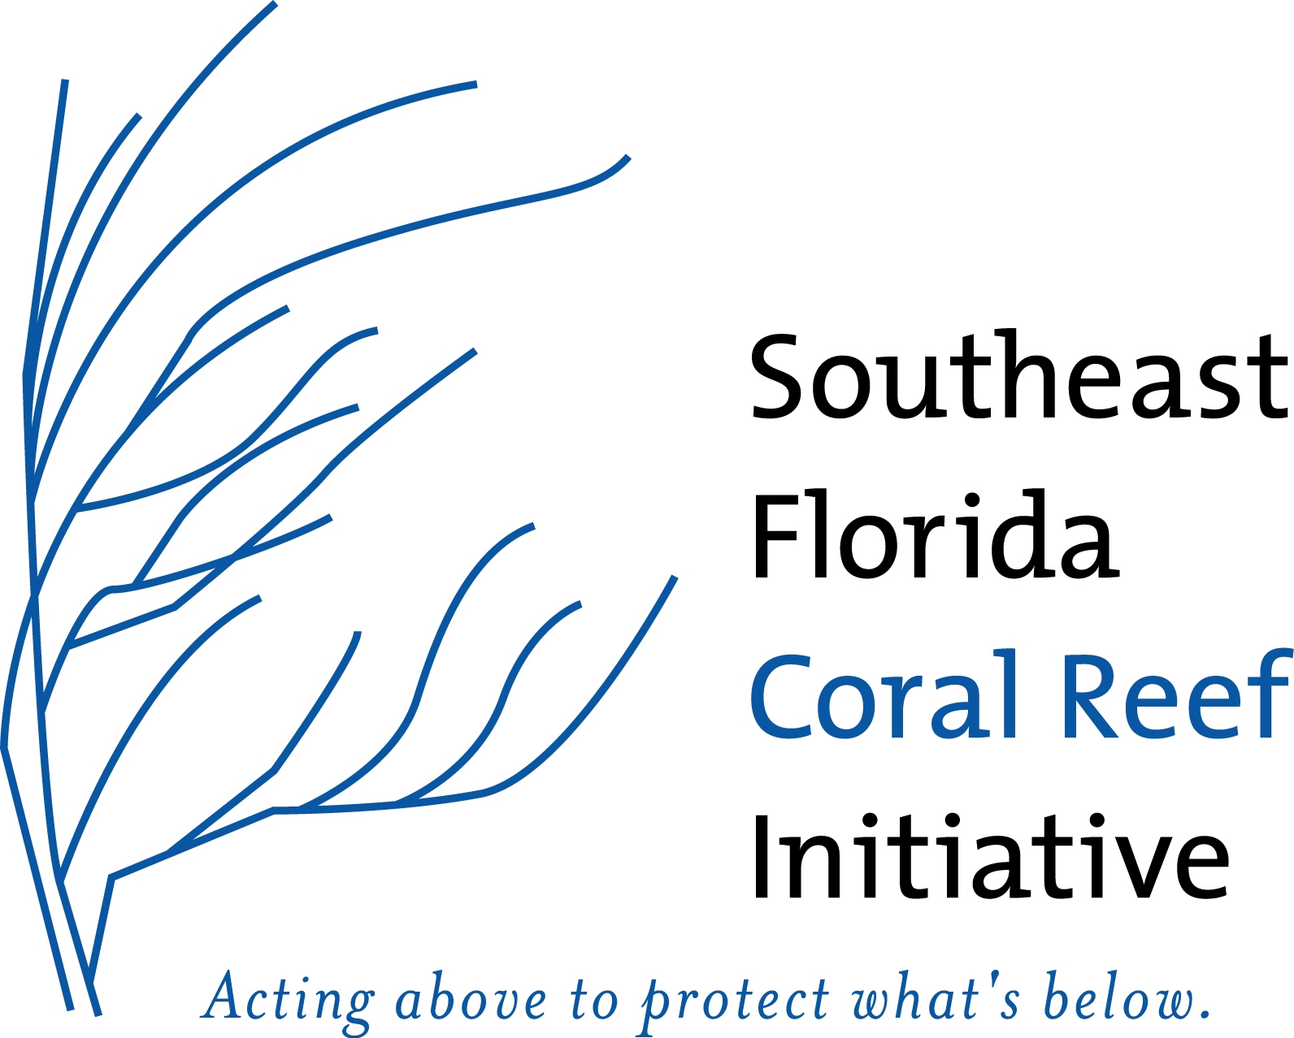

LBSP Project 21 – Review of Programs in Southeast Florida that Generate Pollution and Provide Recommendations to Reduce Land-based Pollution Impacting the Southeast Florida Coral Reefs

Report Prepared By:

Deborah Caraco

Michael Novotney

Center for Watershed Protection
Ellicott City, MD

Nicholas Gadbois

Troy Craig

Florida Department of Environmental Protection
Coral Reef Conservation Program
Miami, FL

May, 2009

Completed in Fulfillment of Contract for NOAA Project NCND3000-7-12707

Southeast Florida Coral Reef Initiative
Land Based Sources of Pollution
Local Action Strategy Project 3&19

and

Florida Department of Environmental Protection
Coral Reef Conservation Program
1277 N.E. 79th Street Causeway
Miami, FL 33138

This report should be cited as follows:
Caraco, D., M. Novotney, N. Gadbois and T. Craig. 2009. Review of Programs to Protect Southeast Florida’s Coral Reefs. Center for Watershed Protection. Ellicott City, MD. 50 Pages

This effort was funded through the NOAA Coral Program, Grant NCND3000-6-00007 Continued Watershed Protection Training and Technical Assistance to Control Land-Based Sources of Pollution to Coral Reefs in the U.S. Caribbean and Pacific Islands.

Table of Contents

Table of Contents 1
1.0 Introduction 1
1.1 Purpose of this Report 1
1.2 Organization of This Report 1
1.3 Background 2
1.4 Project 3/19 Program Surveys 3
1.5 Future Phases 3
2.0 Sources and Impacts of Land-Based Sources of Pollution, and Impacts 5
2.3 Submarine Groundwater Discharge (SGD) 7
2.4 Effects of Everglades Restoration 7
2.5 Carbon Dioxide Rise 7
3.0 Unique Watershed Planning Considerations in Southeast Florida 8
3.1 Unique Topography, Soils and Rainfall Patterns 10
3.2 Explosive Growth and Population Density 10
3.3 Seasonal Population Increases 10
3.4 Concentrated Development on the Coast 11
3.5 Altered Hydrology and Loss of Wetlands 11
3.5 Altered Hydrology and Loss of Wetlands 12
3.6 Need for Water Conservation 13
3.6 Comprehensive Everglades Restoration Plan (CERP) 13
4.0 The Eight Tools of Watershed Protection 15
5.0 Project 3/19 Survey to Identify Programs in Place and Identify BMP Gaps 16
5.1 Approach to Evaluating Programs 16
5.2 Data Gaps in the Survey 16
6.0 Goals to Protect the Southeast Florida Reef from LBSP 17
7.0 Draft Recommendations and Program Highlights 18
7.1 Overall Program Assessment 18
7.2 Watershed Planning 22
7.3 .Land Conservation 26
7.4 Aquatic Buffers 29
7.5 Better Site Design 30
7.6 Erosion and Sediment Control 33
7.7 Stormwater Management 34
7.8 Non-Stormwater Discharges 39
7.9 Watershed Stewardship 42
References 45

Volume 2. Technical Appendices

Appendix A. Survey Form

Appendix B. Survey Results

1.0 Introduction

1.1 Purpose of this Report
This report addresses the Land Based Sources of Pollution (LBSP) Focus Area Project 21 – Evaluate the outcomes of and (LBSP) Project 3 and 19 to identify gaps in best management practices and conduct technical workshops to present the findings. Specifically, LBSP Project 21 provides a preliminary overview of the programs already in place to reduce land based sources of pollution, and makes initial recommendations for improving both state and local programs that affect coral reef habitat. This report presents the first phase of this project, and as such it assesses the program database form LBSP Project 3/19 for gaps, determines priority areas of concern, and establishes a set of recommendations to reduce LBSP from Southeast Florida.

1.2 Organization of This Report
- Section 1.0 Introduction

- Section 2.0 Sources of Land-Based Sources of Pollution, and Impacts on Coral Reefs and
Hardbottom Communities
This section provides an overview of the impacts of pollutants on the reef, and potential pollutant sources.

- Section 3.0 Unique Watershed Planning Considerations in Southeast Florida
This section describes the unique environmental conditions, human-induced pressures and the impact on watershed planning in Southeast Florida. .

- Section 4.0 The Eight Tools of Watershed Protection
The “Eight Tools” framework developed by the Center for Watershed Protection provides guidance on protecting water resources throughout the development process, and was used as the framework for evaluating programs and making recommendations in this report.

- Section 5.0 Overview of LBSP Project 3/19 - Identify Agencies with Programs in Place that Generate LBSP and have BMPs in place to reduce LBSP and Identify BMP Gaps
This survey of state, local and federal agencies with programs designed to protect coral reefs completed by Southeast Florida Coral Reef Initiative (SEFCRI) Team members and Florida Department of Environmental Protection Coral Reef Conservation Program (FDEP CRCP) staff. The survey served as the starting point to describe ongoing programs producing and reducing LBSP in Southeast Florida.

- Section 6.0 Pollutant Reduction Goals
This section identifies overarching pollutant reduction and programmatic goals to reduce LBSP

- Section 7.0 Draft Recommendations and Program Highlights

This section provides recommendations for watershed managers to achieve the watershed goals highlighted in Section 6.0, using existing local, state, and federal programs as examples. These recommendations are derived from the program gaps identified in the survey, combined with known pollution sources in the region.

1.3 Background
The headwaters of the southeast Florida watershed begin at the Chain of Lakes located in central Florida. These lakes flow southward through agricultural areas (crop and livestock) to Lake Okeechobee. Nutrient laden runoff from the agricultural areas washes into the flowing streams that connect the lake and then empties into Lake Okeechobee. Water quality in Lake Okeechobee is not only degraded from agricultural areas to the north but also from the sugar cane fields that surround the southern areas of the Lake. Waters from Lake Okeechobee are then released by the South Florida Water Management District (SFWMD) through a series of manmade canals which were built to control flooding. These canals run through the Florida Everglades to the urbanized coastal areas. Stormwater from the developed areas flow unfiltered into the canals which then flow unfiltered out a series of inlets to the coastal waters. The degraded water quality negatively impacts the marine resources.

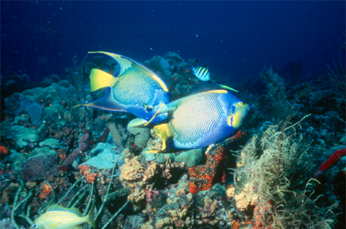
The Southeast Florida reef spans over 100 miles from the Northern end of the Biscayne National Park in Miami-Dade County to the St. Lucie inlet in Martin County (Collier et al., 2008). These beautiful coral reefs, just off the beaches of the most urbanized coastal region in the state, are an extraordinary biological, geological and economic resource (Figure 1).

Unfortunately, many stressors threaten the long-term viability of this unique and beautiful resource. The “State of the Reef” report identifies several stressors, ranging from tropical storms to trade in coral species (Collier et al., 2008). Two significant stressors, Coastal Development and Runoff and Coastal Pollution, however, relate to land based sources of pollution (LBSP). The southeast Florida region supports approximately one third of Florida’s total population of sixteen million residents (U.S. Census Bureau, 2006). The highly developed coastline in southeast Florida contributes to the degradation of coastal water quality by increasing the amount of stormwater runoff from impervious surfaces, destruction of natural landscapes, and the dumping of wastewater into the nearshore environment.
Figure 1. Queen Angelfish are one of the many inhabitants of Florida's Coral Reef (Photo Copyright 2006 Dominick Senna)

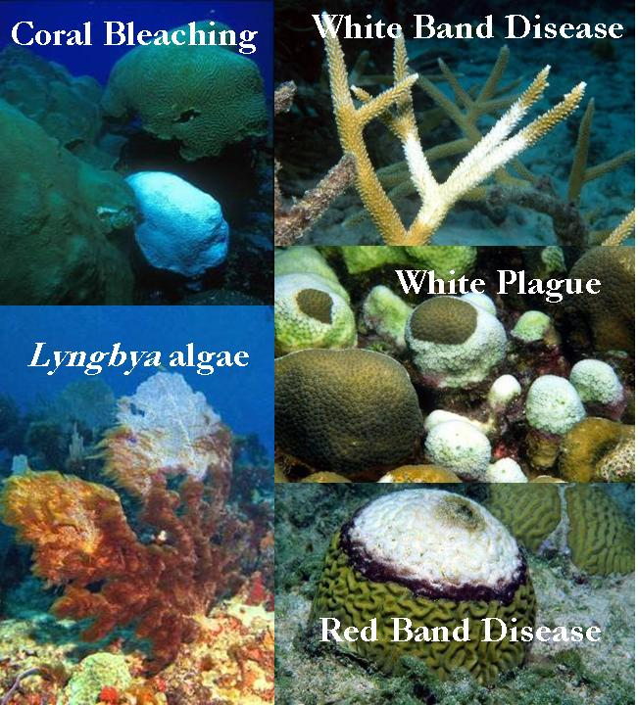
Stress responses from degraded water quality can include coral disease, bleaching and the overgrowth of harmful algae’s and cyanobacteria. While biological monitoring of southeast Florida reefs show a relatively low prevalence of disease, several coral diseases including black band disease, white band and white plague have been observed. Coral bleaching has also been observed, but not at the rates observed in the Caribbean (Collier et al. 2008).

Figure 2. Land Based Sources of Pollution, along with other threats, contribute to coral diseases
(Source: SEFCRI Office)

In response to the degradation of coral reefs around the country, the U.S. Coral Reef Task Force (USCRTF) was established in 1998 by Executive Order. The USCRTF is comprised of twelve federal agencies and seven U.S. States and Territories. Each of the member states was required to develop a “Local Action Strategy” to preserve its coral reef system.

The Southeast Florida Coral Reef Initiative (SEFCRI) Local Action Strategy was developed in 2004 by the Southeast Florida Action Strategy Team (SEFAST), which evolved into the SEFCRI Team. SEFCRI identifies key threats to the coral reefs of Southeast Florida and priority actions needed to reduce the identified threats found throughout a 4 county region; Martin, Palm Beach, Broward and Miami-Dade counties. The SEFCRI is targeting four focus areas including Land Based Sources of Pollution (LBSP), Fishing Diving and Other Uses (FDOU), Lack of Awareness and Appreciation (AA), and Maritime Industry Coastal Construction Impacts (MICCI). The SEFCRI is in its fifth year and the FDEP Coral Reef Conservation Program has collaborated with federal, state, and local agencies and NGOs to implement many of the 140 SEFCRI projects. The website for the Florida Department of Environmental Protection Coral Reef Conservation Program which contains links to SEFCRI information and products is www.dep.state.fl.us/coastal/programs/coral/.

1.4 Project 3/19 Program Surveys
The SEFCRI LBSP Team developed a survey tool as a part of two LBSP projects (Projects 3 and 19) to compile a list of programs in place that generate pollution, and to identity gaps and needs in best management practices (BMP’s). The resulting surveys were mailed to programs throughout the region. The information from the surveys and interviews were entered into a Microsoft Access Database. Both the survey and interview process of LBSP Project 3/19 ended February 2008. This report assesses the data gathered as a part of that effort, identifies gaps within and between programs and BMPs, and generates recommendations for specific projects to target LBSP sources.

1.5 Future Phases
In the second phase of this project, the Center for Watershed Protection and SEFCRI will conduct technical workshops to present the findings of this project to the agencies surveyed and local stakeholders to solicit feedback needed to finalize recommendations. The workshops will include a facilitated review and discussions on the outcomes of LBSP Project 3/19, develop participant consensus on high priority pollution sources (hotspots) and generate recommendations from participants for engineering and/or management actions to address the gaps and high priority areas identified.

2.0 Sources of Land-Based Sources of Pollution, and Impacts to Coral Reefs and hardbottom communities
In the initial phases of its LBSP effort, the SEFCRI LBSP Team compiled and summarized existing literature to determine both the impact of specific pollutants on the coral reef system and the sources of these pollutants. The resulting report, entitled, “Land-Based Sources of Pollution Local Action Strategy Combined Projects 1 & 2” (Trnka et al., 2006) identified ten sources of water quality impacts affecting southeast Florida’s reefs (Table 1). The report discusses the potential sources of these impacts, including treated wastewater outfalls, navigational inlets, ocean wastewater outfalls, submarine groundwater discharge, effects of Everglades’ restoration, and carbon dioxide rise:

Table 1. Impacts of Stressors on Coral Reef Systems
(Adapted from Trnka et al., 2006)
Stressors | Impacts
Nutrients (N and P) | Algal blooms smother corals.
Heavy Metals | Can be toxic at threshold values. May have adverse affects on urchin larval development.
Pharmaceuticals/ Organics | Cause tissue thickening, and reduced growth in corals.
Herbicides/ Pesticides | Are toxic at very low levels. Inhibit photosynthesis and fertilization, and affect larval settlement. Have been known to affect seagrass productivity.
Salinity | Changing salinity appears to reduce corals’ ability to adapt to changing conditions, such as sea level changes.
Carbon Dioxide | Decreases the saturation state of aragonite, a mineral needed for coral calcification.
Temperature | Changes in temperature may lead to coral bleaching (Figure 2).
Turbidity | Reduced light penetration reduces photosynthesis.
Sedimentation | Results in physical smothering of corals and ocean habitats
Disease, Pathogens, Viruses and Bacteria | Bacterial and viral diseases can infect and damage coral. Up to 18 coral diseases have been identified, with 14 confined to the Caribbean.

2.1Wastewater Disposal
Six large wastewater treatment plants in southeast Florida are permitted to discharge approximately 300 million gallons per day of secondarily treated wastewater effluent to the coastal ocean. Although secondarily treated, the effluents are freshwater, contain elevated levels of turbidity and nutrients, and may be a source of pharmaceutical chemicals and microbiotic contaminants.

In addition to the use of outfalls, wastewater is disposed of using deep well injection systems. Deep wells are installed at depths up to 3000 feet into the Floridian Aquifer. Migration of this effluent offshore may occur due to the porous limestone bedrock that makes up the Florida peninsula. Water injected in this manner can appear quite rapidly in groundwater and surface water. According to one study in the Florida Keys, bacteriophage tracers in injected wastewater appear in the groundwater within 8 hours after injection, and in surface marine waters between 10 and 53 hours after injection (Paul et al., 1997).

2.2 Stormwater Runoff
Southeast Florida’s surface waters discharge to the ocean via large inlets (Figure 3). Inlets in the SEFCRI region and the relative volumetric loading to the coastal waters are provided in Table 2 (from Banks et al 2008). Each of these inlets is fed by a series of canals who’s water quality are affected by activities in their watersheds, such as septic systems, urban runoff, and application of fertilizers, pesticides and herbicides. Potential contaminants carried by these waters could include nutrients, metals and other toxins, and pesticides.
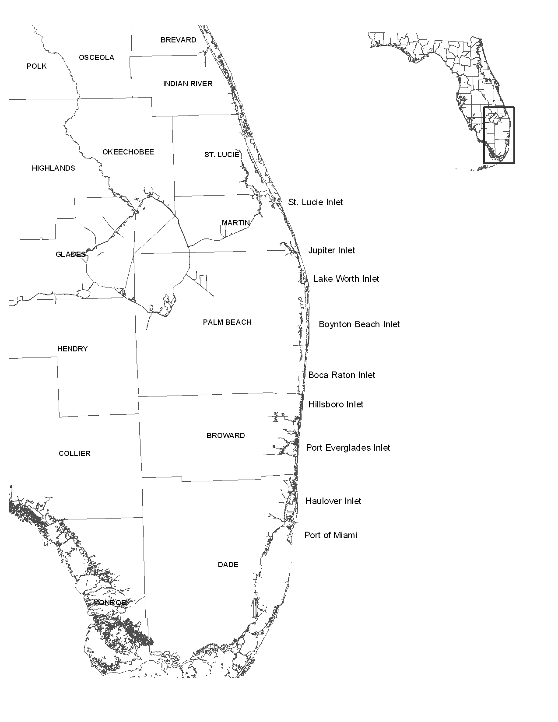
Figure 3. Major Ocean Inlets of Southeast Florida
Table 2. Relative Contribution of Each Inlet to the Coastal Waters (Banks et al., 2008)
Inlet | Tidal Prism  (millions of m³)¹
Lake Worth | 24.0
Boynton | 3.0
Boca Raton | 4.9
Hillsboro | 8.1
Port Everglades | 18.0
Haulover Inlet | 10.2
Port of Miami | 2.7
1: Represents the difference in the volume of water between high tide and low tide at this inlet.

According to the Broward County Atlas, this system of canals includes two hundred and sixty-six miles of waterways in Broward County alone (Broward County DEP, 2001). This analysis of approximately twenty-five years of monitoring data (from 1972 to 1997), coupled with data from a similar analysis of data from 1998 to 2003 (Broward County DEP, 2007) indicates a distinct water quality difference between sampling sites in the western (i.e., water conservation area) portions of the county versus those in the eastern portions of the county, which also drain developed land. In particular, those sampling sites in the eastern portion of the county have higher levels of Total Phosphorus, Nitrate and Nitrite, and chlorophyll a, while those in the western portion have higher total nitrogen (largely organic) and ammonia concentrations. Two of the three canals with the worst water quality in the county have no connection to the conservation areas, and drain developed lands only.

2.3 Submarine Groundwater Discharge (SGD)
SGD is the phenomenon that forces ground water to flow from beneath the seafloor into the overlying ocean regardless of its composition—whether fresh, recirculated seawater, or a combination of both (Reich et al., 2009). The quality of this discharge is directly related to the quality of the groundwater. In southeast Florida, SGD is likely to account for 6-10% of the total water influx to coastal waters (Langevin, 2003). During the dry season, SGD can account for a greater quantity of water influx than surface drainage. Along the Florida coast, SGD is often associated with tidal pumping. Groundwater quality can be degraded by stormwater infiltration, deep well injections, and effluent from malfunctioning septic systems and leaking septic pipes.

2.4 Effects of the Comprehensive Everglades Restoration Plan
The goal of the Comprehensive Everglades Restoration Plan (CERP) is to restore the natural flow of water from Lake Okeechobee through the Everglades. In one of the largest habitat restoration efforts in history, several projects will be completed to ensure the natural flow regime is restored. Currently, freshwater travels from Lake Okeechobee to the coast though canal systems. This freshwater, which recharges the groundwater and surface waters, is used by the coastal communities for drinking and potable uses. Nutrients and pathogens from agricultural areas around Lake Okeechobee enter the canals via stormwater runoff degrading the water quality. In addition, the water in the canals acquires contaminates from the stormwater runoff originating from urban areas. These canals are directly and indirectly connected to several ocean inlets along the southeast Florida Coast, and the inlets allow an access for these nutrient laden waters to flow directly to the nearshore waters impacting the coral reef ecosystem. In an effort to improve the water quality in the canals CERP has plans to create stormwater treatment areas (STAs) to detain this water before it reaches the coast. However, until these STAs are completed freshwater releases from Lake Okeechobee will continue to increase the potential for higher sedimentation and nutrient laden waters to find their way to the coast.

2.5 Carbon Dioxide Rise
Atmospheric deposition of anthropogenic carbon dioxide into marine waters is altering the seawater chemistry of the world’s oceans by lowering pH levels. As pH levels fall, the ability of coral reefs to calcify decreases, negatively impacting the health of the reefs. According to Guinotte and Fabry (2008), a substantial decrease in pH will have serious implications for coral calcification rates and skeletal formation. Weaker coral skeletons will probably result from a reduction in pH, enabling erosion processes to occur at much faster rates than have occurred in the past. These slower growth rates may also reduce corals’ ability to compete for space and light.

3.0 Unique Watershed Planning Considerations in Southeast Florida
The climate and character of Southeast Florida present unique challenges to the watershed manager. In particular, the physical character of the region, historic modification of its hydrology, and the extraordinary recent and projected growth rates of human population and the development need to accommodate the influx of people need to be considered when developing a watershed plan. In addition, CERP will influence planning efforts by altering the hydrology in the region. This section summarizes some of these unique considerations, and their effects on LBSP efforts to protect coral reefs (See Table 2).

Table 2. Unique Watershed Planning Considerations in Southeast Florida
Planning Consideration | Impact on Coral Reefs | Strategies
Unique Topography, Soils and Rainfall Patterns | Limits stormwater management and land development options because of:  - Limited land area without existing wetlands  - Very high percolation rates in limestone  - High groundwater table  - Flat topography  - Seasonal rainfall | - Conserve existing wetlands by promoting redevelopment and wetland conservation on existing sites.  - Pretreat any stormwater or wastewater that is injected into the ground.  - Preserve native vegetation to the extent possible on all sites.  - Promote landscaping that tolerates seasonal rainfall patterns.
Explosive Growth and Population Density | - Increased wastewater loads from increased population.  - Conversion of natural lands to urban and suburban land uses increases pollutant loads in surface runoff. | - Actively manage new development.  - Focus on on-site stormwater controls for existing development.  - Provide advanced wastewater treatment.  - Implement reuse of wastewater
Seasonal Population Increases | - Pollutant loads may be higher in the winter (dry season). | - Focus on educational efforts that target the seasonal population (visitors and residents).
Concentrated Development on the Coast | - Coastal wetlands, which offer pollutant filtering, are no longer in place to perform this function.  - Loss of coastal habitat affects the shoreline and coastal environment. | - Restore wetlands  - Use on-site stormwater practices (storage and treatment) on developed coastal properties.
Altered Hydrology and Loss of Wetlands | - Increased pollutant loads due to wetland loss.  - Historic stream system performed a filtering function which has been lost. | - Restore coastal wetlands and wetlands along the canal system and other riparian wetlands.  - Promote stormwater management practices that minimize both the volume and discharge rates of stormwater runoff.
Need for Water Conservation | - Prudent irrigation practices and other water conservation efforts reduce pollutant laden surface waters | - Pursue stormwater management practices that also enhance water conservation.  - Integrate water conservation into new developments.  - Promote wastewater reuse
Comprehensive Everglades Restoration Plan (CERP) | - Potential increase in pollutant loads to the coast.  - Freshwater discharges from Lake Okeechobee may impact coastal water quality. | - Integrate land use planning with the CERP  - Conduct monitoring to ensure that the coral reef is not negatively impacted by these efforts.
Groundwater Quality | - Poor groundwater quality could affect reefs through submarine discharge. | - Consider groundwater protection in stormwater and septic system design.

3.1 Unique Topography, Soils and Rainfall Patterns
Southeast Florida is unique in both its geology and meteorological patterns. The combination of seasonal rainfall patterns, high groundwater table, extremely flat topography, and rapid percolation rates on some soils make traditional stormwater management somewhat challenging. Alternative stormwater practices that capture and reuse stormwater or preserve natural areas may be the most appropriate in this region.

Furthermore, the remaining developable land within the area is dotted with remnant wetlands. Consequently, future land use planning needs to consider these remaining natural areas.

3.2 Explosive Growth and Population Density
Southeast Florida has grown at an alarming rate over the past several decades. The population of the four-county region increased almost 25% between the 1990 and 2000 census. Between 2000 and 2006 population increased 9.1%, to 5.6 million. The increase seen between 2000 and 2006is dramatically higher than the growth rate in the United States as a whole, which was an estimated 6.4% (US Census Department, 2006). This population growth results in an increase demand for homes which in turn increase impervious cover, wetland loss as well as an increase in wastewater loads. Combined, these impacts result in greater pollutant loads to the Florida reef tract.

As of the writing of this report, however, the region is suffering an economic downturn. One indicator is the 2008 high home foreclosure rate in the region; 4.91 %, 4.66% and 2.62% in Miami-Dade, Broward, and Palm Beach Counties, respectively (Palm Beach Post, 2009). As a direct result of this downturn, current population forecasts estimate much slower population growth over the next few decades. The population in the state of Florida is anticipated to grow at a rate of only 1.1% per year by 2020 and 0.8% per year by 2035 (Smith and Rayer, 2009). Southeast Florida (including Miami-Dade, Broward, Palm Beach and Martin Counties) is forecast to have even slower growth rates, with an annual population increase of 0.6% by 2020 and only 0.4% by 2035.

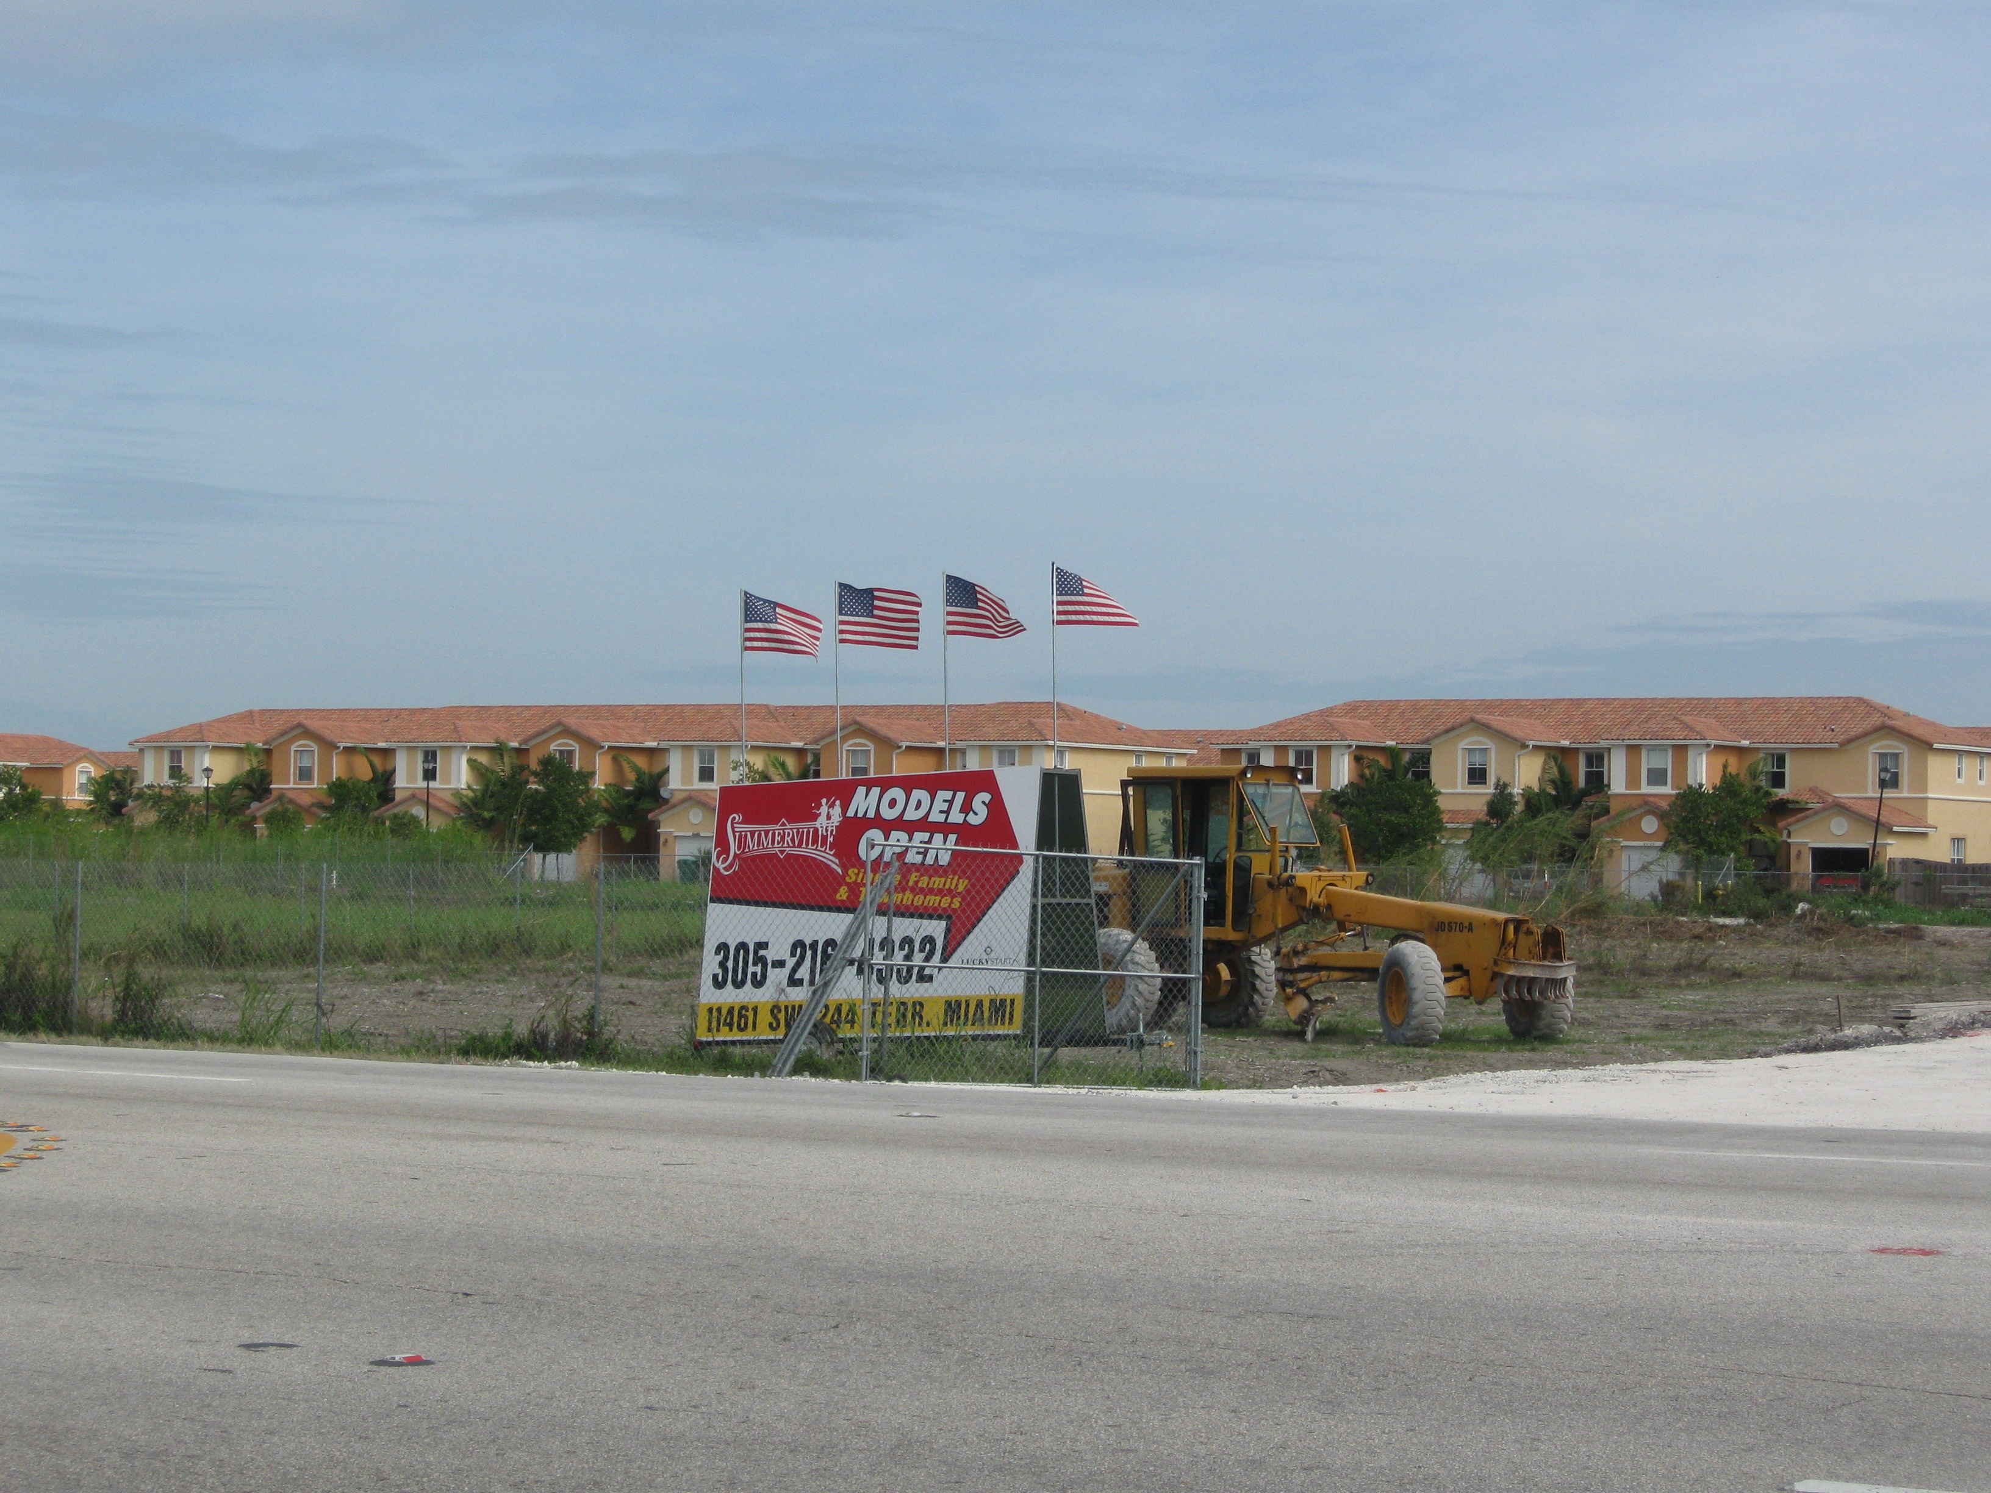
If these forecasts are accurate, the downturn may offer program managers an opportunity to implement programs to reduce LBSP in anticipation of future development (figure 3). At the same time, however, the loss of tax revenues associated with these hard economic times may prove a challenging to program managers.

3.3 Seasonal Population Increases
In addition to its permanent resident population, southeast Florida has a significant annual tourist and seasonal population increase. As of 2008, the Florida Coast had more seasonal coastal homes than any other state, with over 500,000 homes in coastal counties, or 24% of the nation’s total (Crossett et al., 2004). While tourists visit the beaches of southeast Florida year round, the seasonal population throughout Florida increases dramatically in the winter (dry season) months, due to “Snowbirds” who travel to the region for the winter months only, or “Sunbirds”, permanent residents of Florida who leave for at least 30 days during the summer months (Smith and House, 2006).
Figure 3. New Homes in Western Miami-Dade County offer a great opportunity for stormwater management practices to be implemented (January, 2008). Source: CWP

This seasonal migration impacts planning efforts in two ways. First, planners need to consider both water demand and waste load increase during the winter (dry season). Second, any public education and outreach efforts in the watershed need to consider this significant seasonal population.

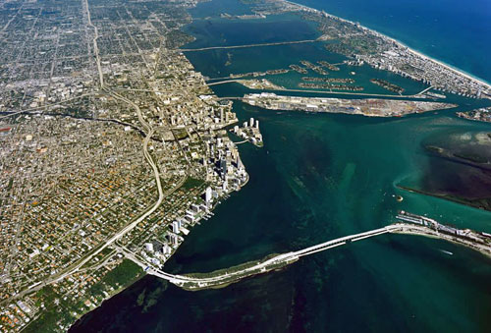
3.4 Concentrated Development on the Coast
In Southeast Florida, as in much of the United States, development is concentrated along the coasts (Figures 4 and 5). This very high density of development along the coast replaced the historic, natural wetlands and mangrove systems which previously characterized the coastal environment. Retention of wetlands and mangroves lessen the impacts of upland development on the Florida reef tract by filtering pollutants from surface water runoff before they reach the coast. The current development pattern, however, allows no buffer between development and the sensitive coastal ecosystem.
Figure 4. Coastal Development in Miami-Dade County. Photo Source: www.floridata.com/tracks/ray/chap10_boat.cfm

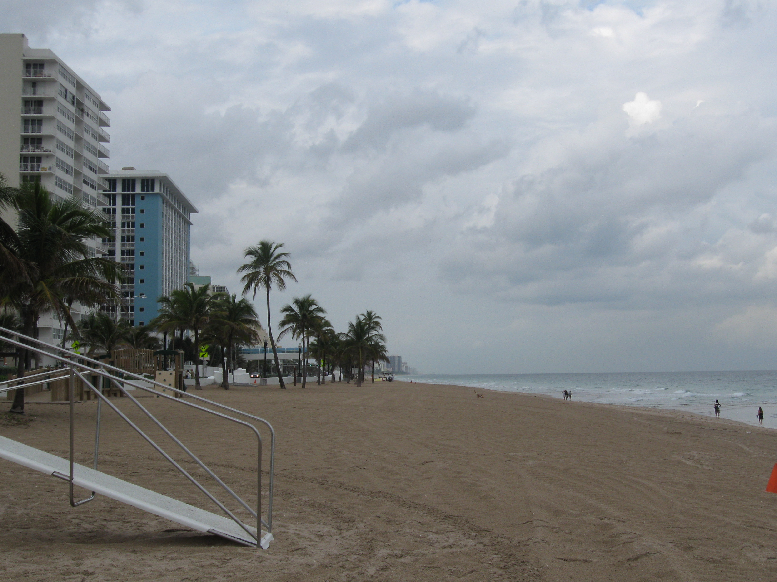
To mimic the historical function of these wetlands, watershed managers need to focus on strategies that remove pollutants from coastal development sources at their point of origin and develop strategies that more nearly mimic the original hydrology of the region. Wherever possible, strategies that restore coastal wetlands can also replenish to some extent the natural function of the coast line.

3.5 Altered Hydrology and Loss of Wetlands
Figure 5. . Development along a beach in Fort Lauderdale is extremely close to the shore.
Photo Source: CWP
Historically, southeast Florida was covered by forests and wetlands of the Everglades. Over the course of the 20th Century, a system of canals was installed throughout the region constructed to drain the wetlands for development and to control flooding in the urbanized areas which, resulting in a much smaller wetland area (Figures 6 and 7).
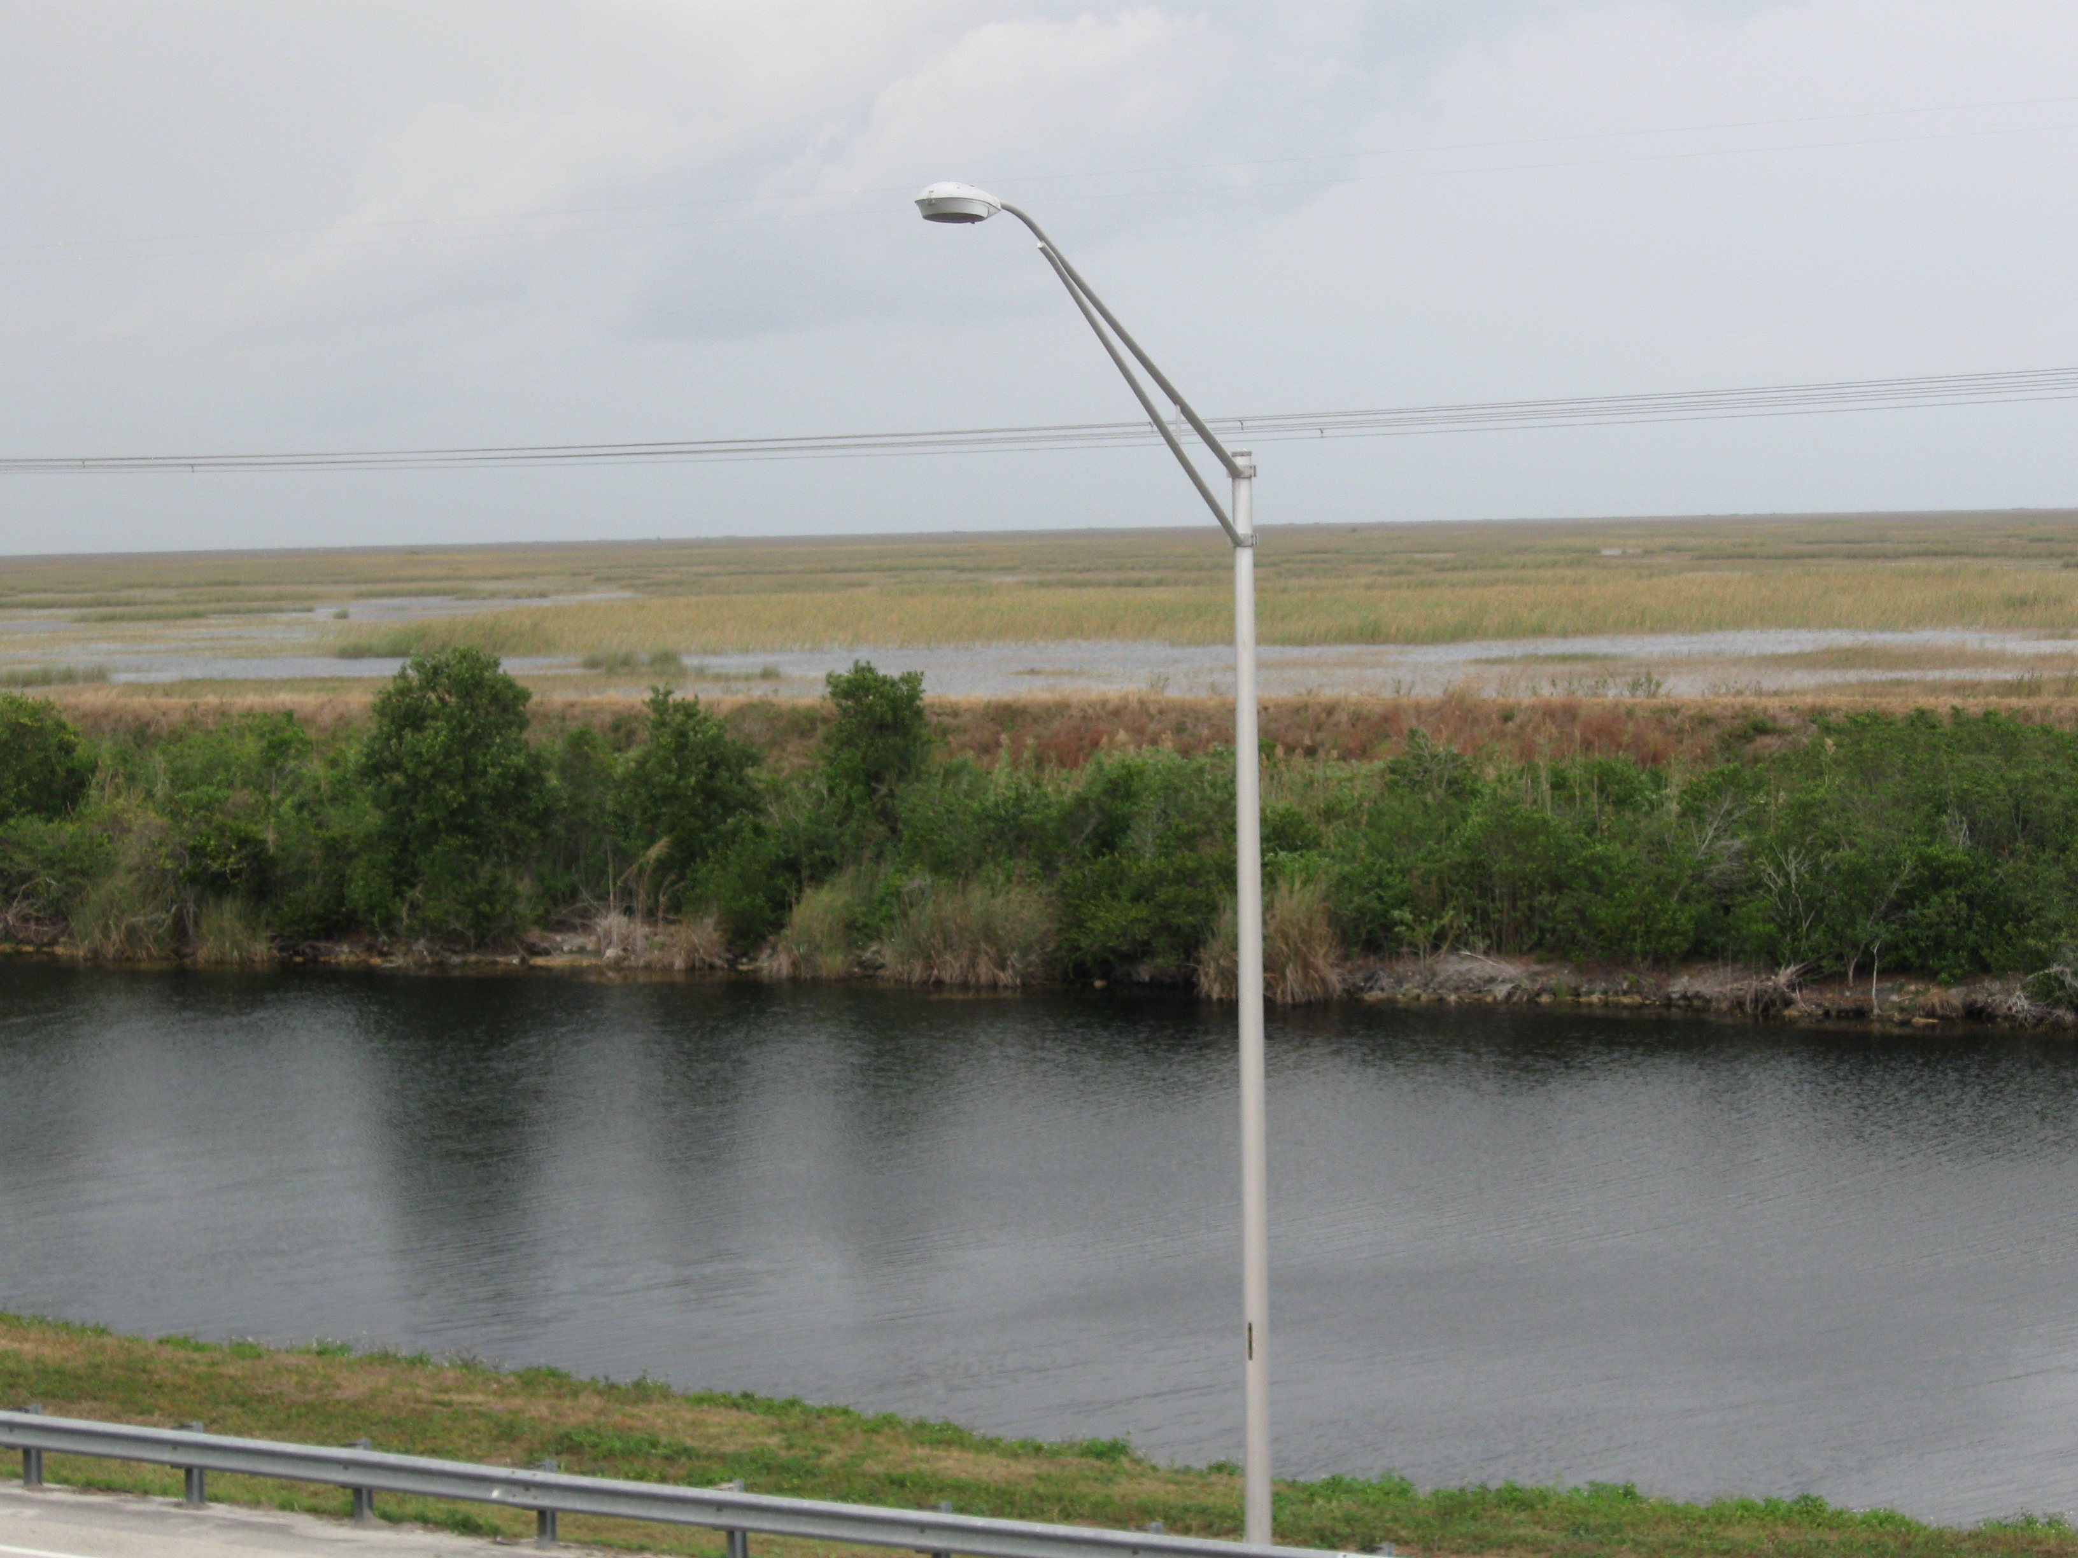
These surface alterations have significantly modified the hydrology of the region. Prior to alteration, the Everglades system converted the great majority of rainfall into evaporation, and some to groundwater recharge. Only a small fraction was discharged to the ocean, or “lost to tide”, via the Florida Bay. The surface modifications have increased the amount of water discharged to the ocean via navigation inlets in continental southeast Florida. At the same time, use of the Biscayne Aquifer as a water source for increasing human population has reduced the quantity of available groundwater.
Figure 6. Edge of the Everglades taken from Alligator Alley in Broward County. Dike constructed in the early 20th century confined the Everglades to a fraction of its original surface area. Photo Source: CWP
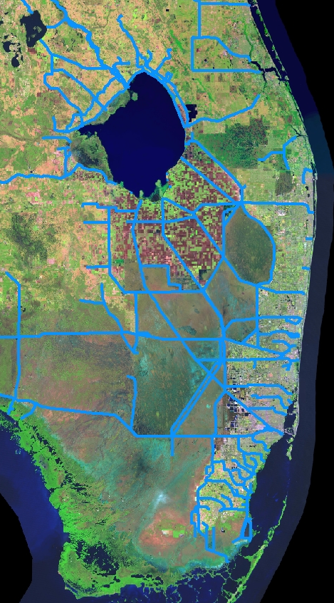
Figure 7. The "stream network" of southeast Florida is now dominated by a series of canal systems.

While the natural hydrology of the region can never be truly reproduced, a combination of on-site stormwater management and larger capital projects can assist with recreating some of the function of this natural system and restore some of the natural hydrology of the area while reducing the demands on the Biscayne Aquifer and increasing groundwater recharge. On individual properties and development sites, practices that harvest runoff for reuse, landscaping practices that incorporate trees and native vegetation, and site assessment techniques that preserve existing wetlands would help to achieve this goal. In addition, techniques such as preservation of buffers at the edge of canals would assist with restoring the natural hydrologic function. Finally, larger scale efforts such as the CERP attempt to restore the natural function of this large wetland area.

3.6 Need for Water Conservation
The availability of potable water for drinking water, irrigation, and other residential and commercial uses is a major concern in Southeast Florida. The citizens of this region consume 175 gallons of water per day (SFWMD, ND), up to twice the national average, largely due to the huge demand for irrigation in this hot, seasonally dry climate. The population relies almost entirely on water from the Biscayne Aquifer, a sensitive aquifer which is highly connected to surface waters due to its shallow depth. As water demand from the Biscayne Aquifer has increased with the increasing population overtime, groundwater levels have declined allowing saltwater intrusion inland, which is threatening wellfields. . Drought conditions and frequent withdrawals have decreased flow rates leading to salt water intrusion from the coast. Recognizing this concern, Florida has charged its Water Management Districts with creating plans to ensure that potable water is available. One such measure is the recent adoption of the Regional Water Availability Rule which limits future withdrawals from the Biscayne Aquifer.

Reducing household water use directly reduces pollutant loads to the reef system by achieving a corresponding reduction in the total wastewater load. Conserving water used for landscape irrigation also reduces pollutant loads, since irrigating landscapes can create saturated ground and resulting increased surface runoff and result in leaching of fertilizers and pesticides to the ground water, which are subsequently carried to the coastal systems. Some strategies to conserve water include:
- Reusing both wastewater and stormwater.
- Landscaping that reduces water use native plants and Florida friendly landscaping.
- Educating the public to reduce household water use.
- Promoting planning efforts that control growth and building trends.
- Identifying and protecting of groundwater recharge areas.
- Preserving pre-development hydrology at individual development sites to maintain recharge to groundwater resources.

3.6 Comprehensive Everglades Restoration Plan (CERP)
As discussed in Section 2.5, the CERP seeks to restore the natural hydrology in the Everglades region (See Figure 8) through a series of projects that, encourage sheet flow through the Everglades, and capture and treat highly polluted runoff in STAs. This large scale effort will affect flows within canals, and will require construction of projects within Miami-Dade, Broward, Palm Beach and Martin counties.

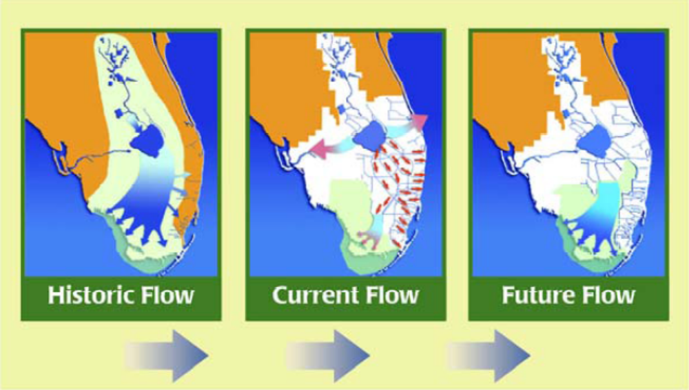
Figure 8. The CERP Plan will attempt to replicate the historic hydrology of the Everglades system by allowing water from Lake Okeechobee, which is currently diverted directly to the Atlantic Coast and the Gulf of Mexico through canals (light blue color), to flow through the Everglades systems. Source: CERP, ND

3.7 Groundwater Quality
The groundwater table throughout south Florida is extremely high. Consequently, water that enters the groundwater from malfunction leach field from septic systems and stormwater discharges receive little soil filtration and percolate through the ground relatively unfiltered impacting the quality of the groundwater. This can lead to contamination of water supplies and potential impacts to the coastal system through submarine discharges. Both wastewater and stormwater management practices need to be designed to protect groundwater, as well as surface water quality.

4.0 The Eight Tools of Watershed Protection
Watershed protection involves developing programs and strategies to protect or restore a watershed’s aquatic and terrestrial resources. In southeast Florida this means choosing the right management techniques to address the issues described above (Section 2.0 and 3.0). The Center for Watershed Protection’s “Eight Tools of Watershed Protection” address each phase of the watershed protection development process, from the initial land use planning, site design and construction through home ownership and these can be used to develop a comprehensive and effective watershed protection strategy (Schueler, 2000a). Throughout the remainder of this document, these eight tools serve as the framework to summarize the programs already in place to address LBSP in southeast Florida, make initial recommendations on how these programs can be improved, and provide recommendations for additional programs needed to meet the stated goals. The Eight Tools of Watershed Protection are as follows:

- Tool 1. Land Use and Watershed Planning
Land use planning that is informed by larger watershed goals.

- Tool 2. Land Conservation
Preservation of conservation areas are identified and preserved.

- Tool 3. Aquatic Buffers
Special conservation areas bordering streams, rivers, lakes, wetlands and other waterways.

- Tool 4. Better Site Design
Decisions made at the site level to minimize impervious cover and encourage conservation of open space and better treatment of stormwater runoff.

- Tool 5. Erosion and Sediment Control
Measures that reduce erosion during the construction process, and near the shore.

- Tool 6. Stormwater Best Management Practices (BMPs)
Practices that capture and treat stormwater runoff and provide storage within the watershed to recharge groundwater, improve water quality, protect channels, and prevent flooding.

- Tool 7. Non-Stormwater Discharges
Measures to reduce pollutant loads from non-point source discharges such as sewage discharge and highly polluted “hotspot areas” such as marinas

- Tool 8. Watershed Stewardship Programs
Programs that reduce pollutant loadings and protect resources once development is in place.

5.0 LBSP Project 3/19 Survey to Identify Programs in Place and Identify Gaps in BMP
In 2006 the SEFCRI LBSP Team developed a survey (Projects 3 and 19) to compile a list of local, state and federal programs that generate land based pollution and to identify best management practices that helped to reduce land based pollution in an effort to identity gaps and needs for BMP’s. In the first mailing effort, only eight out of 30 surveys were returned. In March 2007, the list of agencies/entities was expanded to include municipalities and towns. A letter and the survey were sent out to the previously identified and newly identified constituents (approximately 90 local cities, municipalities, state & federal agencies) explaining the importance of the survey.

A Microsoft Access database was developed to track the survey information. After the surveys were returned, they were entered into the Access database and an interview was scheduled to learn more about the projects and programs. From March 2007-December 2007, 96 surveys were sent out with 35 returned (36% return rate), and 23 interviews were conducted. The results of the survey process are included as an Appendix to this document.

5.1 Approach to Evaluating Programs
Using the “Eight Tools” Framework (described in Section 4.0) this report summarizes known programs in place throughout the region that address LBSP and makes initial recommendations to reduce land based sources of pollution reaching the coral reef system. While the survey data were the primary source of information, these data were supplemented with targeted searches, primarily reviewing county and state program documents.

5.2 Data Gaps in the Survey
Although the survey results were a useful starting point for evaluating programs within the region, there were some geographic, programmatic and topical information gaps, as follows:

Geographic
Although the survey was sent throughout the region, only one survey was returned from Miami-Dade County. Limited information was included on the returned survey about programs currently in place. Consequently, publicly available information was used to supplement data from Miami-Dade County. SFWMD and Palm Beach County also submitted limited information about their programs. Targeted web searches were made to try to identify additional programs currently in place.

Topical
The “Eight Tools” approach to watershed planning was chosen as a starting point to evaluate programs because of its comprehensive overview of watershed planning. However, because of the nature of the survey, some of the tools were not well-represented. For example, only one watershed planning effort was described in the survey, but all four counties in the southeast Florida region have regional planning efforts that encourage “Smart Growth.” Similarly, no efforts to preserve conservation areas were described in the surveys. Again, a targeted web search was used to summarize these data, relying primarily on the web sites of the four counties.

Programmatic
While the survey tool asked participants to summarize obstacles to their programs and provide a total program budget, these data were insufficient to complete a program review. For example, while staffing was raised as an issue for some programs, it was not possible to evaluate if the budget is substantial enough to add additional staff.

6.0 Goals to Protect the Southeast Florida Reef from LBSP
The recommendations in the following section of this document (Section 7.0) ultimately protect the Florida reef tract by reducing loads of LBSP to the nearshore (<30 meter depth) environment (Goal 1 below). The remaining overarching goals identified in this section (Section 6) either or directly or indirectly result in reduced pollutant loads to the reef system. These goals are based on an initial review of the programs in place in southeast Florida (from the survey described in Section 5), combined with the specific management needs to protect the southeast Florida reef system.

Goal 1. Reduce pollutant loads to the reef system
Goal 2. Restore and protect natural areas such as wetlands, mangroves and forest.
Goal 3. Reduce water consumption through policies that reduce water demand and allow for storage and reuse of both stormwater and wastewater.
Goal 4. Protect both the quality and quantity of groundwater
Goal 5. Improve understanding of the linkages between watershed management, water quality, and the health of the reef.
Goal 6. Foster cooperation between the multiple agencies, municipalities and organizations working to reduce land-based pollution to Florida’s coast.
Goal 7. Encourage planning and personal behaviors that reduce the region’s carbon footprint, thus reducing the impacts of global warming on the reef system.
Goal 8. Encourage appreciation and enjoyment of the reef system and other natural resources of Southeast Florida

7.0 Draft Recommendations and Program Highlights

This section summarizes thirty-one recommendations, each of which supports at least one of the watershed protections and restoration goals identified in the Eight Tools Section. In Table 2 the ease of implementation and level of pollution reduction of each tool are indication as High (H), Medium (M), or Low (L). The recommendations framework described in Section 4.0 were developed based on gaps identified during review of the survey result database, combined with additional information gathered from targeted web searches. Table 2 also provides a preliminary assessment of the relative effectiveness of each recommendation, as well as the relative ease of implementation. In the final version of this report, these assessments will be refined further based on additional input from agency staff and watershed managers in workshops.

7.1 Overall Program Assessment
Based on an initial review, results indicate that local, regional, state and federal government agencies recognize the importance of the major watershed management issues in the southeast Florida region. For example, each county surveyed has initiated a program to address growth management and has fairly aggressive measures in place to encourage water conservation. In addition, the programs appear to be relatively well-staffed and well-funded (compared to other regions in the country). Because of the relative strength of these programs, recommendations in this section support ongoing efforts or recommend expanding and transporting successful efforts to other government entities, rather than creating entirely new efforts or programs. For example, some of the recommendations relate to data sharing, such as using a consistent database for various data sources or creating consistent mapping layers. Others encourage active communication between communities to develop consistent criteria that support of overarching goals identified in Section 6.0.

One area for future attention is fostering communication and consistency among the various communities of Southeast Florida. Although the communities all fall under the jurisdiction of the South Florida Watershed Management District (SFWMD), improved communication and coordination would improve regional decision-making to facilitate achievement of the management goals needed to improve the health of the coral reef system.

Table 2. Draft Watershed Protection Recommendations
Recommendations | Tools | Ease of Implementation | Pollution Reduction
Watershed Planning
- Complete subwatershed planning to guide land use decisions throughout the region. | 1-4, 6-8 | H | M
- Track changes in impervious cover, forest cover, vegetation, mangrove loss, canopy cover and wetland cover in watersheds throughout the region to identify areas that can be restored and preserved. | 5-6 | H | M
- Convene a working group to address population growth in the region to help reduce impacts associated with increased populations. | 1-4, 6-7 | L | H
- Adopt a more transparent and consistent plan review and approval process. | 1-4, 6-7 | M | M
- Develop a region-wide digital data layer of stormwater conveyance features (e.g., storm drains, ditches) and stormwater management practices to understand the contribution of runoff and to assist with maintenance of stormwater systems. | 6 | H | M
- Establish regional and, in some cases, water body-specific pollutant load targets to guide land use and stormwater management practice decisions. | 1-3, 5,6 | L | H
Land Conservation
- Actively restore coastal and non-coastal wetlands. | 1, 2, 4, 7 | M | H
- Form regional partnerships to use the wetland mitigation process to establish and expand regionally important wetlands. | 1, 2, 4, 6, 7 | M | M
- Survey remaining critical habitat areas, develop funding sources and acquire land to protect them. | 1, 2, 4, 7 | M | H
Aquatic Buffers
- Require vegetated buffers between waterways and development sites to allow stormwater to percolate before it enters waterways. | 1, 2, 4, 7 | M | H
- Treat canals as greenway systems and enforce setbacks and vegetative targets along these waterways. | 1, 2, 8 | L | M
1: H (High), M (Medium) and L (Low) reflect High, Medium, or Low ease of implementation and relative effectiveness.
Better Site Design
- Require Low Impact Development(LID) techniques on new development sites | 1-4, 7 | M | H
- Revise landscaping standards to specifically require native, plants that require minimal watering and explicitly reduce the amount of managed turf permitted on new developments. | 1-4, 7 | M | H
- Conduct a comprehensive codes and ordinances review of counties and towns to ensure that existing development codes are consistent with LID practices that reduce impervious cover, preserve open space, and treat and retain stormwater on-site. | 1-4, 6, 7 | M | H
- Develop specific standards for redevelopment projects that include impervious cover targets and incorporate on-site stormwater practices. | 1-4, 6, 7 | M | H
Erosion and Sediment Control
- Increase staff available to inspect construction sites and develop a core staff of Certified Inspectors. | 1,6 | M | M
- Document and repair beach discharges. | 1,8 | M | M
- Stabilize canal banks during and following construction. | 1 | M | H
- Actively restore dunes and vegetation along beaches | 1, 2 | M | M
Stormwater Management
- Form a committee to review stormwater practice design standards for southeast Florida. This effort would help develop criteria specific to the region and targeted critical water bodies such as Biscayne Bay, Lake Worth Lagoon, Loxahatchee River, and St Lucie River that would supplement the revised state criteria to be released in 2010. | 1-4, 6 | M | H
- Using the data in Recommendation 6, combined with land use and other data, conduct regional stormwater retrofit inventories in priority watersheds to identify potential retrofit opportunities. | 1, 3,6 | M | M
- Track maintenance of all stormwater practices and infrastructure, including both publicly- and privately-owned facilities. | 1, 6 | M | H
1: H (High), M (Medium) and L (Low) reflect High, Medium, or Low ease of implementation and relative effectiveness.
Non-Stormwater Discharges
- Supplement existing permitting programs with a “Hot Spot Inventory” of areas with high pollutant loads in select watersheds or neighborhoods to refine pollution prevention methods. | 1,4,6 | H | M
- Create an incentive system to provide sewage treatment and retire septic systems throughout the watershed. | 1,4 | L | H
- Provide free pump out of boat sanitary waste in all four counties. | 1,8 | H | H
- Require installation of wastewater reuse infrastructure (purple pipes) concurrent with new developments and redevelopment projects. | 1,3,4 | M | H
- Use the data developed in Recommendation 5 to help agencies work together to identify illicit discharges. | 1,6 | M | H
Watershed Stewardship
- Integrate monitoring efforts to provide consistent data quantifying pollutant loads from the St. Lucie, Jupiter, Lake Worth, Boynton, Boca Raton, Hillsboro, Port Everglades, and Port of Miami Inlets. | 5,6 | M | M
- Expand monitoring efforts to characterize reef quality in concert with monitoring of land-based pollutant loads. | 5, 6 | M | M
- Integrate non-profit organizations and citizens to provide education and enhance watershed quality. | 1-8 | H | L
- Expand the “NatureScape” program to all regions and include a broader suite of stormwater management practices. | 1-4,6-8 | H | L
- Use public properties to demonstrate innovative stormwater practices. | 1-4,6, 8 | H | L
1: H (High), M (Medium) and L (Low) reflect High, Medium, or Low ease of implementation and relative effectiveness.

7.2 Watershed Planning
An initial review of survey results suggested that virtually no watershed or land use planning was in effect throughout the region in 2006 and 2007. In fact, only one project, the “South Miami-Dade Watershed Plan”, was mentioned in any detail. While stormwater master plans were in place in other locations, these efforts were not used to guide land use planning and zoning decisions. Rather, they identified activities or projects such as stormwater maintenance or implementation of BMPs.

Further research showed that several efforts are currently in place and have been for decades but only to concentrate growth in urban centers (or “smart growth initiatives”) with not concern for stormwater management. In addition, communities have initiated impressive long-range planning efforts to effectively use and conserve water in the region. At the same time, several larger watershed planning efforts are underway, primarily managed by the SFWMD.

This section focuses on recommendations that would integrate watershed planning and land use planning efforts in order to preserve high quality resources in the region, and accommodating future population growth.

Recommendation 1. Complete sub-watershed planning to guide land use decisions throughout the region.
For watershed planning to be effective, planning should be conducted at the subwatershed (i.e., approximately 10 square miles) scale, while striving to achieve goals at the larger watershed level. This technique allows the plan to address both larger, watershed-scale issues and more specific details at the subwatershed scale (Schueler, 2000b).

The government agencies of Southeast Florida clearly recognize the importance of land use management. One effort to directly relate land use to a plan for smaller sub-watersheds is the South Miami-Dade Watershed Plan, which developed specific land use recommendations based on watershed modeling results. Elements of this plan that can be adapted to other areas include:
- Utilizing hydrologic modeling at the small catchment scale to make detailed recommendations.
- Translation of model results to recommended zoning categories.

Recommendation 2. Track changes in impervious cover, forest canopy, mangroves, wetland cover, and vegetation in watersheds throughout the region.
An important part of watershed planning is using simple metrics to initially understand the relationship between land use and watershed health. Metrics such as impervious cover, fraction of watershed developed, and tree canopy are all excellent indicators of health of the watershed. Communities within southeast Florida have made efforts to track the success of programs, as well as other stressors’ on environmental indicators. For example, Broward County’s “Environmental Benchmarks” report (Broward County, 2008) tracks the acres of wetlands impacted by development over time. However, these statistics are summarized by county rather than by watershed.

While other counties and agencies have tracked specific metrics over time, no unified set of land cover metrics exists for the region. A unified set of land cover metrics, such as impervious cover, forest canopy, mangroves, wetland cover, and vegetation should be assembled for all of southeast Florida. These data will assist managers with effectively making informed decisions regarding land purchases, zoning decisions, and restoration efforts. Interestingly, impervious cover, which has a very strong influence on water quality, does not appear to be tracked in any jurisdiction of the four counties surveyed.

Recommendation 3. Convene a working group to address population growth in the region
Rapid growth in southeast Florida has resulted in widespread urban development, which is concentrated in the eastern (i.e., closer to the shore) portion of the region because of conservation areas and agricultural areas encompassing the western portion of all four counties. Historically, the region has experienced sprawling development which has encroached on the Florida Everglades. Each of the four counties use a comprehensive planning process to guide growth and development, as required by Florida Law. Although each county utilizes land development tools to concentrate development in urban corridors, their approaches vary slightly (Table 3; see Figure 9 for an example). Further, while data are available to forecast growth in each county and the region as a whole, no group including representatives from planning departments of each county, has a coordinated planning effort.

Table 3. Land Use Planning Tools to Reduce Urban Sprawl in Southeast Florida
County | Primary Planning Tools
Miami-Dade | Urban Growth Boundary, with land use density of 0.2 units per acre beyond this point.  Community Redevelopment and Economic Policy Analysis Division to encourage redevelopment.
Broward | County Effectively Built-Out  Planning tracks remaining open land within the county  Broward County Redevelopment Initiative
Palm Beach | Urban Services Boundary  Agricultural Land Use  Plan Designates a Revitalization, Redevelopment and Infill Overlay  Urban Redevelopment Area
Martin County | Much of the County zoned as “Agriculture” at a 20-acre lot density  Comprehensive Plan designates seven community redevelopment areas.

Some key discussion points for these groups include the following:
- Should there be any efforts to limit future population growth in the region (i.e., a growth cap)?
- In an effort to reduce urban sprawl, should we relax development standards on redevelopment sites, or in highly developed areas?
- Can the counties agree on common regional goals to guide future development?
- How should larger watershed planning goals be integrated into regional land use planning efforts?

One trend in land use planning nationwide is to achieve greater urban densities by relaxing existing regulations such as height restrictions. This method can be controversial because of the impacts on the highly developed areas, and the coast in particular. At the same time, it potentially allows for greater preservation of open space and natural areas by concentrating future growth. One example of such an effort is the City of Miami’s “Miami 21,” which revises the existing code and is much less restrictive, particularly in urban zones designed to receive more development in the future. This “form-based code” describes the form of development desired in each zone, but allows much more flexibility in achieving these goals.

For more information, go to:
www.miami21.org

Recommendation 4. Adopt a more transparent and consistent plan review and approval process.
Project plan review can involve environmental permitting by numerous local, state and federal entities. From available information, it appears that these three reviews are separate and require submittals to separate agencies. This can lead to confusion among all parties involved. For example, it may be unclear to citizen groups, and even to state agencies, which permits are required for a given project.

In addition, while an Environmental Resource Permit (ERP) is required for all sites which generate greater than two acres of impervious cover, sites that are not subject to this permit can be subject to a wide variety of other regulations, depending on the location (i.e., the county or city where the development occurs). While different standards for development may be warranted, two steps can make this process simpler to understand. First, a single “fact sheet” which summarizes permits required and development standards for each size of development and location should be assembled by the local and state agencies of the region. Second, a single database of development sites and permits obtained should be publicly available.

Recommendation 5. Develop a region-wide digital data layer of stormwater conveyance features (e.g., storm drains, ditches) and stormwater management
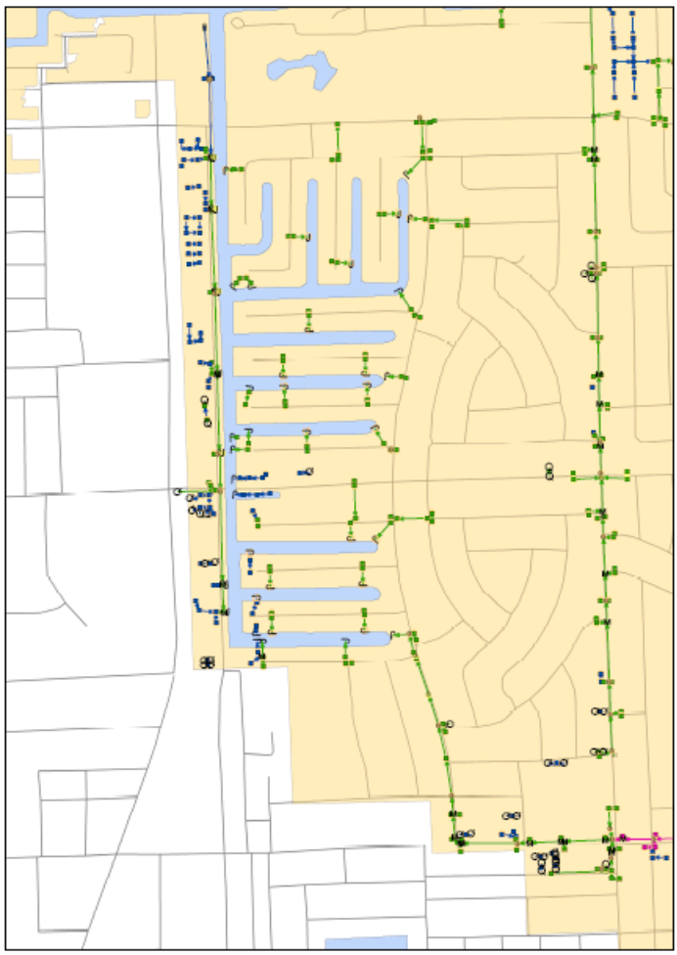
Most of the communities surveyed during LBSP Project 3/19 indicated they have a program in place to maintain stormwater infrastructure and have digital data cataloging this infrastructure (See Figure 9). Some survey respondents, however, identified the need to better track maintenance activities. Similarly, while each community has a program in place to track and eliminate illicit discharges, investigations are made more complicated when the source of a discharge is from another community. Development of a single, regional layer might include: stormwater infrastructure, including canal systems; storm drains; outfalls; stormwater management practices; and techniques for tracking maintenance activities. These data would help managers to maintain infrastructure and conduct watershed planning and restoration efforts more efficiently.
Figure 9. The detailed storm drain network data available in the City of Fort Lauderdale is a powerful resource for the watershed manager, but ends at the city line (unshaded area).

Recommendation 6. Establish regional pollutant load targets to guide land use and stormwater management practice decisions.
While Total maximum Daily Loads (TMDLs) have been established for some of the waterbodies found within this region, and several pollutant reduction efforts associated with the CERP are ongoing, pollutant loads to the near shore environment are not taken into consideration guide management activities. Establishing pollutant load limits for the coastal environment and tracking loads over time would provide several benefits. First, it would help to identify potential sources of pollutants and prioritize funding for projects that provide the greatest pollutant removal to the reef system. Second, it would foster communication and coordination between the agencies that work within the region. Third, it would help to set realistic goals about the amount of growth the region can support without irrevocably damaging the reef system. Finally, it would raise reef protection to a level similar to that currently achieved for the Everglades.

7.3 .Land Conservation
This tool includes conservation and protection of existing healthy resources, as well as restoration of degraded resources.

Recommendation 7. Restore coastal and non-coastal wetlands.
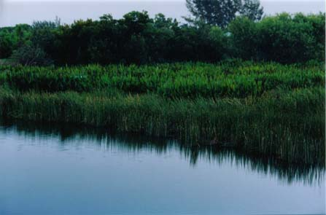
Restoring historic wetlands, or constructing wetlands to restore ecosystem services, is an important component of both reducing pollutant loads and providing habitat throughout the region. In addition, these efforts can help provide distributed wastewater treatment storage areas that result in groundwater recharge (Broward County, 2005). The SEFCRI LBSP survey indentified three wetland restoration projects in the 4-county area (Table 4), which represent only a small fraction of the wetland restoration projects actively occurring in southeast Florida.
Figure 10. The Wakodahatchee Wetlands are created wetlands in Palm Beach County, and are fed by highly treated wastewater. Source: http://www.pbcgov.com/waterutilities/wakodahatchee/tour-05.htm

For example, many additional wetland restoration efforts are underway, largely as a part of the CERP program. For more information on ongoing CERP wetland restoration projects, go to the following link:
http://www.evergladesplan.org/pm/projects/project_list.aspx

Other wetlands have been created in concert with wastewater reuse programs. For example, the Wakodahatchcee Wetland (Figure 10), a fifty acre wetland in Palm Beach County, supports over 140 species of birds and provides treatment for over 2 million gallons of domestic wastewater each day (Palm Beach County Utilities, ND). The Palm Beach Environmental Resources Management Division has also restored a significant amount of wetland habitat, particularly in estuarine areas. For examples, go to:

http://www.co.palm-beach.fl.us/erm/lakes/estuarine/

Table 4. Wetland Restoration Efforts Identified in the LBSP Survey
Project | Description | Location | Partners
Kitching Creek/Flora Avenue Water Quality Improvement Project | Wetland rehydration by redesigning road culverts. | Martin County at Flora Avenue | Martin County, SFWMD, FDEP, Jonathon Dickinson State Park.
Hydrologic restoration of the North Fork St. Lucie River | Breaching artificial (dredge) riverbanks to rehydrate floodplain communities and to reconnect historical oxbows. | Martin County, North Fork St. Lucie River | FFWCC, FDEP, SFWMD, St. Lucie Issues Team, FDOT, USFWS
Biscayne Bay Surface Water Quality and Biological Monitoring Program | Examine the suitability of rehydrating the coastal wetlands near Black Point, the near shore zone and determine water inflow targets. | Miami-Dade County, Biscayne Bay | SFWMD
Broward County Integrated Water Resources Plan (IWRP) | Enhance water resources and water supplies including wetland rehydration at County Parks | Broward County | Municipalities
SFWMD: South Florida Water Management District; FDEP: Florida Department of Environmental Protection; FFWCC: Florida Fish and Wildlife Conservation Commission;
FDOT: Florida Department of Transportation; USFWS: United States Fish and Wildlife Service

Recommendation 8. Form regional partnerships to use the wetland mitigation process to establish and expand regionally important wetlands.
Wetlands are inevitably disturbed during the development process. In an effort to reduce and minimize the disturbance various agencies including the US Army Corps of Engineers, the SFWMD District, and the Florida Department of Environmental Protection as part of the ERP Application must review the project and approve the permit before groundbreaking can begin. SFWMD

While wetland disturbances are mitigated under this permit, the mitigated areas are often out of watershed or even out of county. Ideally, wetland mitigation should occur within the same watershed in order to mitigate the effects of wetland loss during construction. For example, Broward County (2008) tracks the wetland mitigation sent out of county each year, and this fraction can be up to 50 percent of the total wetland mitigation. As a solution, Broward County is in the process of developing partnerships to restore wetlands on public lands, such as parks, within the county. These partnerships can help to maintain wetland cover in highly urbanized watersheds or to “send” wetland mitigation to highly valued wetland locations.

Recommendation 9. Survey remaining critical habitat areas and identify funding sources for protection.
Survey data suggest that land conservation occurs primarily at the state and federal level (Figure 11) through such agencies as the US Department of Agriculture (USDA), the State of Florida and the SFWMD District. Local governments do, however, integrate data about key habitats into land conservation efforts. For example, Martin County completed a series of Environmental and Natural Resources Maps, including maps of “Strategic Habitats”, which can be used to guide future conservation efforts. Broward County in 2000 through the Safe Parks and Lands Preservation Bond Program preserved hundreds of acres of open spaces, green spaces and conservation areas. On a broader scale, the Florida Natural Areas Inventory is attempting to categorize and identify conservation areas throughout the state. A description of this effort can be found at: www.fnai.org.

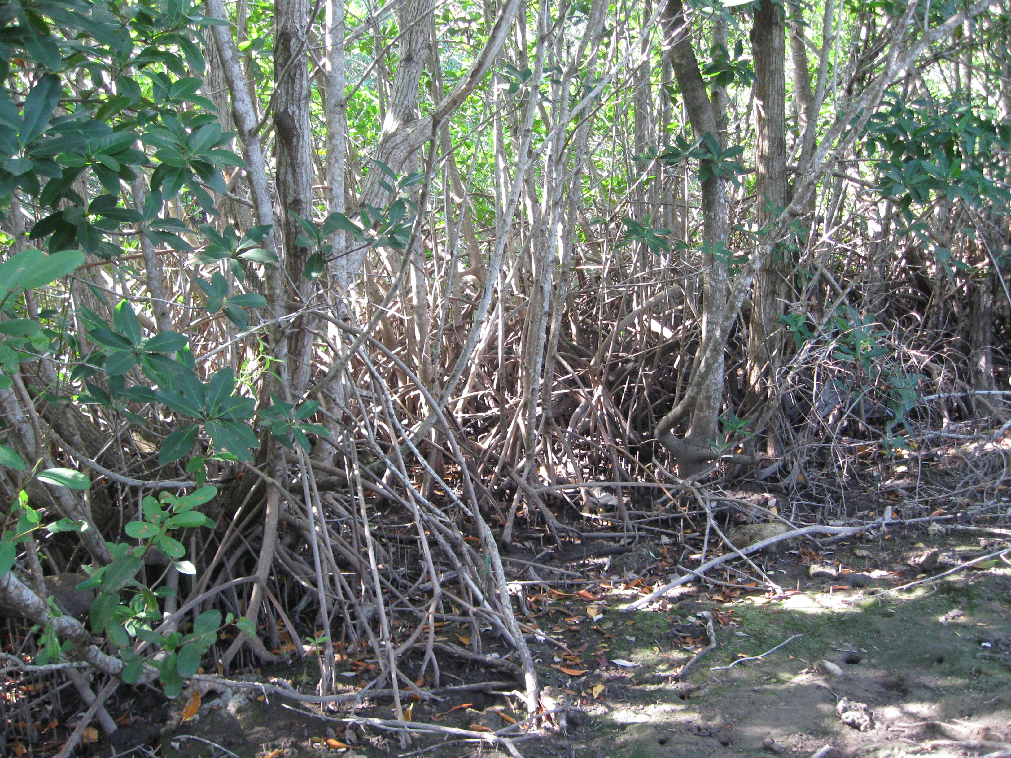
Land is preserved largely through the Florida Forever program, as well as various other funding sources. As of the writing of this document, no funds are available to the Florida Forever program for 2009. . The SFWMD originally budgeted $36.5 million in 2009 for land acquisition. Although this may be a temporary freeze in funding, securing some mechanism to protect remaining habitats is an important goal.
Figure 11. Preserved Mangrove Area in Biscayne National Park. Photo Source: CWP

Local governments also have programs in place to purchase protect natural areas. In Palm Beach County, voters approved referendums providing $250 million in bonds for conservation land acquisition. This was matched with other grants to purchase over 31,000 acres of natural areas. Further, all four counties have a funding mechanism for land conservation, with ad valorem taxes in all four counties, and a sales tax in Martin County (FDEP, 2009).

Some example habitat areas that should or have been protected include:
- Existing wetlands
- Endangered species habitat
- Habitats of regionally important species
- Migratory bird resting sites
- Undeveloped land beyond urban growth boundaries or urban service districts
- Lands necessary to complete restoration projects necessary to meet larger watershed goals.
- Wellfield Protection Areas

Since many resources are impacted or lost during the development process, this is a critical time to identify and protect resources. As a part of the development process, a Natural Resources Inventory should be completed on all development sites. In the recently released “Coastal Supplement to the Georgia Stormwater Manual” (CWP, 2010), a natural resources inventory is required on all sites, and protection of natural resources is incorporated into stormwater criteria.

7.4 Aquatic Buffers
Aquatic buffers are the areas directly adjacent to streams, rivers, wetlands and other waterways. Buffer zones provide an area between development and waterways and allow water to percolate instead of flowing directly into nearby water bodies. Vegetated aquatic buffer zones provide additional pollution reduction by utilizing plants natural ability to uptake nutrients. In southeast Florida, much of the original stream system has been altered and converted to canals. The aquatic corridor is largely regulated by the SFWMD. However, individual communities can also adopt and enforce separate regulations to help protect these critical areas.

Recommendation 10. Require vegetated buffers between natural waterways and development sites.
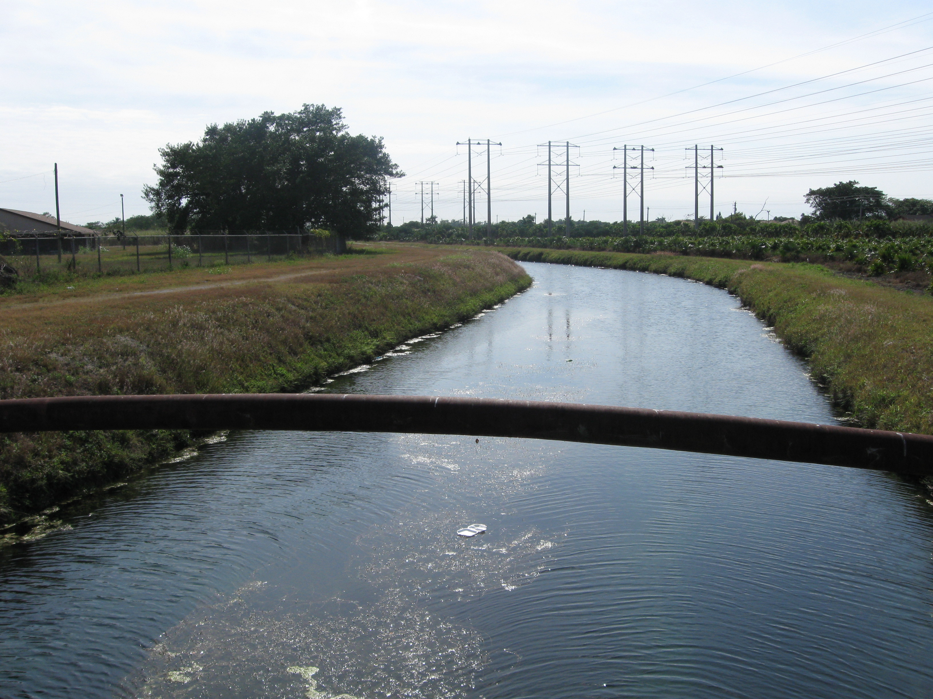
Setbacks from waterways are a requirement of a general Environmental Resource Protection (ERP) permit; however, supplemental local buffer programs provide additional requirements and maintenance of the buffer. One excellent example is Martin County, which has adopted a buffer requirement ranging from 50’ to 100’, including vegetation targets (Martin County Code). Although Martin County is the most rural county in southeast Florida, these policies could, at a minimum, be selectively applied in the remaining counties. A flexible criterion with a minimum (e.g., 25’) buffer in urbanized areas and with wider buffers in open areas could be applied throughout the region.
Figure 12. Although no development is next to this canal, the adjacent vegetation offers little benefit for pollution reduction. This area might offer an excellent opportunity to create wetlands or enhance the corridor with vegetation. Photo Source: CWP

For Martin County regulations, go to:
http://www.municode.com/resources/gateway.asp?pid=13592&sid=9

Recommendation 11. Treat canals as greenway systems and enforce setbacks and vegetative targets along these waterways.
The historic southeast Florida stream and river network has been replaced by a series of canals and structural water management systems to help control flooding (Figure 12). Some of the original stream and river functions can be established along these canals through efforts that preserve or enhance native vegetation at the edge of the canals, provide vegetated buffers around the canals, and reconnect canals with their original floodplain. These canals could serve as green infrastructure corridors to link less disturbed natural areas to one another, provide corridors for wildlife and a host of other environmental benefits.
Broward County has an aggressive campaign to encourage the planting of native vegetated buffers near waterways, including the development of brochures entitles “Landscaping on the Edge.”

In more urbanized areas, canals can act as a public destination by creating walking paths. The Loxahatchee Greenways Project and Northern Everglades Natural Area (NENA) program in Palm Beach and Martin Counties incorporates canals into the greenway system, using trails along canals to connect more extensive conservation areas in the region. For more information go to:
http://www.co.palm-beach.fl.us/erm/nena/ and
http://www.1000friendsofflorida.org/pubs/loxahatchee/page8.asp

7.5 Better Site Design
Better site design, also known as Low Impact Development (LID), is a suite of natural resource protection and stormwater management practices and techniques that reduce runoff and protect water quality at the site level. LID includes techniques that minimize stormwater runoff, protect resources on site, minimize the creation of new impervious and disturbed pervious cover, and encourage small stormwater practices that support infiltration and reuse of stormwater runoff.

Recommendation 12. Require Better Site Design or LID Development Techniques on New Development Sites
Current regulations governing new development in southeast Florida do not require the use of LID site design techniques. Requiring these techniques would help to minimize pollutant loads from new developments, preserve natural areas, and reduce the cost of stormwater management. Several communities nationally have implemented regulations that require LID elements in new development, such as: impervious cover limits, or use of non-structural stormwater practices. Two collections of stormwater LID ordinance materials and guidance are provided below:

Example materials from the Low Impact Development Center
http://www.lowimpactdevelopment.org/ordinances.htm

Ordinances from the Puget Sound Partnership:
http://www.psparchives.com/our_work/stormwater/stormwater_resources.htm#ordinances
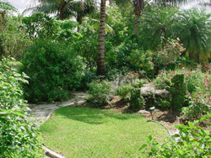
Recommendation 13. Revise landscaping standards to encourage the use of native plants, require plants that need minimal watering, limit the times when fertilizers can be applied, and include a tree canopy standard.
The NatureScape Broward County Program provides excellent information to homeowners on how to construct native habitat on their property and to reduce water use through native plantings and proper irrigation practices (Figure 13). Broward County’s NatureScape Irrigation Service is a mobile irrigation lab that provides large water users such as golf course and multifamily housing units with irrigation system evaluations and recommendations on how to reduce water usage. The program saved over 155 million gallons of water in 2008.
Figure 13. NatureScape Broward County Program encourages use of native plants, minimal lawn area, proper irrigation technique, and using plants that attract wildlife. Source: http://www.broward.org/naturescape/islandsofgreen.htm

This recommendation would be applicable on both redevelopment and new development sites, thus affecting a much larger area of the watershed. The criteria should be developed utilizing existing materials from the NatureScape Broward Program.

Fertilizers contain nutrients such as nitrogen and phosphorus which help plants grow. The over application of fertilizers can be washed into nearby waterbodies after rain events or from irrigation causing harmful algae blooms in downstream waters. Along the reef tract Lyngbya, harmful cyanobacteria, blooms can be triggered by an increase in nutrients in the water column. These blooms can smother and kill corals. Developing regional policies that restrict fertilizing yards before a rain event would help to decrease the chances that fertilizers will end up in waterways.
.
Other online resources are available, such as the “Florida Yards” program developed by the University of Florida Extension, the Florida DEP, the Southwest Florida Water Management District and Florida Yards and Neighbors, which includes an extensive database of native and drought tolerant plants, available at:

http://www.floridayards.org

This landscape guidance should also be accompanied by specific regulations to retain or enhance on-site tree canopy and other native vegetation. One technique is to establish tree canopy requirements based on the land development type. These are typically expressed as a percentage of the site area to be conserved or reforested as new development occurs. In addition to setting these vegetated targets, ordinances also allow for funding to be provided to enhance regional tree planting efforts in lieu of onsite forestation.

The Maryland Forest Conservation Act is one example of a tree preservation standard.
www.dnr.state.md.us/forests/download/sfla_report.pdf.

For other techniques to preserve tree cover at the site level, the Urban Forestry Manual, prepared by the Center for Watershed Protection and the USDA Forest Service is a good guide. Information can be found at:
http://www.cwp.org/Resource_Library/Special_Resource_Management/forestry.htm

Recommendation 14. Conduct a comprehensive Codes and Ordinances Review of Counties and Towns to ensure that existing development codes are consistent with Low Impact Development (LID) practices that reduce impervious cover, preserve open space, and treat and retain stormwater on-site.
Many communities across the country have found that their local development rules (e.g., subdivision ordinances, zoning ordinances, parking lot and street design standards) have prevented better site design techniques from being applied during the site planning and design process (CWP, 1998; Figure 14) and are responsible for the wide streets, expansive parking lots, and large lot subdivisions that are crowding out the very natural resources that they are trying to protect.
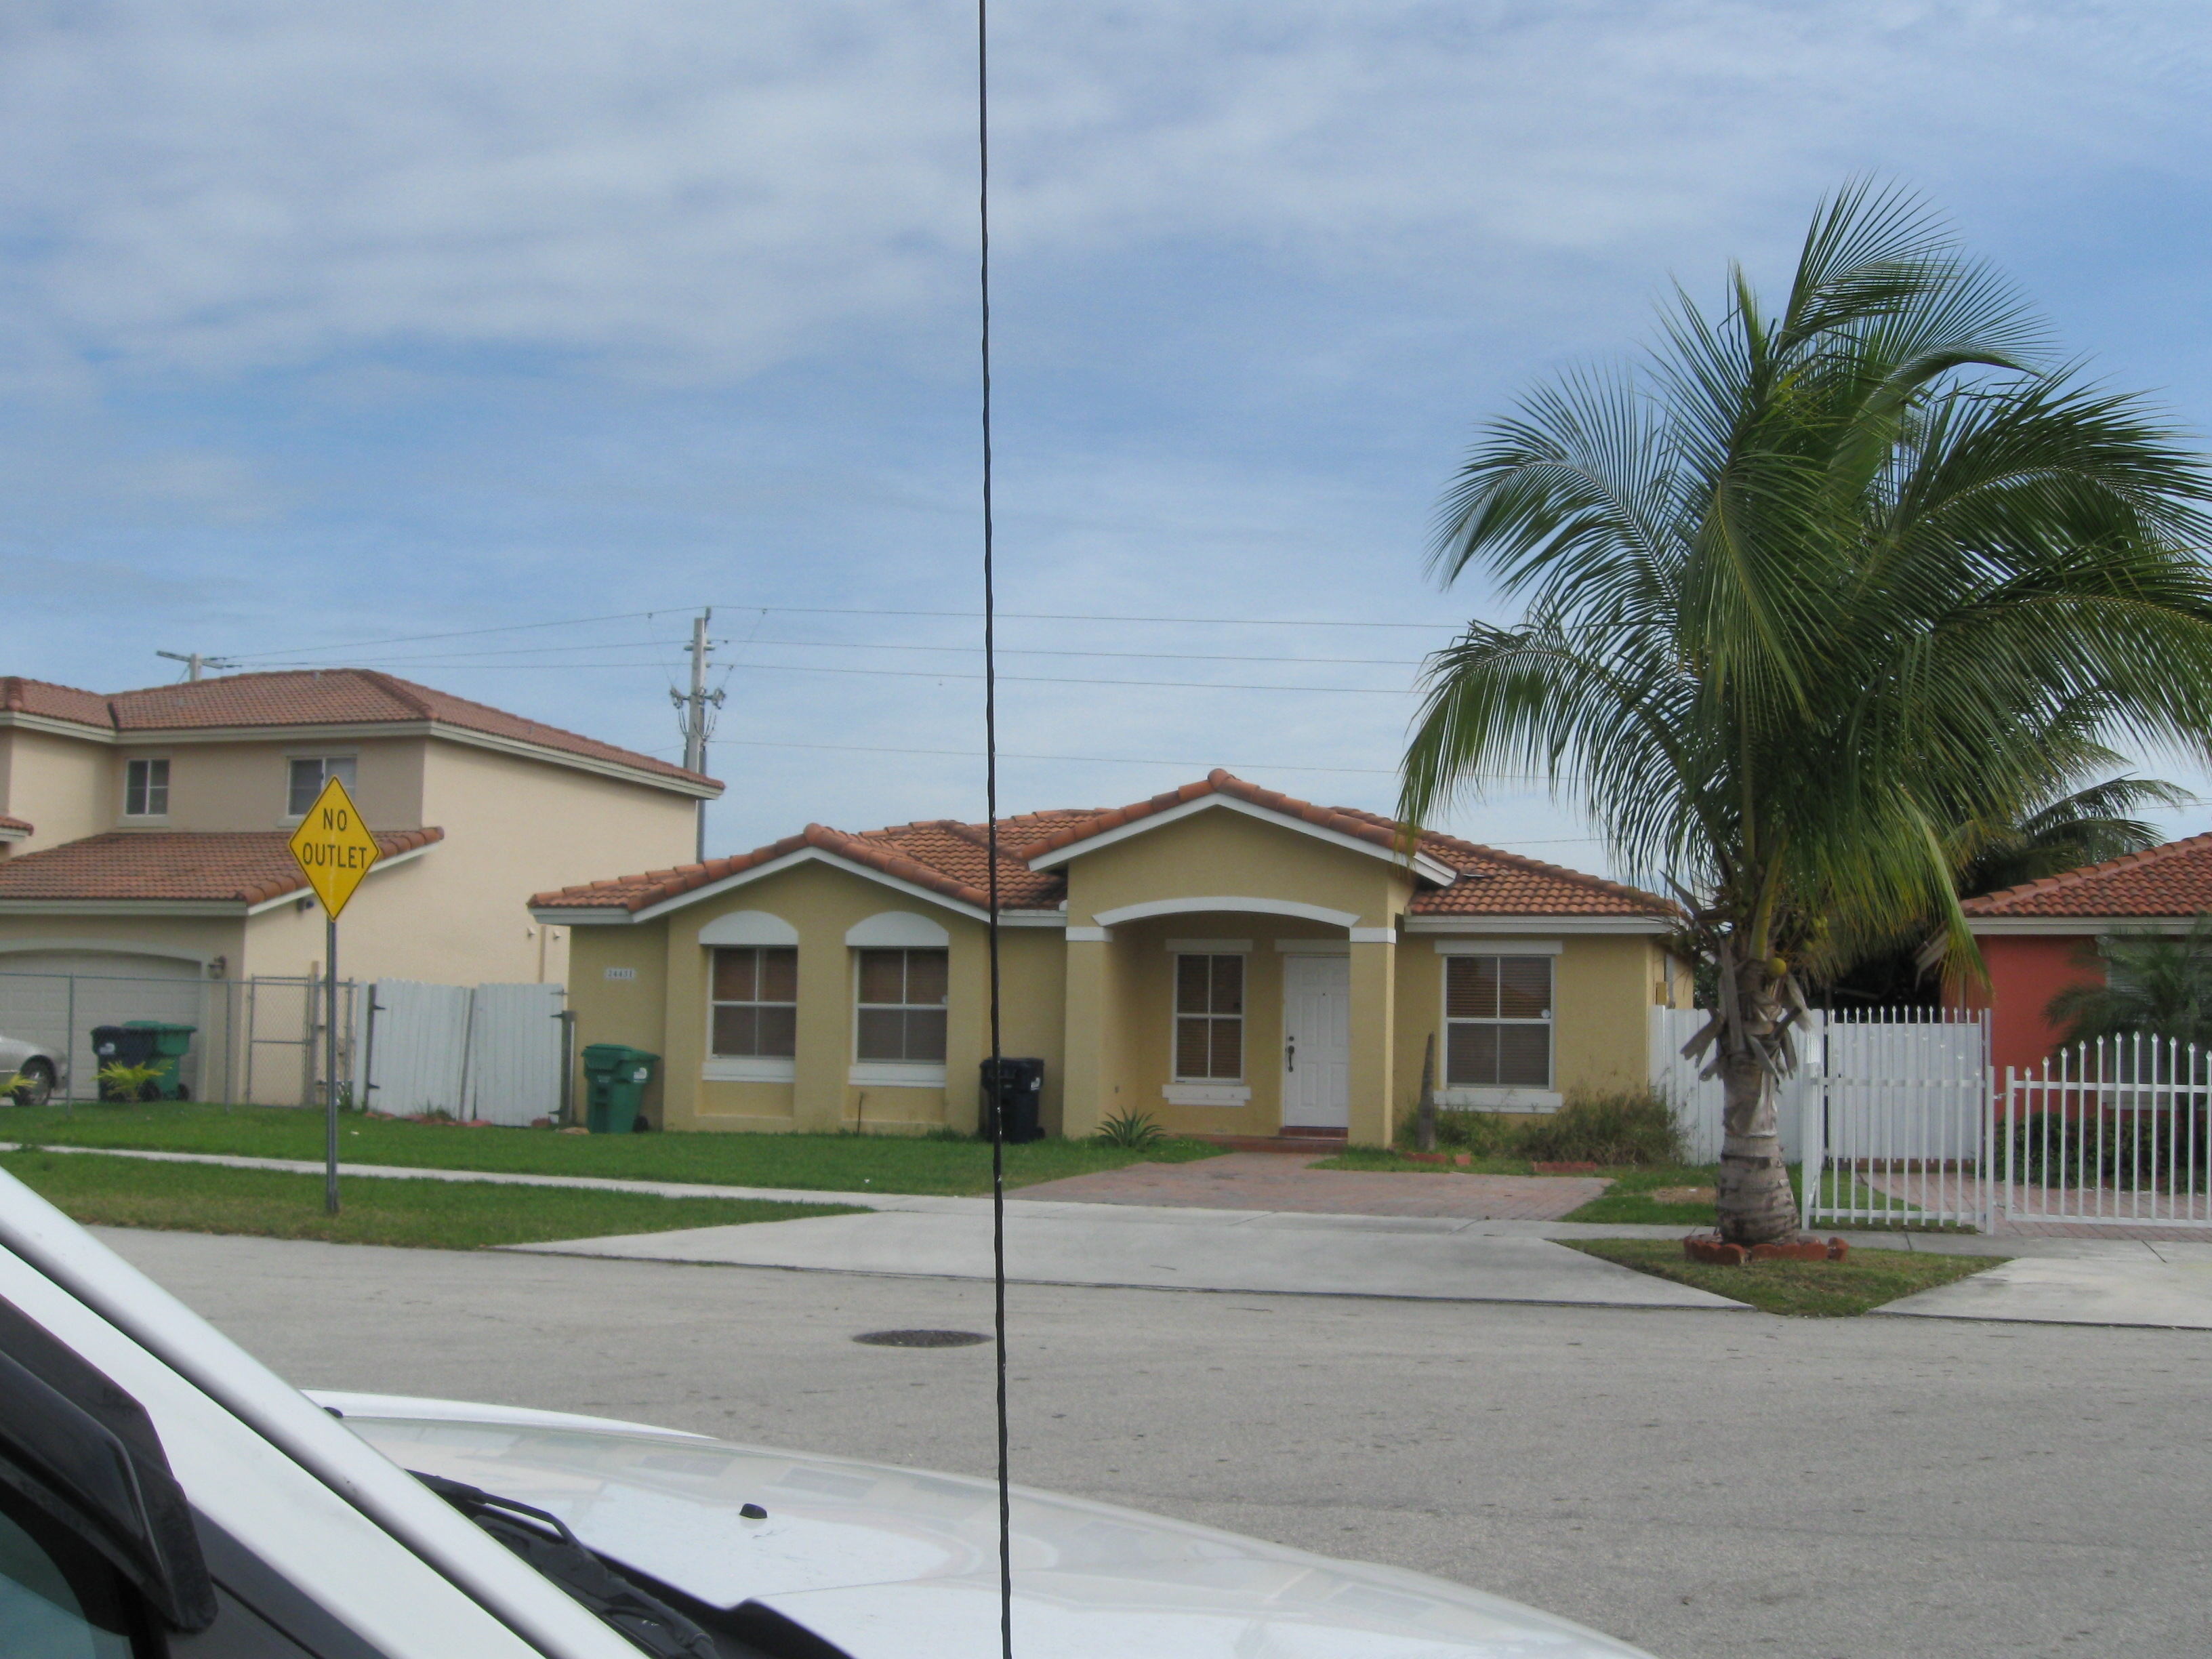
Figure 14. A combination of local codes, such as off-site parking requirements, street widths, and sidewalk requirements increase impervious cover in this residential development. Photo Source: CWP

While this report provides a summary of some programs in place, it does not delve into any details of design standards for new development. Obviously, it will be difficult to make use of better site design techniques if local development rules restrict their use. Although the Center for Watershed Protection has developed a process (CWP, 1998) that communities can use as a model to revise their “development rules,” a comprehensive review of the local ordinances can be a time consuming process. However, the review process would allow individual communities to identify opportunities to decrease the impacts of development throughout the watershed.

The “Codes and Ordinances Worksheet” from the Center for Watershed Protection provides a framework for reviewing new development codes. This worksheet, along with a description of the roundtable process is included in the following document:

Center for Watershed Protection. Codes and Ordinances Worksheet.
http://www.cwp.org/Resource_Library/Better_Site_Design/index.htm

Recommendation 15. Develop specific standards for redevelopment projects that include impervious cover targets and incorporate on-site stormwater practices.

Each county and several towns and cities have developed guidance for redevelopment projects, but data from the surveys and interviews only showed that Palm Beach County specifically, address land based sources of pollutants (http://www.pbcgov.com/pzb/Planning/ura_code/ura_code.pdf). Principles of development that directly address the management of stormwater runoff, preservation of on-site resources, and minimize the creation of impervious cover will directly achieve these goals.

If managed correctly, redevelopment projects can be used to improve conditions in areas that were developed without stormwater controls. Redevelopment is one of the few opportunities to address existing impairments in urbanized watersheds. However, applying stormwater management practices on redevelopment projects can be a challenge. Land availability, cost, and other site constraints often limit the stormwater management options that can be applied in redevelopment situations.

Communities across the US and Canada have used a variety of approaches in their efforts to manage the stormwater impacts created by redevelopment projects, requiring that:

- Existing impervious cover or pollutant loads be reduced by at least 20% (Virginia)
- Water quality treatment be provided for at least 30 percent of the existing on-site impervious cover and any new impervious cover (New York State, Maryland)
- Innovative site design and low impact development practices (e.g., green roofs, porous pavement) be utilized to reduce stormwater impacts on-site (Maryland, Virginia, New York, Minnesota)
- Water quality issues to be addressed by providing equivalent stormwater treatment at an off-site facility (Maryland)
- Water quantity issues (e.g. downstream channel erosion, flooding) be addressed through channel restoration and other off-site remedies (Maryland)
- Water quality and quantity issues be addressed by utilizing funding from a watershed restoration fund (e.g., Maryland)

The following document summarizes principles for design of redevelopment projects:
Redevelopment Roundtable Consensus Agreement: Smart Site Practices for Redevelopment and Infill Projects (CWP, 2001):
http://www.cwp.org/Resource_Library/Better_Site_Design/index.htm

The following website created by Broward County provides innovative stormwater management designs for new and redevelopment projects:
http://www.broward.org/stormwater/newconstruction.htm

The “Maryland Critical Areas” requirements are good example stormwater management requirements for redevelopment, requiring a 10% reduction in pollutant load (post-developed to pre-developed) for redevelopment sites:
www.mde.state.md.us/assets/document/sedimentstormwater/Appnd_D4.pdf

7.6 Erosion and Sediment Control
This tool addresses erosion controls during the construction process, and at the shore line.

Recommendation 16. Increase staff available to inspect construction sites and develop a core staff of Certified Inspectors.
Most jurisdictions throughout the southeast Florida region had some form of erosion and sediment control program, although lack of inspectors to monitor these programs was noted as a weakness. Increasing local government inspections at sites to supplement contractors’ self-inspection can be achieved in three ways. First, communities may need to hire additional inspectors to manage construction sites. Ideally, these staff would have completed the “Certified Inspector” program required of contractors in the State of Florida. Second, the communities can cross-train building inspectors to provide additional oversight during the building process. Finally, the smaller communities appear to have more difficulties with manpower. A sharing arrangement between cities and counties may be possible to achieve full coverage at construction sites.

Recommendation 17. Document and repair beach discharges.
Often, direct discharge from development at or near the shore can result in erosion from beaches and directly to the reef system. Municipalities in Broward County have actively sought to limit these problem areas by cataloging areas where discharges to the beach result in erosion at the shoreline. Some projects have specifically sought to limit these sources of erosion. For example, the “Portals to the Sea” project at the Town of Lauderdale by the Sea the Town is elevating six beach access points to reduce flow from streets to the beach, thus minimizing this erosion source.

Recommendation 18. Stabilize canal banks during and following construction.
Construction in the canal systems can be a significant source of erosion. In addition to providing erosion controls during construction, ongoing monitoring is necessary to ensure that canal banks are stabilized following construction.

Recommendation 19. Actively restore dune systems and vegetation along beaches.
The beaches of southeast Florida used to be comprised of a vegetated dune system which helped stop the beaches from eroding. The dunes were leveled or destroyed to allow construction along the beach line. Actively restoring the dune system and vegetation will help to reduce beach erosion and decrease the amount of turbidity in the coastal waters.

7.7 Stormwater Management
This section makes specific recommendations regarding stormwater criteria and management of stormwater infrastructure. As a part of their National Pollutant Discharge Elimination System (NPDES) Permits, all communities must have a program in place to regulate post-construction stormwater runoff. At the same time, several survey participants commented that they lacked staff to adequately enforce these permits. In addition, each community has a program in place to maintain stormwater infrastructure under this program. The details of these programs were not provided in detail by survey participants, and more data is needed to better understand how the programs are structured, and where additional resources, or cooperation between municipalities is needed.

A strong stormwater management program must have several key elements including:
- Integration of land use planning with stormwater management
- Unified stormwater design criteria
- Legal Authority
- Plan review for stormwater design
- Inspection during construction
- Practice inspection and maintenance
- Program tracking

For a recent publication that provides a useful overview of post-construction stormwater management, consult the following recent document:

Managing Stormwater in Your Community: A Guide for Building an Effective Post-Construction Program. (Hirschman and Kosco, 2008)
Available at: http://www.cwp.org/Resource_Library/Controlling_Runoff_and_Discharges/sm.htm

Recommendation 20. Form a review committee to review stormwater practice design standards for Southeast Florida. This effort would help develop criteria specific to the region that would supplement the revised state criteria to be released in 2010.

7.7.1 Stormwater Management Objectives and Techniques
In Southeast Florida, larger watershed protection and restoration goals can be achieved through practices that mimic natural hydrology and reduce the use of potable water for irrigation and other non-potable uses. Further, stormwater practices should enhance or restore natural habitat and provide the greatest pollutant removal achievable on each site. Finally, stormwater management criteria should reward site design techniques that minimize impervious cover and preserve existing resources on site.

Some key specific measures to achieve these goals include:
- Require a Natural Resources Inventory as the first step in the site planning and design process
- Require that primary conservation areas be protected from the direct impacts of land development
- Specifically require a “runoff reduction” or water reuse volume on each site.
- Incorporate on-site stormwater practices such as cisterns and rain gardens to achieve runoff reduction goals
- Design stormwater ponds to provide water reuse on site (Figure 15).
- Allow credit with SFWMD and FDEP for site design features, such as aquatic buffer protection, rooftop disconnection, and tree conservation.
- Incorporate “state of the art” stormwater designs that provide optimal pollutant removal.
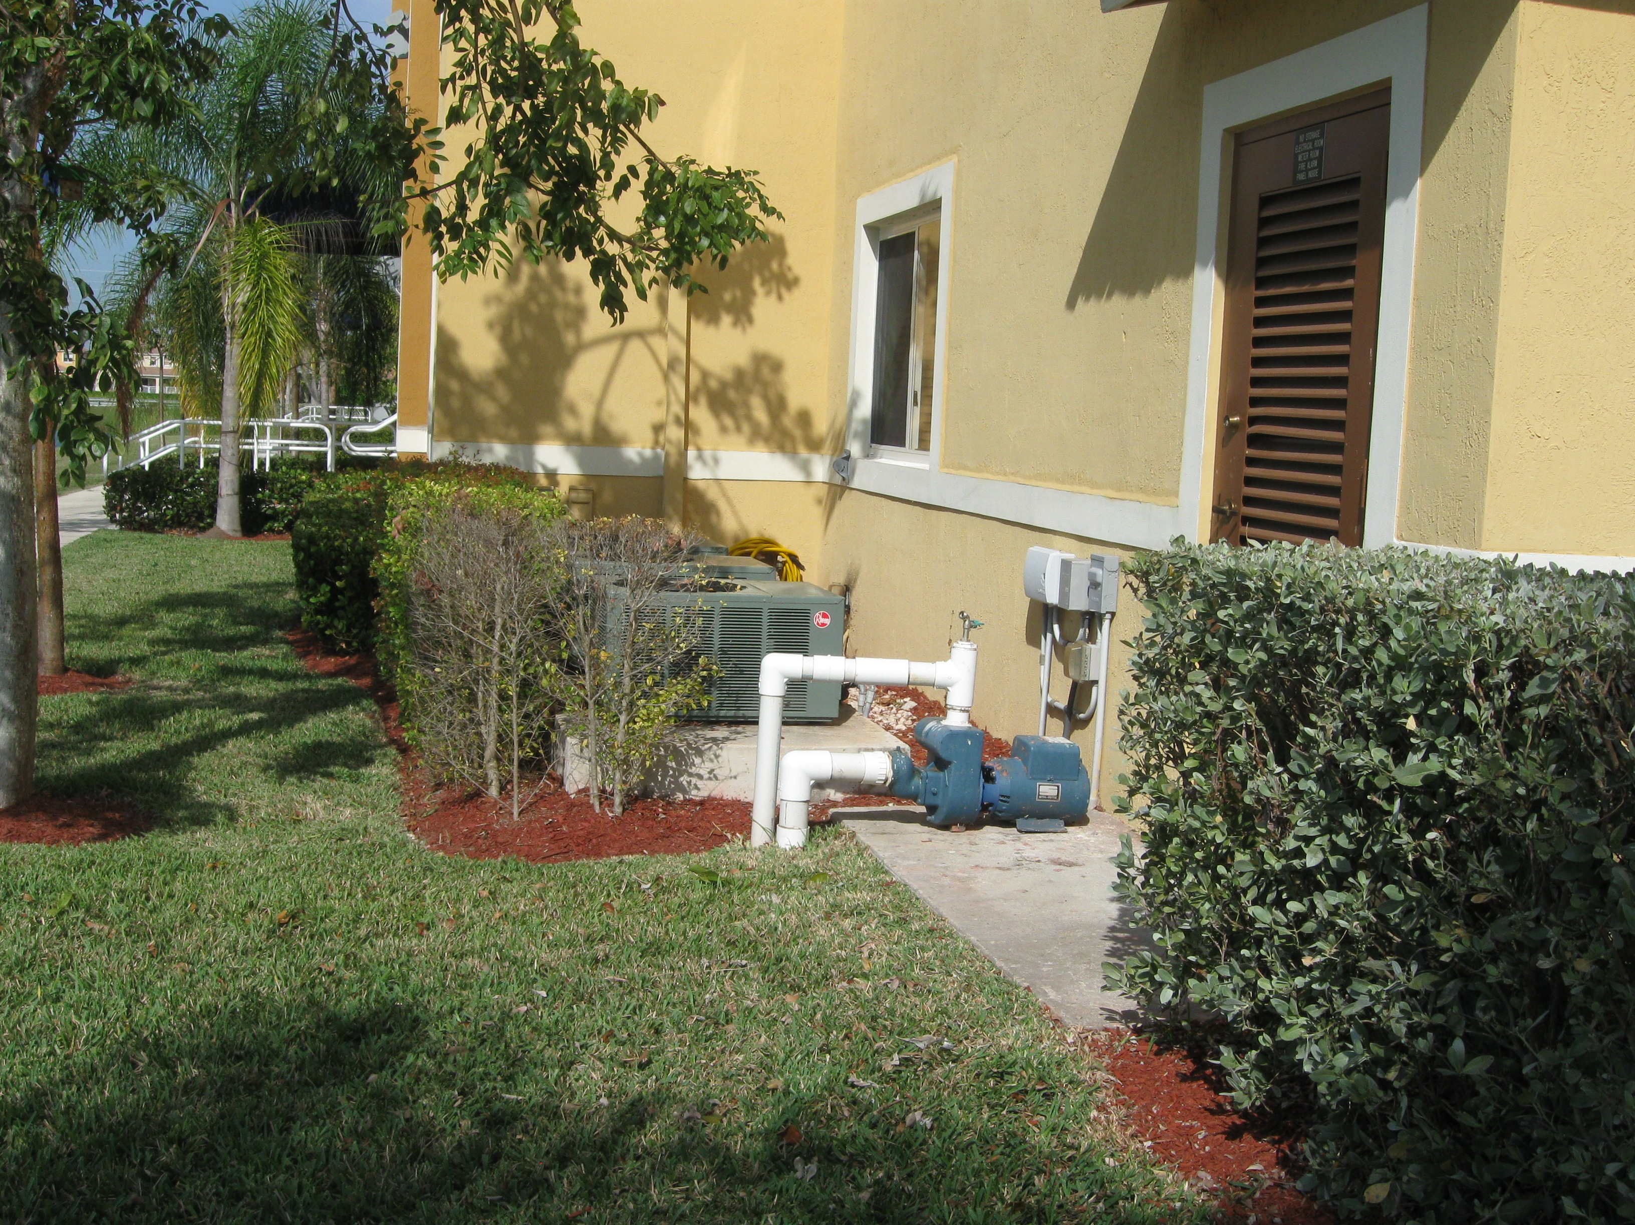
Figure 15. This pump draws water for site irrigation from the stormwater pond in Figure 17. Photo Source: CWP

7.7.2 Current Stormwater Management Criteria
Post-construction stormwater management is currently regulated by a combination of local and state codes. The standards of design, however, are primarily guided by the SFWMD’s “Environmental Resource Permit Information: Manual IV.” While Manual IV provides reasonable design guidance, it does not address some more recent innovations in stormwater management. For example, no LID practices are incorporated and the standards (See Figure 16 for a recently designed stormwater practice).

Some specific elements of the criteria include:
- The criteria primarily rely on traditional stormwater practices, such as ponds or dry basins.
- Stormwater quality volumes are based on site area (1”/acre) or impervious cover (2.5”/acre).
- Flood control is required for larger storm events.
- Design recommendations such as promoting wetland vegetation within pond systems, ease of maintenance, and irregular geometry.

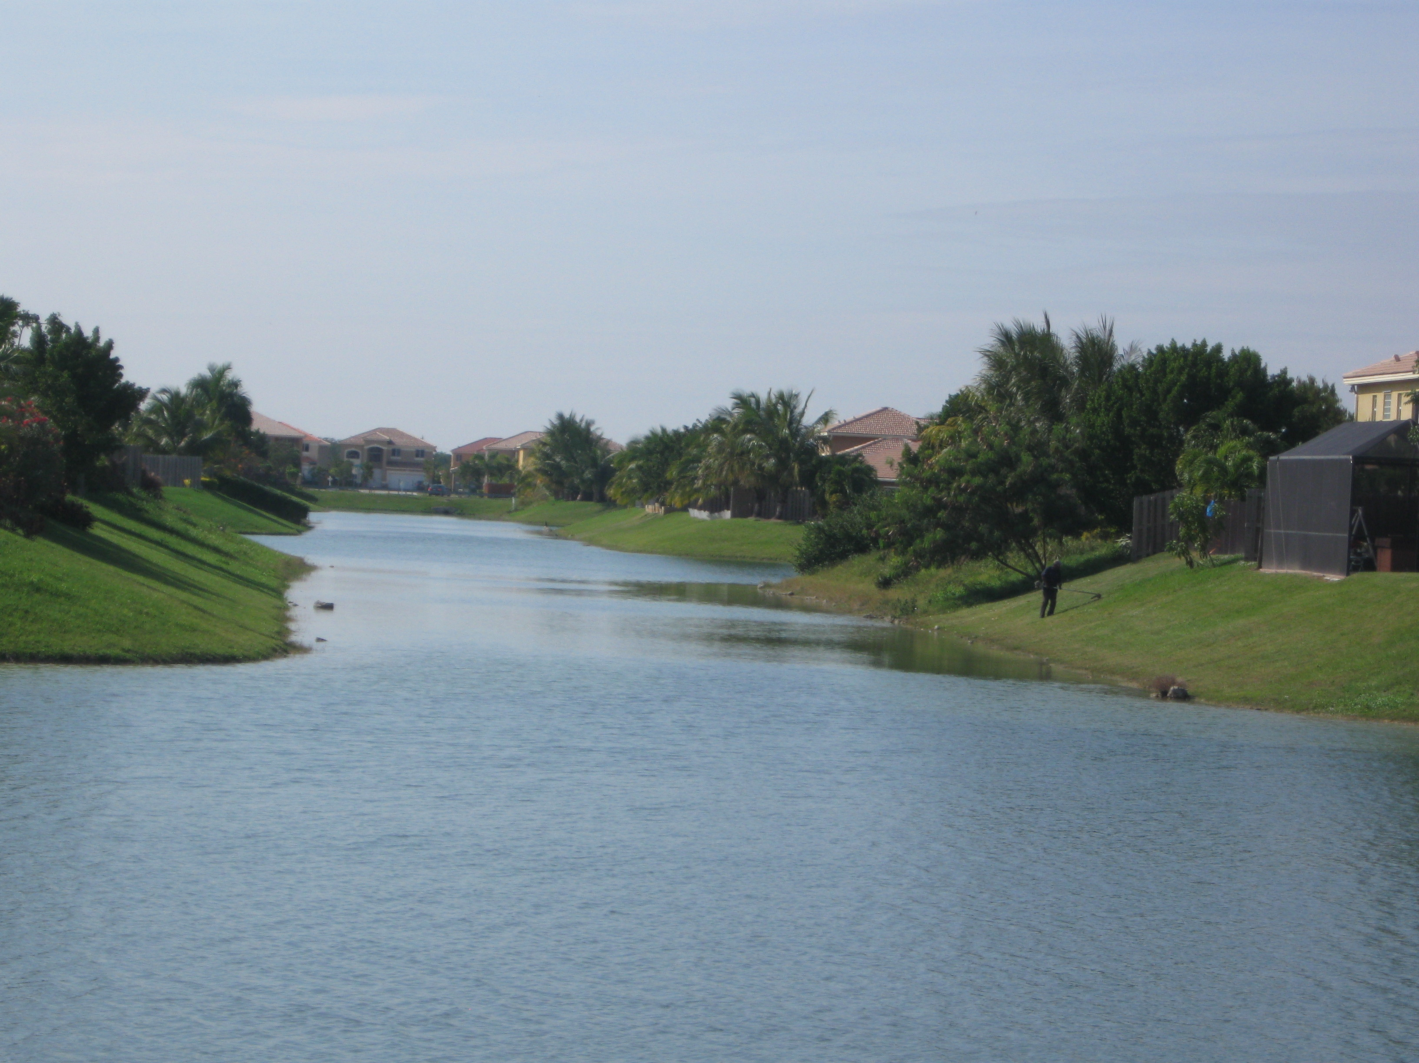
Figure 16. This pond, in Miami-Dade County does not incorporate some features that would improve its performance, such as shallow side slopes, an “aquatic bench” that promotes growth of wetland vegetation, and irregular geometry. Photo Source: CWP

7.7.3 Revised State Stormwater Management Criteria
The Florida Department of Environmental Protection is currently developing universal statewide criteria for post-construction stormwater management. These criteria are being developed through a series of Technical Advisory Committees (TAC). While the proposed regulations have not been released, committees have discussed some topics such as Low Impact Development and Stormwater Reuse. The TAC has created focus group to provide recommendations about the following areas:
- Loading Methodology
- Karst Sensitive Areas/Ground Water Protection
- Wet Detention Systems
- Use of Wetlands for Stormwater Treatment
- Low Impact Design BMPs
- Altered Hydrology/Legacy Pollutants
- Urban Redevelopment
- Permitting Thresholds

The current state of the stormwater rule development can be found at:
http://www.dep.state.fl.us/water/wetlands/erp/rules/stormwater/index.htm

7.7.4 Technical Advisory Committee Role
The Southeast Florida Stormwater Review Committee recommended here would be composed of representative from southeast Florida communities. The committee would identify areas where specific regional stormwater criteria or design guidance would help to supplement the proposed state criteria by:
- Identifying areas where specific stormwater criteria are needed for South Florida.
- Enforcing statewide stormwater regulations with supplemental criteria for southeast Florida.
- Applying criteria on small sites that are not regulated by the State of Florida.

Although statewide criteria are valuable for consistency, special criteria for southeast Florida may also be warranted because of its unique coastal resources. This approach has recently been adopted in Georgia, where specific stormwater criteria for the Coastal Plain were included in a Stormwater Supplement for the coastal region (CWP, 2009).

Recommendation 21. Using the data in Recommendation 5, combined with land use information and other data, conduct regional Stormwater Retrofit Inventories in priority watersheds.
Several individual retrofit practices were identified (Table 5) as a part of the LBSP Project 3/19 survey Most of these practices were a part of larger state-wide watershed planning efforts. Other retrofits have been completed, but were not reported in the survey. For example, the Lake Worth Lagoon Partnership Program, a partnership between the Lake Worth Lagoon Initiative, which distributes funds to local sponsors of projects identified in the Lake Worth Management Plan (http://www.co.palm-beach.fl.us/erm/lakes/estuarine/lake-worth-lagoon/).

A comprehensive review of existing stormwater practices should be used to conduct field surveys for potential stormwater retrofits as a part of a specific watershed planning efforts, crossing jurisdictional boundaries. The following can be used as a guide to the stormwater retrofitting process:

Urban Subwatershed Restoration Manual No. 3: Urban Stormwater Retrofit Practices (Schueler et al., 2007)
Available at: http://www.cwp.org/Resource_Library/Controlling_Runoff_and_Discharges/sm.htm

Table 5. Stormwater Retrofit Practices Identified in the LBSP Survey
Project | Description | Location | Partners
Little Club Drive Stormwater Improvement Project | Design and construct a stormwater detention pond, a stormwater treatment area, and stormwater conveyance systems (roadway swales, culverts, and catch basins). | Martin County | FDEP and Martin County
Flood Control Projects | Maintain a schedule for the flood control & water quality improvements. Maintain a list of the priority projects proposed for design and construction during the 5-year term of this permit. Provide additions and/or deletions to this list in each subsequent Annual Report. | Del Ray Beach (Palm Beach County) | ESD/Engineering
Evaluation of Full Scale Stormwater Treatment Area Enhancements | Demonstrate and document the ability of a limerock berm to contribute to improved treatment effectiveness, and demonstrate and document effective means of converting emergent vegetation treatment effectiveness, and demonstrate and document effective means of converting emergent vegetation treatment cells to Submerged Aquatic Vegetation treatment cells. | Palm Beach County | FDEP and SFWMD
Old Palm City Water Quality Improvement Project | This project involves the construction of a 2-acre detention area and the creation of a 1.5 acre wetland area in Old Palm City for the treatment of stormwater flowing from west to east into the South Fork of the St. Lucie River and into the Indian River Lagoon. | Martin County | FDEP and Martin County
Arch Creek Drainage Wells | Installation of drainage wells (11) and pollutant control devices (2) to improve water quality entering Arch Creek Canal. Installation of approximately 3,000 LF of exfiltration trench (water quality treatment). | North Miami | Miami-Dade County DERM Water Pollution Control
Salerno Creek Stormwater Retrofit | Retention area will capture and treat water (3/4 of an inch) from a 780-acre watershed (primarily the City of Stuart). | Stuart (Martin County) | Martin County, F DEP, FDOT, University of Florida's Institute of Food and Agricultural Sciences, SFWMD
Stormwater Master Plan/Baffle Box Program | Improvements to stormwater drainage systems within the City of Stuart by installing baffle box control structures to reduce pollutant loads to receiving waters | Stuart (Martin County) | Florida "Yes" Program and SFWMD
Town of Ocean Ridge Stormwater Management System | Design, construct, and install a stormwater detention pond, two pump stations, and 5 baffle boxes. | Ocean Ridge, (Palm Beach County) | FDEP, Town of Ocean Ridge, and Palm Beach County's Lake Worth Lagoon Grant.
Tropic Vista Stormwater Improvement Project | Captures stormwater runoff from the Tropic Vista neighborhood (350 single-family homes) in a stormwater retention area. | Martin County | Martin County, Jonathon Dickinson State Park, and FDEP
Local Government Partnerships for Stormwater Retrofits | "Turn-dirt" projects that focus on retrofitting stormwater and/or wastewater systems to result in improved water quality in receiving water bodies. | All | SFWMD, Counties in the region
SFWMD: South Florida Water Management District; FDEP: Florida Department of Environmental
FDOT: Florida Department of Transportation;
DERM: Department of Environmental Resource Management

Recommendation 22. Conduct a program review to determine if sufficient staff exists to provide maintenance of stormwater infrastructure, including storm drains, canals, and stormwater BMPs
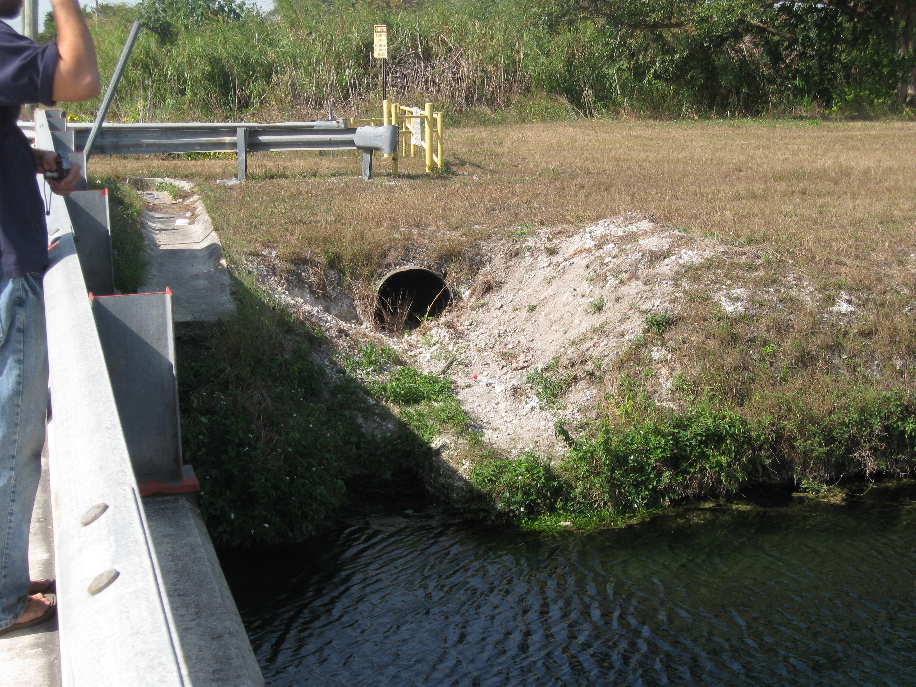
Given the extent of development throughout this region, each jurisdiction has a tremendous amount of infrastructure to maintain (Figure 17). For example, Broward County alone reported having 4,800 stormwater outfalls. Several communities reported having insufficient staff, limited time or inadequate equipment to conduct appropriate maintenance. Using the database established in Recommendation 5, supplemented with data from regular maintenance or inspection visits, communities can determine if they have sufficient staff to inspect existing facilities.
Figure 17. This stormdrain would be a perfect place to implement a BMP to reduce pollution entering the canal. Photo Source: CWP

A “Program Audit” tool to help estimate needed resources and is available from Hirschman and Kosco (2008) at the following site:

http://www.cwp.org/Resource_Library/Controlling_Runoff_and_Discharges/sm.htm

While community governments are responsible for maintaining stormwater infrastructure, implementing stormwater BMPs are the responsibility of private owners. Although best management practices are privately owned, records of each BMP inspection should be included in the same database to evaluate how well these private facilities are maintained.

7.8 Non-Stormwater Discharges
This tool includes measures to reduce pollutant loads from non-storm discharges such as sewage discharge and highly polluted “hotpot areas” such as marinas.

Recommendation 23. Supplement existing permitting programs with “Hot Spot Inventories” in select watersheds or neighborhoods to refine pollution prevention methods.
Communities in southeast Florida regulate discharges from commercial and industrial land uses through the following:
- Administering NPDES Industrial Permits
- Hazardous waste discharge permits

These existing permits are enforced using a combination of cold calls inspections (as reported by Broward County), and implemented in Miami-Dade County, and reliance on complaints. In the Palm Beach County, the county maintains a database of high risk dischargers and prioritizes inspection activity based on this information.

Other local efforts are supplemented with statewide education efforts targeted at industries. Two programs identified in the survey are as follows:
- The voluntary statewide “P2” program provides technical assistance and outreach to industries
- The Best Management Practices for Florida's Green Industries Education Program offers certification for lawn care industry and pesticide management professionals

These programs attempt to limit discharges from businesses, but given the number of industries and businesses in this large and densely populated region this is a challenging task. Some relatively simple field surveys can be used to identify key problems throughout a watershed. One example is the “Hotspot Inventory (HSI), which identifies areas within a site, such as dumpsters and loading areas, which have a high discharge and pollutant loading potential.

The HSI field sheet, as well as approaches for assessing upland pollution are presented in the document:
Unified Subwatershed and Site Reconnaissance: A User’s Manual-Version 2.0. (Wright et al., 2005), available at:
http://www.cwp.org/Resource_Library/Watershed_Management/field.htm

Recommendation 24. Create an incentive system to retire septic systems throughout the watershed.
According to data collected by the Florida Department of Health, the potential cumulative number of septic systems is 212,708 in Miami-Dade, 106,886 in Broward, 79,960 Palm Beach and 28,002 in Martin Counties. The most recent census data regarding the number of homes serviced by septic systems are from 1990 (US Census, ND), and reflect that the fraction of homes on septic systems were 17% in Miami-Dade, 11% in Broward, 14% in Palm Beach and 51% in Martin Counties. Since that time, communities, in cooperation with the Florida Department of Health and the SFWMD, have been gradually working to convert existing septic systems to municipal sewer.

Septic systems are difficult to regulate and pose a direct threat to the fragile aquifer system that acts as a drinking water source. Improperly maintained septic leach fields also have the potential to directly impact the ocean and reef system by leaking bacteria laden effluent into nearby canals that drain to the Atlantic Ocean. Palm Beach County, Martin County and the City of Fort Lauderdale were the only jurisdictions to document septic system management in the survey, and their role was confined to identifying septic system failures.

Recommendation 25. Provide free pumpout of boat sanitary waste in all four counties
Marinas have a very high pollutant potential, and are unique to coastal areas. Several communities in southeast Florida have adopted FDEP’s Clean Marina Program, which includes techniques to minimize pollutant loads associated with boat storage, maintenance refueling, and docking. Another beneficial program is Martin County’s MS-POOP (Martin Ship Pump-Out Operation) Program, in which Martin County offers free removal of sewage from wastewater holding tanks aboard vessels. Between October of 2000 and October of 2007, this program collected 195,500 gallons of sewage, which might otherwise have been discharged into coastal waters.

Recommendation 26. Install wastewater reuse pipes concurrent with new development and redevelopment projects
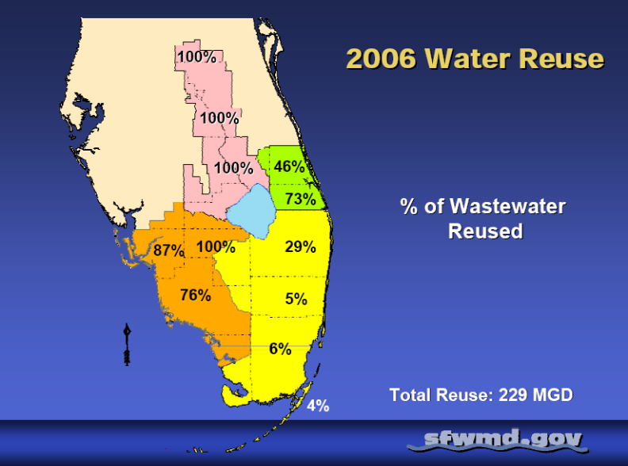
Wastewater reuse is a critical goal to minimize dependence on groundwater and reduce the wastewater load to coastal waters. Typically, wastewater reuse has focused on larger efforts such as wetland restoration. Some examples of reuse include:
Figure 18. Water Reuse by County. While the highly populated Miami-Dade and Broward Counties reuse a small fraction of their total wastewater, more rural counties are able to use a greater fraction (Source: sfwmd.gov).
- Creating the Wakodahatchee Wetlands in Palm Beach County
- Broward County Waste-to-Energy Facility – uses over 1 MGD of reclaimed water for boiler cooling.
- IRIS Plant expansion in the City of Boca Raton, increasing reuse capacity by 5 MGD, with a corresponding increase in reuse demand of 8 MGD through a distribution system in Broward County
- Investigating rehydration of the Biscayne Bay wetlands and groundwater recharge in Miami-Dade County
- Use of brackish water to irrigate golf courses in Broward and Palm Beach Counties

While some Florida counties reuse almost 100% of their wastewater, a relatively small fraction of wastewater is reused in southeast counties (Figure 18). One reason for this difference is that, while more rural counties can use reclaimed water to irrigate cropland or other large vegetated areas, options are limited in the fragmented suburban and urban environment. In fact, Broward County (2005) identified the lack of the infrastructure required to distribute reclaimed water as a major obstacle to wastewater reuse. Reuse is also limited in Broward County due to strict water quality standards and 1,200 miles of canals that receive stormwater runoff.

The 2008 outfall bill (Senate Bill 1302), however, requires six major treatment plants to reuse a total of 60% of their wastewater by 2025.Installing wastewater reuse pipe, at redevelopment and new development sites will increase the demand for water reuse in two ways. First, it will allow access to reclaimed wastewater by urban and suburban residents. Even in highly urbanized areas, this pipe network can be used to supply many uses such as:
- Toilet tank water
- Fountains
- Car washing
- Landscape and lawn irrigation

Second, it will gradually increase the network of reclaimed water pipe (purple pipe), ultimately allowing export of wastewater from urban to which have less supply but greater demand for reclaimed wastewater.

Recommendation 27. Use the data developed in Recommendation 5 to help agencies work together to identify illicit discharges.
As a requirement of NPDES Permit communities must conduct illicit discharge investigations. However, the fragmented nature of storm drain system maps limits the ability to trace discharges that originate beyond the community to their source. In southeast Florida, this problem is exacerbated because storm water systems are owned by a combination of county, city and town governments and by homeowner associations. A regional data layer would allow for more sophisticated investigations and tracking of discharges.

7.9 Watershed Stewardship
Several watershed stewardship efforts, including monitoring and public education/involvement, were highlighted in the LBSP Project 3/19 survey. The recommendations in this section suggest techniques to integrate these efforts to achieve specific watershed objectives or expand existing successful programs.

Recommendation 28. Integrate water quality monitoring efforts to provide consistent data quantifying pollutant loads to the St. Lucie, Jupiter, Lake Worth, Boynton, Boca Raton, Hillsboro, Port Everglades, and Port of Miami Inlets and pollutant loads from these inlets to nearshore coastal waters and coral reefs.
Currently, several inland water quality monitoring efforts are ongoing, but there is minimal nearshore coastal water quality monitoring at the mouth of the ocean inlets. In addition, the water quality monitoring programs are not synchronous with each other and measure different parameters. Thus, it is difficult to understand trends or impacts to the coastal system. In fact, Trnka et al. (2006) identified several data gaps and recommend an integrated monitoring network. One mechanism to achieve this goal is to add ocean load estimates as a component of Inlet Management Plans which are required by State law and managed by the DEP. NOAA’s Coral Reef Conservation Program recently awarded funding to conduct offshore water quality monitoring. Although, this is a start, the funding will only allow for one year of quarterly sampling at 17 sites. Additional funding is still needed to sustain and expand the water quality monitoring program.

Recommendation 29. Expand monitoring efforts to characterize reef quality in concert with monitoring of land-based pollutant loads.
Efforts to characterize the southeast Florida reef system have been initiated only recently, leading to an initial understanding of the species composition, status and trends within the coral reef system. This monitoring known as the Southeast Florida Coral Reef Evaluation and Monitoring Project (SCREMP), should be expanded to 1) develop bioindicators of pollution stress, 2) look for correlations among biocriteria and water quality, 3) identify contributing sources of pollutants, and, 4) expand the number of monitoring sites.

Recommendation 30. Integrate non-profit organizations and citizens into government programs to provide education and enhance watershed quality. Examples may include “Adopt-a-Canal” or “Adopt-a-Pond” programs or tree planting efforts.
Non-profit organizations that are actively working on environmental issues in southeast Florida, and could be integrated into existing or new government programs. For example, several of these non-profit organizations provide environmental education, and could partner with the municipalities to educate citizens.

In Miami, local non-profit organizations and state and local agencies assemble through the Environmental Education Providers of Miami-Dade County (http://www.eepmiami.org/links.htm) to coordinate outreach activities

Some groups, such as “Citizens for a Better South Florida” (http://www.eepmiami.org/links.htm), which has its own native plant nurseries, could be integrated into planting efforts at key locations, such as a part of canal restoration activities, or as demonstration projects in highly visible locations.

Educational efforts should also involve direct citizen involvement. The “Adopt a Canal” program in the South Broward County Drainage District is one example that could be duplicated throughout the region (http://www.sbdd.org/pdfs/AdoptaCanal072507.pdf).

In one model from another region, an “Adopt-a-Pond” program, which encourages stormwater management practice maintenance, was created by the Center for Watershed Protection and Herring Run Watershed Association in Baltimore, MD and is available at:
http://www.cwp.org/Resource_Library/Restoration_and_Watershed_Stewardship/residential.htm. This model could be used to develop best management practices in southeast Florida.

These efforts, where possible, should reach beyond the watershed to address climate change and global warming, since these larger global impacts also impact coral reef health. Tree planting efforts and educational materials that reduce energy consumption are some examples. Broward County hosts Water matters Day, which is attended by thousands of people and features a native plant and tree give away.

The SEFCRI LBSP survey results identified some specific examples of cooperation between local communities and non-profit groups. For example, the City of Miami partners with the Miami River Commission to provide education in association with its City-Wide Sewer Cleaning Contract. In addition, Palm Beach County partners with both the Sandoway Nature Center and Keep Palm Beach Beautiful to manage beach cleanups. Also, Broward County partners with SFWMD to provide NatureScape education in County Schools and Know-the-Flow seminars in basins that drain directly to the Everglades.

Recommendation 31 Expand the NatureScape Broward County program to all regions and include a broader suite of stormwater management practices.
NatureScape Broward County Program is very successful at reducing water use by providing education, integrating native landscaping into their residential property, and reducing fertilizer and pesticides use. The program emphasizes reducing stormwater runoff and recommends practices, such as pervious pavers and swales. Other counties should use this program as a model to develop similar programs within their respective counties.

This program should also be expanded to incorporate practices that retain stormwater onsite. Some examples include:
- Permeable pavers
- Cisterns and rain barrels
- Rain gardens, vegetated depressed areas that capture stormwater runoff
- Native plantings

Some of these practices are already being emphasized by other agencies and communities and could easily be integrated into this program. For example, rain barrels have recently been emphasized in outreach efforts by the SFWMD and University of Florida. Palm Beach County and Broward County also offer free rain barrels to its residents (Van Zile, 2008).

An important consideration when conducting any on-site measures is ensuring that the practices are compliant with other codes. For examples, conversion of septic systems to cisterns was at one point recommended in the Florida Keys. However, recent information suggests that this practice is not in compliance with Department of Health regulations, and would require a specific variance (Thompson, 2009)

Recommendation 32. Demonstrate innovative stormwater and landscaping practices on public properties.
Public properties represent a unique opportunity to demonstrate innovative stormwater and landscaping practices. Creating partnerships with local municipalities and the public to demonstrate best management practices can show homeowners and businesses the value of applying these practices on their own property.

Some demonstration projects have already been initiated in the region. For example, the City of North Miami Beach installed a 30,000 gallon rain harvesting system. The rain water captured in this system is used to irrigate municipal landscapes. The system can save up to 690,000 gallons of water per year and reduce stormwater runoff volume (SFWMD, 2008).

References
Banks, K., B. Riegl, V. Richards, B. Walker, K. Helmle, L. Jordan, J. Phipps, M. Shivji, R. Spieler and R. Dodge. 2008. The Reef Tract of Continental Southeast Florida (Miami-Dade, Broward and Palm Beach Counties, USA), pp. 173-219. In: Riegl, B. and R. Dodge, Coral Reefs of the World.
Broward County. 2005. Broward’s County-Wide Integrated Water Resource Plan. Draft
Broward County Department of Planning and Environmental Protection. 2007. Broward County, Florida Historical Water Quality Atlas: 1998-2003, TR 01-03.
Broward County Department of Planning and Environmental Protection. 2001. Broward County, Florida Historical Water Quality Atlas: 1972-1997, TR 01-03.
Broward County Environmental Protection and Growth Management Department, 2008. Environmental Benchmarks Report. Prepared for: Broward County Board of County Commissioners.
Cappiella, K., Schueler, T., and T. Wright. 2005. Urban Watershed Forestry Manual. Part 1: Methods for Increasing Forest Cover in a Watershed. USDA Forest Service Northeastern Area State and Private Forestry. NA-TP-04-05. Newtown Square, PA.
Center for Watershed Protection (CWP). 2010. Coastal Stormwater Supplement to the Georgia Stormwater
Management Manual – Draft. Prepared for: Chatham County-Savannah Metropolitan Planning Commission, and the Georgia Department of Natural Resources Environmental Protection Division
Center for Watershed Protection (CWP). 2001. Redevelopment Roundtable Consensus Agreement: Smart Site Practices for Redevelopment and Infill Projects.
Center for Watershed Protection (CWP) and Herring Run Watershed Association. 2005. Adopt-A-Pond Document. Prepared for: Baltimore County Department of Environmental Protection and Resource Management
Collier, C. R. Ruzicka, K. Banks, L. Barbieri, J. Beal, D. Bingham, J. Bohnsack, S. Brooke, N. Craig, R. Dodge, L. Fisher, N. Gadbois, D. Gilliam, L. Gregg, T. Kellison, V. Kosmynin, B. Lapointe, E. McDevitt, J. Phipps, N. Poulos, J. Proni, P. Quinn, B. Riegl, R. Spieler, J. Walczak, B. Walker and D. Warrick. 2009. The State of Coral Reef Ecosystems of Southeast Florida, pp. 131 – 159. In: J.E. Waddell and A.M. Clarke (eds.), The State of Coral Reef Ecosystems of the United States and Pacific Freely Associated States: 2008. NOAA Technical Memorandum NOS NCCOS 73. NOAA/NCCOS Center for Coastal Monitoring and Assessment’s Biogeography Team. Silver Spring, MD. 569 pp.
Comprehensive Everglades Restoration Plan, ND. www.evergladesplan.org
Crossett, K., T. Culliton, P. Wiley and T. Goodspeed. 2004. Population Trends Along the Coastal United States: 2980-2008. National Oceanographic and Atmospheric Administration Coastal Trends Series.
Florida Department of Environmental Protection. 2009. Florida Forever Five Year Plan. Tallahassee, FL.
Guinotte, J. and V. Fabry. 2008. Ocean Acidification and Its Potential Effects on Marine Ecosystems. Annals of the New York Academy of Sciences – nyas.org
Hirschman, D. and J. Kosco. 2008. Managing Stormwater in Your Community: A Guide for Building an Effective Post-Construction Program. US EPA Publication 833-R-08-001. Prepared for: US EPA Office of Wastewater Management, Washington, DC.
Hogarth WT (2006) Endangered and threatened species: final listing determinations for the Elkhorn Coral and Staghorn Coral. Federal Register, pgs. 26852–26861.
Langevin, C.D., 2003, Simulation of submarine ground water discharge to a marine estuary: Biscayne Bay, Florida, Groundwater, 41(6), p. 758-771.
Miami (City of), ND. Miami 21 Development Code. Available at: miami21.org
Palm Beach Post. South Florida foreclosures top 100,000 in 2008. Palm Beach Post. January 6, 2009.
Palm Beach Utilities, ND. Wakodahatchee Wetlands. http://www.pbcgov.com/waterutilities/wakodahatchee
Paul, J., J. Rose, S. Jiang, X. Zhous, P. Cochran, C. Kellogg, J. Kang, D. Griffin, S. Farrah, and J. Lukasik. 1997. Evidence for groundwater and surface marine water contamination by waste disposal wells in the Florida Keys. Elsevier Science Ltd. Available online 25 July 1998.Reich, C.D., Swarzenski, P.W., Greenwood, J.W., and Wiese, D.S., 2009, Investigation of coastal hydrogeology utilizing geophysical and geochemical tools along the Broward County coast, Florida: U.S. Geological Survey Open-File Report 2008-1364, 21 p., plus apps. A-C.
Schueler, T. 2000a. “The Tools of Watershed Protection.” In: The Practice of Watershed Protection. pp. 133-144.
Schueler, 2000b. “Crafting better watershed plans.” In: The Practice of Watershed Protection, pp. 171-182
Schueler, T., D. Hirschman, M. Novotney and J. Zielinski. 2007. Urban Stormwater Retrofit Practices, Version 1.0. Center for Watershed Protection. Ellicott City, MD.

Smith, S. and M. House. 2006. “Snow birds, Snowbirds, Sunbirds, and Stayers: Seasonal Migration of Elderly Adults in Florida.” The Journals of Gerontology Series B: Psychological Sciences and Social Sciences 61:S232-S239
Smith, S. and S. Rayer. 2009. Projections of Florida population by county 2008 – 2035. Florida Population Studies, Bureau of Economic and Business Research, v. 42, bulletin 153. 8 pp.
South Florida Regional Planning Council, Miami-Dade County, South Florida Water Management District, and Keith and Schnars. 2007. South Miami-Dade Watershed Study and Plan
South Florida Water Management District (SFWMD). 2008. Water Conservation: A Comprehensive Program for South Florida.
South Florida Water Management District, ND. www.sfwmd.gov
Thompson,
Trnka, M., K. Logan and P. Krauss. 2006. Land-Based Sources of Pollution Local Action Strategy Local Action Strategy Combined Projects 1&2.
U.S. Department of the Census, 2006. http://factfinder.census.gov
VanZile, J. Rain Barrels Save Water, Not Much Money. October 3, 2008 Sun Sentinel
Wright, T., C. Swann, K. Cappiella, T. Schueler. 2005. Unified Subwatershed and Site Reconnaissance: A User’s Manual-Version 2.0. Manual 11 in the Urban Subwatershed Restoration Manual Series. Center for Watershed Protection. Ellicott City, MD.

These areas can also be protected through regulation. For example, Martin County enforces a wellfield protection ordinance with approximately 99 percent compliance. According to survey results, Palm Beach County has a wellfield protection ordinance available at http://www.co.palm-beach.fl.us/erm/permitting/water-resources/wellfield.
These data are based on 1970 census information, plus the cumulative number of installed systems, and do not reflect systems taken out of service.

