FLORIDA GULF OF MEXICO RESTORATION
PROJECT SUBMITTAL FORM

Form Purpose and Instructions:

To assist the project proposal and review process, please complete this Submittal Form. Completion of the Form will contribute to the appropriate information being completely and accurately submitted for each project.

- Take as much space as needed for each question, but please keep responses as focused as possible. It may assist you to review all the questions before addressing any one question.

- Please submit one Form per project, if you have multiple projects - please submit one Form for each project.

- Please submit completed Forms to Restoration.Projects@dep.state.fl.us. Once your Form is successfully submitted, you will receive a confirmation email from the Florida Department of Environmental Protection.

Project Name:

Facilitating Agricultural Resource Management Systems (FARMS) Program - Springs Coast

Contact Information (Include at least one name, phone number, email address, and organization name if applicable):

Eric DeHaven SWFWMD (813) 985-7481 ext 2118 eric.dehaven@watermatters.org
Jennette Seachrist SWFWMD (813) 985-7481 ext 2210 jennette.seachrist@watermatters.org
Chris Zajac SWFWMD (813) 985-7481 ext 4413 chris.zajac@watermatters.org

Project Location (Include a map, if possible, and the city, county, longitude/latitude, and watershed):

Attached map shows the following target counties within the District: Levy, Marion, Citrus, Sumter, Hernando, and Pasco. Springsheds of interest include the following 1st Magnitude Springs Groups: Rainbow, Kings Bay, Homosassa, Chassahowitzka, and Weeki Wachee.

Project Description (Describe all aspects of the project):
The FARMS Program is an agricultural best management practice (BMP) cost-share reimbursement program. It is a public/private partnership developed in 2003 by the Southwest Florida Water Management District (District) and the Florida Department of Agriculture and Consumer Services (FDACS). The purpose of the FARMS Program - Springs Coast initiative is to implement agricultural BMPs that will reduce groundwater

Estimated Project Costs (Describe the estimated costs of the project, including any assumptions for contingency and ongoing operations/maintenance. Identify other secured funding sources such as matching funds, in-kind contributions or state/federal dollars. In addition, if possible, complete and submit the Cost Appendix Sheet associated with this Form):

Estimated FARMS Program - Springs Coast costs for project reimbursement is $1,000,000. Approved agricultural BMP projects will qualify for a 75 percent cost-share reimbursement rate of the total project cost and the additional 25 percent cost-share will be funded by grower contribution. The District is budgeting $6.0M for the overall FARMS Program in FY2016-17.

Other Funding (Indicate if the project is submitted for any potential funding or if it may be used to leverage additional funding, if so please describe the funding source [e.g. State/Federal Grants]):

The FARMS Program - Springs Coast will leverage public funds from a variety of sources (Florida State Legislature, FDACS, District), with private cooperators (agricultural) at a rate that matches the programs historic rate of 55/45 percent public versus private funds. Additional funding and assistance has also been leveraged through the USDA Natural Resource Conservation Service (NRCS) through their Environmental Quality Incentive Program (EQIP).

Technical Feasibility (Describe the technologies involved and any relevant past experience or proven success with similar projects):

The BMPs involve a number of water resource benefits that have shown success, as documented in the approximately 184 District Governing Board-approved projects in operation that have been implemented since the program's start in 2003. FARMS Program - Springs Coast BMP's are expected to include practices to reduce water use and improve water quality. Precision irrigation technologies to reduce water use may include: weather stations; soil moisture sensors; automatic valves, timers and pumps; and irrigation retrofits

Environmental Benefits (Describe the nature, magnitude, and timing of any environmental benefits attributable to the project. If possible, describe potential environmental performance measures [e.g. pollutant reduction]. Please address any potential environmental impacts associated with implementing or maintaining the project [e.g. loss of a habitat or conversion of habitat from one type to another during implementation]):

The FARMS Program involves both water quantity and water quality benefits. Water quantity benefits will be attained through a reduction in Upper Floridan groundwater quantities currently used in agricultural operations, and flow meter data will be tracked to measure performance. As an example, over 25.0 million gallons per day (gpd) has been reduced in the District's Southern Water Use Caution Area (SWUCA) through implemented FARMS Program projects. Water quality benefits will be attained by implementation of nutrient BMPs such as

Economic and Social Benefits (Describe the economic and social benefits including those related to the project’s improved ecosystem services and any estimates on jobs created or preserved):

This region of Florida enjoys a natural environment, with its first-magnitude springs and beaches, and also supports industry such as agriculture and tourism, in addition to facing population growth stresses. The improved water quantity and water quality generated by a FARMS Program - Springs Coast project not only protects and conserves Florida's water resources, specifically springs systems, but ultimately benefits the entire community. Future tourism revenue is enhanced when the environment flourishes, water resources are protected for future planned growth, and the residents themselves enjoy a better quality of life.

Community Resilience (Describe if the project assists Florida’s ability to anticipate, withstand, or recover from hazards or threats [e.g. hurricane preparedness, establishing living shorelines]):

The purpose of the FARMS Program - Springs Coast initiative is to provide an incentive to the agricultural community within the District to implement agricultural BMPs that will provide resource benefits that include improved flow to springs and reduced nutrient impacts that are perceived as threats to spring systems.

Conflicts or Complements to Existing Efforts (Describe any ongoing activities in the project implementation area, if the project is part of another plan, and why the project does or does not interfere with that work. Please consider how the project may complement existing local, regional, and state efforts/plans/objectives):
The FARMS Program supports District's initiatives such as the SWUCA recovery strategy, reduction of groundwater use in the Dover/Plant City Water Use Caution Area (DPCWUCA) in response to January 2010 extreme freeze events, the Shell and Prairie Creek Watershed Management Plan - Reasonable Assurance Documentation, and the Regional Water Supply Plan. This funding request will allow for expansion of the

Complies with Federal, State, Local, and Tribal Laws/Regulations (Describe any concerns or potential conflicts):
The FARMS program is authorized by rule 40D-26, Florida Administrative Code (F.A.C.) and works closely with other agencies involved to meet applicable laws and regulations. Any federal, state, local or tribal permits needed for a FARMS project would first be obtained prior to any construction. Potential concerns or conflicts are not foreseen at this time.

Readiness for Implementation (Describe if the project has had any design or permitting work started or completed [attach permits or design work]. Please address any issues that may delay start or finish of the project):
The FARMS Program is poised to initiate the program. The FARMS Program is governed by rule, and internal operating procedures already exist. Existing agricultural properties with Water Use Permits (WUPs) issued by the District within the named springsheds in the target counties have already been identified (247 WUPs) and additional agricultural operations will be identified. FARMS is ready to start the next step of contacting potential

Public Acceptance (Describe any known or potential public approval or opposition to the project):

The FARMS Program is known and accepted in the grower community, and supported by local agricultural leaders including past endorsements by the Governor, Commissioner of Agriculture, and the state legislature. This funding will not only provide the intended water quantity and water quality benefits, but will also allow for a continued FARMS presence and a heightened awareness in the community as projects are successfully completed and become operational.

Additional Information you wish to provide (Please include any maps, designs, drawings, photos, or background resources that may assist in completely and accurately understanding the project):

Please visit our website link for more information about our current FARMS Program at:
http://www.swfwmd.state.fl.us/agriculture/farms/

Cost Appendix Sheet
Cost Item | Cost Estimate
Planning
Contracts
Feasibility
Engineering, Design, Land Rights, & Bid Prep
Restoration Plan
Site Visits & Cost of Site Selection
Administration, Overhead, and Indirect
Other
Planning Subtotal: | $0.00
Construction
Contracts
Administration & Mobilization/Demobilization
Other
Construction Subtotal: | $0.00
Monitoring
Contracts
Data Collection
Monitoring Administration
Other
Monitoring Subtotal: | $0.00
Project Cost
Supervision
Subtotal: | $0.00
Contingency
TOTAL: | $1,000,000.00

Estimated Costs by Year
Year 1 | $500,000.00
Year 2 | $500,000.00
Year 3
Year 4
Year 5
Year 6

FARMS Program - Springs Coast Planned Project Area

LEVY

MARION

Rainbow Group

!P!P!P!P!P!P!P!P!P!PP!P!P!P!P!P
!P

Kings Bay Group

Homosassa Group

Chassahowitzka Group
!P
!P!P!P!P!P!P
!P!P!P!P
!P!P P!P!P!P!P!P!P!P!P!

!P!P
!P!P!P!P!P
!P

CITRUS

SUMTER

Weeki Wachee Group

!P!P

!P!P
HERNANDO

PASCO

Legend
!P Springs
0 10
20
Miles
µ

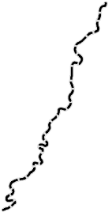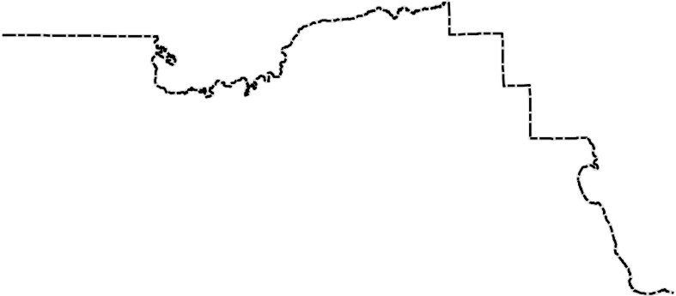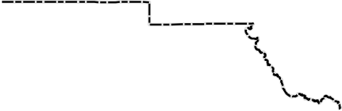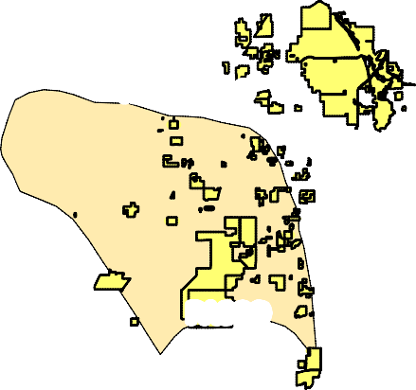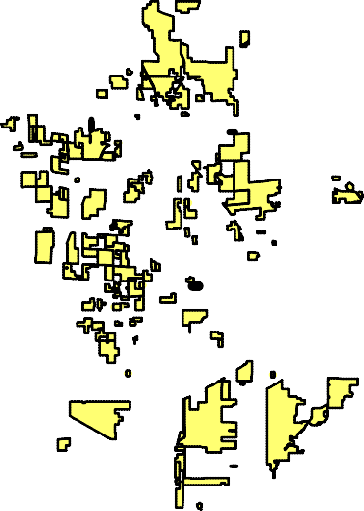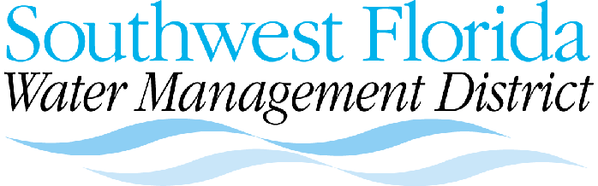Springsheds
Agricultural WUPs within Springsheds County Boundary

FARMS 15 Mar 2013
2012 Aerial

