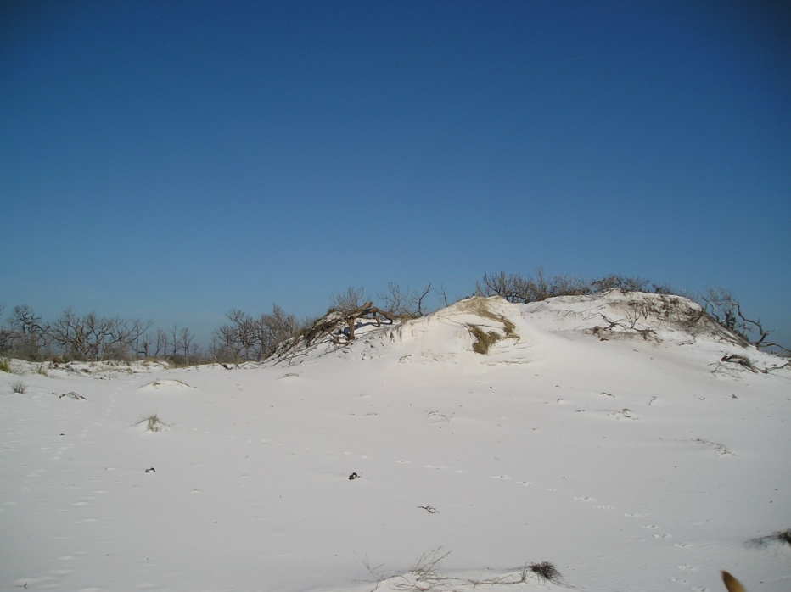
Exhibit 1:Escambia County Santa Rosa Island Proposed Boardwalk
