Attached Figures

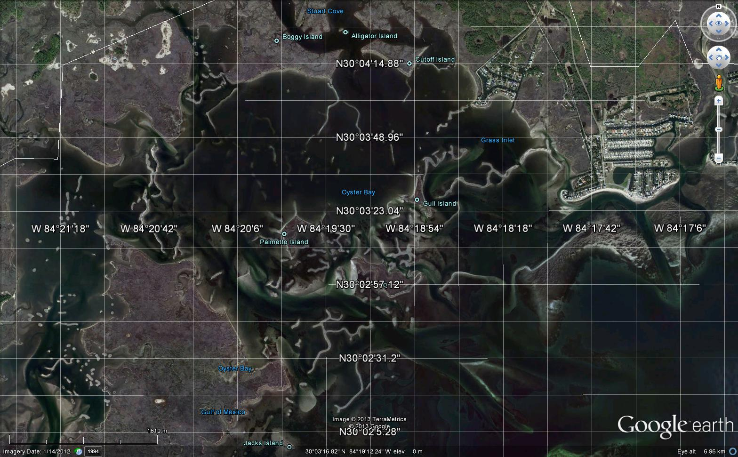
Figure 1. Wakulla County and Apalachee Bay; close up showing the extensive, anastomosing oyster bars.
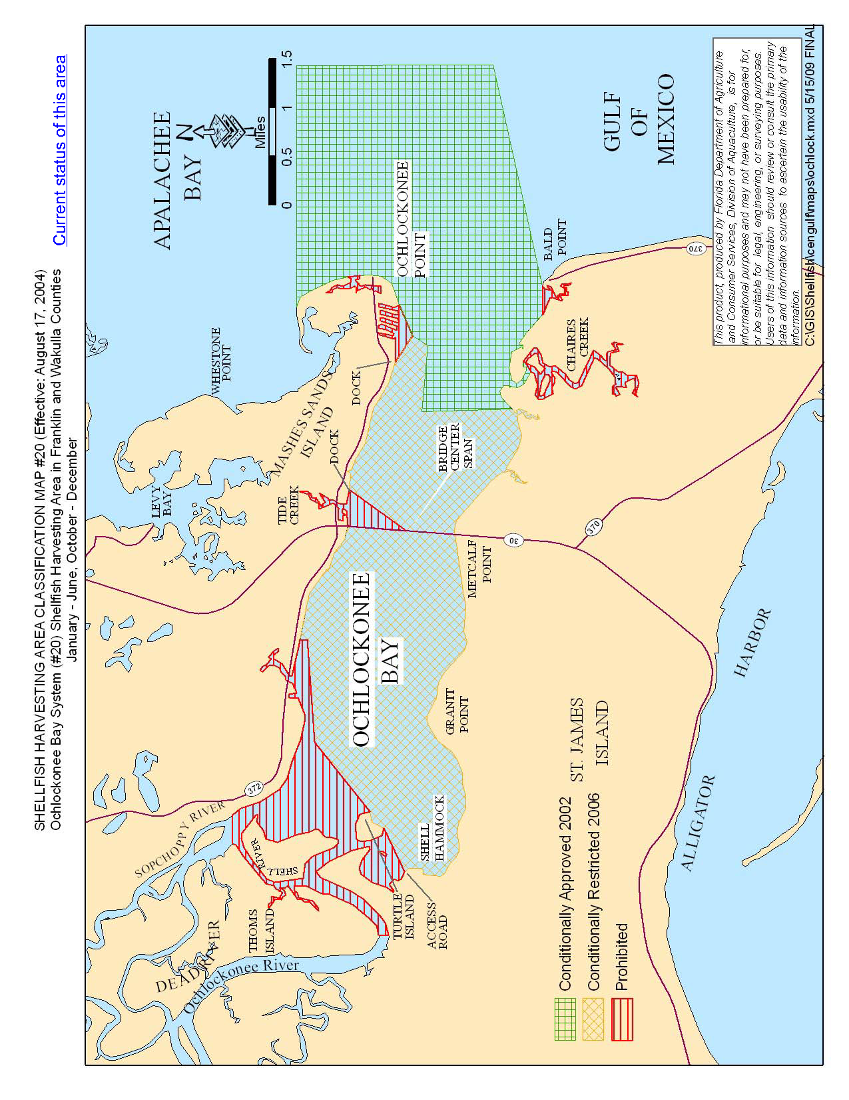 | 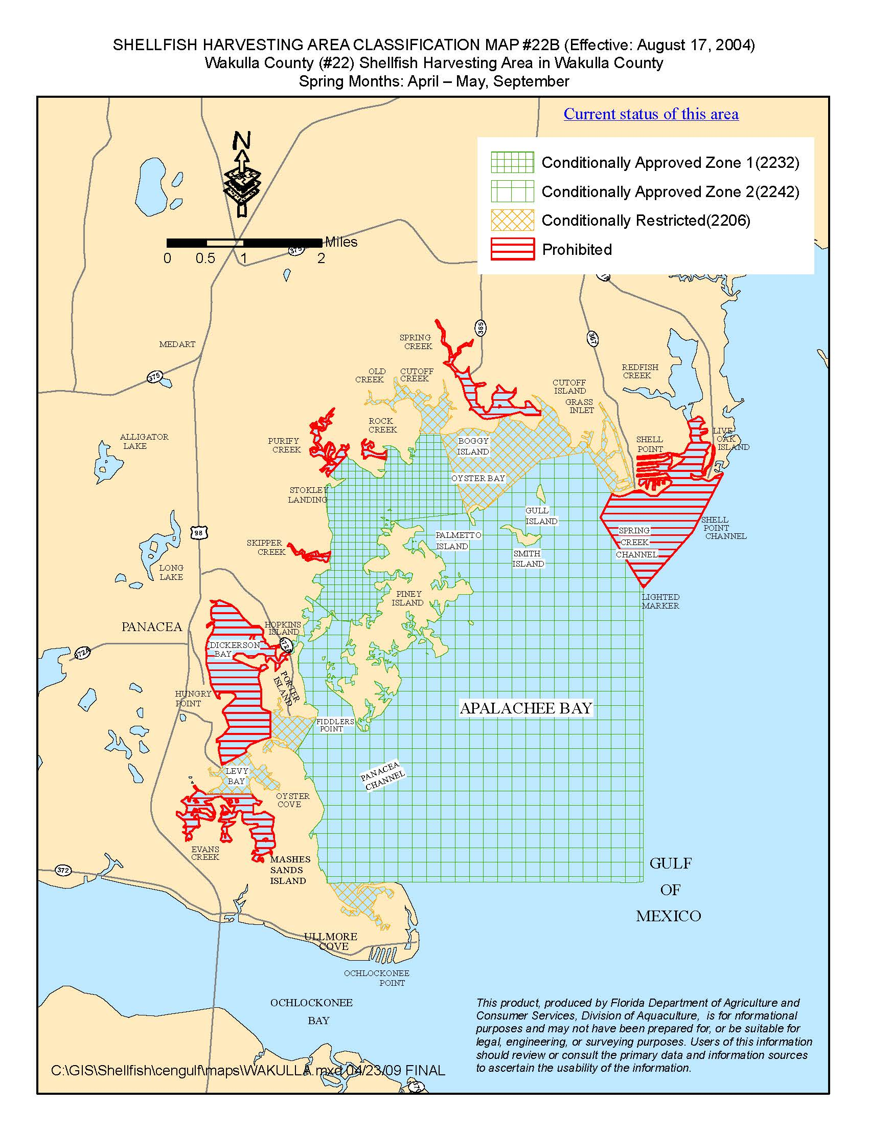
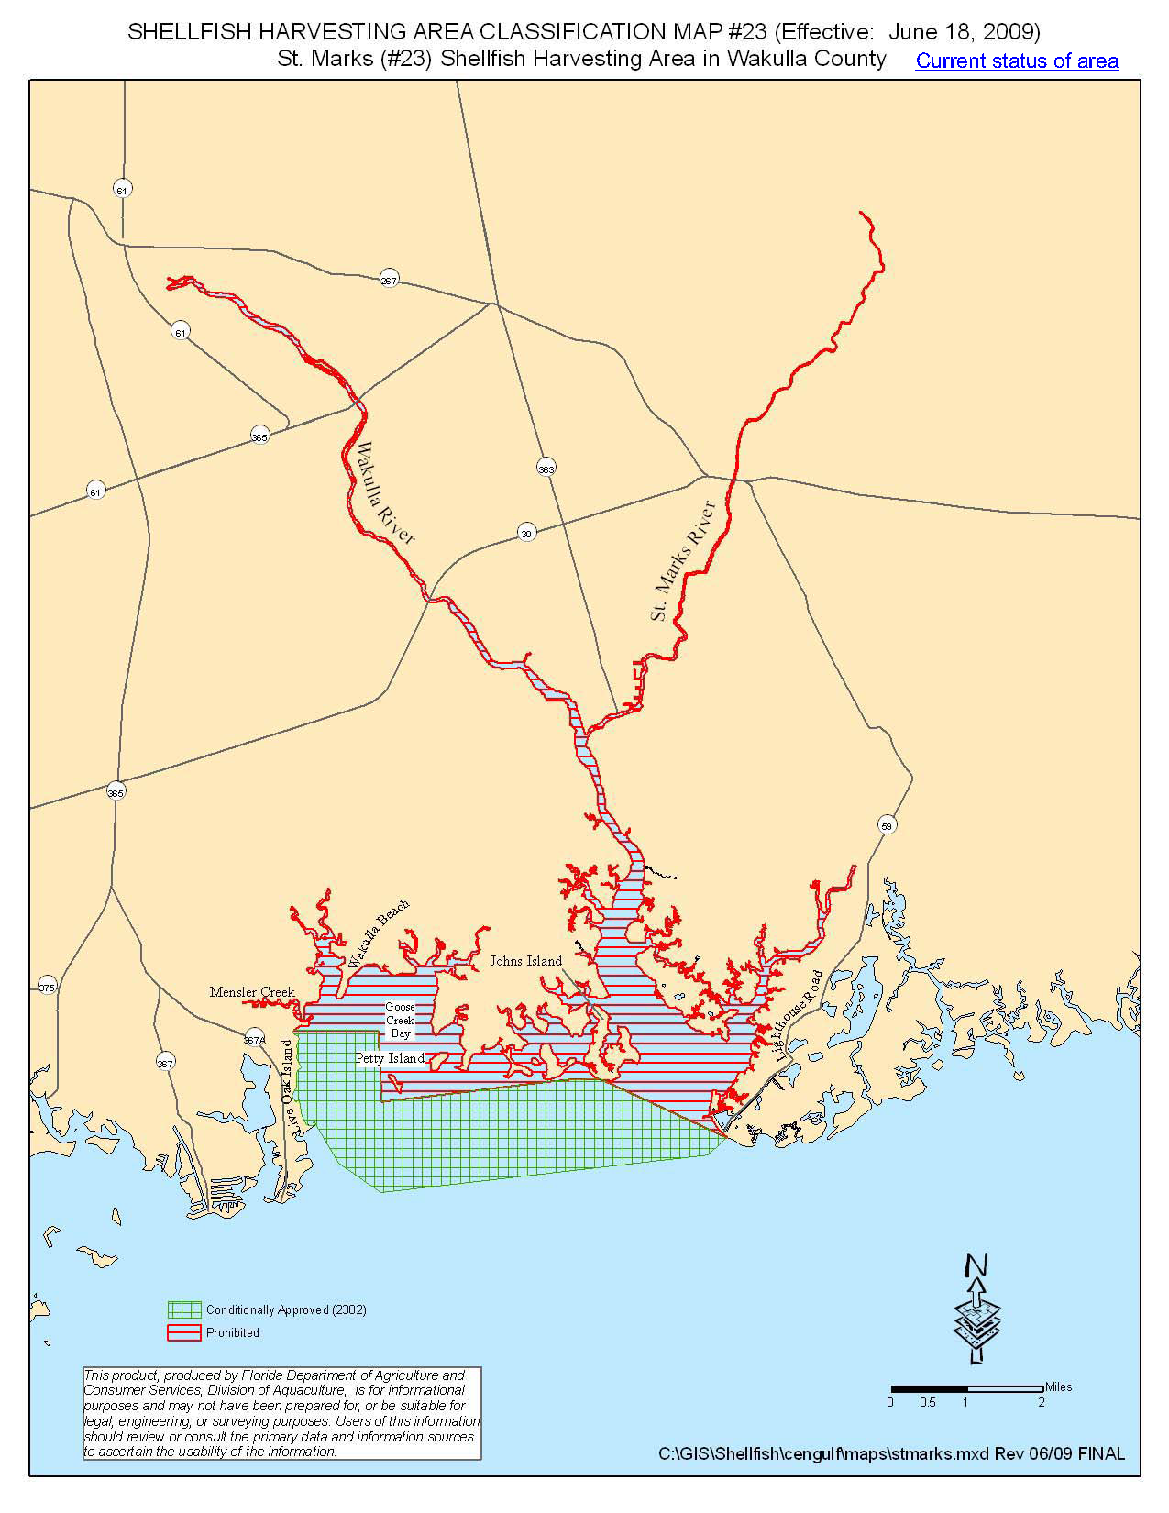
Figure 2. Maps show classified oyster waters off Wakulla County. Areas that are conditionally restricted and potentially those prohibited areas (orange diamonds and red stripes) provide opportunities during the closed summer season to transfer oysters to viable habitats for reef rehabilitation and, ultimately, harvest and an improved fishery.
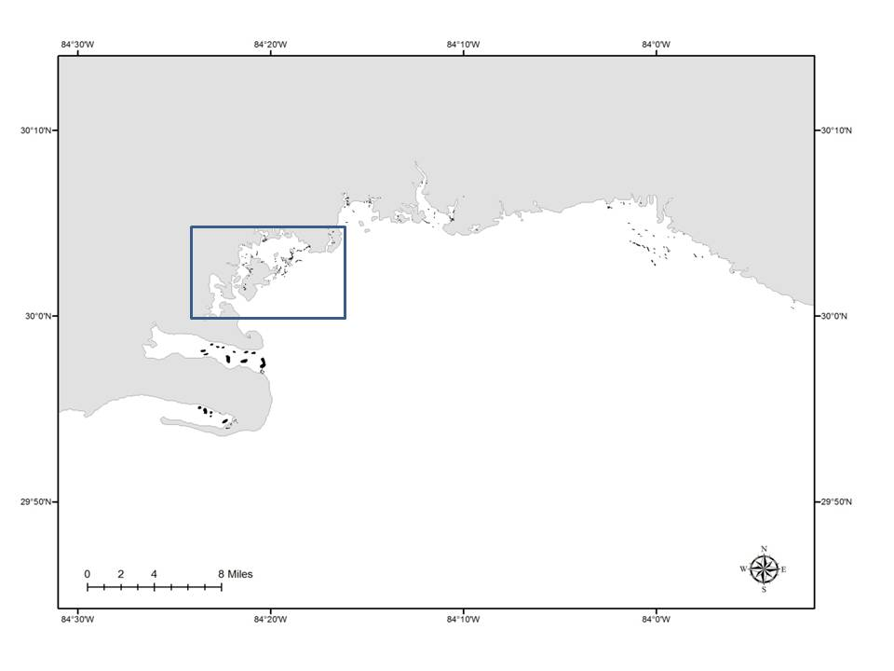
Figure 3. Current delineation of producing oyster beds in Wakulla County (black polygons); note the discrepancy of this map with the observable oyster reefs in Figure 1 (inset rectangle = approximate view of Figure 1). Taken from VanderKooy (2012).
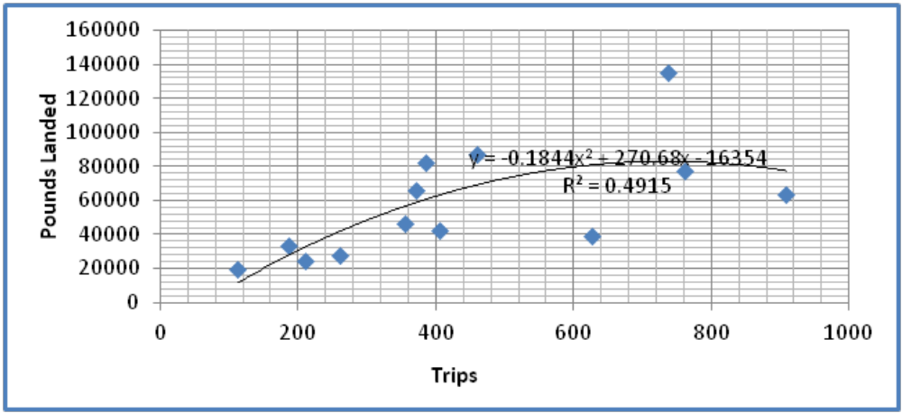
Figure 4. Wakulla County pounds of oysters landed vs. trips.
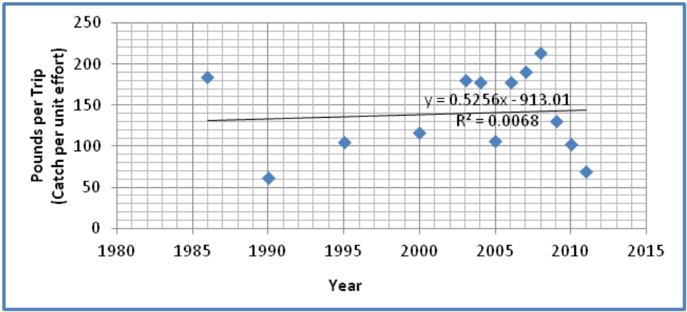
Figure 5. Wakulla County catch per unit effort (pounds of oysters per trip) over time; note dramatic decline in last 4 years.

