FLORIDA GULF OF MEXICO RESTORATION
PROJECT SUBMITTAL FORM

Form Purpose and Instructions:

- To assist the project proposal and review process, please complete this Submittal Form. Completion of the Form will contribute to the appropriate information being completely and accurately submitted for each project.
- Take as much space as needed for each question, but please keep responses as focused as possible. It may assist you to review all the questions before addressing any one question.
- Please submit one Form per project, if you have multiple projects - please submit one Form for each project.
- Please submit completed Forms to Restoration.Projects@dep.state.fl.us. Once your Form is successfully submitted, you will receive a confirmation email from the Florida Department of Environmental Protection.

PROJECT NAME:

Bonefish and Tarpon Conservation Research and Outreach Center. Located at the Florida Fish and Wildlife Conservation Commission’s Keys Marine Laboratory (co-managed by the Florida Institute of Oceanography).

CONTACT INFORMATION:

Brett Boston, Executive Director
The Wildlife Foundation of Florida, Inc.
brettboston@wildlifeflorida.org
850-922-1066

Aaron Adams, Ph.D. Director of Operations
Bonefish and Tarpon Trust
aaron@bonefishtarpontrust.org.
239-896-5055

Jerald S. Ault, Ph.D., Professor of Marine Biology and Fisheries
Director, Tarpon & Bonefish Research Center
Rosenstiel School of Marine and Atmospheric Sciences
University of Miami
jault@rsmas.miami.edu
305-421-4884

Jonathan Shenker, Ph.D., Associate Professor
Florida Institute of Technology
shenker@fit.edu
321-674-8145

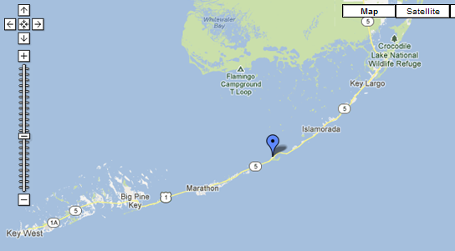
PROJECT LOCATION
Keys Marine Laboratory
68486 US Highway 1
Layton, Florida 33001
Monroe County

Latitude: 24.826 N
Longitude: 80.814 W

Florida Keys Watershed

Figure shows the location of the Florida Wildlife Conservation Commission’s Keys Marine Laboratory at Layton on Long Key, Florida, and the proposed site of the Bonefish and Tarpon Conservation Research and Outreach Center (blue arrow).
Bonefish and Tarpon Conservation Research and Outreach Center

To be located at the Florida Fish and Wildlife Conservation Commission’s Keys Marine Laboratory

Project Description

Florida’s recreational and commercial fishing industries and associated businesses, worth billions of dollars and hundreds of thousands of jobs to the State’s economy, have been severely impacted by the 2010 Deepwater Horizon (DWH) oil spill. These effects are still obvious 3 years after the event. Besides having our beautiful beaches, estuaries and other sensitive coastal areas directly impacted by oil intrusion, vast expanses of state and federal waters were under fishery closures for months on end. Moreover, the extensive media coverage of the spill negatively impacted tourism-related fisheries businesses throughout the state. Combined, these impacts resulted in significant loss of human uses and access to Florida’s saltwater fisheries resources. The consequences of such losses have included:

- A documented substantial reduction in the numbers of recreational fishing trips (i.e., angler-days) in Florida that greatly impacted private recreational anglers, and the solvency of guided charter and headboat fishing operations.
- Sharp reductions in resident and out-of-state visiting anglers due to the perception of lost fishing opportunities and/or unhealthy or contaminated fishes.
- Drastic reductions in fishing-related tourism revenues.
- Reductions in commercial fishery harvests (i.e., landed less than the available quotas) for several key fish stocks due to the extended fishery spatial closures directly associated with the DWH oil spill.
- Lost sales and new market development opportunities for Florida’s seafoods given the regional, national and international perception of unsafe and tainted seafoods resulting from the DWH oil spill.

This drastic reduction in fishing-related revenues had severe economic consequences.
Sportfishing in Florida accounts for more than $5 billion dollars of economic impact to the State, rivaling the Citrus industry in economic productivity, supporting one of the largest saltwater fishing-related tourism industries in the world. Close to half of the estimated recreational fishing trips in Florida are made by visitors to the state, driving a tremendous economic engine, including $119.7 million in indirect business taxes. The importance of recreational fishing to the State of Florida, particularly the Florida Keys, is underscored by the legislative promotion of Florida as the “Fishing Capital of the World”.

Despite the economic and social importance of these sportfisheries, data to assess and manage these valuable resources are very scarce. The state of marine sportfisheries is generally characterized by declining catches, degradation of spawning and natal habitats, and depletion of prey populations, rendering many of the State’s premier sportfisheries vulnerable to collapse. Concomitantly, new regional environmental threats such as cold snaps and oil spills have heightened concerns about fishery sustainability. The growing litany of observations underscores the increased recognition that precious marine ecosystems like the Florida Keys and the Gulf of Mexico, and the world-class fisheries they support, are not inexhaustible resources. Development of methods and strategies to sustain these lucrative and ecologically important fisheries is critical for the economic and cultural stability of Florida in coming decades.
Bonefish and tarpon sportfisheries, perhaps some of the world’s most storied fisheries, provide livelihoods to tens of thousands of Americans from Texas to Florida to Virginia. Tarpon fisheries alone have billions of dollars of economic impact annually to the Gulf of Mexico and southeastern U.S. economies. About 70% of all the current IGFA world records (fly- and saltwater line class) for bonefish and tarpon have been caught in the Florida Keys, making it a world-class destination. In fact, South Florida is the birthplace of “flats fishing,” (which includes bonefish, tarpon, and permit) a unique set of “local” fisheries with an annual economic impact exceeding $465 million. Tarpon are also a vital seasonal component of the Florida Keys fishery during their annual migration and also support important recreational fisheries throughout Florida, the Gulf of Mexico, southeastern United States, and Caribbean Sea. Bonefish and tarpon are also important components of the recreational fishery in the Florida Everglades, with an estimated annual economic impact of about $1 billion dollars. These premier sportfisheries are also of significant economic and cultural importance to developing nations in the region including the Bahamas, Belize, Cuba, Costa Rica, Nicaragua, Panama, Columbia and Trinidad. The fisheries along these countries are interconnected with those in the United States, so lack of coordination and regulation on these shared fishery resources can affect Florida fisheries too!

The importance of the South Florida coastal marine ecosystem to broader Florida and surrounding region’s fisheries is underscored by our research that clearly shows that most adult tarpon seen seasonally (spring, summer) in the Florida Keys and the more northerly Florida coastlines migrate to the plume of the Mississippi River in the northern Gulf of Mexico, while others migrate northward along the southeastern U.S. coast to as far north as the Chesapeake Bay (Fig. 1). In addition, juveniles spawned each year during late spring-early summer depend exclusively upon intact coastal estuaries and wetlands for their first few years of life. These fragile and vulnerable young fish would suffer egregiously from losses and degradation of these critically important coastal habitats. Due to its subtropical climate and tropical marine environment, southern Florida supports the highest abundance of juvenile tarpon in the entire coastal United States, Thus, a healthy Florida tarpon population is essential to a sustaining a robust regional U.S. fishery.

Due to observed declines in catches and apparent abundance from known historical levels, there are serious concerns today about the status and sustainability of bonefish and tarpon populations in Florida and the Gulf of Mexico and southeast U.S. region, and thus, the economic, ecological, and culturally important fisheries they support. The Florida Keys’ bonefish population has declined believed to be due in part due to fishing, habitat degradation and prey loss, and environmental changes. Tarpon populations in the region have sharply declined and are also severely stressed. For example, a recent review by the International Union for the Conservation of Nature classified Atlantic tarpon as “vulnerable”. The classification was attributed to overfishing (primarily in directed central and South American subsistence fisheries), but also due to increasing levels of habitat degradation and prey losses, pollution, and reductions in coastal water quality. Unfortunately, for both species we lack substantive and sufficient scientific knowledge on their biology, ecology and population dynamics to reverse these population declines and ensure resource sustainability. However, we do know that continued environmental degradation and intensive fishing will exacerbate these deleterious population declines.

Of particular concern are impacts on tarpon and bonefish spawning populations and reproductive dynamics, particularly as it relates to the sensitive early life stages, but also to the physiological response to the environment (i.e., bioenergetics) of spawning adults. Both species spawn well offshore, so their larvae are vulnerable the vagaries of ocean currents and waterborne contaminants. Recent research indicates that tarpon likely spawn in the area proximal to the DWH oil spill. Satellite-tagged and tracked adult tarpon traveled to the offshore DWH spill area during the full moons of summer, the exact period when tarpon spawn (Fig. 1).

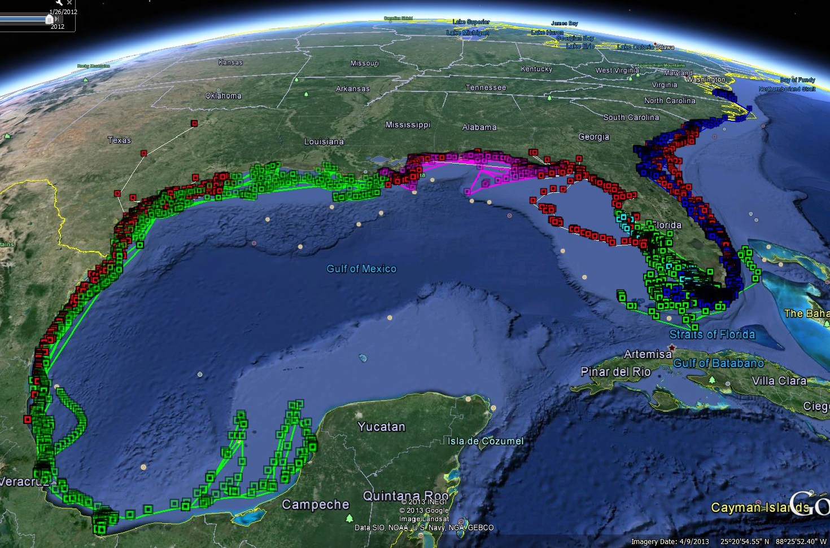

Figure 1. Documented migration tracks of adult Atlantic tarpon obtained from more than 250 satellite-tags deployed at various locations in Florida, the Gulf of Mexico and the southeastern U.S. Atlantic (Ault, 2008; Luo et al. 2008, 2010; Ault, 2010; Luo and Ault, 2012)

Although substantial additional research is needed to determine the specific migratory pathways, the extent of offshore movements, exact spawning locations, and the portion of the regional tarpon population that uses the northern Gulf of Mexico as opposed to the southeastern US coast, enough is known about adult tarpon migrations and ocean circulation and transport patterns to indicate that the DWH spill greatly impacted the population. Additional research is needed to better understand the extent that the DWH spill, and other perturbations in the future, impact these population migrations and spawning successes.

Recent larval sampling and satellite-tagging research has identified several major spawning locations for tarpon – both in areas that were impacted by the DWH spill (Fig. 2). An ongoing reexamination of larval fishes collected by the NMFS SEAMAP Ichthyoplankton Survey identified a site off the Mississippi River Delta, directly in the region of severe DWH impact. Another suspected site is on the outer edge of the western shelf of the Florida peninsula, and another in the Florida Keys Larvae produced in the DWH area were impacted by the spill. Larvae produced at the western shelf edge and Florida Keys would have been subject to DWH petroleum exposure if the Loop current had picked up the petroleum, as many researchers anticipated. Such impacts can have profound regional and population level effects.

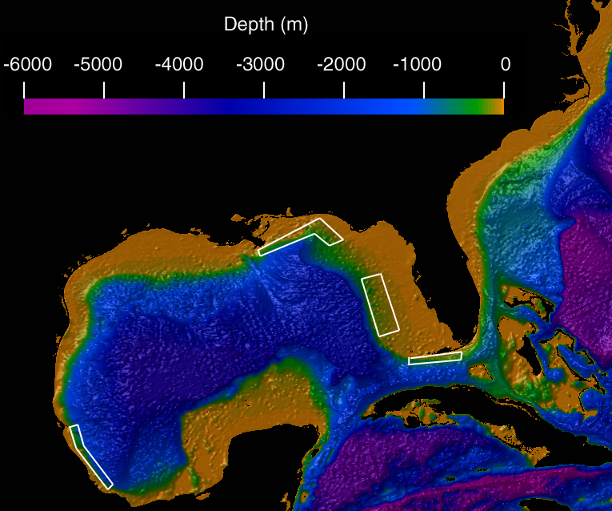

Figure 2. Suspected tarpon spawning locations (white rectangles) along coastal Florida and the Gulf of Mexico identified from satellite-tagging observations and re-examination of samples from the SEAMAP ichthyoplankton survey (Shenker et al., in prep.).

After an approximate 3 week period in the plankton, tarpon larvae produced from the Mississippi River and Florida regions are expected to move into nursery habitats ranging from the Mississippi Delta to marshes all along the western shore of Florida, across the Keys and up the east coast to the Indian River Lagoon. In fact, if oil from the DWH had been entrained in the loop current, expectations were that the nursery areas in the Keys and east coast of Florida would have been affected. These nursery habitats are easily impacted by oil spills, with long-lasting effects. The nurseries represent the future of the fishery, so their loss or degradation is very worrisome. Similarly, juvenile bonefish use shallow, soft-bottom habitats near deep water, which are extremely valuable to contamination and degradation.

For bonefish and those tarpon spawned along peninsular Florida, winds and currents that occurred during the DWH spill event are believed to have kept the bulk of the oil in the northern Gulf. Although northern Gulf wetlands and offshore areas were severely damaged, and the tarpon spawning off the Mississippi River Delta may have been dramatically impacted, the situation could have easily been far worse for the regional tarpon and bonefish populations. Under other frequent wind and current conditions, the oil could easily been transported south and around the Florida Keys and have impacted a much broader swath of vital coastal waters, estuaries and wetlands throughout the eastern Gulf of Mexico, Everglades, Florida Keys, and along the Atlantic coast of Florida.

Better understanding of the environmental requirements of bonefish and tarpon, their essential habitats and spawning requirements is a prudent way to evaluate the lingering impacts resulting from the 2010 DWH oil spill. Such knowledge is critical for preparation of impact assessment efforts and post-impact recovery activities for future events that may affect the region. This preparation includes comprehensive analyses of habitat-based potential impacts on wild populations as well as development aquaculture methods for eventual stock enhancement for these two species. Such programs of habitat evaluation, restoration of essential spawning and nursery habitats, and culture and release of young fish (fingerlings) have proven critical for the restoration of vital striped bass and red drum fisheries along the mid-Atlantic and Gulf states). Many other similar stock enhancement restoration programs in coastal marine environments exist for a variety of fish species around the country.

The Bonefish & Tarpon Trust (BTT) has long prioritized research on the biology and ecology of bonefish and tarpon, their habitats, and their management, as part of their mission to identify and implement ways to sustain or enhance wild populations. .As part of this effort, BTT strives to be able to conduct stock enhancement of tarpon and bonefish, but thus far this remains a distant goal. Two primary difficulties hinder the initiation of aquaculture of bonefish and tarpon: 1) getting adults to spawn in captivity and 2) rearing their unusual larval stages. Since their larval stages are nearly identical, research on rearing one of the species will have direct and immediate applications for the other species.

Given the importance of these two species to the economies of Florida and the Florida Keys and of tarpon to the entire Gulf of Mexico and southeastern US, their vulnerability to coastal habitat alteration, and their susceptibility to serious damage from events like the DWH, it is imperative to develop a program to sustain these vital fishery species. A critical component of this strategy is to conduct the research necessary to successfully culture and stock these species for use in population restoration programs.

The Wildlife Foundation of Florida (WFF), acting on behalf of the Florida Fish and Wildlife Conservation Commission (FWC) and the Florida Institute of Oceanography (FIO), therefore proposes to establish a basic facility for bonefish and tarpon culture propagation research in the Florida Keys. The site will also serve as an education and outreach center for professional fishing guides, marine anglers, tourists and other stakeholders. In addition, the site will also provide a base of operations and public outreach for satellite-tracking studies of the movement patterns, spawning and ocean habitat use of adult “Florida” tarpon as they migrate to and from the Florida Keys and Florida throughout the Gulf of Mexico, southeast Atlantic and Caribbean Sea.

Key project partners in this endeavor include: Keys Marine Laboratory (KML), BTT, University of Miami’s Rosenstiel School of Marine and Atmospheric Sciences (UM), Florida Institute of Technology (FIT), FAU/Harbor Branch Oceanographic Institute, and the Florida Marine Fisheries Enhancement Initiative.

Through a series of preliminary discussions, the project partners have identified an under-utilized area of FWC’s KML property that is suitable for the BTCROC (Fig. 3). The proposed site will be the principal location for culture and propagation research methods for the production of bonefish and tarpon. Additional complimentary research will be conducted at other locations on specific biological, ecological and aquaculture processes.

Development of spawning stocks of adult fishes is one of the primary goals of the proposed BT-ROC. This is a difficult task, and we anticipate that development of successful techniques to induce spawning will take several years of effort. Compounding the difficulty of culturing bonefish and tarpon is that they (along with closely-related ladyfish and more distantly related eels) have a very unusual larval stage that has not yet been grown in culture systems. Because it will be critical to have larval culture methods ready to use when the adults produce eggs, we will develop methods to culture those larvae from ladyfish maintained in captivity at the Florida Institute of Technology’s Vero Beach Marine Laboratory, and on wild bonefish captured during their spawning migration in the Abacos, Bahamas. These culture methods will include development of larval feeds based on natural and artificial foods that simulate the hypothesized primary natural nutrient sources: gelatinous zooplankton and “marine snow.”

For the bonefish and tarpon culture and propagation research component, the project partners propose to:

- Utilize and modify existing KML structures with a variety of large controlled-environment aquaculture tanks. Water treatment technology will produce high quality temperature controlled seawater for reproductive conditioning.
- Characterize the spawning and feeding migrations of adult tarpon by intensive satellite-tracking of adults tagged in the Florida Keys and southwest Florida.
- Conduct long-term experiments on captive adult bonefish and tarpon to determine ways to induce reproductive maturation and spawning in these aquaculture facilities (using both environmental and hormonal manipulation).
- Build a state-of-the-art biofilter for fish effluent from the hatchery operation and tanks.
- Use the water cleansed by the biofilter for additional aquaculture of organisms vital to the Keys ecosystem, including sea grasses, conch and urchins.
- Establish BTCROC Staffing: two on-site personnel (either FWC, FIT or UM researchers).
- Conduct off-site studies, as appropriate, on specific biology, bioenergetic and aquaculture husbandry processes.

For the outreach component, the project partners propose to:
- Enclose and utilize the large covered structure on the north end of the property for an outreach facility.
- Allow visitors access and limited parking via the road on the north end of the property, reducing traffic through the main facility entrance.
- Allow guides and anglers to access the center via their boats. Utilize a shallow pond area, with island in the center, as a viewing and demonstration area for visitors.
- Provide visitors with information about the goals and operations of the BT-ROC.
- Create an on-line presence enabling people from around to world to view and learn about the research goals and progress.
- BT-ROC Staffing: one person on-site (BTT)

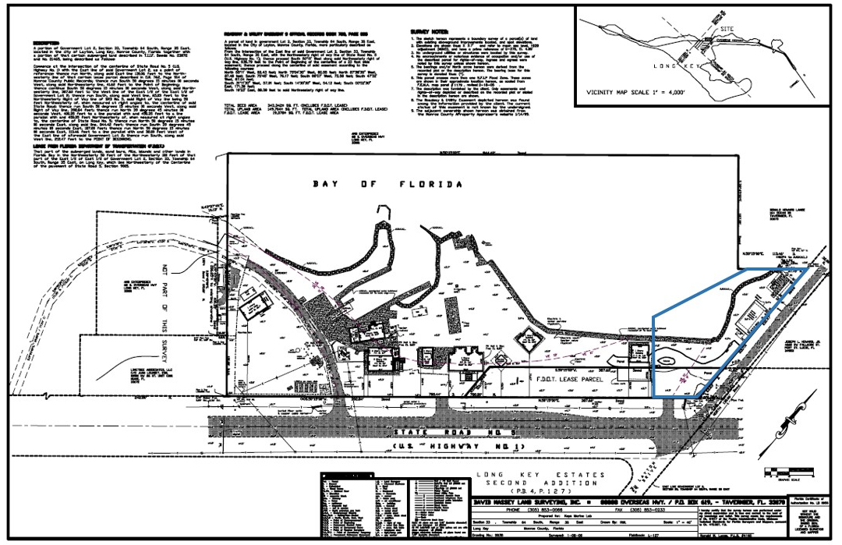

Figure 3. Land survey of the FWCC Keys Marine Laboratory and the proposed Bonefish and Tarpon Conservation Research and Outreach Center (outlined in blue).

Estimated Project Costs

The projected cost of this project is as follows:

Construction and Year 1 operations: $ 2,966,206

Year 2 - 6 operations: 4,270,975

Total costs through Year 6 of operations: $ 7,237,181

The attached Cost Appendix sheet provides details about specific budgets and expenditures.

FWC will provide the land on the northern portion of the Keys Marine Laboratory for the BTCROC. Approximately 20,000 square feet in extent), this land has a very high value; the value of similar waterfront land in the Florida Keys often exceeds $1M/acre.

BTT has provided years of research funding that is making the endeavors of the BT-ROC feasible. Their funding is also presently enabling research on ladyfish spawning at larval culture at FIT, and research on wild spawning populations of bonefish in the Abacos.

Other Funding

Project partners, including the BTT and the FWC, continue to support research on maintenance of tarpon and bonefish populations, and have indicated their willingness to contribute financially to this project.

Technical Feasibility

The partners of the BTCROC bring tremendous expertise to focus on the goals of culturing bonefish and tarpon, and ultimately conducting stock enhancement programs for these vital fishery species. These participants provide the knowledge and operational skills to make this project technically feasible.

The WFF is coordinating the Florida Marine Fisheries Enhancement Initiative, which seeks to employ aquaculture to produce and release juveniles of many coastal fish species to rebuild Florida fishery populations. Although their efforts primarily focus on species that are much closer to large scale production than are bonefish and tarpon, this organization brings together a wide range of experts that can assist in the bonefish and tarpon endeavor.

The Florida Fish and Wildlife Conservation Commission is a major component of the Florida Marine Fisheries Enhancement Initiative. The organization has decades of experience in aquaculture and fishery restoration, through the operations of the Stock Enhancement Research Facility (Port Manatee, FL), the Keys Marine Laboratory and other facilities. The experience of a wide array of FWC aquaculturists will be utilized in developing culture methods for adult maturation and spawning of bonefish and tarpon.

The Bonefish and Tarpon Trust, a research and funding organization and leading coordinator of tarpon and bonefish research, has directly sponsored and conducted many research projects focusing on these species, and has developed a large membership and outreach program. Dr. Aaron Adams, Director of Operations of BTT, is the leading research biologist on spawning studies on wild populations of bonefish and directs projects on the population structure and dynamics of bonefish.

Dr. Jerald Ault at the University of Miami’s Rosenstiel School of Marine and Atmospheric Sciences is an internationally renowned fisheries scientist who has pioneered the satellite-tracking of adult tarpon. His team’s efforts over the past 10 years have defined basic migratory pathways, spawning locations and ocean-estuary habitat use of adult fish around Florida, the Gulf of Mexico and the east coast of the United States. He is currently adopting the use of the newest state-of-the-art technological generation of satellite tags that provide real-time positioning and environmental data that permits far more precise descriptions of migrations and habitat use than was previously available.

Dr. Jon Shenker at the Florida Institute of Technology had established an adult ladyfish brood stock at the university’s Vero Beach Marine Laboratory, and is initiating studies on spawning and culture of the unique larvae of these fishes. He has been working on larval stages of bonefish and tarpon for over 15 years. His work also includes intensive studies on the biology, ecology and habitat requirements of juvenile tarpon.

Florida Atlantic University/Harbor Branch Oceanographic Institution is a leading aquaculture research institute and will assist in the implementation of biofilter water treatment at BT-ROC.

Environmental Benefits

This project will be of great benefit to populations of bonefish and tarpon, with the goal of counteracting the dramatic decline of bonefish in many parts of the Florida Keys, and addressing the vulnerable status of tarpon, as recently designated by the IUCN Red List. We propose a genetically and ecologically sound method of propagation to help protect these species. Since the recreational fishery for these species depends on healthy habitats, propagation of these species that enhances the fishery will also provide impetus for increased habitat conservation.

Waters used in conjunction with fish propagation will be treated with a state-of-the-art bio-filter system, which in turn will be used for culturing other organisms that are critical components of coastal ecosystems.

This facility will be developed on property that is already minimally developed. As such, there is no loss or conversion of habitat.

Economic and Social Benefits

This project will enhance Florida’s recreational saltwater fishing industry, as well as positively influence regional fisheries. Recreational saltwater fishing impacts Florida's economy with over $5.7 billion and over 50,000 jobs. Florida is considered the "Fishing Capital of the World" with more world record fish catches than any other state or country. From an economic perspective, Florida also leads all states in economic impacts for its marine recreational fisheries and has one of the top producing commercial fisheries in the country.

In the 2010/2011 fiscal year, over 1.2 million individuals bought a saltwater recreational fishing license including more than 860,000 Florida residents and 394,000 non-residents. Total revenue for all marine recreational fishing license sales was over $25 million.

In 2009, the Department of Commerce's Fisheries Economics of the United States 2009 says eastern Florida recreational anglers took 10 million fishing trips: 5.4 million by private/rental boats, 4.5 million from shore, and 180,000 by party/charter boat. West Florida recreational anglers took 15.5 million trips: 8.4 million private/rental, 6.4 million by shore, and 567,000 by party/charter boat.

Recent studies on the economic impact of the recreational fishery in Florida are revealing: the Florida Everglades recreational fishery has an annual economic impact of approximately $1 billion; the flats fishery in the Florida Keys annual economic impact exceeds $465 million; local anglers fishing for tarpon in southwest Florida’s Charlotte Harbor estuary had a $110 million impact. Therefore, to the extent that this work increases the quality of the fisheries, it will have significant positive economic effects on the region.

Community Resilience

Bonefish and tarpon are key components in the ecosystem of southern Florida and the wider Caribbean, including mangroves, wetlands, seagrasses, coral reefs, and other nearshore habitats. Tarpon are also ecologically important throughout the Gulf of Mexico and southeastern United States. Therefore, propagation of these species to return their populations to historic levels will have ecosystem-level effects resulting from these species’ roles as important predators and prey. Stock enhancement efforts may also help species and fisheries recover from episodic environmental perturbations (such as the DWH incident) and adapt to changing ecosystems as global climate change alters coastal and nursery habitats.

The fisheries for bonefish and tarpon are also important culturally. Generations of fishing guides have relied upon the fishery to make a living, and this has created a culture around the fishery. Since this project will increase the resiliency of the fishery to environmental perturbations, it will also make the culture of these coastal communities more resilient.

Conflicts or Complements to Existing Efforts

This project will complement the Florida Fish and Wildlife Conservation Commission’s research and implementation of fishery enhancement programs being conducted at the Stock Enhancement Research Facility and the Florida Bass Conservation Center. In addition, it will complement the Florida Marine Fisheries Enhancement Initiative being coordinated by the Wildlife Foundation of Florida.

Complies with Federal, State, Local, and Tribal Laws/Regulations

There are no apparent issues or potential conflicts with federal, state, local or tribal laws or regulations.

Readiness for Implementation

Multiple meetings have been held with the leadership and staff of the Keys Marine Laboratory regarding this concept to ensure the staff is on board and that decisions made regarding where to place the experimental hatchery have their full support. Collectively, the group determined the best location within the KML property to place this facility.

The Wildlife Foundation of Florida has commissioned a suite of design plans which are attached. At the time of construction, permits will need to be applied for from the City of Layton, Florida. The City has a long-standing relationship with the KML and we anticipate that there will be no significant delays related to permitting.

Public Acceptance

The project will seek the cooperation of nearby property owners for use of an access road to the site. The neighborhood views the KML as a valuable asset to the community, and we anticipate that the BT-ROC will increase the value of the facility to the surrounding community and tourism industry.

Cost Appendix Sheet
Cost Item – Construction and Year 1 Operations | Cost Estimate
Planning | 55,000
Contracts | 4,500
Feasibility | 6,500
Engineering, Design, Land Rights & Bid Prep | 7,100
Restoration Plan | 11,000
Site Visits & Cost of Site Selection | 6,300
Administration, Overhead and Indirect | 50,100
Other | 12,200
Planning Subtotal: | 152,700
Construction
Contracts | 1,250,000
Administration & Mobilization/Demobilization | 38,300
Other – Equipment/materials | 350,900
Construction Subtotal: | 1,639,200
Monitoring
Contracts | 10,000
Tarpon, bonefish, ladyfish research field data collection | 600,000
Monitoring Administration | 25,000
Annual operating cost (includes larval rearing) | 357,512
Monitoring Subtotal: | 992,512
Project Cost | 2,784,412
Supervision | 95,400
Subtotal: | 2,879,812
Contingency 3% | 86,394
TOTAL: | 2,966,206

Estimated Costs by Year | Operations | Research and Monitoring
Year 2 | 364,052 | 600,000
Year 3 | 368,974 | 600,000
Year 4 | 374,043 | 600,000
Year 5 | 379,265 | 600,000
Year 6 | 384,641 | 600,000
Total | 1,870,975 | 2,400,000
6 year Project Total | 7,237,181

