RESTORE Act Ecosystem Restoration Project Proposals
for consideration in the Gulf Coast Ecosystem Restoration Council’s Comprehensive Plan
2012
Contact Information: Veronica Craw, Environmental Section Manager  Southwest Florida Water Management District  2379 Broad Street  Brooksville, FL 34604  352-796-7211 ext. 4267  Veronica.Craw@SWFWMD.state.fl.us |  |  |  |  |  | Date of Submittal: 10/9/2012
Name of Project: Chassahowitzka Spring Dredging Restoration Phases I and II |  |  |  |  |  | Org and Rank:
Project Description: The dredge and fill activities in the 1960’s in the Chassahowitzka area caused excessive sediment transport from residential canals to the headsprings. To alleviate the deposition of nutrients to the system from residential septic tanks along these canals, Citrus County provided central sewer to the residents. Phase I of the restoration project consists of the suction dredge removal of 3,800 cubic yards for the Chassahowitzka Headsprings complex. Phase II consists of the suction dredge removal of 1,500 cubic yards or sediment from an upstream turn basin. The removal of sediments in the turn basin will keep the sediments from entering the springs and the turn basin will serve to act as a sediment sump to capture and hold sediments thereby eliminating the possibility that they are transported to the springs.
Project Location: The project is located in the community of Chassahowitzka, Florida between Weeki Wachee and Homosassa.
Responsible Party: Southwest Florida Water Management District (SWFWMD) |  |  |  | Partners:
NEP: |  | Project Cost: $1,247,800 |  |  | Dollars Needed: $1,247,800
Start: 09/03/2010 |  |  |  | Completion: PI-09/30/2013 PII- 09/30/2015
Status of Project Design and Permitting: Design and permitting are complete for Phase I which is scheduled to be bid out for construction in November 2012 with a completion date of September 2013. Feasibility and conceptual design for Phase II is complete and design, permitting and construction will be will be budgeted for in FY2014-15.
What Date or Year could Construction Feasibly Begin:2013
Your Proposed Timing of Funding (given permits, phasing, staging, etc.)
FY | Previous | 12/13 | 13/14 | 14/15 | 15/16 | 16/17 | Total
 | $413,200.00 | $439,600 | $395,000 |  |  |  | $1,247,800.00
Quantify Environmental Results and How to Measure Them: The primary benefit to the headspring will be an improvement in water quality through the removal of nutrient-rich sediments and an improvement in water clarity. Phase II includes the removal of sediments from the Turn Basin thereby providing a sediment sump to attenuate sediments. It is expected that the improvements to the water clarity will provide increased use by recreational divers and fisherman providing economic benefits to the local economy.
Economic Benefits (including ecosystem services): Total value added (Value-added is the sum of employee compensation, proprietor income, other property type income and indirect business taxes, values are in 2012 dollars) equals $1,251,577.13. Local businesses are dependent on tourism and ecotourism dollars with saltwater fishing contributing over $3 million dollars annually to the economy with more than 50 percent of the population (tourist and resident) participating in freshwater and saltwater activities in the area. Additional research show that improved water quality that results in a 17% increase in Secchi disk depths equates to an $11,155.00 increase in water front property values.
Estimated number of Jobs Created or Preserved: 19
How much Habitat will be restored and conserved: The Chassahowitzka Springs complex represents approximately 3 acres total.
Quantify pollutant reductions:
What living coastal/marine resources will be improved and by how much: Macrobenthic communities, fish communities and native plant communities by reduction of nitrogen and phosphorous. It is anticipated that the dredging will provide the ability for desirable aquatic plants to become re-established in the springs providing a sanctuary for juvenile fish and provide a food source for wintering west-Indian manatees that frequent the springs in the winter months. In addition to the direct removal of nutrients in the sediments, the submerged aquatic vegetation will provide additional nutrient assimilation.
How will community resilience be enhanced: The removal of sediments from the headsprings and turn basin will provide the ability for desirable aquatic plants to become re-established in the springs providing a sanctuary for juvenile fish and provide a food source for wintering west-Indian manatees that frequent the springs in the winter months.
Additional Justification:
Add any photos or maps that explain project: Attached below.

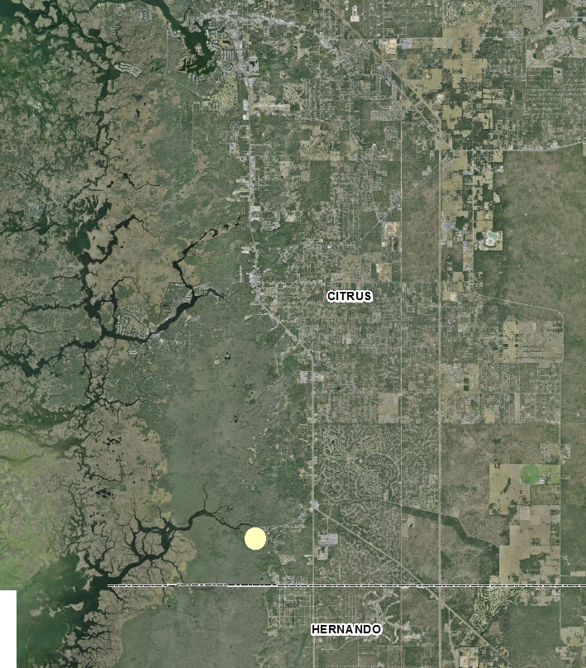

General Project Location Map of the Chassahowitzka Project

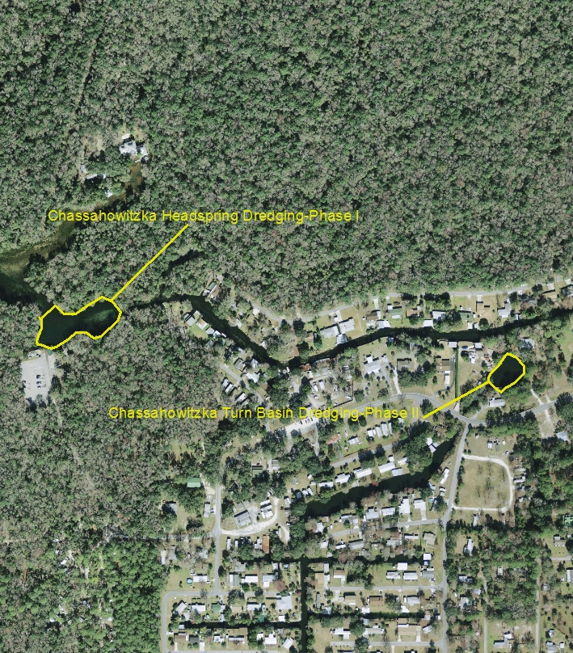
Location of Chassahowitzka Projects-Phases I and II.

