RESTORE Act Ecosystem Restoration Project Proposals
for consideration in the Gulf Coast Ecosystem Restoration Council’s Comprehensive Plan
2012
Contact Information: Veronica Craw, Environmental Section Manager  Southwest Florida Water Management District  2379 Broad Street  Brooksville, FL 34604  352-796-7211 ext. 4267  Veronica.Craw@SWFWMD.state.fl.us |  |  |  |  |  | Date of Submittal: 10/9/2012
Name of Project: Hunter Springs Water Quality Improvement Project |  |  |  |  |  | Org and Rank:
Project Description: The purpose of this project is to expand an existing water quality treatment area at the intersection of NE 2nd Street and NE 3rd Avenue in Crystal River and to dredge and remove accumulated sediment adjacent to the outfall. The proposed project would relocate the forcemain and expand the pond to the maximum size possible on the site. The expansion equates to a 40% increase in volume, which represents a significant increase in treatment capacity. The dredging project will remove accumulated sediment adjacent to the outfall pipe from the water quality treatment area.
Project Location: Citrus county, FL
Responsible Party: South West Florida Water Management District |  |  |  | Partners: Citrus County Public Works Department
NEP: |  | Project Cost: $354,083.00 |  |  | Dollars Needed: $354,083.00
Start: 01/31/2013 |  |  |  | Completion: 09/30/2014
Status of Project Design and Permitting: Design and Permitting scheduled to be complete 09/30/2013
What Date or Year could Construction Feasibly Begin: 2014
Your Proposed Timing of Funding (given permits, phasing, staging, etc.)
FY | Previous | 12/13 | 13/14 | 14/15 | 15/16 | 16/17 | Total
 |  | $354,083.00 |  |  |  |  | $354,083.00
Quantify Environmental Results and How to Measure Them: This project will improve treatment to stormwater that is discharged into Hunter Spring basin, which is part of Kings Bay, an Outstanding Florida Water. In addition, the project will remove accumulated sediments in Hunter Spring basin near the outfall of the stormwater discharge, improving aquatic habitat. Water quality sampling pre and post project completion will determine the potential reduction in nutrient loading to Kings Bay.
Economic Benefits (including ecosystem services): Total Value-added is the sum of employee compensation, proprietor income, other property type income and indirect business taxes valued at $355,154.82. Water quality improvements that results in a 17% increase in Secchi disk depths equates to an $11,155.00 increase in water front property values. Additional ecosystem services include: Saltwater fishing which contributes over $3 million dollars annually to the economy with more than 50 percent of the population (tourist and resident) participating in freshwater and saltwater activities in the area.
Estimated number of Jobs Created or Preserved: 5
How much Habitat will be restored and conserved:
Quantify pollutant reductions:
What living coastal/marine resources will be improved and by how much: Water quality improvements to Kings Bay will positively affect estuary and fresh water fisheries and endangered manatee populations.
How will community resilience be enhanced:
Additional Justification:
Add any photos or maps that explain project:

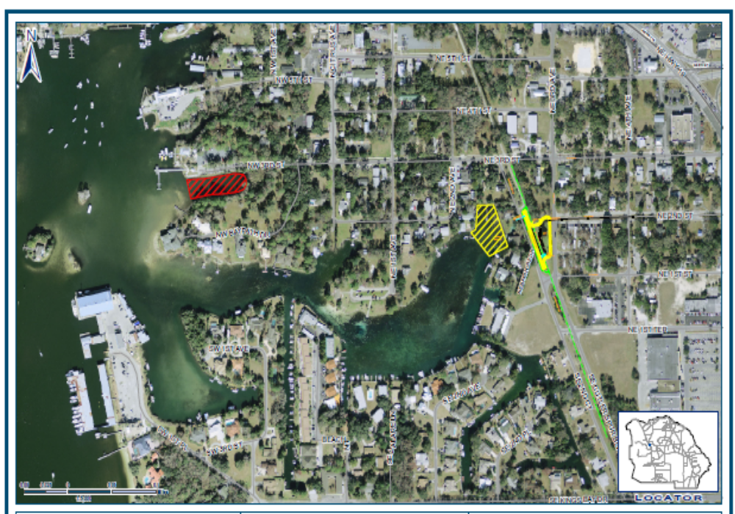
Figure 1- Areas in yellow denote locations of treatment wetland and outfall dredging.

