RESTORE Act Ecosystem Restoration Project Proposals
for consideration in the Gulf Coast Ecosystem Restoration Council’s Comprehensive Plan
2012
Contact Information: Veronica Craw, Environmental Section Manager  Southwest Florida Water Management District  2379 Broad Street  Brooksville, FL 34604  352-796-7211 ext. 4267  Veronica.Craw@SWFWMD.state.fl.us |  |  |  |  |  | Date of Submittal: 10/9/2012
Name of Project: Project COAST-North Water Quality Monitoring (Hernando, Citrus, & Levy Co) |  |  |  |  |  | Org and Rank:
Project Description: Project COAST - North (Citrus, Hernando, and Levy Counties) was initiated in 1996 and involves a monitoring program extending from the Withlacoochee River to the Weeki Wachee River. This project represents an extension of an existing water quality monitoring program for the Springs Coast region that provides information on the health of the coastal springs, rivers and estuary. Earlier agreements provided for monitoring from 1996 - 2011. Because historical data for the coastal areas of Pasco County were lacking, Project COAST was expanded southward along the coast of Pasco County in FY2000. This project uses all data that have been collected over the life of Project COAST to examine the status and trends in water quality throughout the coastal areas of Citrus, Hernando, Levy, and Pasco counties. The University of Florida (UF) will collect monthly samples at a total of ninety fixed stations in the nearshore waters along the coasts of Weeki Wachee, Chassahowitzka, Homosassa, Crystal, Withlacoochee Rivers and Pasco County for total nitrogen, total phosphorus, total chlorophyll, Secchi depth, light attenuation, color, temperature, dissolved oxygen, and salinity. Project COAST - North (Citrus, Hernando, and Levy Counties, B678) was initiated in 1996 and involves a monitoring program extending from the Withlacoochee River to the Weeki Wachee River. The University of Florida samples fifty fixed stations in and near the Weeki Wachee, Chassahowitzka, Homosassa, Crystal and Withlacoochee Rivers for water quality parameters.
Project Location: Hernando, Citrus, Pasco & Levy Counties
Responsible Party: South West Florida Water Management District |  |  |  | Partners: University of Florida
NEP: |  | Project Cost: $2,267,992.00 |  |  | Dollars Needed: $2,267,992.00
Start: 04/25/2004 |  |  |  | Completion:09/30/2015
Status of Project Design and Permitting: N/A
What Date or Year could Construction Feasibly Begin: N/A
Your Proposed Timing of Funding (given permits, phasing, staging, etc.)
FY | Previous | 12/13 | 13/14 | 14/15 | 15/16 | 16/17 | Total
 | $1,868,875.00 | $89,260.00 | $309,857.00 |  |  |  | $2,267,992.00
Quantify Environmental Results and How to Measure Them: This project, initiated in 1996, provides data to help assess the consequences of increased nutrients in the estuaries and near shore habitats and provides baseline data to assess algal blooms and other ecological impacts due to water quality changes. This project continues to provide data to help assess the health of the coastal waters and habitats, to determine the consequences of increased trends in nutrients in the estuaries and near shore habitats, and has provided critical baseline data to assess algal blooms and other ecological impacts due to water quality changes.

.
Economic Benefits (including ecosystem services): Total value added (Value-added is the sum of employee compensation, proprietor income, other property type income and indirect business taxes, values are in 2012 dollars) equals $3,023,216.38. Local businesses are dependent on tourism and ecotourism dollars with saltwater fishing contributing over $3 million dollars annually to the economy with more than 50 percent of the population (tourist and resident) participating in freshwater and saltwater activities in the area. Additional research show that improved water quality that results in a 17% increase in Secchi disk depths equates to an $11,155.00 increase in water front property values.
Estimated number of Jobs Created or Preserved: 54
How much Habitat will be restored and conserved:
Quantify pollutant reductions:
What living coastal/marine resources will be improved and by how much: Macrobenthic communities, fish communities and native plant communities by potential improvements to water quality from trending data.
How will community resilience be enhanced:
Additional Justification:
Add any photos or maps that explain project:
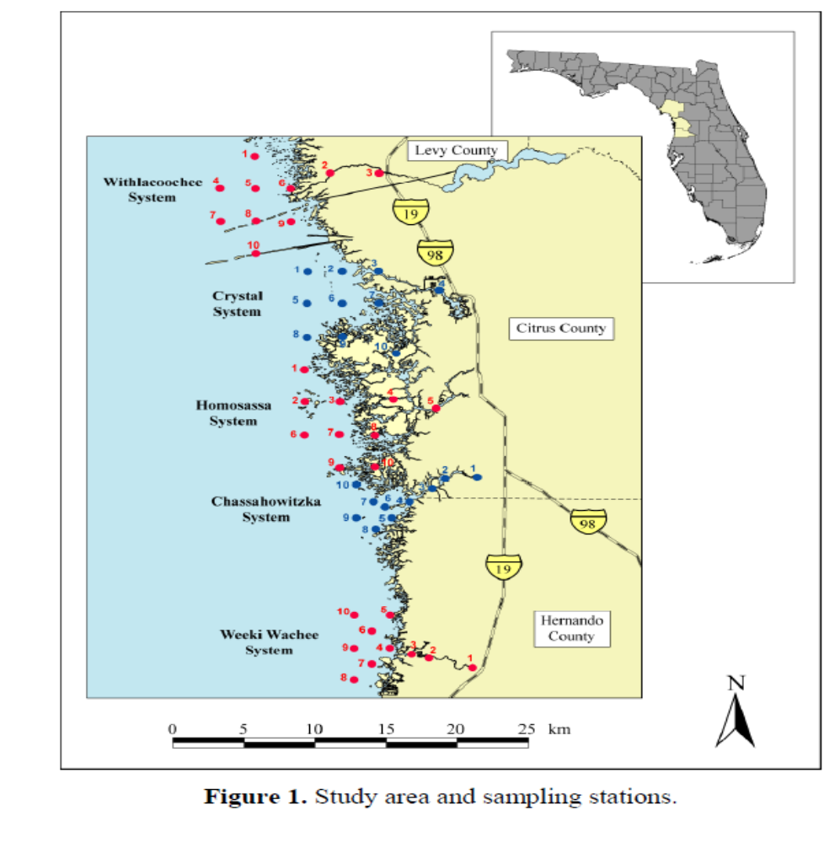
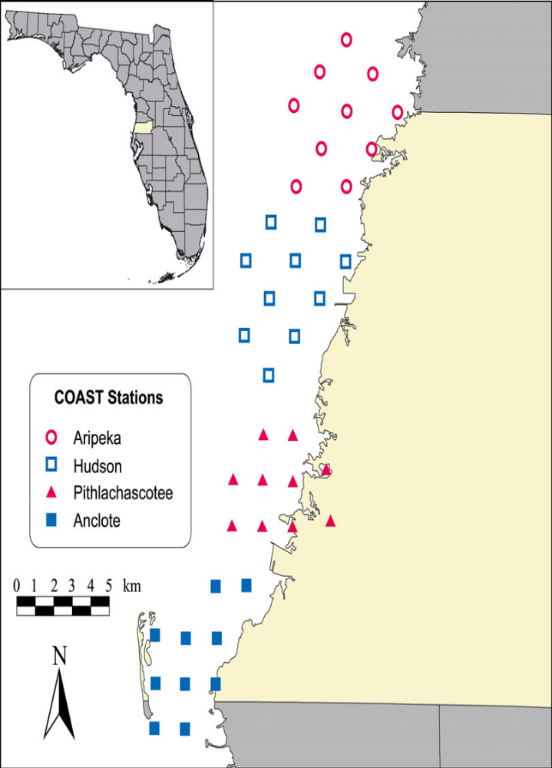

Figure 1. The four areas and 40 sampling stations off Pasco County (highlighted in yellow).

