Ecosystem Restoration Project Proposals
for consideration in the High Priority Projects List for Sarasota Bay Region
2016
Contact Information (Name, email, phone number, organization):  Christopher Cole; cbcole@scgov.net; 941-232-5952; Sarasota County |  |  | Date of Submittal: December 15, 2016
Name of Project:  Siesta Key Master Pump Station and Force Main |  |  | Rank (1 is highest): T4
Project Description:
This project consists of design, permitting and construction of a master pump station and transmission force main to allow the decommissioning of the county’s Siesta Key Wastewater Treatment Plant (WWTP). This WWTP’s effluent is permitted for surface water discharge to Sarasota Bay.

Once the new infrastructure is installed the plant will be decommissioned and the wastewater flows will be diverted to the mainland and treated at one of the county’s regional wastewater reclamation facilities. The 1.5 million gallons per day of contributing flow from the Siesta Key service area will then be treated and beneficially reused in the county’s reclaimed water system.
Project Location:
Sarasota County, Siesta Key, Lat. and Long.: 27.27099677, -82.54108129
Responsible Party:  Sarasota County | Partners:
Estimated Project Cost:  $12,600,000 |  | Dollars needed:  $5,200,000
Expected match and source:

Start Year: FY09 | Completion Year: FY18
Status of Project Design and Permitting:
An alternatives analysis was completed on 01/05/09. Design and permitting for the project is 100% complete. Construction of phases 1 and 2 is underway. Construction contract for phase 3 was awarded on August 23, 2016, with substantial completion scheduled for November 2017.
Goals and Florida Priorities addressed, from “Goals and Florida Priorities” document:
Primary Goal: Restore Water Quality
Primary Florida Priority: Reduce excessive sediment, pollutant and nutrient loads in waterways by improving the management of urban and agricultural stormwater runoff, increasing the treatment levels of wastewater and encouraging their reuse, restoring inland waterways that flow to Sarasota Bay and the Gulf, restoring canals and altered floodplains to represent more natural systems, and promoting more sustainable adjacent land use policies.

Secondary Goal (if appropriate):
Secondary Florida Priority:

Environmental Results expected: (i.e., acres and types of habitat restored or protected; lbs. of pollutant reduced; etc):
Removal of this point source will have an immediate reduction of nutrients (estimated 5,800 lbs of nitrogen and 2,000 lbs of phosphorous per year) into Sarasota Bay. The project will enhance water quality, and will contribute to reductions in chlorophyll levels within Sarasota Bay, which in turn will promote sea grass growth and enhance native habitat for small fish and bivalves..
Additional Benefits:
The Siesta Key Wastewater Treatment Plant is permitted with a direct surface water discharge into the Grand Canal which feeds into Sarasota Bay and ultimately to the Gulf of Mexico. The project will also increase the amount of beneficially used reclaimed water (1.5 mgd), and will reduce the amount of groundwater withdrawals used for irrigation in the region. Further, moving key wastewater infrastructure off a barrier island and away from a storm surge area will improve the utility system’s resiliency.
Add any photos or maps or other materials that explain project
Attached
Forcemain Route
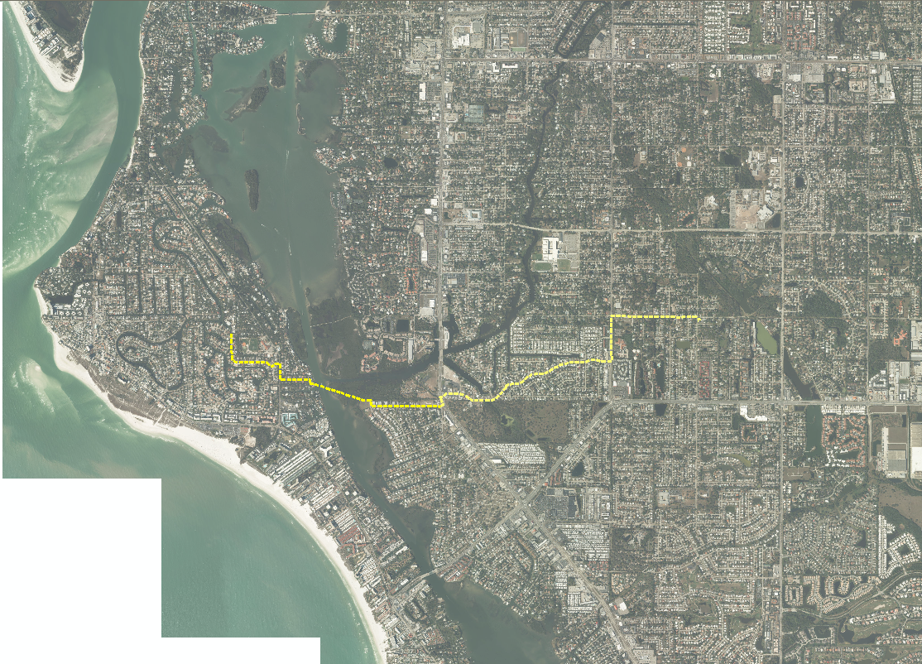

Plant Site
