RESTORE Act Ecosystem Restoration Project Proposals
for consideration in the Gulf Coast Ecosystem Restoration Council’s Comprehensive Plan
2012
Contact Information:  Veronica Craw, Environmental Section Manager &  Kris Kaufman, Staff Environmental Scientist, SWIM Section  Southwest Florida Water Management District  2379 Broad Street  Brooksville, FL 34604  352-796-7211 ext. 4267  Veronica.Craw@SWFWMD.state.fl.us  Kristen.kaufman@swfwmd.state.fl.us |  |  |  |  |  | Date of Submittal: 1/3/2013
Name of Project: Southwest Florida Water Management District Seagrass Mapping Projects |  |  |  |  |  | Org and Rank:
Project Description: The District’s seagrass mapping efforts involve a combination of aerial photography and on the ground verification. The District maps seagrass for the Springs Coast every five years. Aerial photography was acquired in 2007 and 2012 with plans to re-acquire in 2017. In 2011, the Springs Coast coverage area was approximately 1,304 square miles and produced 1,454 digital photographs.

The District also maps the extent and distribution of seagrass in five Gulf coast estuaries (St. Joseph Sound / Clearwater Harbor, Tampa Bay, Sarasota Bay, Lemon Bay, and Charlotte Harbor) using digital aerial imagery. The SWIM Estuarine Seagrass Mapping Initiative has been mapping seagrass from aerial photography every two years since 1988. Most recently, aerial imagery was acquired in 2008, 2010 and 2012 with plans to re-acquire in 2014 and 2016.

These projects create an invaluable tool that will (a) quantify existing conditions, (b) track long-term ecological changes in seagrass distribution, and (c) accurately assess impacts due to natural and man-made disasters such as hurricanes and oil spills. Deliverables for this project include: one-foot digital orthophotos, a seamless mosaic of all frames, seagrass map shape files, and a change analysis comparing the previous maps with a newly created map. Release dates of the 2012 seagrass map products will be in early 2013.
Project Location: Offshore Pasco, Hernando, Citrus, and Levy Counties, as well as nearshore coastal waters of Pinellas, Hillsborough, Manatee, Sarasota, and Charlotte Counties, FL

Responsible Party: Southwest Florida Water Management District |  |  |  | Partners: Florida Fish and Wildlife Conservation Commission (Springs Coast)
NEP: SWIM Project – TBEP, SBEP, CHNEP |  | Project Cost: $2,854,000.00 |  |  | Dollars Needed: $1,268,000
Start: 01/16/2007 (Springs Coast) 10/01/2007 (SWIM) |  |  |  | Completion: 12/31/2016 (Springs Coast)  12/31/2016 (SWIM)
Status of Project Design and Permitting: N/A
What Date or Year could Construction Feasibly Begin: N/A
Your Proposed Timing of Funding (given permits, phasing, staging, etc.)
FY | Previous | 12/13 | 13/14 | 14/15 | 15/16 | 16/17 | Total
 | $1,018,000 | $568,000 | $368,000 |  | $400,000 | $500,000 | $2,854,000.00
Quantify Environmental Results and How to Measure Them:
The Springs Coast Project area makes up the southern portion of the Florida Big Bend, an area estimated to have one million acres of seagrass, of which 700,000 occur within the Springs Coast. Such a resource must not be taken for granted. The Springs Coast Seagrass area is one of the Nation’s most valuable natural resources. Seagrass are estimated to comprise approximately 700,000 acres along the Florida Gulf Coast from Cedar Key to Tarpon Springs and out more than 20 miles offshore. In addition to seagrass, this area is also home to hard bottom habitat, corals, sponges, and oyster reefs. Not surprisingly this area provides critical habitat to commercially and recreationally important fish species and is also critical habitat for the endangered West Indian Manatee.

The objective of the SWIM Estuarine project is to create spatially and thematically accurate seagrass maps that provide estimates of the overall seagrass acreage within: Tampa Bay, Sarasota Bay, St. Joseph Sound / Clearwater Harbor, Lemon Bay, and Charlotte Harbor. Within these estuaries, over 80,000 acres of seagrass were mapped during the 2010 effort. Percent change in acreage between subsequent mapping efforts is the measure most often used to monitor trends in seagrass habitat for the systems. The seagrass habitats within each estuary provide critical habitat to commercially and recreationally important fish species and is also critical habitat for the endangered West Indian Manatee.

Economic Benefits (including ecosystem services): The total value added (Value-added is the sum of employee compensation, proprietor income, other property type income and indirect business taxes, values are in 2012 dollars) equals approximately $3.6 million.

Local businesses are dependent on tourism and ecotourism dollars with saltwater fishing contributing over $3 million dollars annually to the economy with more than 50 percent of the population (tourist and resident) participating in freshwater and saltwater activities in the area. While seagrass ecological services provide $20 billion dollars annually to Florida.
Estimated number of Jobs Created or Preserved:48
How much Habitat will be restored and conserved:
Quantify pollutant reductions:
What living coastal/marine resources will be improved and by how much:
How will community resilience be enhanced:
Additional Justification: In Tampa Bay, since 1950, about 50 percent of the bay's natural shoreline and 40 percent of its seagrass acreage were lost as a result of physical destruction and water quality impairment. This resulted in a decline in the aesthetic, recreational, and commercial value of the bay, as well as a loss of habitat for native plants and animals. The SWIM Plan for Tampa Bay outlines goals to restore habitat and reduce pollutants entering Tampa Bay. The objectives of this project are consistent with these goals and the goals found within the other relevant SWIM Plans.
Add any photos or maps that explain project:
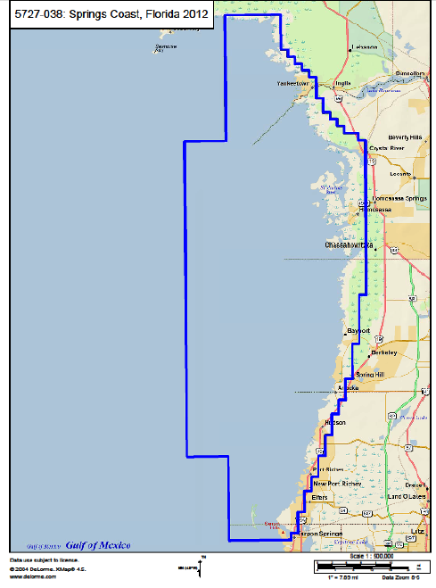
Extent of aerial photography acquired in December 2011. Coverage area is approximately 1,304 square miles. Aerial photographs taken using a Z/I Intergraph DMC airborne digital sensor.
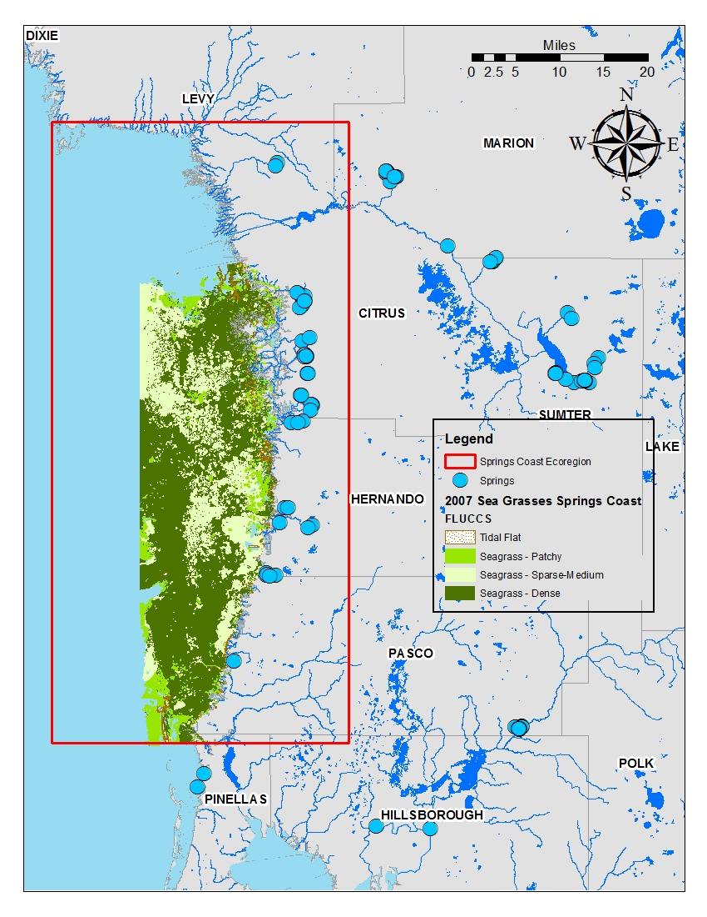
The 2007 seagrass map product and the approximate extent of the Springs Coast Eco-Region (red box). Map also show the location of the approximately 40 first and second magnitude springs found along the Springs Coast.

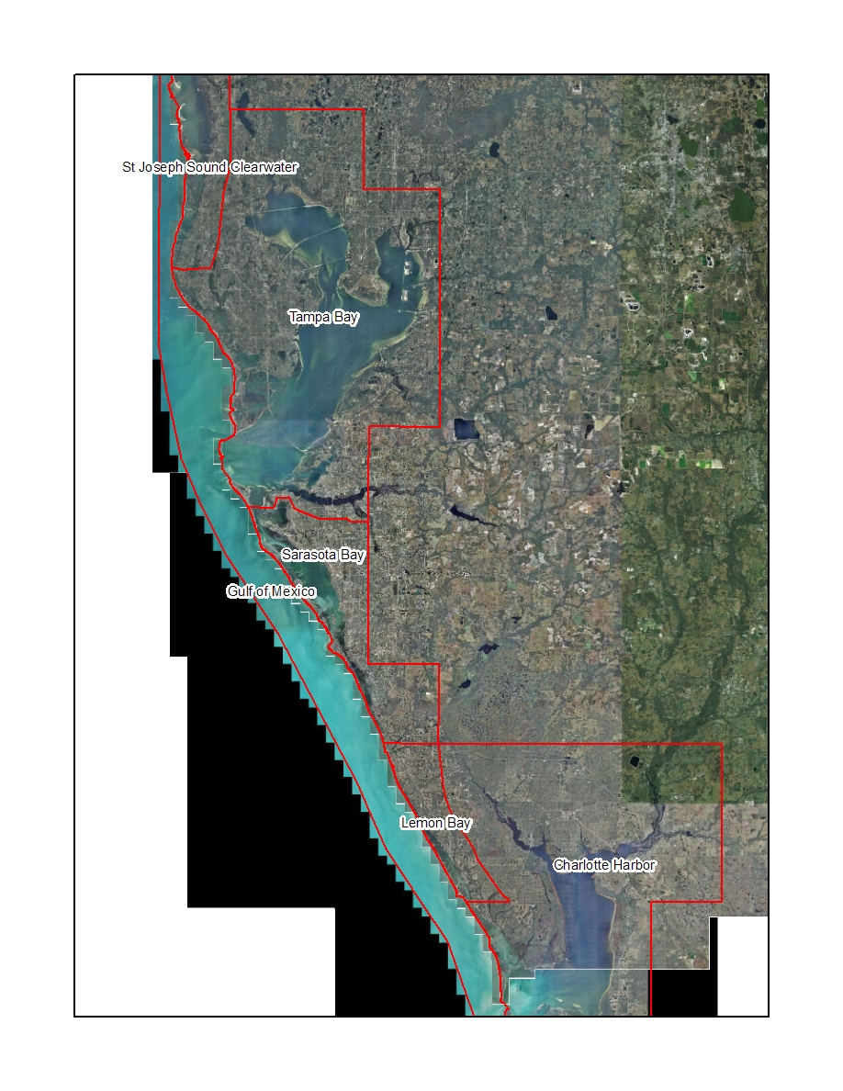
Project boundaries for the SWIM Estuarine Seagrass Mapping Project.
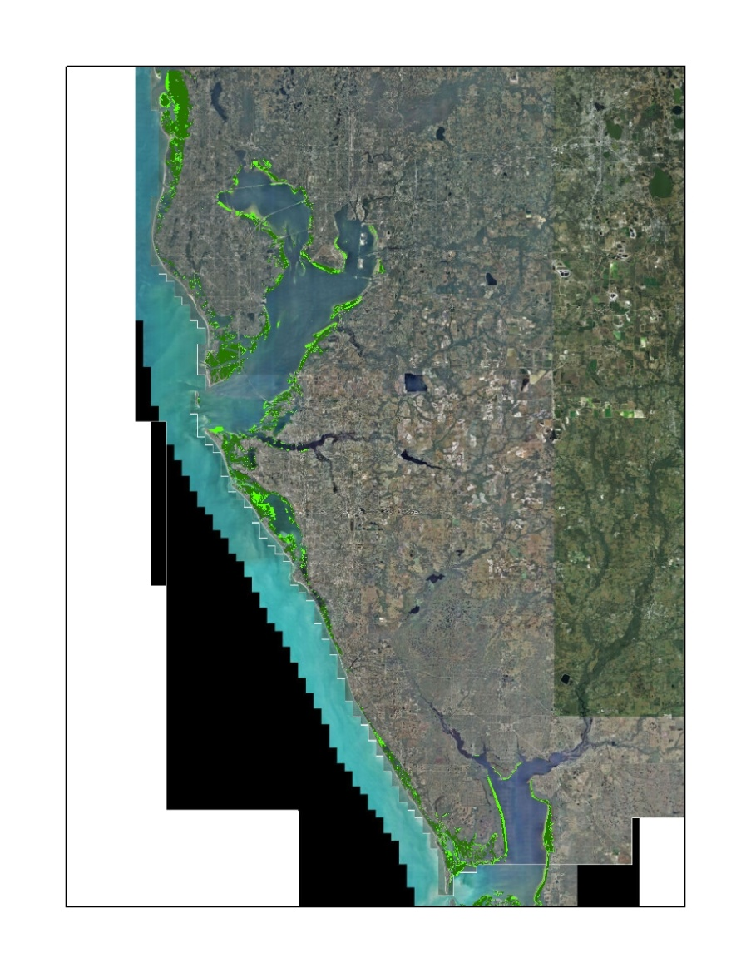
Example graphic of 2010 SWIM Estuarine Seagrass Mapping products.

