Project Name: Lake Hicpochee Hydrologic Enhancement Project
Project Number: 836
Contact Information:
Luis Colon
561-682-6501
Lcolon@sfwmd.gov
SFWMD

Project Location:
The Lake Hicpochee Hydrologic Enhancement Project (LHHEP and Project) is located approximately 5 miles west of Lake Okeechobee near the Town of Moore Haven city limits in Glades County Florida. The LHHEP abuts the northwest quadrant of Lake Hicpochee and is bordered by the South Florida Water Management District (SFWMD) C-19 Canal to the east, US Hwy 27 on the North, US Hwy 78 on the west. The LHHEP is located within the Caloosahatchee Watershed. The project land centroid is approximately located at Lat 26.816271°N, Long -81.167135°W.

Project Description:
Lake Hicpochee is one of 3 historic lakes which formed the headwaters of the Caloosahatchee River. The construction of the C-43 Canal cut through Lake Hicpochee and split the historic lake into 2 areas now referred to as Lake Hicpochee north and Lake Hicpochee south. The construction of the C-43 Canal adversely affected the watershed natural hydropattern, dried-up portions of the historic lake bed and conveys water to the Caloosahatchee River estuary. At times the water-conveyance effectiveness of the C-43 Canal can be detrimental to the health of the downstream brackish systems as a result of the increased stormwater input.

The LHHEP abuts the Lake Hicpochee north area and consists of approximately 3,700 acres of lands. The project civil engineering design components include water storage areas, flow equalization basins, levees, pump stations, ditches, canals, and water control structures. The project captures, stores and redistributes surface water from the Caloosahatchee Watershed and rehydrates the northwestern portion of the historic lake bed. The surface water managed by the project would otherwise be discharged through the C-43 Canal to the Caloosahatchee Estuary. In addition to the lakebed rehydration benefits, the project also will provide ancillary water quality benefits, water storage and help the Caloosahatchee River estuaries by capturing freshwater flows.

The C-19 Canal discharges to the Caloosahatchee River and runs north-south along the eastern boundary of the LHHEP. The project has been separated into 3 project components. The first project component consists of a 744 acre system (Component 1) that will capture surface water from the C-19 Canal via a 150 cfs pump station which will convey the water into a Flow Equalization Basin (FEB). When the FEB reaches capacity it will discharge through a 150 cfs weir onto a 6,500 linear feet spreader swale that distributes the water to Lake Hicpochee for rehydration. The second project component consists of a project expansion. The project expansion component will augment the water storage capacity of the system, provides an opportunity to also capture water directly from the C-43 Canal and would provide an opportunity to extend the length of the rehydration spreader swale. The second project component is divided into 2 sub-components due to a land acquisition opportunity which provides for the purchase of 2,489 acres (Component 2.1) and leaves a balance of 461 acres to be pursued at a later time (Component 2.2). It is estimated that the project would have a total static-capacity of approximately 10,300 acre-feet of static-storage when fully built.

The SFWMD commenced construction of the first project component (Component 1, consisting of the inflow pump, FEB, discharge weir and the spreader swale) on May 2017. Acquisition for a portion of lands (approximately 2,489 acres, Component 2.1) associated with the second project component is ongoing (year 2017). Negotiations for the remainder lands associated with the second project component (approximately 461 acres, Component 2.2) are anticipated to commence in the year 2018.

Estimated Project Costs:
The initial components of the LHHEP have been partially funded by state appropriations and SFWMD ad-valorem revenues. (See attached Table 1 – Estimated Project Costs Table for summary of costs and funding sources). The following list shows the itemization of project component costs.

Component 1, 750 acres
- Land acquisition: $2.38M
- Land acquisition due diligence: $652K
- Design: $1.64M
- Construction: $11.33M
- Construction Management Contracts: $1.2M

Component 2.1, 2,489 acres
- Land acquisition: $16.9M
- Land acquisition due diligence: $311K
- Estimated design costs: $7.5M
- Estimated construction costs: $75M

Component 2.2, 461 acres
- Estimated Land acquisition: $3.76M
- Estimated Land acquisition due diligence: $300K
- Estimated design costs: $1.2M
- Estimated construction costs: $11.5M

As shown in Table 1 – Estimated Project Costs Table several project actions remain unbudgeted due to the lack of available funding.

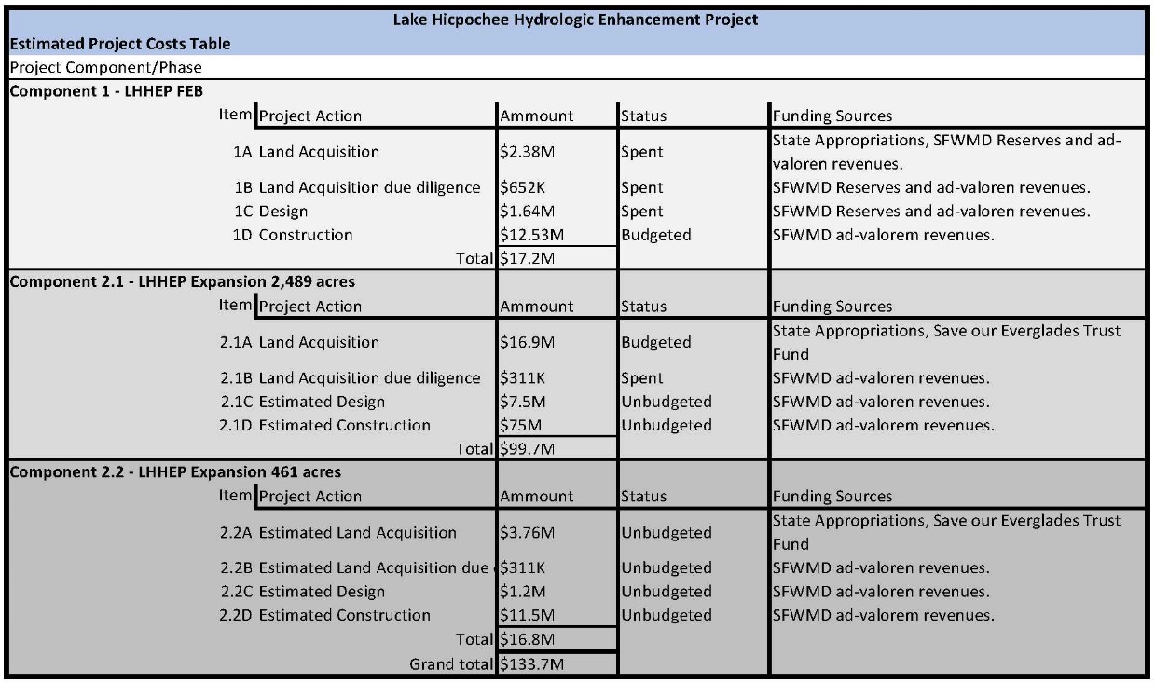
Table 1 – Estimated Project Costs Table

Other Funding:
The costs related to the acquisition of the 461 acre land part of component 2 are anticipated to be obtained from State appropriation funds. However, the funding for the design and construction of project components associated with the Expansion (Components 2.1 and 2.2) are yet to be identified.

Technical Feasibility:
The SFWMD was established by the legislature to manage and protect the water resources and has constructed and operates numerous projects which enhance the hydrology of natural systems and restores native habitats. The surface water management system operated by the SFWMD is the second largest in the world with approximately 2,100 miles of canals and 2,000 miles of levees. The ecosystem restoration projects that are built and operated by the SFWMD include the Everglades, the Kissimmee River, and Lake Okeechobee. The water quality improvement projects conducted by the SFWMD include Stormwater Treatment Areas which consist of constructed wetlands which remove excess nutrients from the water and regulates the implementation of urban and agricultural best management practices.

The LHHEP Component 1 includes the construction of a 670 acre flow equalization basin and a 6,500 linear foot spreader swale which discharges into the historic Lake Hicpochee lake bed. Other project components include a 150 cfs inflow pump and a passive 150 cfs capacity outflow weir into the spreader swale. The project expansion (Component 2) would also include a reservoir component increasing the static-storage capacity of the system. Over the last 20 years the SFWMD has invested $1.8 Billion in water treatment technologies which include FEB, Stormwater Treatment Areas, pump stations, canals, and levees. The effectiveness of the water quality infrastructure is demonstrated by the approximately 5,400 metric tons of phosphorus that has been removed from water flowing to the Everglades. In addition, the SFWMD by direct involvement or via project partnering with local and federal agencies has helped restore natural areas utilizing technologies similar to those proposed with the LHHEP project. Therefore, the SFWMD demonstrates it has the experience and proven success in implementing effective solutions to water resource challenges.

Conflicts or complements to existing efforts:
The LHHEP is been implemented under the Northern Everglades and Estuaries Protection Program (NEEPP) Caloosahatchee River Estuaries (CRE) watershed construction project plan. NEEPP was enacted in 2007 to provide a program that restores and preserves the Lake Okeechobee watershed and the Caloosahatchee and St. Lucie River estuaries. NEEPP recognizes that the Lake Okeechobee, Caloosahatchee and St. Lucie watersheds are critical water resources of the State. The CRE watershed construction project plan includes activities that focus on water quality and storage to improve hydrology, water quality, and aquatic habitats in both the watersheds and estuaries.

The LHHEP will capture basin runoff that would otherwise drain to the CRE. The water that is captured by the project will help the local area with aquifer recharge and it is anticipated to also receive some ancillary water quality benefits. The LHHEP in combination with other regional initiatives like the Caloosahatchee River Estuaries BMAP, C-43 Reservoir, BOMA, the Lake Okeechobee Watershed Restoration Project, and the Lake Okeechobee Regulatory Schedule will contribute to the overall state objectives of reducing the frequency and magnitude of salinity fluctuations in the CRE.

Complies with Federal, State, Local and Tribal Laws/Regulations:
The LHHEP Phase 1 project was authorized for construction under the Northern Everglades and Estuaries Protection Program Section 373.4595 Florida Statutes. The federal construction authorization was obtained under Section 404 of the Clean Water Act and Section 10 of the River and Harbors Act. The State authorization also is consistent with Section 307 Coastal Zone Management Act and certifies compliance with Section 401 of the Clean Water Act. Both State and Federal permitting processes included opportunities for public comments, including tribal interests. The public comment record statements are in favor of the project and no concerns about compliance with State, Federal, or Local regulations or tribal interests have been documented. Future phases of the project are anticipated to follow the same regulatory authorization process, therefore, there are no regulatory conflicts, nor tribal interest conflicts, anticipated.

Readiness for Implementation:
The LHHEP Phase 1 project was authorized for construction by Florida Department of Environmental Protection Permit No. 0338438-001 under the Northern Everglades and Estuaries Protection Program - Section 373.4595 of the Florida Statutes. The Federal construction authorization for Phase 1 was obtained under Section 404 of the Clean Water Act and Section 10 of the River and Harbors Act and is documented by Permit file SAJ2015-002404 (NW-ACM) with the U.S. Army Corps of Engineers. A second phase of the project is being conceptualized by the South Florida Water Management District and will include an approximate 2,500 acre expansion of the Phase 1 facilities under construction. And additional regional assessments will continue in year 2018 for other phases/components of the project, including expansions of the hydrologic enhancement features and storage capacity of the project. The regional assessment will assist in identifying additional parcels of land necessary to achieve the overall objective of storing approximately 11,000 acre feet of runoff at this geographical location. Lack of funding is the only setback in the continuation of the regional assessments and construction of additional phases of the project.

Environmental Benefits:
The elevated concentrations of nitrogen and phosphorus in runoff that reach the Caloosahatchee River Estuary (CRE) contributes to water quality impairments as evidenced by excessive algae blooms and decreased dissolved oxygen content. The Total Maximum Daily Loads established by the State of Florida calls for a 23 percent load reduction in total nitrogen into the CRE. The runoff that will be captured by the project (Approximately 11,000 acre feet) will beneficially assist with controlling the freshwater discharges that reach the CRE. The CRE is home to many protected species, including species listed as endangered by both State and Federal rules, and provides home and spawning grounds to many sport and commercial fisheries and invertebrates (crabs, shrimp, and oysters). The operation of the LHHEP, in concert with other regional projects, will assist in improving the health of the CRE revitalizing fish and oyster habitat by reducing the frequency of undesirable salinity ranges which is also a goal of the CRE Minimum Flows and Levels Plan (MFL) and the Lake Okeechobee Regulation Schedule.

The project will convey water which will enhance the hydrology within the portion of Lake Hicpochee located to the west of the C-19 Canal. The anticipated benefits of the project include increased ground saturation, and ground water recharge which would result in a more hydrophitic vegetative community with less seasonal variation. The existing uses of the project site includes active sugar cane agricultural areas within the FEB and Reservoir components and portions of the historic Lake Hicpochee lakebed are used for cattle grazing. Areas within Lake Hicpochee consist predominantly of exotic vegetation dominated areas and short hydroperiod wetlands (Wet Prairies). The existing agricultural uses predominantly consist of active sugar cane which will be replaced by the proposed project components. The project components include, reservoirs, ditches and other infrastructure necessary for storage and conveyance of surface water. Phase 1 and 2 Environmental Site Assessments and screening level ecological risk assessment (SLERA) conducted for the LHHEP and the expansion parcels have demonstrated low potential for risk to future benthic invertebrate or aquatic-feeding bird populations that may inhabit the sites.

Wetlands within the project benefit area boundaries experience 2 types of hydrologic conditions, continual or regularly inundated areas, and saturated areas with periodical inundation (based on staff observed evidence of hydrologic indicators that include standing water and adventitious roots, elevated lichen lines, observed inundation, aquatic fauna, drainage patterns, and oxidized rhizospheres). Review of historical aerial photography for the project site indicates that the extent of wetlands and the seasonal variation onsite has diminished over the years and the wetlands have attained a shorter hydroperiod. Freshwater that historically would have been captured in Lake Hicpochee now flows to the Caloosahatchee River Estuary (CRE).

During operation, the proposed project will capture surface water, detain (with ancillary water quality treatment benefits) and discharge, through the FEB and spreader swale, to Lake Hicpochee wetlands. The lake’s topography dictates that the water will flow from the north (spreader swale) towards the south-southeast following the natural contours within Lake Hicpochee. This additional hydration in the areas will help reduce the seasonal hydrologic variation, enhance the wetland communities within Lake Hicpochee and help remove nutrients from the system that can cause detrimental effects downstream in the estuary. The land area within the FEB is anticipated to colonize by wetland dependent vegetation once the project is in operation. The created wetlands within the FEB assist in the overall restoration of floodplain wetland systems that used to exist within the watershed. In addition the project will assist in aquifer recharge and capture runoff that would otherwise be discharged to the CRE.

During construction adjacent waters and wetlands will be protected from erosion, turbidity or water quality degradation by the implementation of erosion and turbidity control measures. The SFWMD also proposes a Compliance Monitoring Plan (CMP) for water quality once the system begins operations and permanent erosion control measures such as vegetated/sodded slopes.

Economic and social benefits:
The Caloosahatchee River and Estuary (CRE) are social and economical treasures of the State of Florida. The CRE is enjoyed by residents and visitors alike. In recognition that the health of the river and its estuary is essential to the overall way of life for area residents, and to the local economy the South Florida Water Management District has implemented plans and programs for the protection and improvement of the Caloosahatchee watershed. As a result of extensive historical modifications to the Caloosahatchee River and its watershed the hydrology of the region has been altered. The increased freshwater flows affect salinity levels and water quality in the estuary, which can be attributed to adverse effects to the well-being of the ecological communities and fisheries within the CRE. The LHHEP is part of a variety of strategies to improve the health of the CRE, which in turn provide economic and social benefits to those who enjoy and use the CRE as well to industries which depend on the marine productivity of the system.

The areas influenced by the CRE include Charlotte Harbor. Estimates from the tourism industry indicate that Charlotte Harbor can produce tourism related cash-flows of $1.2 Billion Dollars annually. In addition, during construction the project brings workforce related benefits at the project local level and new recreational opportunities. Therefore, the project has significant social and economic benefits.

Community Resilience:
The LHHEP water storage components can serve as reservoirs to alleviate downstream runoff volumes and allow the overall system to recover from extreme weather events or provide a source of water during dry periods. The ecological benefits of the system include the enhancement of wetlands and restoration of natural systems that were converted to agriculture. Natural systems have better adaptations to withstand severe weather systems or effects when compared to human-produced landscapes. Therefore, the project water and ecological benefits include a system that has a lower susceptibility to adverse effects from both natural or human-induced hazards.

Public Acceptance:
This project is part of the state of Florida Governor's 20-year commitment for Everglades restoration. Overall, implementation of the Governor’s 20-year funding plan will provide significant regional environmental benefits through construction of water storage reservoirs; aquifer storage and recovery systems; stormwater treatment areas; wetland restoration; and infrastructure improvements. When completed, these projects will deliver critical benefits across the entire South Florida ecosystem including creation of water storage, reduction of nutrients, restoration of more natural water flows, increase in water supply.
Southwest Florida planners have considered the enhancement or restoration of Lake Hicpochee a priority for many years. The Southwest Florida Regional Restoration Coordination Team report to the South Florida Ecosystem Restoration working Group: Restoration and Science Project Recommendations (May 2003) cites the Lake Hicpochee Restoration concept as a priority. Since the inception of the Caloosahatchee River Watershed Protection Plan as part of NEEPP all actions which would benefit Lake Hicpochee has received positively by stakeholders. Caloosahatchee River and Estuary Restoration Vision, public initiative to collaboratively develop a restoration vision for the Caloosahatchee watershed focused on the ecological conditions of the system. Process involved prioritizing existing regional and local projects that will benefit the estuary, and includes the Lake Hicpochee Hydrologic Enhancement Project.

In August 2011, at the request of our west coast Governing Board member, the District convened the first of several meetings with key area stakeholders to discuss water storage opportunities within the Caloosahatchee River watershed. The group’s direction was to identify potential projects that could store a large quantity of water, provide water quality benefits, and be implemented cost effectively. The focus was directed toward projects that had been previously evaluated and identified in the Caloosahatchee River Watershed Protection Plan. $19M in spend down funds had been allocated over a five-year period to implement the regional effort. Of which $17.6M was directed towards the LHHEP. These funds were separate from the dispersed storage program funds that were available at the time. The results of the meetings were the identification of four potential storage projects: 1) rehydration of the northern portion of Lake Hicpochee; 2) rehydration of the southern portion of Lake Hicpochee; 3) interim storage at the C-43 reservoir site; and 4) rehydration of Mirror Lakes. The participants supported moving forward with the rehydration of Mirror Lakes and the northern portion of Lake Hicpochee and agreed that further evaluation was necessary for use of the C-43 reservoir site as interim storage and the rehydration of the southern portion of Lake Hicpochee. The District decided to utilize the funding to construct the Mirror Lakes and north Lake Hicpochee projects. Funding is still needed to continue the expansion of the Lake Hicpochee Hydrologic Enhancement Project to its conceptual capacity.

Additional Information:
Maps of the project Phase 1, 2 and Evaluation areas.
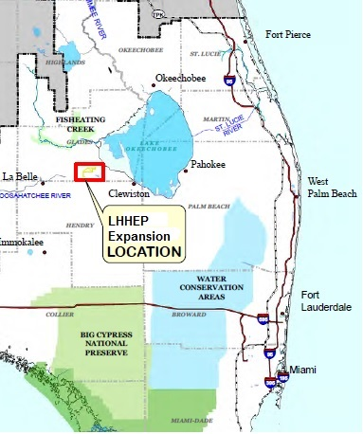
Figure 1 – Lake Hicpochee Hydrologic Enhancement Project Location Map

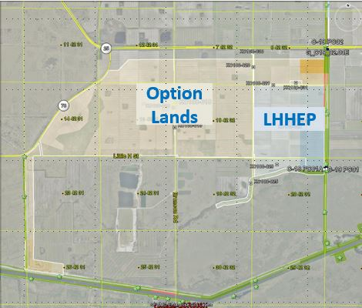
Figure 2 – Lake Hicpochee Hydrologic Enhancement Project FEB and conceptual expansion area 1 (Option Lands – Component 2.1). Lake Hicpochee is located at the bottom right corner of map. The C-43 Canal traverses Lake Hicpochee and is represented by the green color lines that run across the map from right to left. North is the top of the map.

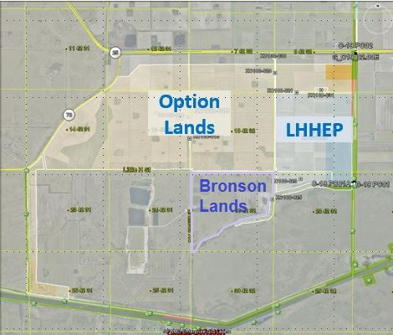
Figure 3 - Lake Hicpochee Hydrologic Enhancement Project FEB and conceptual expansion areas 1 and 2 (Option Lands – Component 2.1 and Bronson Lands – Component 2.2). Lake Hicpochee is located at the bottom right corner of map. The C-43 Canal traverses Lake Hicpochee and is represented by the green color lines that run across the map from right to left. North is the top of the map.

