FLORIDA GULF OF MEXICO RESTORATION
PROJECT SUBMITTAL FORM

Form Purpose and Instructions:
- To assist the project proposal and review process, please complete this Submittal Form. Completion of the Form will contribute to the appropriate information being completely and accurately submitted for each project.
- Take as much space as needed for each question, but please keep responses as focused as possible. It my assist you to review all the questions before addressing any one question.
- If you have multiple projects – please submit one Form for each project.
- Submit the completed form and all back-up maps, information, etc. to Restoration.Projects@dep.state.fl.us
- Once your Form is successfully submitted and received, you will receive a confirmation email from the Florida Department of Environmental Protection.
- To submit updated information, please fill out this form and updating fields as needed.

* Required Fields for project updates
New Project X Update to Previous Submittal __
*Project # _______________________ (Project number can be found on the project summary spreadsheet.)
*Project Name Locklin Lake Restoration Phase 1 and 2

*Contact Information: (Include at least one name, phone number, email address, and organization name if applicable)

Brian Watkins, 850-983-5414, brian.watkins@ci.milton.fl.us, City of Milton

Project Location: (Include a map, if possible, and the city, county, watershed)
Latitude & Longitude in Decimal Degrees: City of Milton, Santa Rosa County, Collins Mill Creek Watershed, Latitude 30.6278889, Longitude 87.0485556
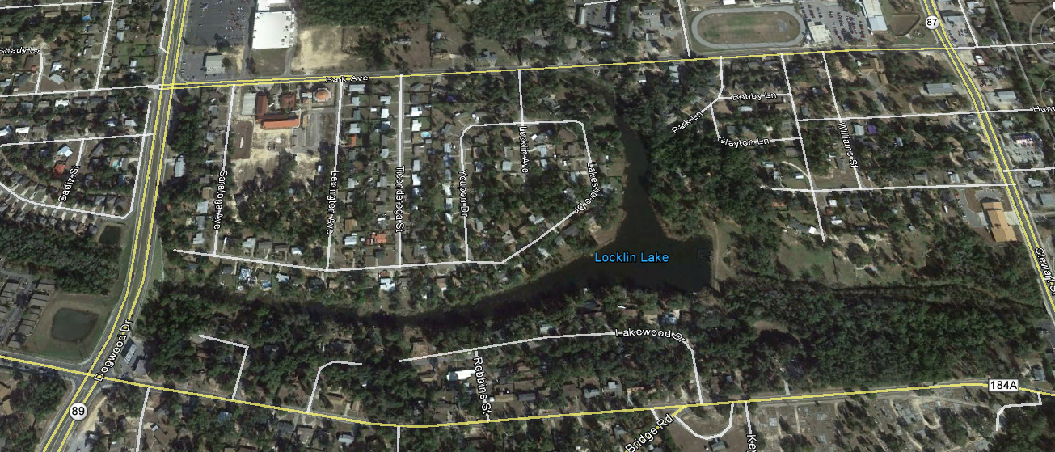Parcel Number: (if applicable) N/A

Project Description: (Describe all aspects of the project)

Locklin Lake was created sometime in the early 1800’s at the confines of 2 creeks that form Collins Mill Creek. Collins Mill Creek then flows from the lake, easterly into the Blackwater River. The Blackwater River is an Outstanding Florida Waters and noted as the ONLY pristine sand river left in the United States. The total contributing watershed into Locklin Lake is estimated at approximately 3,000 acres. Locklin Lake is, because of its location, a natural collector of silt, sediment, trash, debris and all other things that flow into the lake. Over time, silt and sediment has filled in the lake causing it to become less effective. Because of the shallower depths, grass and weed growth have caused addition problems with flows.
Phase 1 would allow for the excavation of the lake bottom back to historical depths, along with the littoral shelf restoration around its shoreline. As with past restoration projects, the lake would require draining and then the removal of all sand, silt and debris by means of mechanical excavation.
Phase 2 would allow for the installation of sediment and trash collection devices on many of the existing stormwater discharge points into the lake.
Reduction of silt and sedimentation into the Collins Mill Creek Watershed, thereby creating additional protection to the Blackwater River.

All of the following are Required Fields for project updates

Estimated Project Costs: (Describe the estimated costs of the project, including any assumptions for contingency and ongoing operations/maintenance. Identify other secured funding sources such as matching funds, in-kind contributions or state/federal dollars. In addition, if possible, complete and submit the Cost Appendix Sheet associated with this Form)
Phase I:
- Excavation of lake bottom - $1,000,000
- Littoral Shelf Restoration - $ 400,000
- Contingency @ 10% - $ 140,000
TOTAL - $1,540,000

Phase 2:
- Sediment and Trash Collection Units, including engineering and permitting;
10 units @ $400,000/unit - $4,000,000
- Contingency @ 10% - $ 400,000
TOTAL $4,400,000

TOTAL PROJECT COST: $5,940,000

Other Funding: (Indicate if the project is submitted for any potential funding or if it may be used to leverage additional funding, if so, please describe the funding source [e.g. State/Federal Grants])
The project is also submitted for funding with the Gulf Environmental Benefit Fund, the National Fish and Wildlife Foundation, and the Natural Resource Damage Assessment.

Technical Feasibility: (Describe the technologies involved and any relevant past experience or proven success with similar projects)
Current engineering practices utilizing sediment and trash collection devices are proven to be successful in reducing silt, sedimentation and trash from entering the target body of water.

Environmental Benefits: (Describe the nature, magnitude, and timing of any environmental benefits attributable to the project. If possible, describe potential environmental performance measures [e.g. pollutant reduction]. Please address any potential environmental impacts associated with implementing or maintaining the project [e.g. loss of a habitat or conversion of habitat from one type to another during implementation])
The project will provide for pollutant reduction not just in the lake system but the downstream waterways as well.

Economic and Social Benefits: (Describe the economic and social benefits including those related to the project’s improved ecosystem services and any estimates on jobs created or preserved)
Providing for a cleaner body of water at Locklin Lake will benefit the area residents regardless of age, race, gender, or economic status by enhancing the recreational use of the lake.

Community Resilience: (Describe if the project assists Florida’s ability to anticipate, withstand, or recover from hazards or threats [e.g. hurricane preparedness, establishing living shorelines])
Projects that provide for cleaner waterways will provide for the continued establishment of living shorelines.

Conflicts or Complements to Existing Efforts: (Describe any ongoing activities in the project implementation area, if the project is part of another plan, and why the project does or does not interfere with that work. Please consider how the project may complement existing local, regional, and state efforts/plans/objectives)
There are no ongoing activities in the project area.

Complies with Federal, State, Local, and Tribal Laws/Regulations: (Describe any concerns or potential conflicts)
The project complies with all Federal, State, Local and Tribal Laws/Regulations.

Readiness for Implementation: (Describe if the project has had any design or permitting work started or completed [attach permits or design work]. Please address any issues that may delay start or finish of the project)
Phase 1 has been designed and permitted and is ready to advertise for bid.
Phase 2 has not been designed or permitted

Public Acceptance: (Describe any known or potential public approval or opposition to the project)

There have not been any public meetings associated with this project however, projects that will reduce pollutants to area waterways are generally accepted by the public.

Additional Information you wish to provide: (Please include any maps, designs, drawings, photos or background resources that may assist in completely and accurately understanding the project. If these are too large to attach here, please email them to Restoration.Projects@dep.state.fl.us)

Cost Appendix Sheet
Cost Item | Cost Estimate
Planning
Contracts
Feasibility
Engineering, Design, Land Rights & Bid Prep | $400,000.00
Restoration Plan
Site Visits & Cost of Site Selection
Administration, Overhead and Indirect
Other
Planning Subtotal: | $400,000.00
Construction
Contracts | $4,700,000.00
Administration & Mobilization/Demobilization
Other
Construction Subtotal: | $4,700,000.00
Monitoring
Contracts
Data Collection
Monitoring Administration
Other
Monitoring Subtotal: | $0.00
Project Cost
Supervision | $50,000.00
Subtotal: | $5,350,000.00
Contingency (traditionally calculated at 10% of the subtotal) | $540,000.00
TOTAL: | $4,940,000.00
Estimated Costs by Year
Year 1 | $1,540,000.00
Year 2 | $22,000.00
Year 3 | $22,000.00
Year 4
Year 5
Year 6

