Tapegrass Restoration in the upper Caloosahatchee
Cost: $250K
Contact: Eric Milbrandt, emilbran@sccf.org, Sanibel-Captiva Conservation Foundation Marine Laboratory, 239-395-4617

Biomass of submersed macrophytes in the Caloosahatchee and some areas in Pine Island Sound has been impacted by water quality issues, cownose rays, macrograzers, and motorboats. This project will help re-establish macrophytes in areas where roots and rhizomes have been lost. A planned C43 reservoir will increase the suitability for tape grass which once carpeted the shallows of the estuary from Beautiful Island to Iona. Until the reservoir is implemented, tape grass restoration efforts will be targeted east of Ft. Myers where salinities are normally below the lethal level for tape grass. Ruppia will be planted in between Beautiful Island and Shell Point and shoal grass will be restored in the lower estuary and San Carlos Bay where low salinities or motor boats have reduced its coverage. Within the Caloosahatchee, areas near shore in shallows, and away from seawalls will be targeted for restoration and will be stocked with plants grown at SCCF Marine Lab. These shallow areas are generally out of reach of large grazers. Aerial photos will be examined for prop scar damage in San Carlos Bay and Pine Island Sound. These areas will be visited and if the scars are severe and through turtle grass beds, shoal grass sods grown at SCCF will be transplanted into the scars every 5 meters. Shoot density and height at each site will be monitored 6 times per year inside and outside the transplanted areas or scars. This project would increase densities of tape grass, widgeon grass and shoal grass in the River and Sound. Once dense beds are established, the plants can spread through vegetative growth, seed and propagule dispersal. The SCCF RECON probes will record salinity, turbidity, chlorophyll and CDOM hourly at 3 sites in the river, (Shell Point, Fort Myers and Beautiful Island). These values will be used to monitor salinity and light conditions for submersed plants in each area of the river. Water quality monitoring will improve our understanding of nutrient loading effects for MFL and TMDL improvements that will help improve conditions for submersed plants.
The Caloosahtchee river is home to numerous juvenile commercially and recreationally important fish species including, estuarine-dependent fish such as red and black drum, spotted sea trout, snook, sheepshead, southern flounder, Florida pompano, striped mullet, bay anchovy, and gulf menhaden. The common snook, an important game fish, is protected by the State of Florida. A species of special concern (federal) and threatened (Florida) status in the Caloosahatchee is the Atlantic sturgeon and Florida manatee while the endangered smalltoothed sawfish also utilizes the estuary. Other resources in the River include blue crab, stone crab, eastern oyster, pink and brown shrimp, hard clams, Florida manatee, and dozens of other species and their supporting habitats such as seagrass beds. The river also provides forage areas for the region's wading bird population. Project will advertise and provide volunteer events to maintain exclosures. SCCF will coordinate with local newspapers to keep public aware of submersed macrophyte values.
Permits: All necessary FDEP and USACOE permits are held by the Sanibel-Captiva Conservation Foundation until 2020.
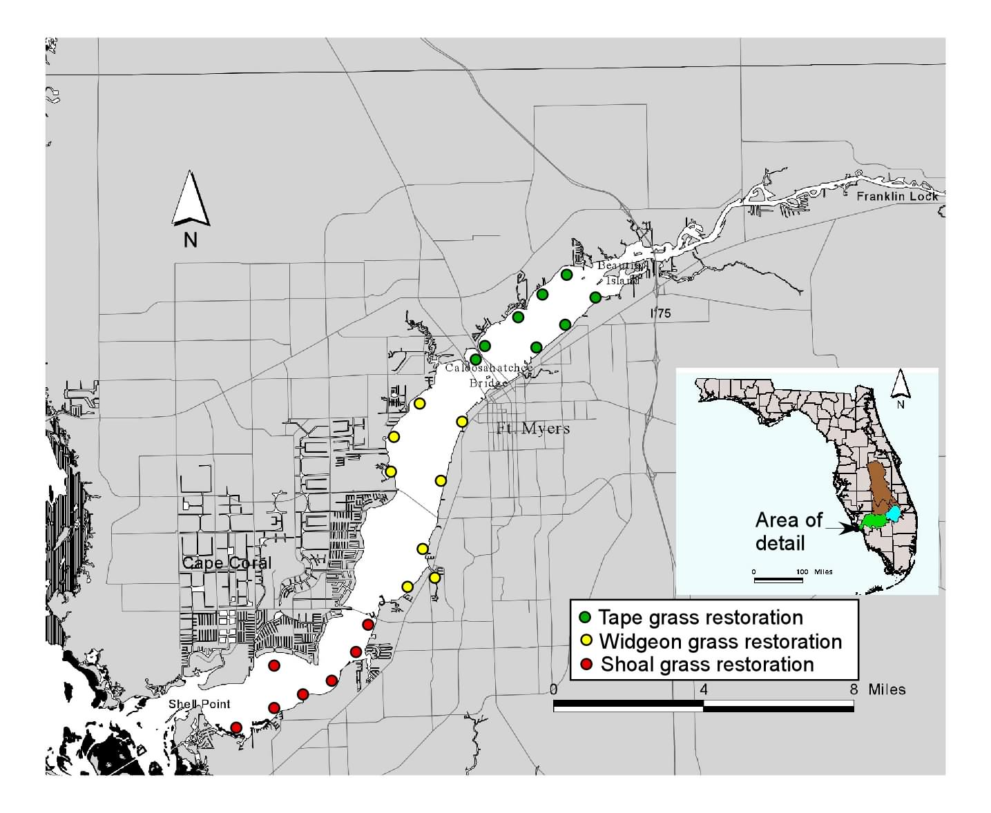

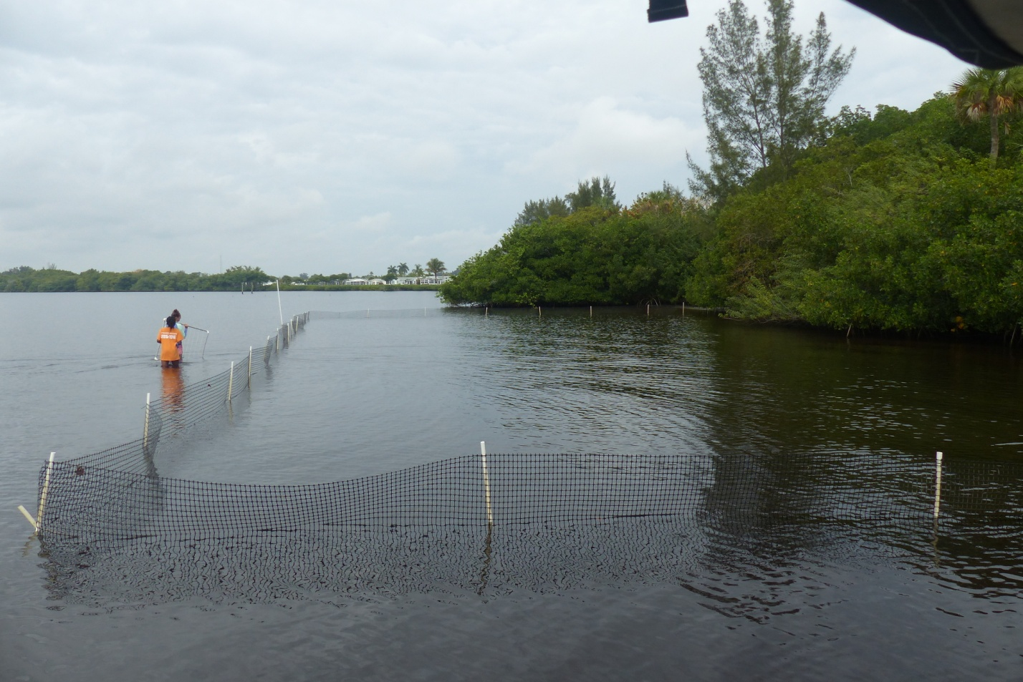
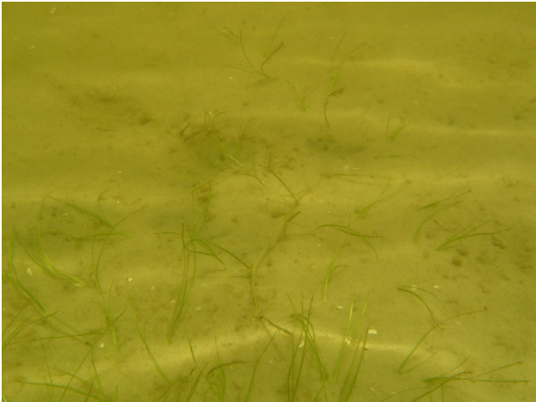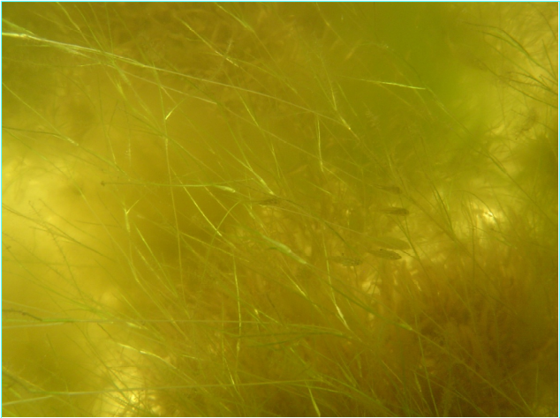
Above unplanted, Below: planted

