From: Marina Daniel [mailto:marina@secon.com]
Sent: Monday, November 12, 2012 11:04 AM
To: DAVE@VISITSOUTHWALTON.COM; dsell@beachesofsouthwalton.com; dawn@visitsouthwalton.com
Cc: mckbilly@co.walton.fl.us; Kanes, Jessica; joncecilia@co.walton.fl.us; comsara@co.walton.fl.us; jonlarry@co.walton.fl.us; prikenneth@co.walton.fl.us; brascott@co.walton.fl.us; southwaltoncc@earthlink.net; Bill@BillImfeld.com; 2012@cindymeadowsforcommissioner.com
Subject: Walton Dunes Neighborhood Beach Access Proposed Parking Plan - MAJOR SAFETY ISSUE

Hello Dawn/Dave and County Commissioners,
After attending the recent workshop on 11/8 for the proposed conceptual plan for the Walton Dunes Neighborhood Beach Access on-street parking facility, there are clearly major safety concerns with the proposed concept that will inevitably lead to injury and potential law suits against the county. Although there are many additional reasons the community (residents, property owners, and visitors) as a whole opposes the proposed plan, safety should be the priority and I have focused this email on that aspect alone.
The proposed Walton Dunes Neighborhood Beach Access parking plan is unique to any other parking plan completed or proposed by the TDC because it involves on-street parking, and, as such, requires additional analysis to ensure the safety of our residents and tourists.
When on-street parking is under consideration, due diligence must be performed by completing a comprehensive parking study. Below is a short description of what should be included in the parking study for on-street parking:
Parking Study
In determining needs for a specific location, the designer must perform a comprehensive and detailed analysis. A parking study should inventory existing parking areas, spaces, and their use to determine the adequacy and efficiency of current configurations. These studies can be used to determine deficiencies in the total number of spaces and how long the spaces are being occupied. The parking study may be used as the basis for recommending additional spaces as well as altering configuration or circulation patterns.

The parking study may include the following items:
- Inventory of total parking spaces within a specific area
- Analysis of specific problems such as poor location or deficiency of handicap parking spaces
- Determination of parking duration and turnover rates
- Identifying access difficulties and poor pavement
On-street Parking
According to AF Handbook, 32-1084, the Department of Defense does not support constructing streets that include on-street parking. Many installations however, are using existing streets to accommodate their parking needs this way. If on-street parking is used, the following factors must be considered:
- Permit only parallel parking
- Maintain a minimum distance of 15 meters from on-street parking spaces to intersections and off-street parking area entrances
- Break up long lines of vehicles with occasional planting island projections if appropriate
- Ensure streets maintain required traffic-carrying capacities and provide safe vehicular and pedestrian passage
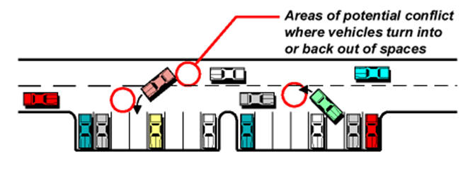
Figure 14-4 (from Department of Defense Study): Avoid On-street Perpendicular Parking
Figure 14-4 represents the areas of conflict introduced with only perpendicular parking on one side of a roadway. The proposal for Beachfront Trail involves perpendicular parking on both sides of the roadway directly opposite one another. This compounds the potential conflict areas.
Below are considerations for the proposed Walton Dunes parking plan:
- On-street parking, particularly the perpendicular parking proposed on Beachfront Trail, will impede traffic flow. When a car pulls in or backs out of a space it essentially stops traffic while it maneuvers. Perpendicular parking forces the driver pulling in to the parking lot to veer into the oncoming traffic to create the proper angle for entry into the parking space. This road is utilized by many pedestrians and cyclists. Perpendicular parking will create unsafe conditions. As stated previously, this safety issue will be compounded with this plan as perpendicular parking is proposed on both sides of the street.
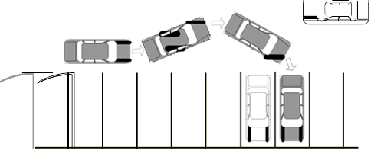
- On-street perpendicular parking will limit sight lines for pedestrians trying to cross Beachfront Trail, in particular, and is unsafe.
- On-street perpendicular parking prevents adequate lane width for ingress and egress traffic. Each parking space should conform to standards of 18 feet in length and 8.5 feet in width. Also, for two-way traffic, the street must be 60 feet in width.
ACCEPTIBLE PARKING DIMENSIONS

Angle | Dimensions |  |  |  | One Way  Traffic |  | Two Way  Traffic
Parking  Angle | Stall Width (ft) | Curb Length (ft) | Stall Depth (ft) | Stripe Length (ft) | Aisle Width (ft) | Section Width (ft) | Aisle Width (ft) | Section Width (ft)
A | B | C | D | G | E | F | E | F
30° | 8.5 | 17 | 16.4 | 32.7 | 12 | 44.7 | 24 | 56.7
45° | 8.5 | 12 | 18.7 | 26.5 | 14 | 51.4 | 24 | 61.4
60° | 8.5 | 9.8 | 19.8 | 22.9 | 16 | 55.6 | 24 | 63.6
90° | 8.5 | 8.5 | 18 | 18 | 22 | 58 | 24 | 60

- On-street parking will increase traffic to area. The proposed plan has no areas for vehicle turnaround leading to increased traffic to the neighborhood dead-end street.
- The proposed practice of parking a vehicle perpendicular on Beachfront Trail is a serious and unsafe issue for cyclists and pedestrians. This creates a public safety hazard, forcing pedestrians--including those with strollers and in wheelchairs--into traffic lanes. Cyclists will also be forced into traffic lanes. The plan does not include any pedestrian walkways or lanes for cyclists. Dimensions for a typical cyclists are 3.4 feet in width. Beachfront Trail experiences a multitude of cyclists moving in both directions during peak summer months.
  - The total roadway width is critical to the safety and operational behaviors of both cyclists and motorists. A wider roadway will increase the lateral positions of both the cyclist and motorist and decrease the probability of motor vehicle encroachments.
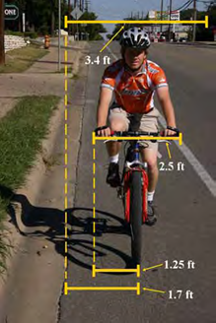
  - The parking space length dimensions will be further challenged in this unique situation because those parking will spend an extended amount of time behind their vehicles loading and unloading their beach items. During this time, it can be expected children will be moving about freely across the street because it will be “perceived” as a parking lot to visitors. Injuries are inevitable resulting in law suits against the county for poor design.
  - Longer vehicles project further into the road endangering other road users. Very often, visitors travel in SUVs and minivans and further extend their vehicles with bicycle racks and cargo carriers to transport all their beach items.
- Perpendicular parking will create a dangerous situation for bicyclists and pedestrians as drivers are pulling in and out of the parking space into the street. There is a significant risk to cyclists from vehicles reversing out, as approaching bicycles are in the blind spot of the reversing and turning vehicles. Parallel parking is the only on-street parking recommended when cyclists are also utilizing the road. Again, injuries are inevitable resulting in law suits against the county for poor design.
- Currently, sand consistently encroaches on the street reducing the overall width of the street. This will likely occur to the proposed parking spaces causing vehicles to be unable to pull forward to the intended front of the spot. This situation will cause the vehicles to protrude into the street.
- Drop-off situations will be introduced blocking traffic in both directions on Beachfront Trail.
- Beachfront trail is utilized by residents, guests of properties, garbage trucks, construction vehicles, and delivery trucks. This type of through traffic is not appropriate for a beach parking lot when visitors spend an extended amount of time loading and unloading. Below is a picture taken on 11/8/12 of such an instance.
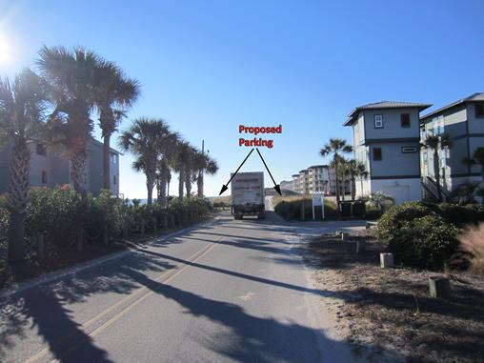

- Furthermore, I have not been able to identify any other instances of on-street perpendicular parking in South Walton, Destin, or Panama City.
Obviously, there are many contributing factors clearly indicating on-street parking, especially perpendicular, will create unnecessary safety issues for residents, guests, and tourists/visitors to the Walton Dunes Neighborhood Beach Access area. We implore the BCC and TDC to complete the necessary analysis required to ensure the need for parking exists at the Walton Dunes Neighborhood Beach Access and to ensure the appropriate safety issues are considered.
As many in the community have already expressed, there are a variety of reasons for opposition to the proposed Walton Dunes Neighborhood Beach Access plan, but safety should be the foremost concern. It is very disconcerting that the BCC and TDC would proceed with parking facility plans based solely on the addition of parking spaces with no needs analysis and no regard to safety considerations.
Below was taken from research done by Virginia P. Sisiopiku, Ph.D. addressing the capacity and safety effects of on-street parking:
EFFECTS OF PARKING
Capacity
The effect of on-street parking on roadway capacity is well known. On-street parking limits street capacity in two ways. First, it preempts lanes that otherwise would be used by moving traffic. Second, parking and un-parking maneuvers frequently reduce the capacity of the adjacent lanes. Even a single vehicle parked within a curb lane can effectively close the lane to moving traffic. An early study on traffic signal design by Webster and Cobbe (Webster F.V. and Cobbe B.M., 1966) reported that a single parked vehicle at or within 7.6 m of the stop line caused a loss in the effective width of the roadway directly equivalent to the width of the vehicle. As the distance between the stop line and the nearest parked vehicle increased, the effective loss of carriage width at the stop line could be expressed as: K1.68 −0.9(Z −7.72).…. Equ. 1 where Z is the clear distance of the nearest parked vehicle from the stop line (in meters) and K is the green duration, in seconds. The expression above applies for values of Z greater than 7.62 m, otherwise the distance should be taken as 7.62 meters.

Safety
On-street parking adversely affects the safety of the street system. Early sources estimated that about 20% of all crashes are related to on-street parking (Roadway Research Board, 1971). More recent reports attribute approximately 15% of all crashes to the presence of parked vehicles. About 5% of all pedestrian fatalities involve people who entered the roadway from between parked cars (Weant R.A. and Levinson H.S., 1990). These proportions vary from city to city. An early study in Chicago examined the frequency of crashes involving parking (Chicago Police Department, 1974). It was found that moving vehicles striking parked vehicles accounted for 2% of all fatal crashes, 6% of all injury crashes, and 26% of all property damage crashes. An analysis of 1994 crashes within the Greater London area (London Accident Analysis Unit, 1995) revealed that nearly 6% of all crashes in London were directly attributable to a parked vehicle. However, this only represents crashes where it is recognized that the parked vehicle is the direct contributory cause. One should keep in mind that these figures may actually be much higher since there are also many incidences where a parked vehicle is involved but not recorded as the main contributory factor. Analysis of state highways in Nebraska concluded that, whenever practical, parking should not be allowed, and whenever parking cannot be restricted, it should be of parallel rather than angle type (McCoy P.T. et al, 1990). In smaller communities, higher percentages of local and collector street crashes involve curb parking. One study in a community of 65,000 population found that 43% of all local and collector street crashes involved on-street parking (Box P.C., 1968a). Another related study reported that parking-related midblock crashes accounted for 49% of all crashes along major streets, 68% along collector streets, and 72% along local streets (Humphreys J.B. et al, 1979). A comprehensive study of curb-parking crashes in 10 cities and five states gathered street and crash data for over 170 miles of urban streets. This study related the magnitude and characteristics of urban street crashes to varying parking configurations, land uses, street widths, and street classifications (Humphreys K.B. et al, 1979). Literature review also reveals that the arrangement of parking spaces, either parallel to the curb or at an angle, affects safety. Most of research work reported in the literature confirms that angle parking is more hazardous than parallel. The principal hazard in angle parking is the lack of adequate visibility for the driver during the back-out maneuver. Additional hazard results from the drivers who stop suddenly upon seeing a vehicle ahead in the process of backing out. Moreover, drivers searching for a parking spot must either proceed slowly (thus tying up traffic) in order to see the empty stall, or slow abruptly when they come upon an empty space. Several more studies have compared the crash experience of angle and parallel parking and reported crash rates for parallel parking to be from 19 to 71% lower than those for angle parking (U.S. Department of Transportation, 1982). For example, studies in nine Utah cities showed that changes from angle to parallel layout were accompanied by a reduction in parking crashes of 57% and a 31% overall decrease in injury or fatal crashes for the study section (Box P.C., 1968b). A similar study of two business blocks in Salem, Oregon, revealed a 65% reduction in parking crashes. Many of the studies in the literature were before-and-after studies of changes from parallel to angle parking, and none of the studies accounted for the change in crash exposure associated with the change in parking configuration. A study (McCoy P.T. et al, 1991) on the safety effects of converting on-street parking from parallel to angle found that the conversion resulted in a significant increase in the number of parking-related crashes as well as the number of parking related crashes per million vehicle miles. Contradictory standpoints are found in the literature with respect to the effect of on-street parking on pedestrian safety. Many sources agree that improperly designed and/or controlled parking facilities can invite pedestrian crashes. Parked vehicles can block sight distance that is necessary for safe pedestrian and vehicular crossings. Dart-out crashes (where pedestrians, especially children, dart out from between parked vehicles into the traffic stream) increase when on-street parking is encouraged.

In conclusion, on-street parking is known to be a contributory cause in road traffic crashes. When on-street parking is deemed necessary, it should be of parallel rather than angle type. The choice of parking angles has important bearing on the design of on-street space. Arranging parking at an angle to the curb length results in more parking spaces per unit of curb length than parallel parking. On the other hand, as the parking angle increases, there is a corresponding need for more road space for vehicle maneuvering and the potential risk for traffic crashes. The latter is due to the lack of visibility in leaving the stall and the fact that the backing maneuver conflicts with one additional lane of moving traffic (Institute of Traffic Engineers, 1941). Where parking is an element of street design, parallel parking is usually more acceptable and should be used wherever parking is permitted on streets (Weant R.A. and Levinson H.S., 1990).

Sincerely,
Marina Daniel

