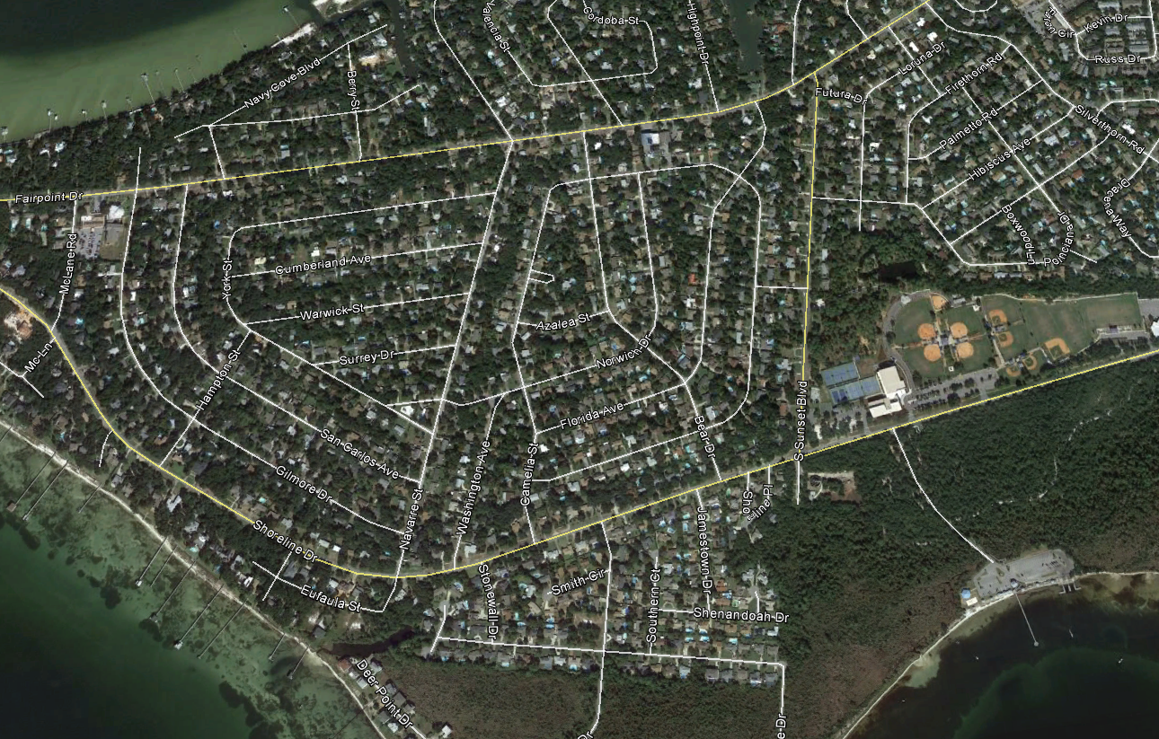
Camelia/Bear/Navarre/York/Cumberland/Warwick Stormwater Improvement Area map

