East Bay Heights Septic Tank Abatement Program Area Map

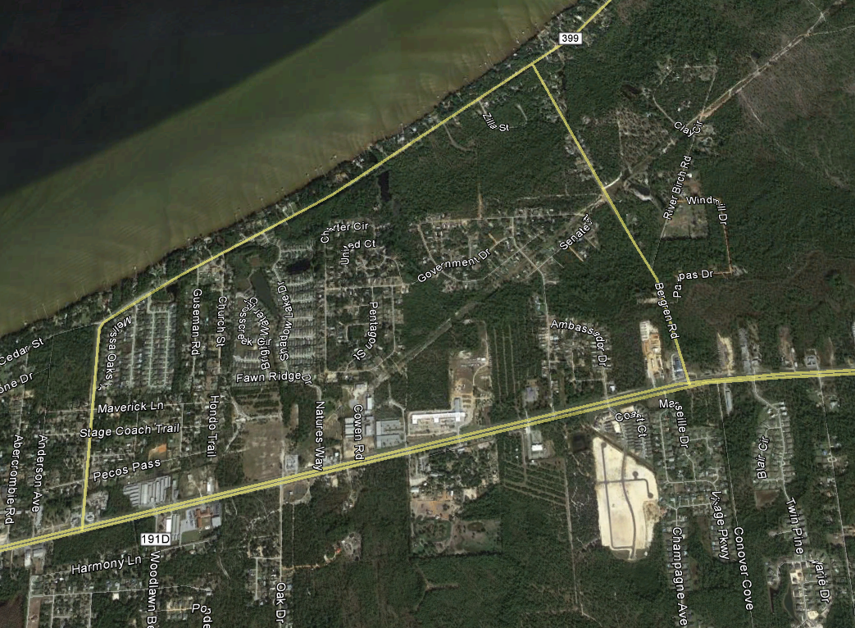
1
3
2

