Lions Gate Stormwater Discharge Pipe Upgrade Area Map

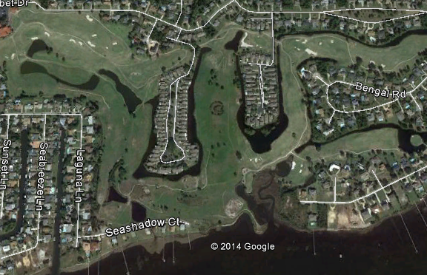
EXISTING PIPE CONNECTOR TOO SMALL

