Upgrade Stormwater Discharge Channel from FDOT areas across the east golf course Upgrade Area Map

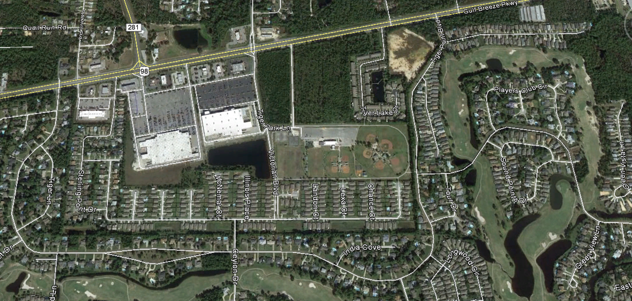
FLOW RESTRICTED AREA

