Oyster reef restoration in Tarpon Bay and other sites near Sanibel

Cost: $750K
Contact: Eric Milbrandt, emilbran@sccf.org, Sanibel-Captiva Conservation Foundation Marine Laboratory, 239-395-4617

Description: This Project is designed to complement other larger oyster habitat restoration efforts being conducted throughout the Gulf, including work in the three contiguous NEP regions of Tampa Bay, Sarasota Bay and Charlotte Harbor. The Project will implement the CHNEP Oyster Habitat Restoration Plan (2012) (Plan). As defined in the Plan, the oyster habitat restoration goals are to enhance and restore self-sustaining oyster habitat and related ecosystem services throughout the estuaries and tidal rivers and creeks in the CHNEP watershed. To accomplish these long term goals, the following short term actions are identified in the Plan and recommended to be implemented by 2020. We will establish 1 to 2 large intertidal/subtidal fringe reefs (up to 0.5 acre) in Tarpon Bay and San Carlos Bay (TBC, SCBC, MPC). For a 0.5-acre reef, we estimate 950 tons of shell will be needed (40 truckloads of fossilized shell). Fossilized shell (90%) and restaurant collected oyster shell (10%) will be staged, barged, and lowered using a barge and marine contractor. This approach is currently being employed for oyster reef enhancement/shoreline stabilization in Florida, Louisiana, North Carolina, and Alabama. Performance measures will include the following oyster population metrics: recruitment, survival and growth rate, density/m2, mean size, and resident invertebrate species richness. These metrics will be measured using shell-filled trays (0.125 m2) deployed within the oyster reefs allowing removal of trays following construction (Hadley, et al. 2010). Control sites will be established to compare results at these sites versus restored reef. Parametric and non-parametric statistics will be used to compare oyster metrics and water quality values between years and between control and restoration sites. Multivariate statistical methods (Primer®) will be used to try to establish a link between environmental parameters and changes in oyster metrics.

Acres: 1-2 Acres of oyster reef habitat
Permits: All permits are held by the Sanibel-Captiva Conservation Foundation through 2020 (FDEP Environmental Resource Permits, a NMFS Biological Opinion, and USACOE Nationwide Permit)

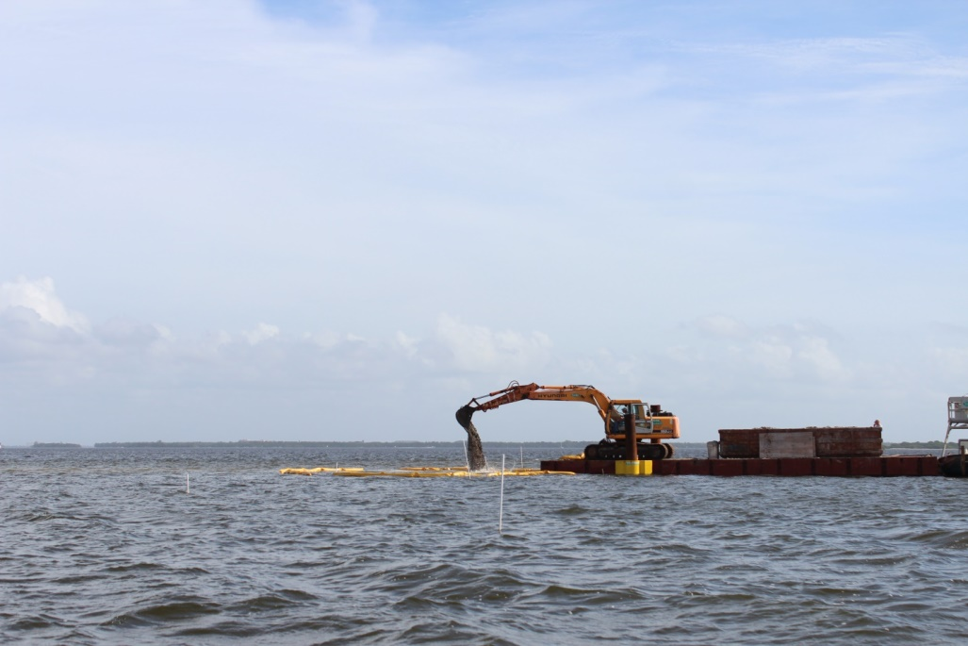

Bay Scallop Enhancement in Tarpon Bay
Cost: $250K

Contact: Eric Milbrandt, emilbran@sccf.org, Sanibel-Captiva Conservation Foundation Marine Laboratory, 239-395-4617

Tarpon Bay (Figure 1; Latitude 26.452318, Longitude -82.079486, Zip Code 33957) is a 900 acre estuarine embayment connected to southern Pine Island Sound and located within the J.N. “Ding” Darling National Wildlife Refuge on Sanibel Island, a barrier island in southwest Florida (Fig. 1). Its immediate watershed is composed primarily of federally protected coastal habitats however, canals and stormwater structures from private developments discharge into the bay. Tarpon Bay was once known for incredible fishing and very productive subtropical habitats. Currently, these are in decline (Personal communication, R. Woodring) and the bay scallop (Argopecten irradians) population has virtually disappeared (Geiger et al. 2006), although some populations on Florida’s west coast remain viable.
In this project we propose to establish ‘spawner sanctuaries’ for bay scallops (Argopecten irradians) around Tarpon Bay, FL to re-establish a viable local population which will be an important future contributor to the regional meta-population and also improve water quality through filtering and improved nutrient cycling. Recent scallop restoration efforts have demonstrated success in increasing adult scallop densities and spat recruitment. We will collect juvenile scallops from spat collectors distributed throughout Pine Island Sound (SCCF) and Tampa Bay (FWRI). Spat will be picked off the collectors and placed in cages (spawner sanctuaries) and distributed throughout Tarpon Bay and a variety of cage locations at the homes of our volunteers. The spawner sanctuaries will likely increase spawning success and lead to higher scallop densities around the locations where they are deployed. Adult scallop densities will be determined during volunteer scallop searches to be conducted annually in Tarpon Bay and portions of Pine Island Sound. We will be working with a local shrimp boat operator to obtain scallops caught as by-catch in Tarpon Bay, which will be placed into the spawner sanctuaries to increase genetic diversity.
Goals: The Tarpon Bay sub-population will be restored and serve as a population that could seed surrounding seagrass habitats including J.N. “Ding” Darling National Wildlife Refuge. Long-term measures of success will include: increased abundance and distribution as observed in surveys conducted by FWRI and annual volunteer surveys; an increase in the mean and peak spat recruitment rates; an increase in the recruitment duration.
Adult density: We will use established protocols (Thayer et al. 2003, Thayer et al. 2005) to evaluate the progress of the project. No adult scallop abundance data exist for Tarpon Bay, so we will assess pre-restoration levels, and then establish success criteria for the expected increases in abundance, distribution and recruitment rate within this sub-basin. Long term goals will be assessed using existing annual volunteer monitoring events coupled with other sources of monitoring data (FWRI adult scallop surveys). The target density within Tarpon bay will be 10 scallops/100 m² with scallops present at more than half of the stations surveyed. This represents the approximate density of scallops in the Steinhatchee recreational scallop habitats which is considered a healthy population (FWC 2010). The 2010-2011 average for southern Pine Island Sound was 2.5 scallops /100 m².
We will expand the annual volunteer bay scallop search (Figure 4) to include Tarpon Bay and surrounding waters. Our success will be determined by increasing the number of volunteers by 20% of current levels, increase the number of volunteer hours by 20%, and expanding the area sampled by volunteers during an annual scallop survey. We will also monitor the number of scallops collected as by-catch by a local commercial shrimp fisherman (R. Woodring, FL5678SE; SP48547; 8 ft. Roller drag gear, 3/4 inch maximum mesh size). The bycatch scallops will be placed in spawner sanctuaries if sufficient numbers are caught.
Recruitment Rate: Monthly recruitment and annual adult scallop monitoring at stations in Pine Island Sound and newly established stations in Tarpon Bay will be undertaken by SCCF and Florida FWC (Figure 5). Measures of success will include at least a doubling of the number of juvenile scallops collected from the spat recruitment bags (2010-11 rate ~ 0.7 spat per deployment; target = 1.4) and a doubling of the number during the peak recruit event (5.5 per bag; target = 11 per bag). We will set up to 50 spat collectors in the Demere Key area of Pine Island Sound which has high recruitment rates and organize volunteer events to pick the live juvenile scallops off the collection units at the SCCF Marine Lab. The spat collectors will consist of the FWC-proven design of citrus bag with float attached to an anchor within seagrass habitat (Figure 6). These traps will be placed at least twice annually, creating four volunteer harvest events. .

Permits: A Special Activity License (SAL) is held by the SCCF Marine Laboratory to conduct the enhancement of scallop populations under the guidance of Dr. Steve Geiger (FWC). The local shrimp boat operator has FL Commercial bait shrimp license.
