- Project Title: Expand and Improve Gulf of Mexico Marine Mammal Stranding Response and Science Capacity

Proposed Restoration Project: The project will augment resources available to the Marine Mammal Health and Stranding Response Program (MMHSRP) network members in the Gulf, helping them respond to and learn from future marine mammal strandings and thus increase the survival of rescued animals and the recovery of populations impacted by the Deepwater Horizon (DWH) oil spill. Added benefits from this project are the ability to augment the resources and response capability across networks that serve other impacted marine wildlife species, such as sea turtles and sea birds.

Link to Injury: Marine mammals (whales, dolphins, and manatees) inhabit the northern Gulf and likely were exposed to petroleum hydrocarbons and impacted by cleanup activities resulting from the Deepwater Horizon oil spill. Aerial surveys conducted under the Natural Resource Damage Assessment observed 6 species of whales or dolphins swimming in surface oil in offshore waters. Two dolphins were rescued after being trapped behind oil booms in Alabama during the spill event. Live dolphin health assessments conducted in Barataria Bay in 2011 showed that animals in this highly impacted region were exhibiting signs of severely compromised immune systems -- symptoms consistent with those seen in other mammals exposed to oil.

Approximately 930 marine mammal strandings (almost entirely bottlenose dolphin) have been reported as of 7 April 2013 as part of an ongoing Unusual Mortality Event that began in February 2010 in the northern Gulf. Strandings in 2010-2012 far exceeded the historical average (Figure 1). The majority of the strandings occurred in Louisiana, followed by Mississippi, Alabama, and the Florida panhandle (Figure 2). Scientists are still investigating the cause of the strandings. The potential for long-term impacts exists for marine mammals that were exposed to contaminants, but may take many years to be realized.
Figure 1

Figure 2

Benefit and Rationale: The collection of biological information from stranded marine mammals is critical to understanding more clearly the long-term effects of the DWH oil spill and to ensuring the recovery of affected populations. Prior to the spill, stranding response efforts were patchy and inconsistent in many portions of the region, especially Louisiana and Alabama. Response capabilities increased in certain areas during the spill with funding from the Natural Resource Damage Assessment; however, long-term funding is needed across the Gulf because it is not known where or when delayed strandings related to the DWH spill may arise in the future. Institutional funding is variable but generally inadequate to provide the level of response needed for ongoing injury assessment. Limited global expertise in marine mammal veterinary care and diagnosis underscores the need to recruit and retain properly trained specialists in the impacted region.

MMHSRP network members are often the first and only responders to marine mammal strandings in the Gulf region. Rapid response to live- and dead-stranded animals is key to collecting the high quality samples necessary to determine cause of death and to monitor the health status of wild populations. The availability of trained and qualified stranding responders, technicians, and veterinarians is essential in providing effective medical and forensic response. The unusually high number of sick and dead marine mammals recovered in the northern Gulf since the DWH oil spill underscores the importance of network members in responding to, rescuing, and rehabilitating stranded marine mammals. Often, MMHSRP network members participate also in response efforts for other injured or dead marine wildlife, including sea turtles and seabirds.

Although none of the marine mammals rescued during the DWH event could be released back into the wild, other live-stranded marine animals (e.g., seabirds and sea turtles) were rescued and rehabilitated by network members and typically were released. There is an ongoing need to treat and successfully release stranded dolphins, whales, and manatees back to the Gulf. Released animals are then able to reproduce and contribute to the recovery of the wild population. Follow-up monitoring of released animals via tagging and resightings will provide data on the success of rehabilitation efforts and assist in adaptive management of rehabilitation and release techniques.

Marine mammals, among other species, are the ocean’s “canaries in the coal mine,” and MMHSRP network members, through biological sampling and post-mortem examinations, collect high value information on the condition of animals that can help scientists not only understand the cause of illness or death, but also detect subtle or significant changes in ecosystem condition and function.

Stranding response complements on-water observational studies of free-swimming wild animals, which provide a means to measure population vitality, births, juvenile survival, visual health indicators, and incidences of injury or harassment by human activities (e.g., vessel strikes and fisheries interactions).

Description: This project would maximize the survival and recovery of marine mammals affected by the DWH oil spill by increasing the capacity of Gulf marine mammal health and stranding response program network members, with emphasis on areas affected by the spill, to 1) respond to reports or sightings of live- and dead-stranded marine animals, 2) support facilities and personnel involved in rehabilitation and release of stranded marine mammals, 3) conduct timely and thorough examinations of live- and dead-stranded animals, and 4) collect, analyze, maintain, and disseminate consistent and high quality information from stranded animals and stranding events.

Specifically, this project would increase capacity within the existing MMHSRP network across the Gulf, particularly in the areas more heavily affected by the spill, over a 10-year period. The project emphasizes investments in the following operational areas: 1) salary support for stranding coordinators, veterinarians, and technicians to respond to strandings, conduct examinations, and collect and organize samples and data; 2) equipment, supplies, and contracted services needed to locate and respond to strandings, conduct examinations, and collect and store biological samples; 3) laboratory analyses of biological samples; 4) operation and maintenance of necropsy and rehabilitation facilities; and 5) training of stranding responders.

Adequate resources for existing Gulf MMHSRP network members would ensure that information collected from stranded marine mammals is consistent throughout the Gulf and with other U.S. regions. This vital work is integrated with other health assessment studies and contributes to a better understanding of the impacts of the DWH oil spill on Gulf marine mammals to inform marine mammal recovery strategies going forward. Enhancing capacity and long-term consistency of the MMSHRP network in the Gulf region will also augment response efforts that focus on other impacted species of wildlife.

Location of Project: The project would increase capacity for MMHSRP network members throughout the Gulf, emphasizing investments in areas most heavily affected by the spill (Louisiana, Mississippi, Alabama, and the western edge of the Florida panhandle).

Funding Source/Mechanism: Funding for this project would come primarily from funds awarded by the court or an out-of-court settlement under the Oil Pollution Act Natural Resource Damage Assessment to restore injured natural resources and services to pre-spill conditions. Other sources of funds could include funds from state trustee agencies, the National Fish and Wildlife Foundation, and/or the Gulf Coast Ecosystem Restoration Council.

NOAA, as the lead Trustee for marine resources, is in the best position to administer and coordinate the allocation of funds for this project. Designated network members (see list below and the attached map) would work in close partnership with the project administrator to determine the type of enhancements needed at their facilities. NOAA and other state and federal trustees, as appropriate, would determine the amount of funding for each network member based on restoration scaling; that is, the level of funding would be based on nexus to injury and the number and type of strandings (i.e., injuries) that occurred or are likely to occur in each network member’s area of responsibility (see attached map).

Network members in the primary DWH oil spill impact zone:
- Audubon Aquarium of the Americas (New Orleans, LA; Suzanne Smith)
- Louisiana Department of Wildlife and Fisheries (Grand Isle, LA; Mandy Tumlin)
- Institute for Marine Mammal Studies (Gulfport, MS; Moby Solangi/Delphine Vanderpool)
- Dauphin Island Sea Lab (Dauphin Island, AL; Ruth Carmichael)
- Emerald Coast Wildlife Refuge (Fort Walton Beach, FL; Amanda Wilkerson/Steve Shippee)
- Gulf World (Panama City Beach, FL; Ron Hardy)
Network members in other areas of the Gulf potentially affected by the spill:
- Texas Marine Mammal Stranding Network and authorized designees (Galveston, TX; Heidi Whitehead)
- Marine Mammal Conservancy (Key Largo, FL; Art Cooper, Jr.)
- Florida Fish and Wildlife Conservation Commission Marine Mammal Pathobiology Laboratory (Saint Petersburg, FL; Andy Garrett)
- Florida Fish and Wildlife Conservation Commission Southwest Field Laboratory (Port Charlotte, FL; Denise Boyd)
- Florida Aquarium (Tampa, FL; Kristen Aanerud)
- Mote Marine Laboratory (Sarasota, FL; Gretchen Lovewell)
- Clearwater Aquarium (Clearwater, FL; Mike Hurst)
Cost Estimate: Approximately $45 million over 10 years

The following cost estimates are for planning purposes only; the actual resource needs for each network member organization will vary considerably on both an initial and annual basis, based on each organization’s existing capabilities and facilities as well as actual marine mammal stranding levels in the DWH oil spill impact zone (footprint of oiled areas) or other areas of the Gulf that could be potentially affected by the DWH oil spill. Resource needs could extend beyond ten years, depending on the type and severity of any long-term, chronic effects on marine mammals.

Capital Equipment for responders in heavily affected areas of the Gulf (every 5 years):
Trucks (7 @ $45K) $315K
ATVs (7 @ $12K) $84K
Small boats (7 @ $50K) $350K
Ultracold freezers (7 @ $10K) $70K
Modernization of existing rehabilitation facilities $500K
TOTAL (per 5 years) $1,319K

Recurring costs per category for responders in heavily affected areas of the Gulf (per year):
Salaries
Stranding coordinators (7 @ $65K) $455K
Veterinarians (4 @ $100K) $400K
Technicians (14 @ $50K) $700K
Aerial surveys of remote areas (2/month @ $10K) $240K
Equipment (fuel, maintenance, repairs) (7 @ $25K) $175K
Supplies (sampling and storage) (7 @ $20K) $140K
Sample analyses (laboratory) $500K
Rehabilitation facilities
(operation and maintenance) (3 @ $150K) $450K
Training $100K
TOTAL (per year) $3,160K

Recurring costs per category for responders in other areas of the Gulf potentially affected by the spill (per year):
Salaries
Stranding coordinators (6 @ $65K) $390K
Veterinarians (2 @ $100K) $200K
Supplies (sampling and storage) (6 @ $20K) $120K
Sample analyses (laboratory) $200K
Training $50K
TOTAL (per year) $960K

GRAND TOTAL (for ten years) $43,838K*

*This estimate does not include institutional overhead

Timeframe: 10 years

Authors: This proposal was prepared by staff from Ocean Conservancy and the Marine Mammal Commission, with input from stranding network members throughout the northern Gulf and in coordination with the NOAA Restoration Center. Neither Ocean Conservancy nor the Marine Mammal Commission is seeking funding for this project, nor do they anticipate receiving funds, if approved and adopted in whole or in part, by the Natural Resource Trustees, the Gulf states, the National Fish and Wildlife Foundation, the Restoration Council, or any other funding entity.

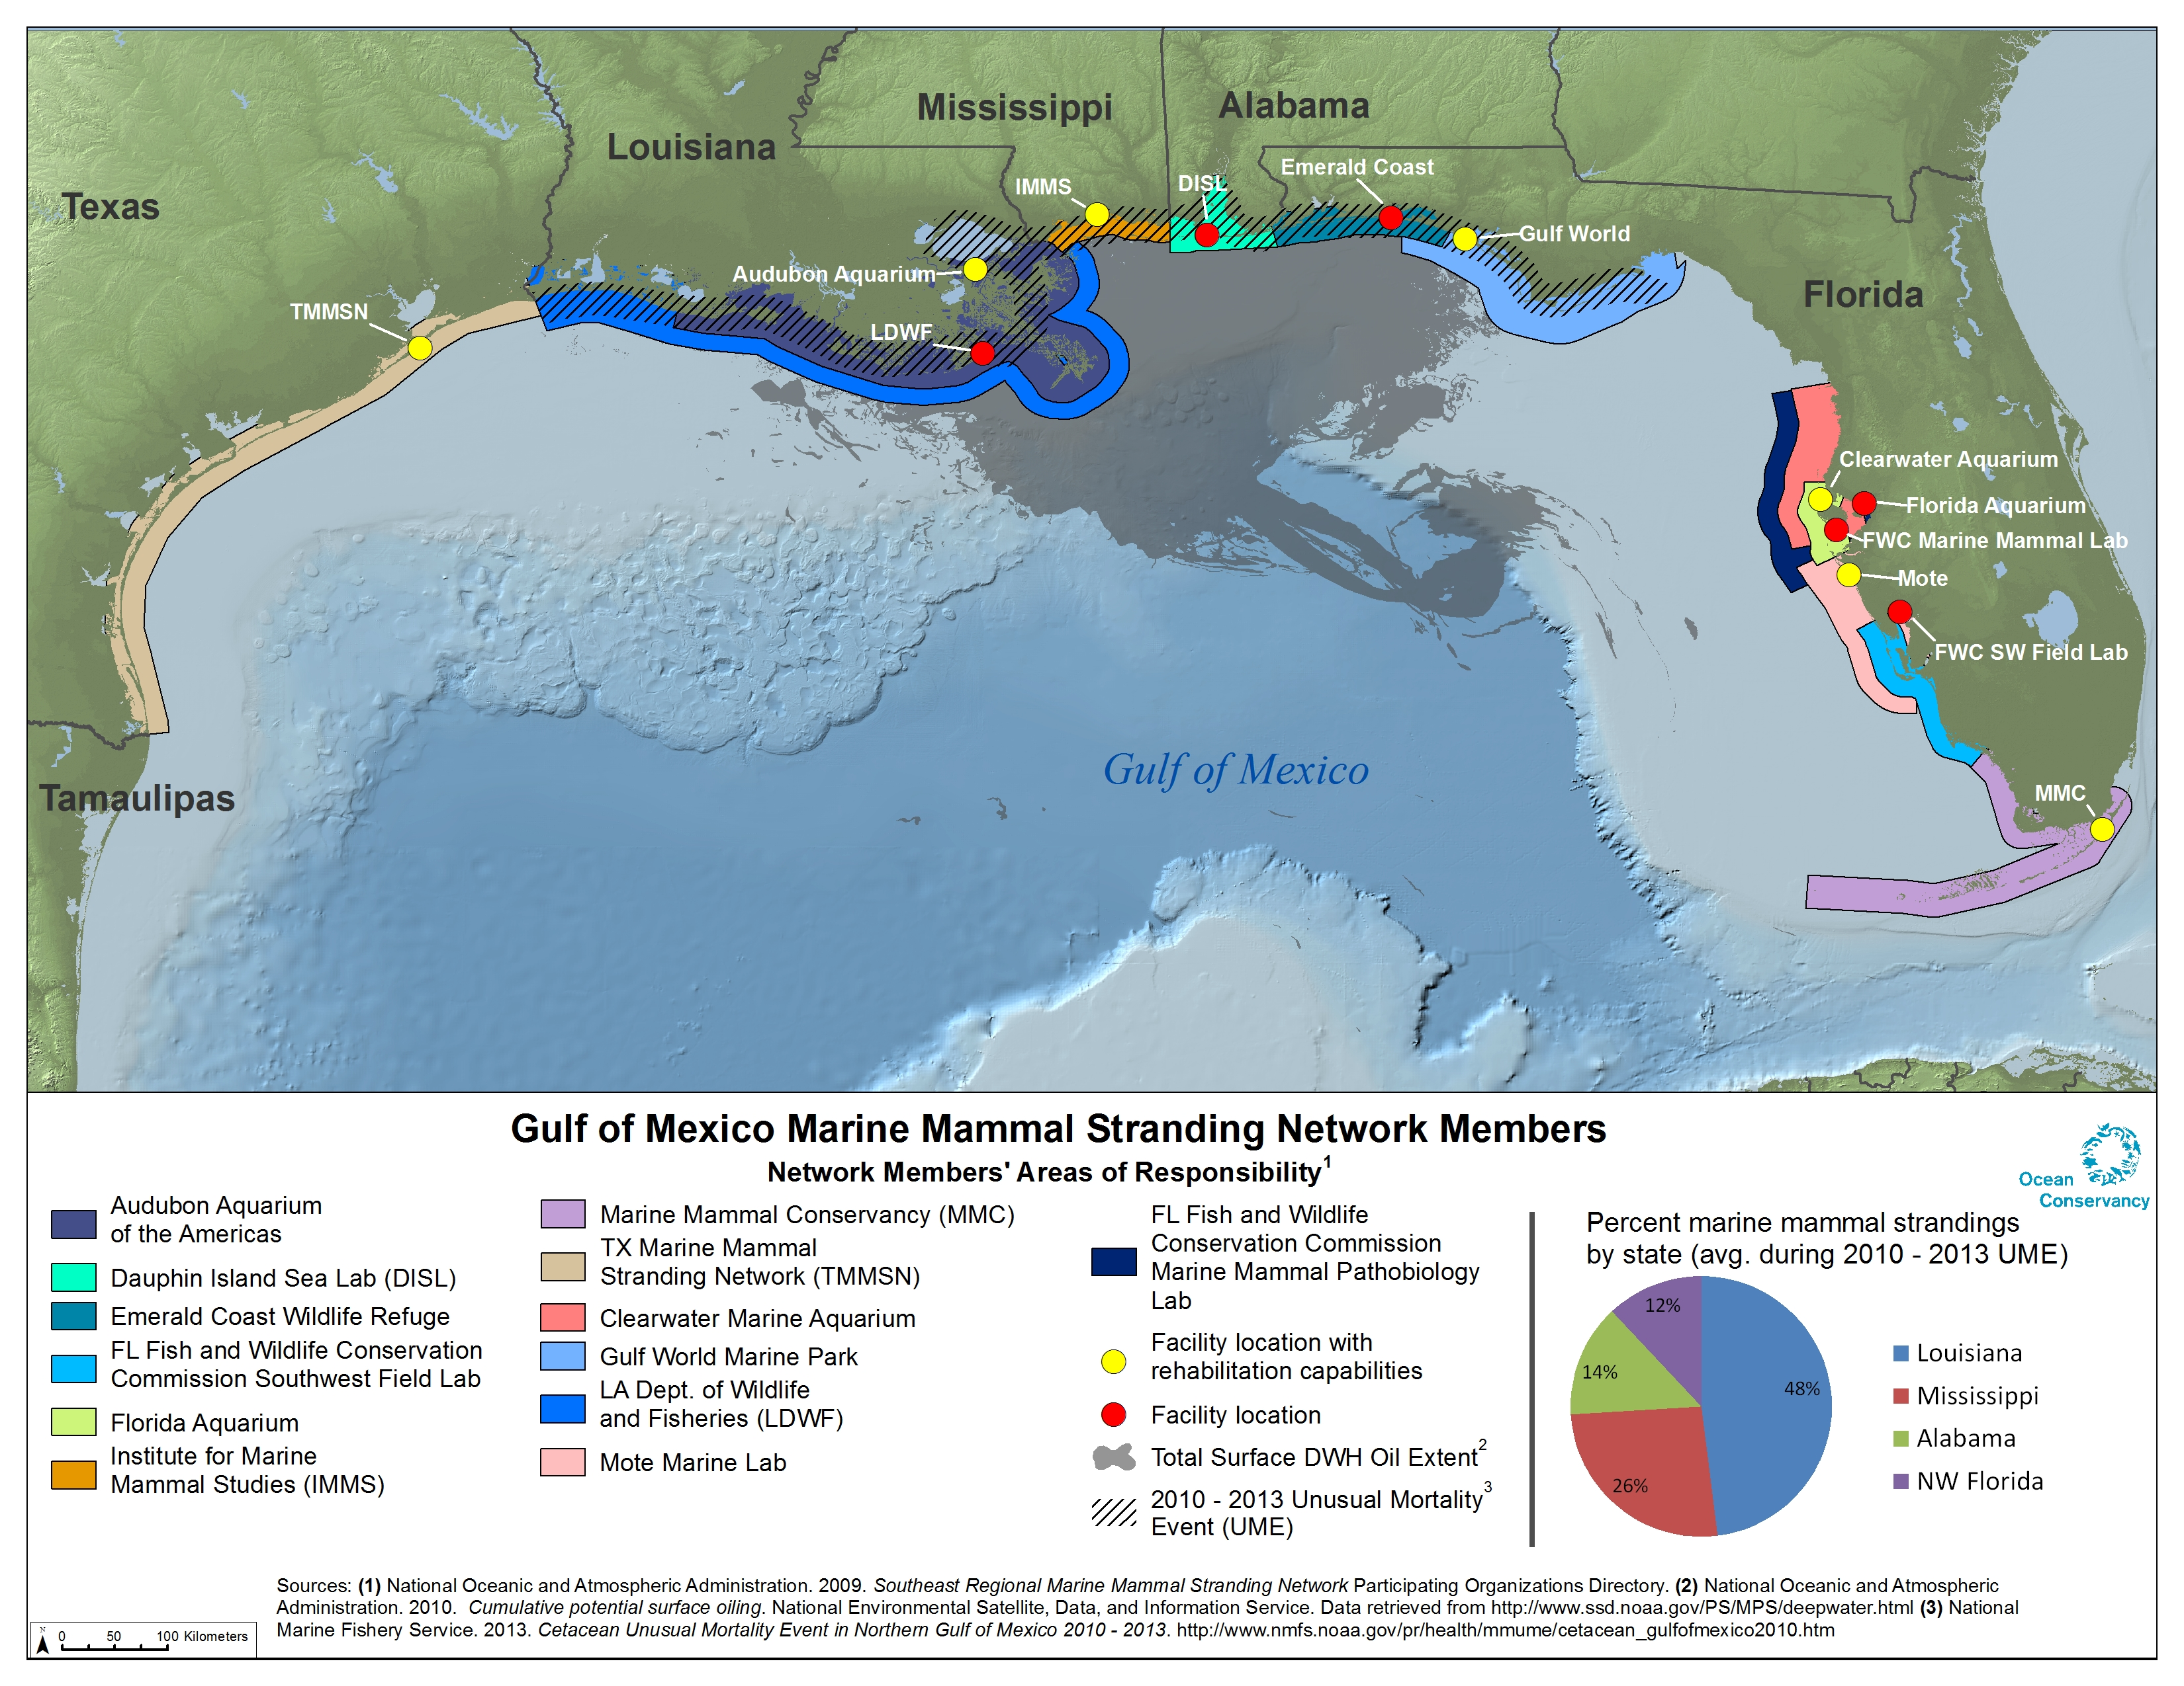

Although this project is focused on marine mammals, most of the network members listed herein also respond to sea turtle strandings, which have increased significantly in the Gulf since the DWH oil spill. However, other entities are also involved in sea turtle stranding response, so a separate proposal is expected to be submitted for enhanced capacity for sea turtle stranding response. Nevertheless, marine mammal and sea turtle responders will coordinate to maximize efficiencies where possible.
NOAA. 2012. Draft 2012 Marine Mammal Stock Assessment Report for the Atlantic, Gulf and Caribbean. NOAA Fisheries Service, Office of Protected Species. http://www.nmfs.noaa.gov/pr/sars/draft.htm.
Study by NOAA and Partners Shows Some Gulf Dolphins Severely Ill Health. www.gulfspillrestoration. noaa.gov/2012/03/study-shows-some-gulf-dolphins-severely-ill/; NOAA Gulf Spill Restoration: Gulf Dolphins Questions & Answers. www.gulfspillrestoration.noaa.gov/2012/03/gulf-dolphins-answers/.
The northern Gulf is defined as the Texas/ Louisiana border through Franklin County, Florida.
2010-2013 Cetacean Unusual Mortality Event in Northern Gulf of Mexico. www.nmfs.noaa.gov/pr/ health/mmume/cetacean_gulfofmexico2010.htm.
Matkin, C.O., E.L. Saulitis, G.M. Ellis, P. Olesiuk, and S.D. Rice. 2008. Ongoing population-level impacts on killer whales Orcinus orca following the Exxon Valdez oil spill in Prince William Sound, Alaska. Marine Ecology Progress Series 356:269-281.
In the past, some networks have received limited federal support from NOAA’s Prescott grant program; however, those funds were eliminated from NOAA’s budget requests in 2013 and 2014 and are not expected to be available in the future.
The Texas Marine Mammal Stranding Network has several designee organizations operating in different parts of the state.

