Project Name
Choctawhatchee Watershed Blue Way Trail
Contact Information (Include at least one name, phone number, email address, and organization name if applicable)
Billy McKee; (850)892-8108; mckbilly@co.walton.fl.us; Walton County Board of County Commissioners Public Works Division
Project Location (Include a map, if possible, and the city, county, longitude/latitude, and watershed)
The project includes portions of the Choctawhatchee River and Holmes Creek, beginning at East Pittman Landing (Holmes County) and ending at Cowford Landing (Walton County).
Project Description (Describe all aspects of the project)
Water trails, or “blue ways,” have been shown to be effective in bringing tourism, getting communities on their local waterways, and promoting conservation. This project proposes a multi-county blue way trail, beginning at East Pittman Landing in Holmes County, including numerous sites along Holmes Creek in Washington County, and ending at Cowford Landing in Walton County. Featured along the blue way trail would be several camping locations, ranging from designated primitive campsites to riverside cabins, that would include overnight watercraft storage for canoes and kayaks, renovations or repairs to existing river access points and ramps or the construction of new multi-use ramps, screened decks/picnic pavilions, picnic tables, grill pits, campfire circles, and public restrooms/showers where suitable. Additional features along the blue way trail would include outdoor pavilions for school, camp, and club retreats, environmental education kiosks, wildlife observatories, and informative markers of historical and/or geological significance along the blue way, its many tributaries, freshwater springs, oxbow lakes, and vast floodplain. The addition of a blue way trail will provide residents and tourists’ alike increased opportunities to explore the Choctawhatchee Watershed, visit natural springs, explore a variety of Florida’s natural flora and fauna, as well as fish and camp.
Estimated Project Costs (Describe the estimated costs of the project, including any assumptions for contingency and ongoing operations/maintenance. Identify other secured funding sources such as matching funds, in-kind contributions or state/federal dollars. In addition, if possible, complete and submit the Cost Appendix Sheet associated with this Form)

The proposed cost of the project is $20,000,000, which includes ongoing operations/maintenance costs accrued by the counties for all recreational amenities and staff.

Other Funding (Indicate if the project is submitted for any potential funding or if it may be used to leverage additional funding, if so please describe the funding source [e.g. State/Federal Grants])

As a watershed based project, the blue way trail allows for the involvement and collaboration of multiple stakeholders, and promotes partnerships among non-profit organizations, government municipalities, and private land and business owners. These partnerships, formed by parties interested in increasing tourism, boosting the local economy, getting communities on their local waterways, improving the condition of our natural resources, and promoting advocacy and conservation, allow for cost-sharing and the ability to explore additional funding among organizations or through outside sources. Potential suppliers of funds, materials, and land may include the Northwest Florida Water Management District, the Recreational Trails Program, the Florida Department of Environmental Protection Office of Greenways and Trails, the E.O. Wilson Biophilia Center, and the Florida Historical Society.

Technical Feasibility (Describe the technologies involved and any relevant past experience or proven success with similar projects)

Blue way trails are one way that communities can highlight their local waterway in order to encourage a variety of river recreation. In doing so, the river is promoted as an established trail with signs, designated access, camping, and attraction points, websites and maps.

As of present, several blue way trails have been established in the United States including one of the most well-known, the North Forest Canoe Trail (NFCT), a 740-mile water trail that travels through four U.S. states and one Canadian province. Several outdoor recreation studies have documented the economic benefits local communities can receive from natural attractions and amenities, often leading to increased support for the protection and conservation of the resource.

An economic impact study of the NFCT was done to calculate the impact of paddlers on regional communities (Pollock, 2007). The study looked at six regions that were affected by the blue way trail, and determined that paddlers infused local communities with $12 million in economic impact and supported up to 280 jobs. Across the six regions, the addition of the NFCT created new markets and job opportunities (paddle suppliers, outfitters, guides) and benefited existing businesses (local restaurants, motels, gas stations), leading to increased personal income for residents and more tax revenue for local governments.

In addition to the economic success associated with blue way trails, promoting river recreation often leads to communities placing a higher value on their local waterways and citizens more likely to serve to protect biodiversity and generally improve water quality.

Environmental Benefits (Describe the nature, magnitude, and timing of any environmental benefits attributable to the project. If possible, describe potential environmental performance measures [e.g. pollutant reduction]. Please address any potential environmental impacts associated with implementing or maintaining the project [e.g. loss of a habitat or conversion of habitat from one type to another during implementation])

Blue way trails facilitate recreation, and subsequently increase visibility and knowledge about local rivers and watersheds. This newfound enthusiasm about local waters can be turned into advocacy and conservation, promoting protective efforts for flora and fauna, improving water quality and many of the ecosystem services provided by freshwater systems. These protective efforts often take the form of conservation easements, riparian buffers, flow protections, and higher water quality standards. Likewise, the addition of educational kiosks, wildlife observatories, and outdoor recreational centers suited for school and camp field trips, work retreats, etc. increase environmental awareness and encourage ecological stewardship.

Founded in nature-based tourism, paddle sports (kayaking, canoeing) promote sustainability and are a low-carbon activity. With an estimated 12.5 million participants and a 63% increase from 2000 to 2007, paddle sports are rare in their ability to positively impact local economies while maintaining a low impact. Additionally, all recreational amenities such as campsites, pavilions, and boat ramps proposed for the Choctawhatchee Watershed Blue Way Trail will be constructed to work within the environmental framework of the watershed, ensuring a low impact during the implementation and duration of the trail.

Economic and Social Benefits (Describe the economic and social benefits including those related to the project’s improved ecosystem services and any estimates on jobs created or preserved)

Several studies have documented the increasing interest in paddle sports and nature based tourism throughout the United States as well as the economic return provided to local communities. Pollock (2007) analyzed six regions affected by the NFCT, and determined that paddlers infused local communities with $12 million in economic impact and supported up to 280 jobs. The study also separated paddler spending by local and non-local finding that local paddlers spent $5 per person per day, and non-locals spent $46 per person per day. Additionally, the study revealed that roughly 12% of paddlers used guide services, spending around $50 per group throughout the six impacted regions.

Marcouiler et al. (2005) found that blue way trails and other forms of nature based recreational activities diversified the local economy, often leading to decreases in income inequality and bridging the gap that so often occurs between rural and urban areas. The diversified economy allows for new and expanding markets including outfitters for recreational activities and guides, as well as increased attraction for existing businesses and services including the food and hospitality industry, gas stations, and other local stores.

Southwick, Bergstrom, and Wall (2009) determined the total direct, indirect and induced economic impact of paddle-based recreation in the US to be over $36 billion and an employment of over 308,000 people per year. In 2005 alone, 87 million day trips were taken and 23 million paddlers participated in over 80 million overnight paddling trips. As interest in paddle sports and nature-based tourism has and is projected to be on the rise, communities are able to capitalize on the increased revenue both privately and publically, fostering positive environmental management strategies and helping retain and develop local infrastructure. Blue way trails are the perfect, low-impact catalyst to capturing the growing paddle sport and eco-tourism market.

Community Resilience (Describe if the project assists Florida’s ability to anticipate, withstand, or recover from hazards or threats [e.g. hurricane preparedness, establishing living shorelines])

The addition of a blue way trail in the Choctawhatchee Watershed diversifies the existing tourism and recreational market, providing tourists an alternative to the traditional “beach vacation” and a recreational “hot spot” for thrill seekers and nature enthusiasts interested in exploring Florida’s vast and diverse natural resources. In the event of another disaster negatively impacting the Panhandle’s major tourist attraction, the beach, it now has a tourism fail safe in the form of a blue way trail, capable of attracting visitors worldwide.

Conflicts or Complements to Existing Efforts (Describe any ongoing activities in the project implementation area, if the project is part of another plan, and why the project does or does not interfere with that work. Please consider how the project may complement existing local, regional, and state efforts/plans/objectives)

The Choctawhatchee Watershed Blue Way Trail has no direct or indirect conflicts with any existing efforts in the area, and if anything will complement the existing effort of local, regional, and statewide plans to increase tourism, expand the economy, create jobs, promote conservation, and protect the local environment.

Complies with Federal, State, Local, and Tribal Laws/Regulations (Describe any concerns or potential conflicts):

The Choctawhatchee Blue Way Trail will comply with all federal, state, local and tribal laws and regulations.

Readiness for Implementation (Describe if the project has had any design or permitting work started or completed [attach permits or design work]. Please address any issues that may delay start or finish of the project)

Aside from preliminary concepts and designs, no formal permits or design work have been submitted. That said, organizers and engineers involved with the Choctawhatchee Watershed Blue Way Trail have and will continue to be in communication with personnel responsible for the implementation of the extremely successful Suwanee River Wilderness Trail, which will serve as the template for the Choctawhatchee Watershed Blue Way Trail. So too, state lands, river access points, and personnel managed by the state and governing agencies have been cleared for renovation, restoration, or development for the implementation of the blue way trail.

Public Acceptance (Describe any known or potential public approval or opposition to the project)

There is no known opposition to the proposed Choctawhatchee Watershed Blue Way Trail. Local residents, municipalities, and vested organizations are in full support of the proposed project.

Additional Information you wish to provide (Please include any maps, designs, drawings, photos, or background resources that may assist in completely and accurately understanding the project)

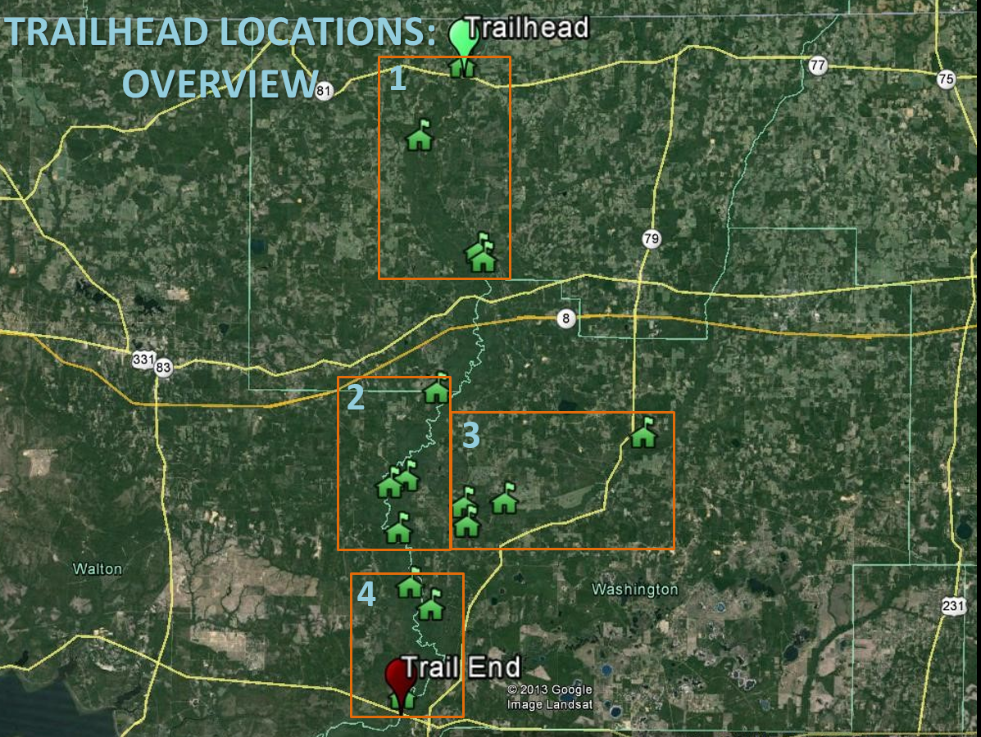

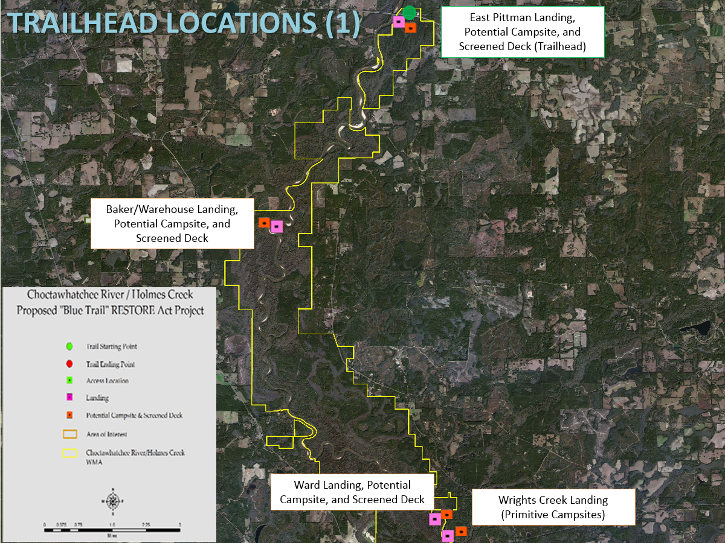

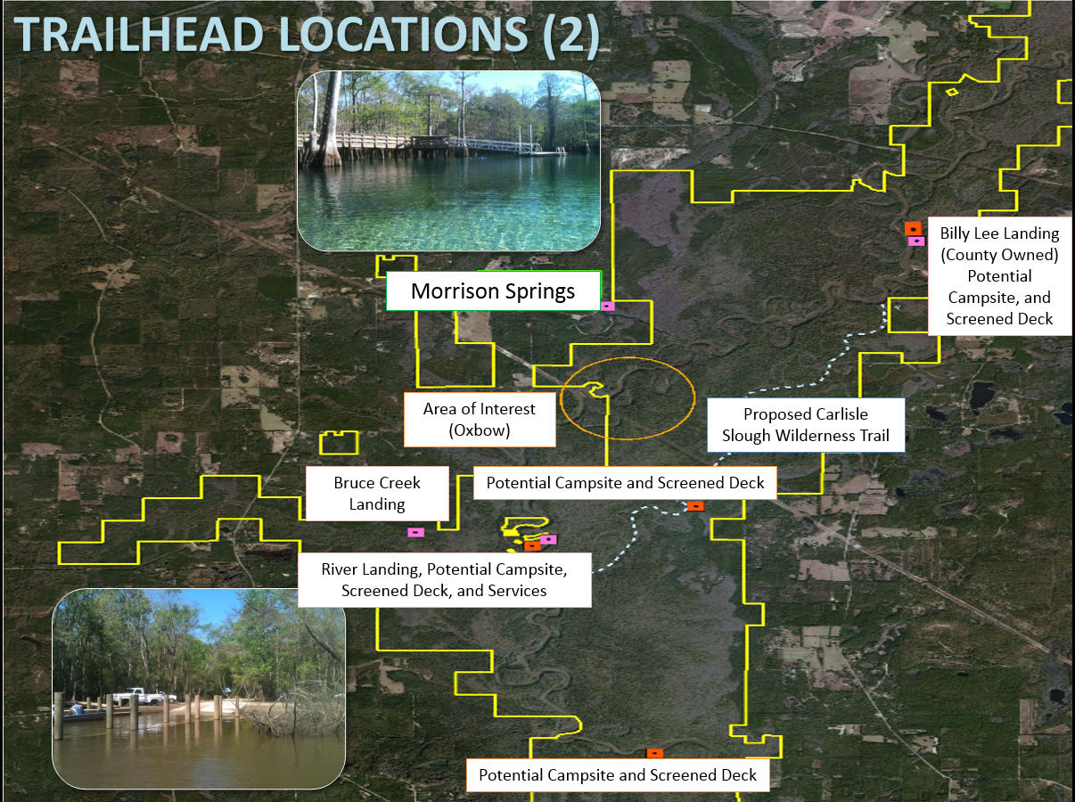

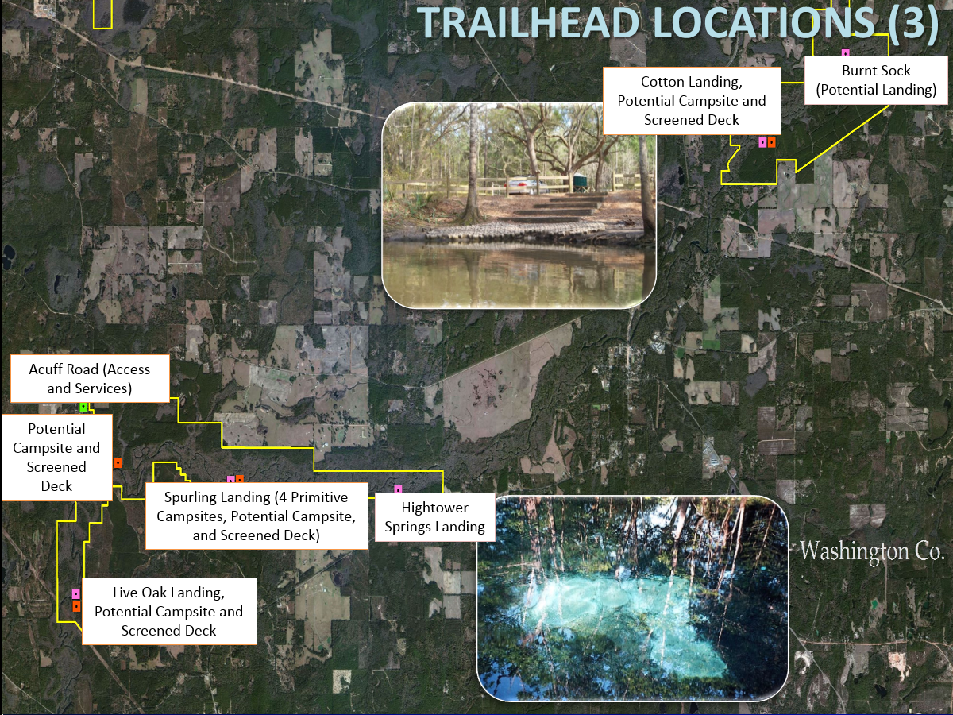

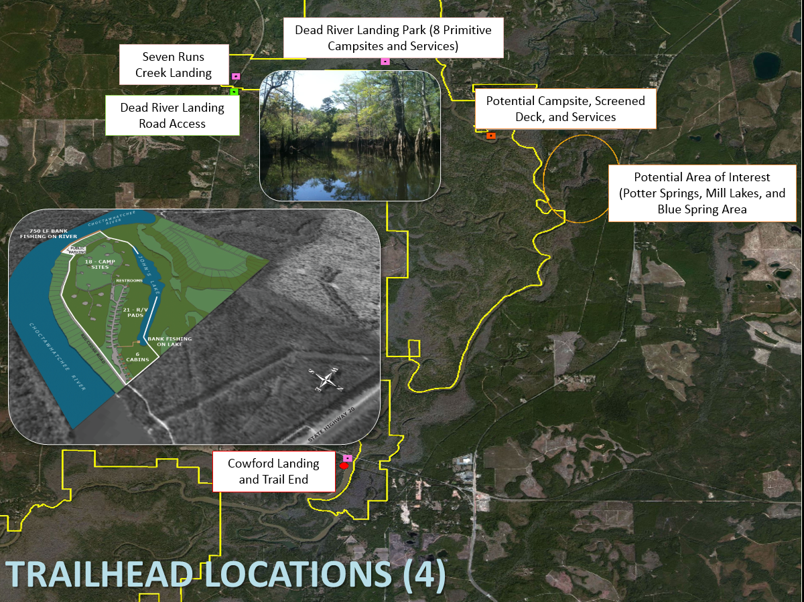

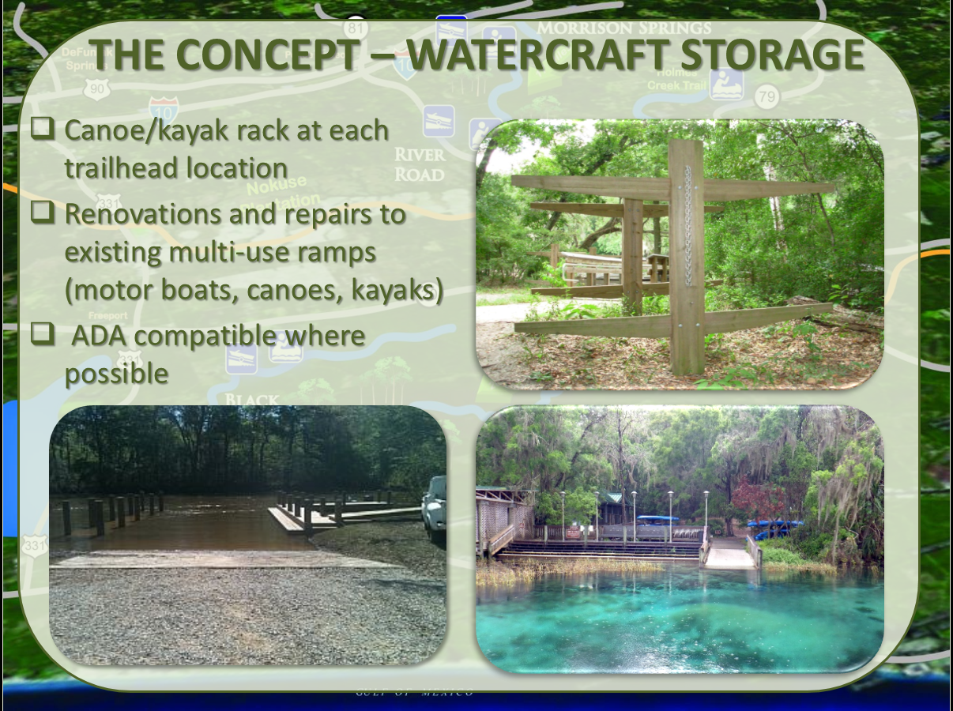

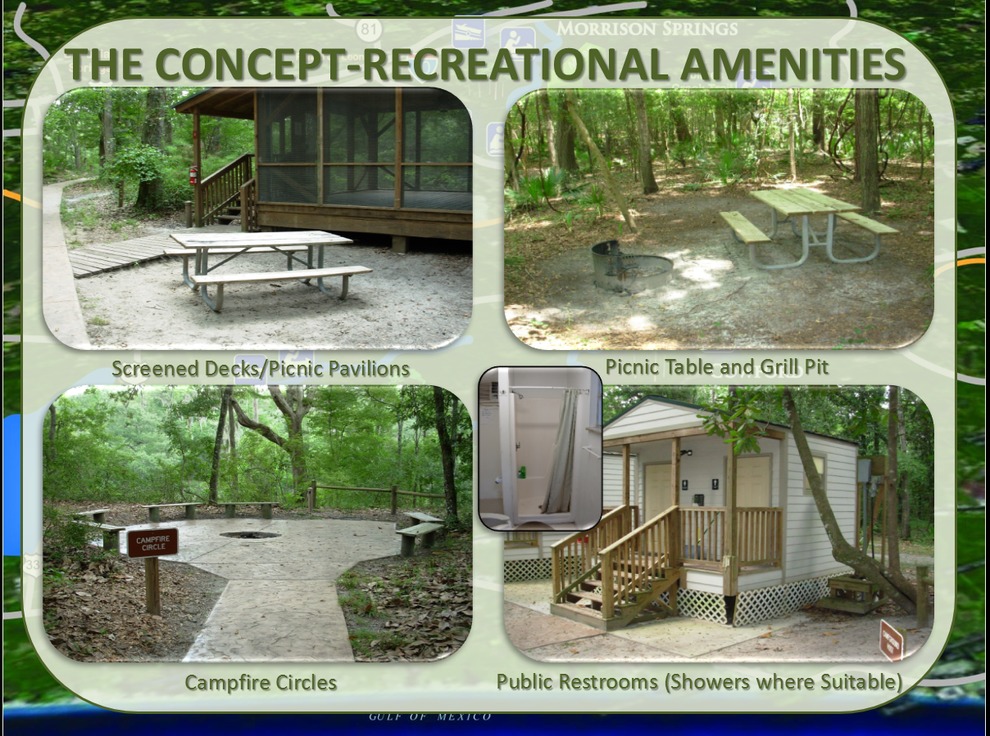

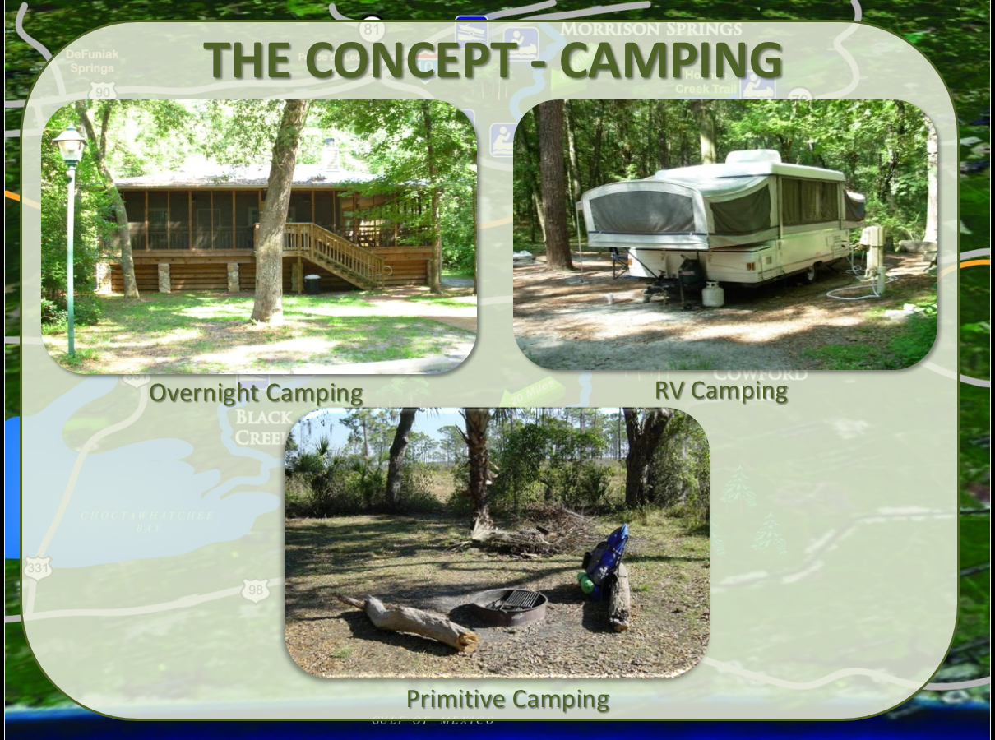

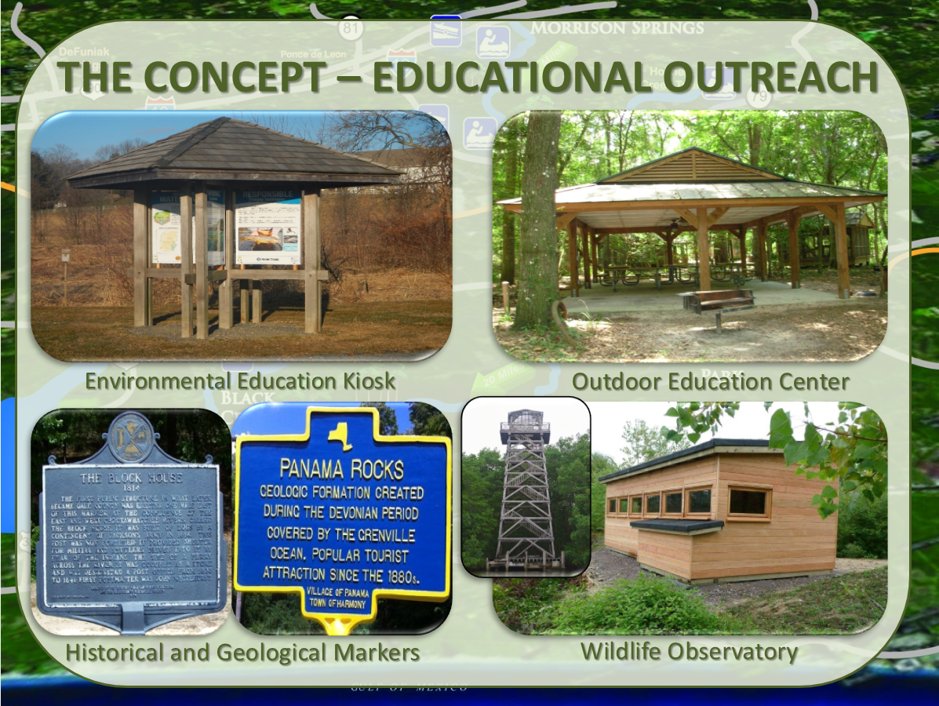

Cost Appendix Sheet
Cost Item |  |  | Cost Estimate
Planning
Contracts |  |  | $250,000
Feasibility |  |  | $100,000
Engineering, Design, Land Rights, and Bid Prep |  |  | $1,000,000
Restoration Plan |  |  | $250,000
Site Visit and Cost of Site Seletion |  |  | $250,000
Administration, Overhead, and Indirect |  |  | $500,000
Other
Planning Subtotal |  |  | $2,350,000
Construction
Contracts |  |  | $16,000,000
Administration and Mobilization/Demobilization |  |  | $1,000,000
Other
Construction Subtotal |  |  | $17,000,000
Monitoring |  |  | $200,000
Contracts |  |  | $150,000
Data Collection |  |  | $200,000
Monitoring Administration |  |  | $50,000
Other
Monitoring Subtotal |  |  | $600,000
Project Cost
Supervision |  |  | $50,000
Subtotal |  |  | $50,000
Contingency
TOTAL |  |  | $20,000,000
Estimated Costs by Year
Year 1 |  |  | $2,000,000
Year 2 |  |  | $5,000,000
Year 3 |  |  | $5,000,000
Year 4 |  |  | $5,000,000
Year 5 |  |  | $2,000,000
Year 6 |  |  | $1,000,000

