FINAL
Identification and Assessment of Potential Disposal Sites for
Apalachicola River Fluvial Geomorphic/Hydrologic Restoration and Evaluation

Restoration Program for Recovery of Partially Blocked Connections between the Mainstem of the Apalachicola River and Floodplain

TASK IV - Deliverable #6

Dan Tonsmeire

ABSTRACT

To reduce, eliminate, and mitigate the myriad impacts on the Apalachicola River system over the last 50 years it will be necessary to develop a scientifically based restoration program. This program should have specific and definable goals which allow for:

Restoration of the natural functioning of the river by re-establishing the integrity of the Apalachicola River basin ecosystem (including restoration of freshwater flows, channel dimensions, bend ways, interconnecting waterways, sloughs, watersheds, associated land areas, and fish and wildlife habitat) to the extent that the natural ecological functions are preserved;
- Supporting and sustaining a balanced, integrated, adaptive community of organisms having species composition, diversity, and functional organization comparable to those of the natural habitat of the Apalachicola River; and
- Monitoring and assessing the fluvial geomorphology of the river including cross sections, profiles and pattern of the river channel, tributaries, sloughs and floodplain of the Apalachicola River to assess restoration activities, their benefits and impacts.

Under the guidance of Dr. Matt Kondolf and Dr. Joann Mossa, this report has been developed to provide the feasibility assessment necessary for the evaluation of specific activities/programs directed towards the recovery and maintenance of the ecological integrity of the Apalachicola River system which would require the removal of sand from the Apalachicola Mainstem River and/or the Floodplain.

The target of this particular feasibility assessment is to determine the capacity and availability of disposal sites for recovery projects which may improve the connection of the Apalachicola River and Floodplain. Areas proximate to and between Wewahitchka and Blountstown within the project designated reaches of the river (RM 40-63) were considered as an example of a pilot project to initiate the reconnection of a backwater slough (Iamonia Lake) and the proximate floodplain/swamps requiring removal of a significant volume of sand. Other potential projects that may require disposal of sand material may be considered, but this example was selected due to the improvement of flowing water habitat, improvement of fish habitat, land access, proximity and availability of disposal sites, willing landowners, high public support, and viability of removal and transportation of material from the river.

An adaptive management approach will be used to initiate the final projects selected at a level of effort to confirm the proof of concept and then working up to the full scale project.

Table of Contents

1. EXECUTIVE SUMMARY
2. INTRODUCTION and BACKGROUND
3. JUSTIFICATION
4. SOLUTION
5. ALTERNATIVES
6. COST-BENEFIT ANALYSIS
7. CONCLUSION
8. RECOMMENDATION
APPENDIX A – Assessment of Habitat Quality in Relation to Connection of Floodplain Water Bodies with the Mainstem Apalachicola River
APPENDIX B – Iamonia Lake – Bee Tree – Middle Slough Project
APPENDIX C – Contacts List
APPENDIX D – Disposal Site Documentation
APPENDIX E – Project Calculation Spreadsheets

- Executive Summary

➢ Overview: The recovery of the ecological functions resulting from the connection of the Mainstem Apalachicola River Channel with the floodplain includes (but is not limited to): inundation of the floodplain with a timing, frequency and duration that supports the integrity (physical, chemical and biological) of the ecosystem. Integrity could be defined as supporting and sustaining a balanced, integrated, adaptive community of organisms whose species composition, diversity, and functional organization is comparable to those of the natural river and floodplain habitat. Such a condition will, by association and ecological dependency, sustain a highly productive Apalachicola estuary.

Through a series of field trips, fluvial geomorphic data collection and observations, it was determined that the first priority in recovering the Apalachicola River is to reestablish the connection between the Mainstem River and the floodplain using methods that do the least disturbance. Connections have been broken by a combination of reduced flows, widening of the river with resultant lowering of river stage, and partial blocking of sloughs. Recovery of flows is paramount - no amount of physical work will overcome impairment to ecological function if sufficient flows are not established to hydrate the floodplain. Reconnection of the floodplain by cleaning out partially blocked key sloughs can potentially speed the recovery of floodplain inundation from many generations to a very few. Narrowing of the over-widen river channel could also increase mainstem river/floodplain connection. For purposes of this feasibility report, a project that would remove a substantial amount of sand from the river/floodplain was selected to show the viability of removing accumulations of sand that potentially would improve connectivity.

A protocol was developed that would minimize impact to the surrounding floodplain habitat and species, while reestablishing the elevations necessary to restore flowing water habitat within a slough at lower water stages (as would have occurred prior to impacts from Corps activities on the River). This involves a combination of hand clearing, mechanical removal of sediment, vegetation and filled in wood debris, and light dredging to remove the main volume of sediment in the slough. Sediment removal is not intended to be comprehensive, but rather to reestablish flowing water in the floodplain at lower water stages thereby allowing the floodplain vegetation and backwater swamps to more quickly and naturally recover and to increase flowing water habitat within the swamp.

The selected pilot project described is in a selected slough that feeds a relatively large loop stream in the floodplain known as Iamonia Lake. The selected project would remove sand deposits from approximately 2.5 miles of sloughs and increase flowing water through over 10 miles of slough. Sediment removal requirements are estimated based on preliminary surveys. Estimated costs of sediment are $1,295,000 for Iamonia Lake – Bee Tree Slough – Middle Slough. Estimated cost is $43/cubic yard to survey, design, permit, and remove the sediment to a private sand pit outside the floodplain. The project description estimates the most extensive sediment removal anticipated. An adaptive approach is recommended such that the proof of concept is established in areas where less intensive efforts and smaller volumes will be moved. Efforts will then be graduated to larger volumes and greater dredging quantities.

The conclusions and recommendations provide a positive benefit/cost ratio when a benefit accrues to 10 miles of slough and approximately 8 square miles (5,120 – 6,400 acres) of the floodplain adjacent to and downstream of the flowing water habitat at a cost of $250/acre. The very minimal potential pollution and habitat disruption risk from the mechanical operations to remove the sediment are far exceeded by the potential benefit to this major slough. See Appendix E for evaluation of impacts from decreased water quality in disconnected sloughs.
2. Introduction and Background

➢ Overview: The primary objective of this report is to determine if there are feasible locations to dispose of sand removed from the banks and sloughs in the Apalachicola River Floodplain as part of an ecological restoration program. This report involves investigations of the feasibility from a market, operational, environmental and legal perspective. These secondary feasibility components were necessary in order to determine the viability and location of the project. Therefore, a number of assumptions had to be made in order to proceed to the following tasks and objectives.

Tasks:

a. From candidate sites suggested by knowledgeable scientists and others familiar with the river, as well as other sites encountered during reconnaissance, assess (in terms of environmental impact, access, etc.) potential as disposal sites for sand that might be removed from sloughs.

b. Apalachicola Riverkeeper (AR) will consult local governments and property owners re: willingness to receive sand at proposed sites.

c. AR will conduct an overall feasibility evaluation of potential disposal sites.

d. Provide field data reports for each potential disposal site and specific information procured from contacts and inquiries, along with a narrative of the feasibility evaluation.

Issues:
- A viable and cost effective overall restoration plan that addresses the recovery of the ecological functions (provided by the connection of the main Apalachicola River Channel to the floodplain) is necessary in order to implement reasonable projects that will be sustainable and effective. Fluvial geomorphologists investigated the characteristics and changes occurring to the river geomorphology and determined that three primary operations would speed and enhance the recovery of the connection of the river floodplain. The three drivers were:

  - Return of the freshwater flow reduced by upstream withdrawal, development, and management.
  - Narrowing of the river channel (as closely as possible to pre-dredging widths) without doing additional harm.
  - Reopening of partially blocked sloughs that were constricted by sediment loads carried downstream during the construction of the Jim Woodruff Dam as well as extensive dredging/disposal activities undertaken by the U.S. Army Corps of Engineers.

- The Target Audience for this report is the Florida Fish and Wildlife Conservation Commission (FWCC), Northwest Florida Water Management District (NWFWMD), the six Riparian Counties along the Apalachicola River and those members of general public having a keen interest in the restoration of the natural ecological functions of this magnificent river system. Caveat: restoration aim is not a literal recreation of the pre-dam era, rather, the recovery of basic connectivity between river, floodplain and bay.
- An overview of different approaches was considered, culminating in the final selection of recovery activities to be addressed. A summary of those are presented in Deliverable #2 of this project. In the final analysis, the best approach was felt to be the use of less intensive restoration techniques that would assist the river in its natural recovery process. Since dredging has been discontinued and the river has begun to restore itself, avoidance of more dramatic, more expensive and, possibly, more harmful interventions are desirable. Ultimately, reconnection of the mainstem river with the sloughs and back water swamps was determined to be the most effective immediate action necessary to improve ecological function.
- In order to examine the feasibility of proposed disposal sites, it was necessary to identify specific sloughs/swamps such that the volume of removed material could be determined and applied to the area in which the activity would take place. A particular site was selected within the bounds of the ongoing study effort and the methods of removal and disposal were projected for that particular area.

3. Justification

➢ Overview:

The Apalachicola River and Estuary system is of exceptional ecological importance and constitutes one of the least polluted, most undeveloped, resource-rich systems left in the United States. Despite its enormous ecological value, the Apalachicola River ecosystem has been severely degraded through a long history of human alterations, including consumptive use of water by farms and cities upstream (especially reducing flows during dry months), dam construction, navigational dredging, channel shortening, and other alterations. In reaches affected by channel alterations, the river down cut, widened, and destabilized. Reduced flows affected all reaches (including those downstream reaches unaffected by channel change) where lowered water levels dried out the floodplain and sloughs, resulting in loss of important swamp tree species (e.g. Ogeechee Tupelo), freshwater mussel habitat and critical spawning, nursery and fish feeding grounds. These systemic problems affect aquatic and wetland habitats throughout the Apalachicola River floodplain. Restoration of the Apalachicola River will depend on adequate river flows, and, in reaches affected by channel change, actions to reverse or mitigate the hydrologic disconnections resulting from dam and navigational dredging impacts.

The Apalachicola River floodplain is traversed by a network of sloughs, most of which can be considered ‘loop streams’ in that they diverge from the mainstem, flow through the floodplain (for many miles in most cases), connect with other such sloughs, and eventually flow back into the mainstem downstream (Light et al. 1998). This 400-mile network of sloughs provides important habitat to fish, aquatic invertebrates and terrestrial organisms and, also, maintains high water tables to support floodplain forests. The connectivity of many sloughs with the mainstem has been reduced due to diminished flows from the upstream basin, channel down-cutting and widening, and in some cases, by deposition of sand berms near the slough inlets (thereby blocking or reducing river flows into the sloughs) (Light et al. 1998). Restoring hydrologic connectivity between river and floodplain water bodies is one of the most effective strategies to restore riverine ecosystem function (Kondolf ET a. 2006). Specifically, restoring Apalachicola River floodplain slough connectivity could be the single most effective and feasible measure to restore floodplain function (besides insuring an adequate flow regime).

BACKGROUND

Human impacts on the Apalachicola River System were briefly summarized in Deliverable #2, with the exception of reduced freshwater flows due to upstream water consumption and development. The reduction of freshwater flow is a systemic problem that must be remedied in order for the floodplain to regain adequate productivity and diversity of species. This report is focused on the activities that will improve conditions in the Apalachicola River and Floodplain with positive benefits accruing to Apalachicola Bay.

Potential restoration activities were considered and are discussed in Deliverable #2 of this project. In the final analysis, an assessment of the slough recovery and correlations with flowing water habitat was needed in order to determine the full breath of restoration methods. Knowledgeable scientists and others familiar with the river (local governments, individuals and landowners) were consulted to determine high priority recovery sites and the capacity of disposal sites for the material removed from the river sloughs and/or old disposal sites. Based on these considerations, it was determined that both the sloughs and disposal sites on the west side of the river, proximate to Blountstown and Wewahitchka, were the most feasible - owing to access and local interest/cooperation - and were, also, within the reach of the river upon which this project is focused. After consultation with local commercial sand mine operators, local government staff and landowners, it became apparent that numerous disposal sites were available in existing, no longer viable sand pits that would accommodate large volumes of sediment. Just a few were selected to understand the necessary considerations and demonstrate feasibility.

Near Wewahitchka, the Taunton Family has a number of sand pits. They offered one 80-acre site that is no longer operational and could be filled, essentially giving almost unlimited capacity. It is located north of Wewahitchka and is shown on the attached map as Disposal site W1 in Appendix D. A second site, still actively being mined, offers additional capacity (See Appendix D Site W2). Others are available if needed.

South of Blountstown, Mr. Joe Wood - Public Works Director for Calhoun County and a private landowner - offered a 20 acre, failed aquaculture site (Shown as B1 in Appendix D) with approximately 20 1-acre pits and other, much larger, pits in a proximate location. There is also a usable sand pit on the Corbin-Tucker property a few miles south of the Wood property (Shown as B2 in Appendix D).

North of Blountstown, Roberts Sand Company has access to a sand pit in the process of being closed (shown as Disposal B3 in Appendix D). This site is located approximately 5 miles north of Blountstown just south of John Reed Road.

4. Solution

Overview: Selection of Initial Recovery Actions to Reconnect the Mainstem River and Floodplain

Recovery of lost flowing water habitat via reconnection of sloughs with the mainstem river was determined to be a critical ecological function need in the floodplain, particularly if it was possible without doing further harms. Methods were considered for reconnecting impacted sloughs. The evaluation considered reconnecting sloughs with the mainstem river by removing sediment plugs, thereby allowing greater flow thru the sloughs and reconnection for longer periods of time at lower river stages. There are ma number of sites where this strategy might be applicable. As part of this project a geomorphic analysis of the river system from River Mile 40-63 was undertaken. Proximate locations with slough connections have been identified in earlier studies and were considered for implementation of pilot projects.

Reasonable study design and methods, the permitting process, and pre-project monitoring of the projects were anticipated (within an adaptive management framework, recognizing the uncertainties in implementing such efforts in the field). The effect of the slough openings on water flow should be measured by monitoring (pre- and post- project) water levels, flowing water velocities, water quality (temperature, pH, conductivity, dissolved oxygen), shallow groundwater levels and soil moisture in and around the re-connected sloughs. In addition, in selected sloughs, sampling for mussels and other aquatic invertebrates and fish was anticipated. Because of the long time periods required for floodplain trees to respond to changed hydrologic conditions, we cannot expect to document changes in forest condition in our grant period, but will make baseline assessments of floodplain forest condition along selected sloughs, building upon prior work by the US Geological Survey (Light et al. 1998, Darst and Light 2008), FWCC staff, and local citizens, which will serve as a baseline against which to measure future change.

Likely candidate sloughs to be assessed (based on past field reconnaissance and data from Light et al. 1998 and 2002, and 2008, consultation with local citizens, landowners and local government contacts) include: Bee Tree and Middle Slough that feed Iamonia Lake, Maddox and Gum Slough system of the lower Chipola River 3 miles south of the confluence of the Chipola Cutoff into the Chipola River, Spider Cuts (set of subparallel channels diverging from the lower Chipola River and flowing southward to the Brothers River) and Douglas Sloughs (set of subparallel channels diverging from the mainstem and flowing to the Lower Chipola River). All of these sloughs, and others, have potential to provide more habitat if the duration of their connection with the mainstem is increased. In each case, however, the potential benefits must be quantified and balanced against the feasibility and potential harms of berm removal, and removed sediment disposal.

This project is an initial step in the development and evaluation of a scientifically-sound recovery strategy, drawing upon prior scientific research, input from agency staff, researchers, NGO partners and knowledgeable local citizens, as well as systematic field work, sediment sampling, analysis of remotely sensed imagery, state-of-the-art geomorphic analysis and hydrodynamic modeling. More survey and engineering will be necessary to establish an accurate evaluation of the project and to be prepared for permit applications. For the purpose of this feasibility report, evaluation of one pilot project to reconnect part of the slough system to the mainstem of the river was undertaken.

5. Alternatives

➢ Overview: Three different approaches were considered for sediment removal from sloughs in order to maximize efficiency and minimize the costs and environmental impact associated with access, excavation and transportation. All three methods would require transport of the material out of the floodplain by truck, boat and/or barge. Costs associated with these methods are somewhat difficult to estimate, however, an educated guess was made for the selected alternative. This gives some indication of relative cost and time requirements. The three methods of opening sloughs to improve flowing water habitat by sediment and debris removal include:

- Human, labor intensive, excavation and removal during low water, minimal environmental impact
- Light, land based, equipment excavation and removal during low water, some environmental impacts
- Use of a small floating suction dredge for excavation during most water stages, some environmental impact.

Proposed methods and impacts of each

- Method 1: Human, labor intensive, excavation and removal during low water – This process would use human labor to shovel sediment onto relatively small boats or barges then transported to a nearby boat ramp and unloaded via a small excavator into a dump truck to be hauled to the nearest available sand pit for disposal. Numerous crews of shovelers and small barges would be employed at various entrances to the sloughs, working their way inward to the meet the crews coming from other directions. Crews would be required to chainsaw fallen trees, clear debris and beaver dams before and during the sediment removal. This method has the advantage of less environmental impact than use of land based equipment but is the most time consuming owing to its limitations for application to sloughs that are dry during low water periods. Due to the difficulty inherent in maintaining a work force for these specific times, as well as the very labor-intensive work, this method was not seen as viable as the primary method of sediment removal.
- Method 2: Light, land based equipment excavation and removal during low water – Small trackhoe/backhoe excavators with a push blade would be employed to work from the ends of the sloughs, similarly to the hand shoveling crews. Numerous crews of excavators and small barges would be employed at various entrances to the sloughs to work their way inward, meeting the crews from the other directions. Although much faster than Method 1, this method still has the advantage of only minor additional impact. Unfortunately, the same disadvantages as Method 1 (access to dry sloughs, workforce issues) apply to Method 2 and neither can be judged as viable long-term options. This method was employed by the FWCC at Battle Bend during the project to reopen the upper and lower ends of the old River channel to create flow during medium - high water times. The project was delayed and discontinued by higher water conditions requiring the contractor to suspend work for several months.
- Method 3: Use of a small floating suction dredge for excavation during most water stages – Using a 6” suction dredge mounted on a small shallow draft barge, sediment would be pumped to 30 yard capacity geotechnical bags held in metal frames on barges. These bags allow for water drainage, leaving the sediment relatively dry for transportation. This method may require a limited degree of manual work and/or the use of a trackhoe crews (as in Methods 1 and 2) during low water. Minimal environmental impacts are expected other than some turbidity in the water proximate to the head of the suction dredge and dewatering bags. This method of sediment removal has been successfully used in remediation of an oil spill in the Kalamazoo River and other lake remediation projects around the country. One dealer representative of this type of dredge can be found at http://www.aquacleaner.com/spot_dredging_services.html. Also, local sand companies are available that have the requisite equipment and work force to implement such operations. This method is expected to be the most efficient and effective to achieve successful recovery of slough depths year-round.
- In all three methods, the sediment will need to be transported to a disposal site/sandpit by truck. Maximum hauling distance will be 7 miles based on the example provided in Appendix B.
- In all three methods a Section 62-330.631 Individual Permit is required by the State of Florida. Discussions with Jared Searcy, Environmental Specialist II with the Florida Department of Environmental Protection will be required. The Individual Permit application is a joint application to the U.S. Army Corps of Engineers. The fluvial geomorphic and mussel expert team can be available to perform pre- and post-project monitoring and inspect operations and conditions.

- Cost-Benefit Analysis

Overview: Estimated costs of using a combination of Methods 1, 2, and 3 for moving the material from the dredged location to the sandpit is $42.50/cubic yard based on the following equipment and personnel requirements.

Equipment required will include:

- Small Dredge, including barge mount
- Small push boat to move dredge and barges to transport sand
- Two - three barges to transport sand in geotech bags
- Sediment curtains - will be required to be deployed with the dredge and at the dewatering location.
- Geotech bags and frames for dewatering and moving sediment (https://www.usfabricsinc.com/products/us-450t-ecotube-dumpster-bag)
- Slide truck for transporting full geotech bags to sandpit
- Small trackhoe for removing large trees, debris, and/or sediment
- Chainsaws and hand tools for removing trees or debris

Personnel required will include:

- Dredge operator
- Diver
- Hose tender
- Push boat operator
- Barge tender/deckhand
- Slide truck operator
- Trackhoe operator
- Chainsaw and survey crew boss
- Chainsaw/ground survey crew
- Chainsaw/ground survey crew

During extended low water times, and where vehicle access is possible, the trackhoe could be employed to remove sediment and load into dump trucks. When water levels allow for dredge and barge access/operation, the material removed from the slough would be pumped into the geotech bags on the barges and transported to an unloading site for transfer to a truck for hauling to the sandpit.

In either low or higher water application, ground crews will be required to survey, mark and clear debris as possible in preparation for the sediment removal equipment. Surveying will provide core samples for evaluation of soils characteristics and accurate volumes of materials to be removed. These will need to be done well in advance of the actual work in order to provide data and information for permitting and contracting.

Appendix B, C, D, and E outline the project in the selected location. Estimates of the project site indicate that the hydrology of approximately 8-10 square miles (5,120 – 6,400 acres) of Floodplain Forest and 10 miles of slough could see improvement from the extended period of flowing water. Using these figures, Iamonia Lake-Bee Tree Slough-Middle Sough benefits will cost approximately $253/acre (See Appendix E).

- Conclusion

The pilot project has been outlined with rough estimates of the volume of material to be moved to sand pits in the vicinity of Blountstown and/or Wewahitchka, Florida near the Apalachicola River Floodplain. The project site will recover some volume of flow at lower river stages and extend the time during which flowing water will move thru the floodplain/backwater swamps. It is anticipated that a proof of concept effort using an adaptive management approach will be used initially; and as the methods are fine-tuned the projects will be ramped up to undertake the most effective level of effort to accomplish the best results.

This project should improve conditions for aquatic species and to some degree the Floodplain Forest which has been significantly impacted by the drier conditions caused by lower flow and disconnection of the floodplain to the Mainstem River. The project will improve flow to a much larger areas of the floodplain than are actually being uncovered by the excavation; and improve nutrient transport and loads to Apalachicola Bay at lower flows. The full extent of the improvement will not be understood until after the projects are completed and the pre and post project monitoring is complete, but rough estimates of acreage improved are provided.

There are numerous sandpits available proximate to this project and other areas of the River. The experts consulted are confident that disposal capacity in old sandpits on either side of the river would be more than adequate to hold even the largest conceivable volumes of sediment to be removed. A list of the sites proposed for use during this project and their respective owners is included in Appendix C and D.

- Recommendation

Surveys and engineering designs are necessary for the proposed project discussed in this report for a more accurate determination of sand volumes to be removed and associated cost. (See detailed descriptions in Appendix B for Lake Iamonia-Bee Tree Slough-Middle Slough.) This will provide information for evaluation of the projects, permitting and contracting. The pilot project should provide the initial groundwork for establishing the feasibility of removing sand from the river system to the degree that a realistic evaluation if the Apalachicola floodplain can be reconnected at river stages that resemble its former condition, leading to improvement in nutrient transport from the floodplain to Apalachicola Bay.

Detailed Geomorphic Assessment of the reaches of the river outside of RM 40-63 should be undertaken in order to complete the understanding of the impacts of floodplain and within bank disposal and the degree to which other floodplain areas and backwater swamps have been impacted. Other examples of large backwater swamp systems would include, but not be limited to:

- Poloway Cutoff thru Outside Lake to Estiffanulga
- Florida River to River Styx to Kennedy Creek
APPENDIX A

Assessment of Habitat Quality in Relation to Connection of Floodplain Water Bodies with the Mainstem Apalachicola River

APPENDIX B – Iamonia Lake – Bee Tree – Middle Slough

The following project is used to provide a rough feasibility assessment and estimate of the approximate cost of sand removal and transport to local privately owned sand pits. Quantities and distances are provided in the following example using Methods 1, 2, and 3 described as:

Use of a small floating suction dredge for excavation during most water stages – Using a 6” suction dredge mounted on a small shallow draft barge, sediment would be pumped to 30 yard capacity geotechnical bags in metal frames on barges. The bags allow for drainage of excess water, leaving the sediment relatively dry for transportation. This method may require some degree of hand work as well as a trackhoe crew (see Methods 1 and 2) during low water but minimal environmental impacts are expected to result other than some turbidity in the water proximate to the head of the suction dredge. This method of sediment removal has been used in remediation of an oil spill in the Kalamazoo River and other lake remediation projects around the country. One dealer representative of this type of dredge or contract can be found at http://www.aquacleaner.com/spot_dredging_services.html. Specifications for these dredges give a capacity to pump material up to 2000’ to its retainer for dewatering and transport.

Taunton Sand LLC, a local sand company, also has small dredging equipment and an experienced work force to implement the operation. The fluvial geomorphic and mussel expertise team is available to perform pre- and post-project monitoring and inspection of operations and conditions. This combination of methods is expected to be the most efficient and effective at removing the volume of sediment required in a reasonable amount of time to achieve a successful recovery of slough depths with an ability to work year-round.

Estimated cost of moving the material from the dredged location to the sandpit is approximately $43/cubic yard based on the following equipment and personnel requirements.

Equipment required will include:
- Small Dredge including barge mount
- Small push boat to move dredge and barges to transport sand
- Two to three barges to transport sand in geotech bags
- Sediment curtains will be required to be deployed with the dredge and at the dewatering location.
- Geotech bags and frames for dewatering and moving sediment (https://www.usfabricsinc.com/products/us-450t-ecotube-dumpster-bag)
- Slide truck for transporting full geotech bags to sandpit
- Small trackhoe for removing large trees, debris, and/or sediment
- Chainsaws and hand tools for removing trees or debris

Personnel required will include:
- Dredge operator
- Diver
- Hose tender
- Push boat operator
- Barge tender/deckhand
- Slide truck operator
- Trackhoe operator
- Chainsaw and survey crew boss
- Chainsaw/ground survey crew
- Chainsaw/ground survey crew

Iamonia Lake is partially feed by Bee Tree and Middle Slough as shown in Figure 2. Bee Tree Slough is located at approximately RM 60. It runs approximately .47 miles where it intersects Middle Slough, which runs approximately1.67 miles and empties into the McDougal Lake near the head of Lake Iamonia impacting an 8 square mile area. Total distance is approximately 2.5 miles (13,200’) of slough that requires removal of sediment with an average depth of 3’ and average width of 20’ which rounds out to 792,000/27=29,333 cubic yards approximately. While this measure could vary considerably, for calculation purposes we will use 30,000 cubic years as the volume to be moved from Slough to Sandpit.

Material will need to be pumped or loaded onto barges in geotech bags and transported to an offload site (Figure 1. LS1) located on the west end of the bridge across Dead Lakes on Lake Groove Road. In the worst case scenario, the distance to the sandpit will be approximately 7 miles from the barge unloading site to the disposal site at Sand Pit at B3. This would cost $100/25 cubic yard load and require 1,200 loads for a total cost of $125,000.

At the referenced Dredge Dealer web site, dredging cost is estimated at $20-$30/cubic yard. We used $25/cubic yard. Dredging costs for 30,000 cubic yards would be approximately $750,000. Barge transport to the loading facility would be approximately $10/cubic yard for a total barging cost of $300,000. Survey and engineers costs were estimated at $50,000/mile for a total of $125,000.

Total project cost estimate is presented in the attached Excel Spread sheet and summarized below:

Sediment Removal by Suction Dredge or Trackhoe $ 750,000
Barge transportation 300,000
Truck Transportation 120,000
Engineering, Survey and ground crew 125,000
Total Cost $1,295,000
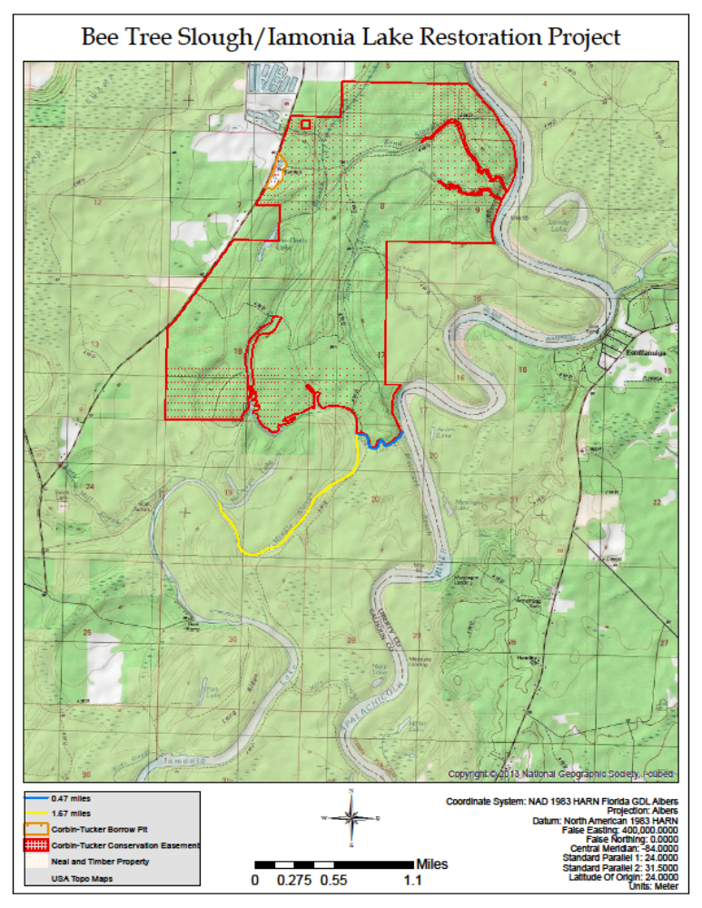
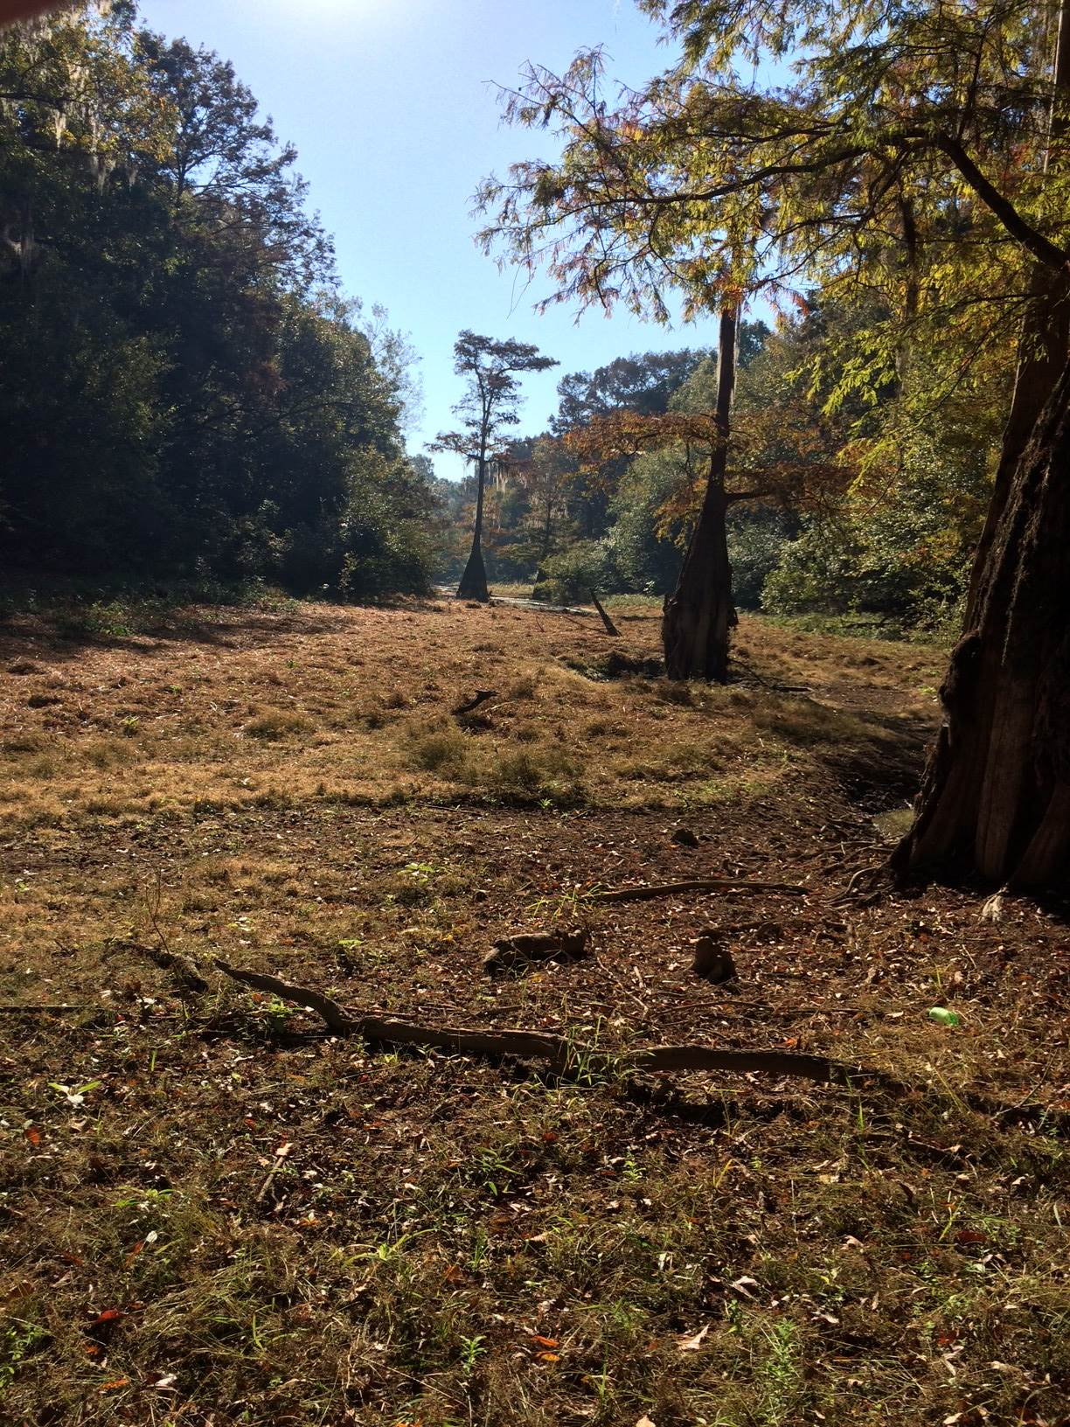

The photo above was taken from Iamonia Lake where McDougal Slough (McDougal Lake on the map) meets Middle Slough. McDougal is off to your left and you are looking up Middle Slough.

The low vegetation area in the photo represents all the sediments that have filled the slough - approximately 2-3 feet. The project would only open a 15-20’ wide channel to keep water flowing during the lower water period and allow the channel to naturally recover it full slough/backwater swamp condition.

APPENDIX C
Contacts List

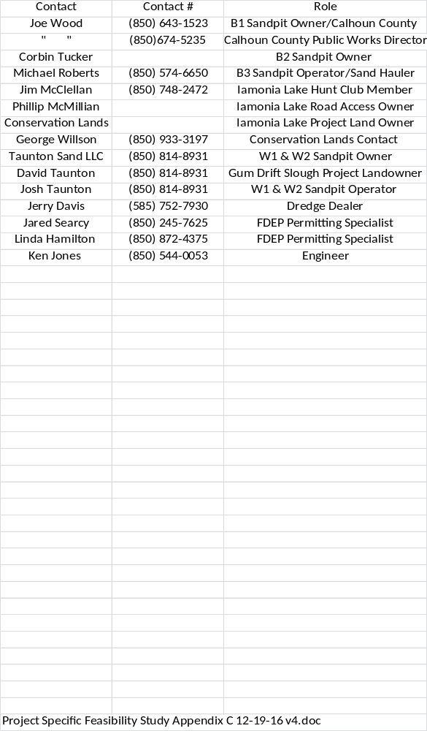
APPENDIX D

Disposal Site Documentation

W1 and W2 Sand Pits location map for Wewahitchka area courtesy of Scott Walls
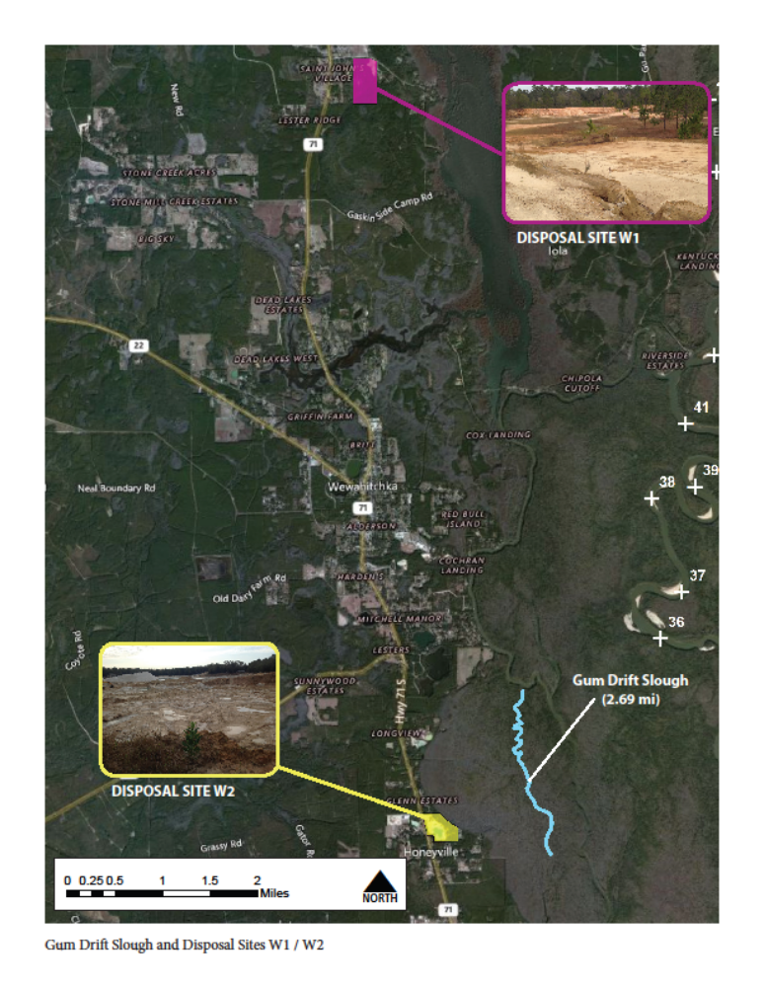
W1 Sand Pit available for Wewahitchka Area Slough Project

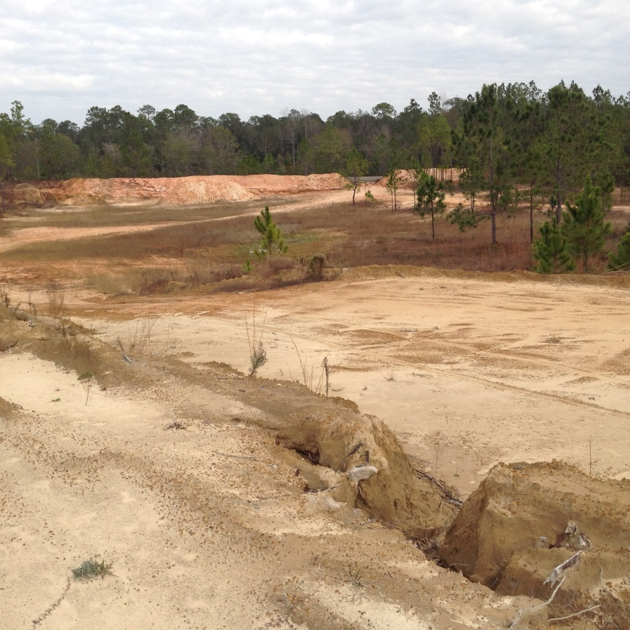

W2 Sand Pit available for Wewahitchka Area Slough Project

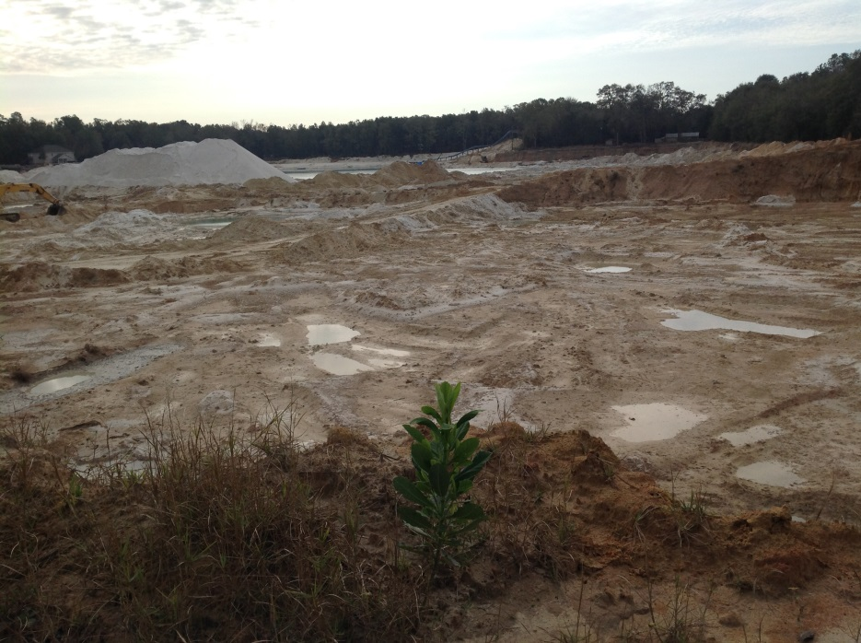

B1 and B2 Sand Pits location map for the Iamonia Lake - Bee Tree Slough – Middle Slough Project
Map Courtesy of Scott Walls
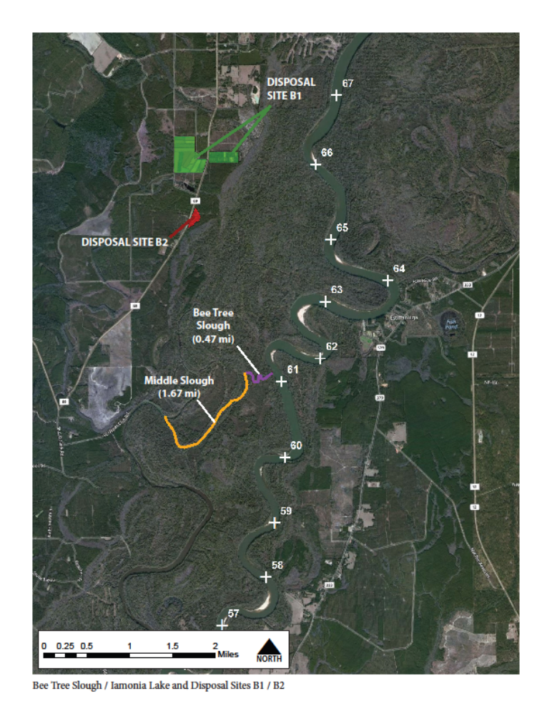
B1 Sand Pit for the Iamonia Lake - Bee Tree Slough – Middle Slough Project –

Joe Wood is the owner and is willing to fill the series of old aquaculture ponds that never held water. He is willing to clear the pines that have grown in the bottom of the drier depressions and allow them to be filled back to the top of grade.

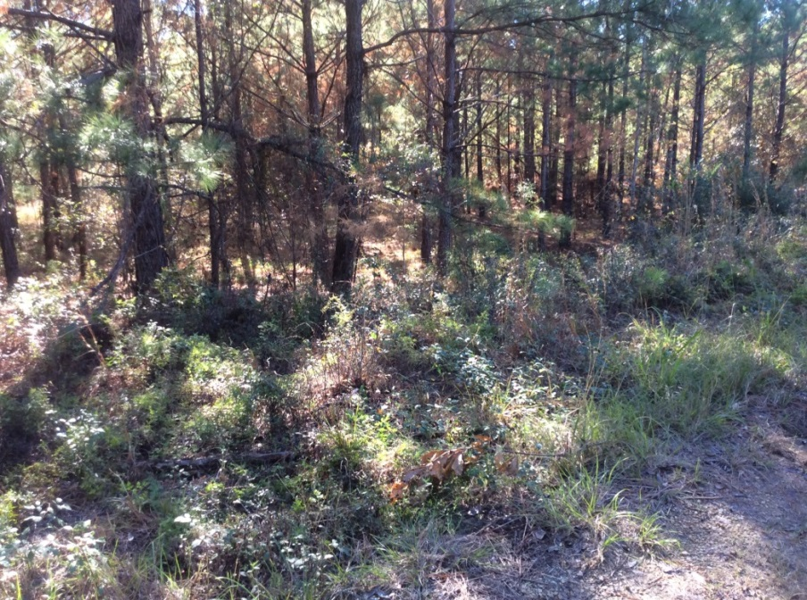

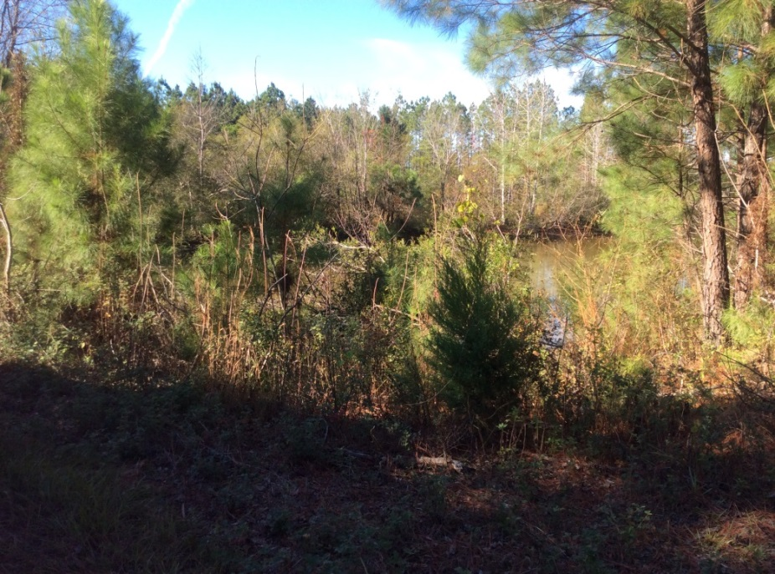

B2 Sand Pit for the Iamonia Lake - Bee Tree Slough – Middle Slough Project

(The Owner of this Sand Pit is converting it to a lake. It will not be available for use.)
B3 Sand Pit located 5 miles north of Blountstown just south of Reed Road Landing (An alternative unloading site on the Main River)

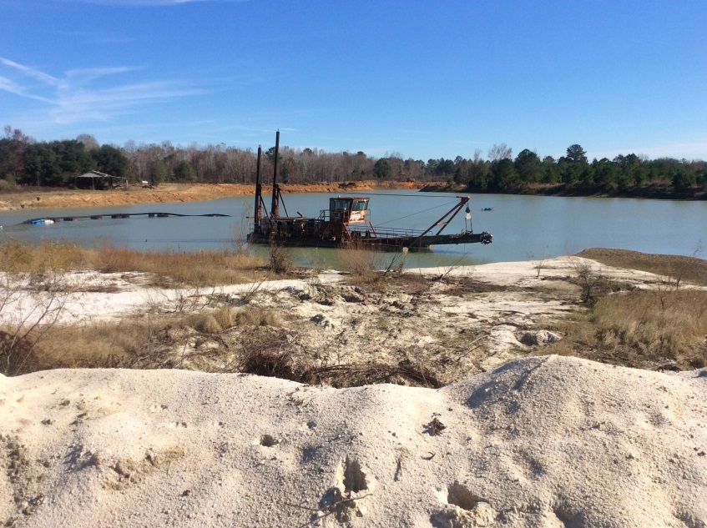

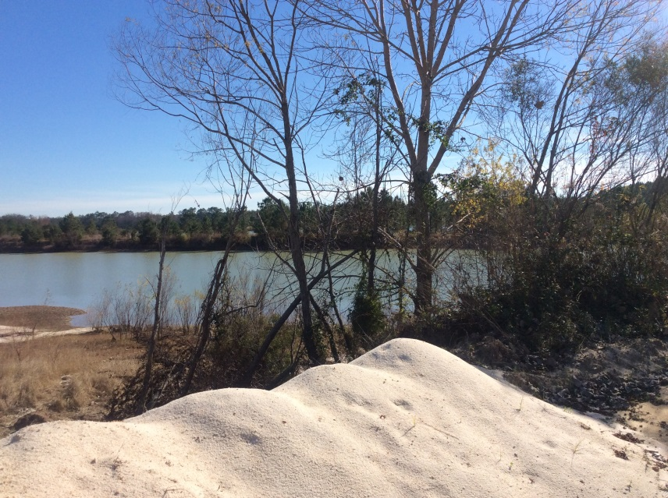

APPENDIX E

Project Calculations Spreadsheets

