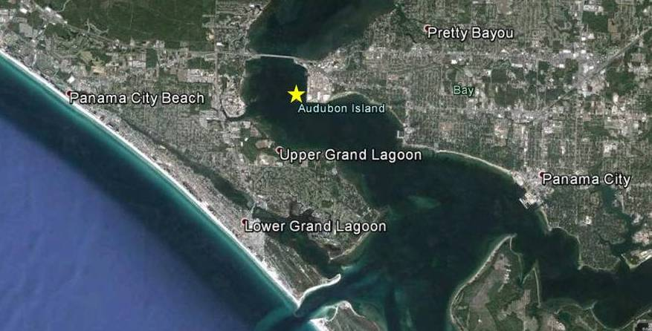

Figure 1. Audubon Island, St. Andrew Bay, Bay County, Florida.

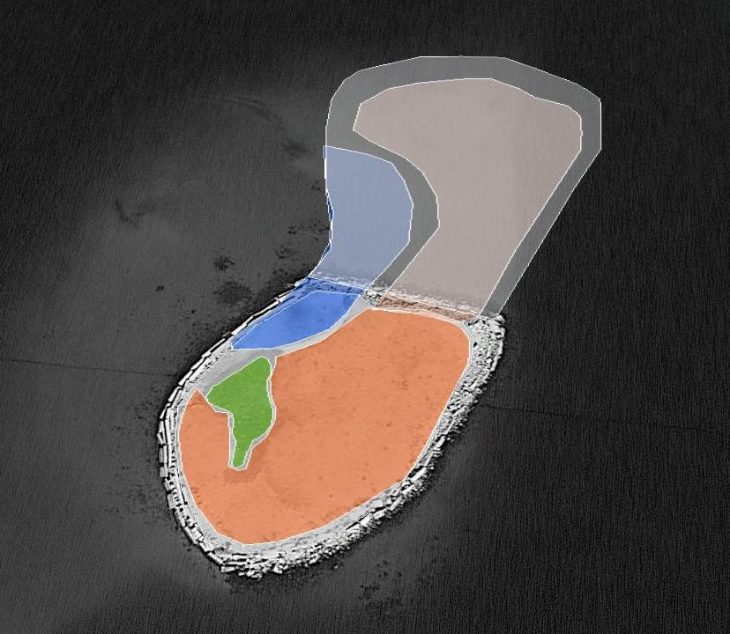

Figure 2. Current brown pelican nesting location (green), proposed phase 1 vegetation planting (orange), dredged material location (dk grey), phase 2 vegetation planting (lt grey), and lagoon location (blue).
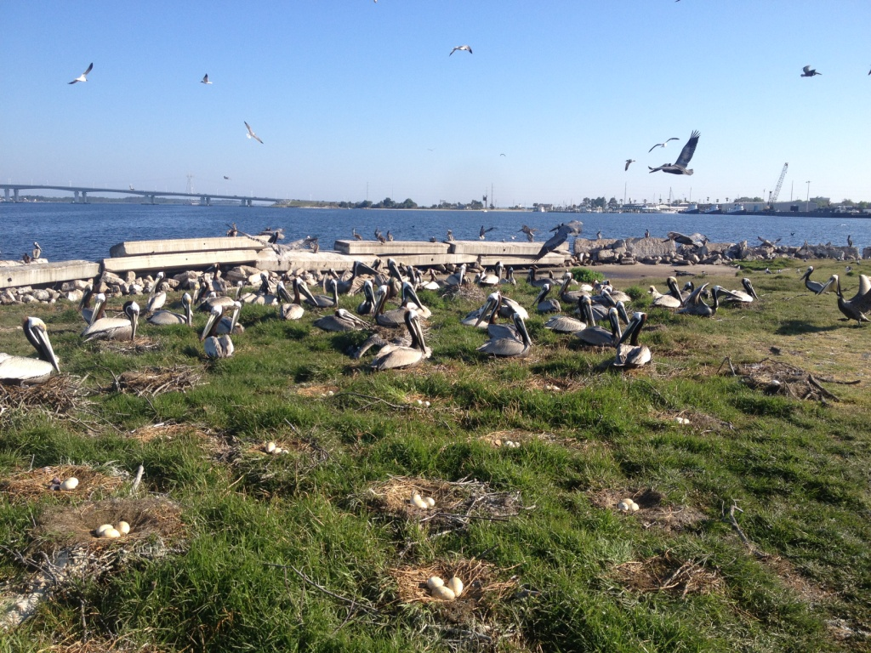

Figure 3. Pelicans nesting in existing vegetation on Audubon Island (see Fig. 2) using provided sticks to reinforce nests.

