EARL GILBERT PARK – LIVING SHORELINE

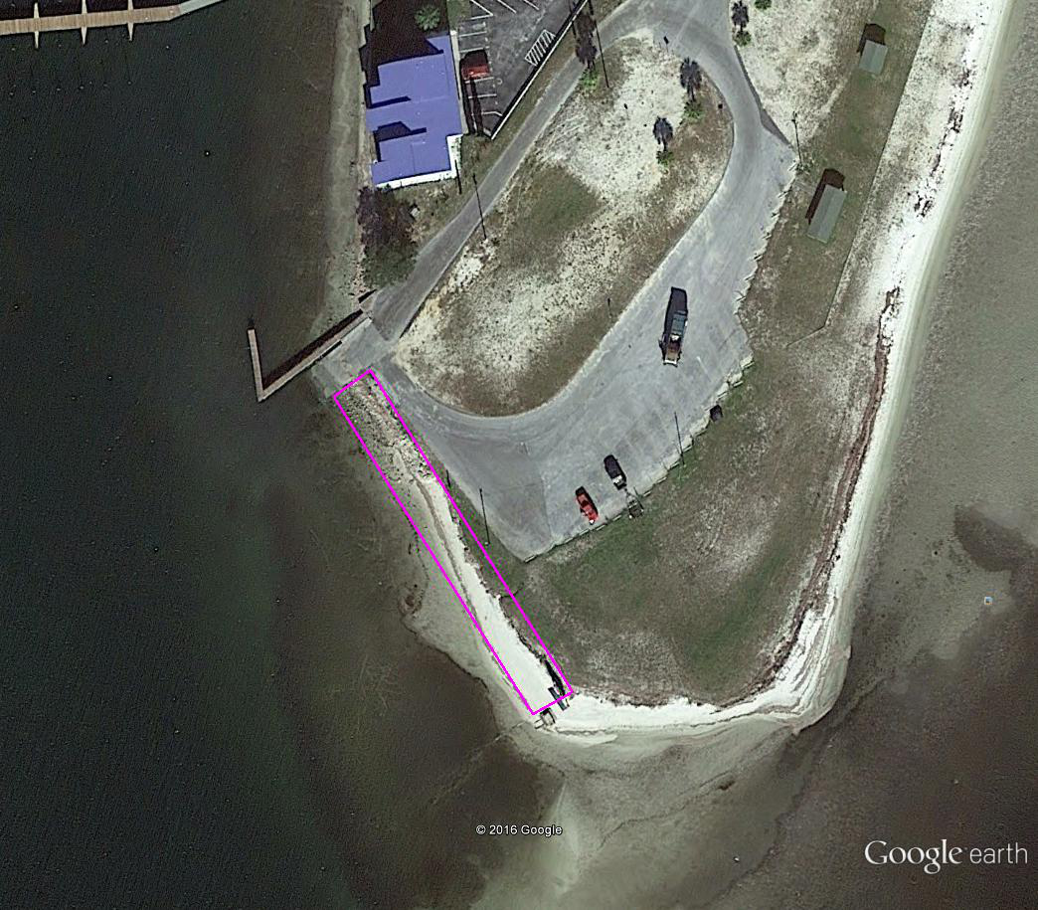
Figure 1 Proposed Earl Gilbert Park Living Shoreline Location

