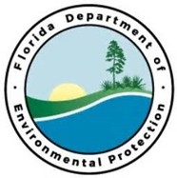
Project Outcomes:

Utilizing Unmanned Aerial Systems (UAS) technology and high resolution imagery sensors to adequately map and monitor seagrass habitat and the extent of prop scar damage across the panhandle aquatic preserves. This project would focus specifically on the extent of prop scar damage with the goal of getting additional seagrass habitat mapped if funding allowed. This project budget would include data collection, analysis, and products in a useable format as well as ground-truthing efforts.
Partners:
FDEP/FCO/CAMA
Funding Required:
$200,000
Location:
Franklin, Gulf, Bay Counties; 29.7818° N, 84.8568° W
Project Timeline:

Mapping and Monitoring Seagrass Habitat
Project Objectives:
Central Panhandle Priority Restoration Projects

