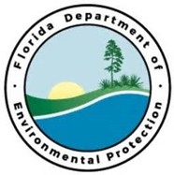

Project Outcomes:
Partners:
FDEP/FCO/CAMA
Funding Required:
$50,000
Location:
Franklin County; 29.7818° N, 84.8568° W
Project Timeline:

Imagery Assessment of Propeller Scar Damage in Alligator Harbor
Project Objectives:
This project would utilize imagery collected in 2012 in Alligator Harbor AP to determine extent of propeller scar damage in the preserve using multispectral imagery. This project would focus specifically on the extent of prop scar damage with the goal of getting additional seagrass habitat mapped if funding allowed. This project budget would include data collection, analysis, and products in a useable format as well as ground-truthing efforts.
Central Panhandle Priority Restoration Projects

