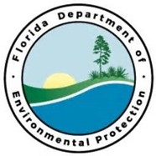
Project Outcomes:

To further develop and expand water quality monitoring efforts across the Florida Panhandle AP’s.
Partners:
FDEP/FCO/CAMA
Funding Required:
$200,000
Location:
Franklin, Gulf, Bay Counties; 29.7818° N, 84.8568° W

Project Timeline:

Extend and Enhance Water Quality Monitoring
Project Objectives:
Central Panhandle Priority Restoration Projects

