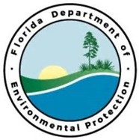
Panhandle Bay Watch
Partners:
St. Andrew Bay Watch, Panhandle Watershed Alliance, Choctawhatchee Basic Alliance, Friends of the St. Joseph Bay Friends, University of Florida, CPAP
Funding Required:
$200,000
Location:
Gulf and Bay County; 29.8002° N, 85.3550° W
Project Timeline:

Project Outcomes:

The project is designed to restore and protect the natural resources, ecosystems, fisheries, marine and wildlife habitats, beaches, coastal wetlands and the economy that thrives off these resources in the Panhandle region of Florida. This project will serve highlight areas in need and will significantly extend and enhance several years of water quality monitoring, habitat restoration, efforts to build resiliency, disaster preparations, and environmental outreach/education in each watershed. Partners: St. Andrew Bay Watch, Panhandle Watershed Alliance, Choctawhatchee Basic Alliance, Friends of the St. Joseph Bay Friends, University of Florida, CPAP

Project Objectives:
Central Panhandle Priority Restoration Projects

