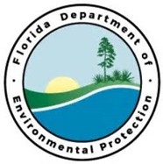
Project Outcomes:

Strengthening Coastal Resilience in the Florida Panhandle by Restoring near-shore habitats utilizing living shorelines on identified public/private lands. This goal of this project is to return public and private coastal properties to functioning estuarine habitats by working with and educating local contractors and coastal property owners about the advantages and protection offered by non-hardened green stabilization techniques (living shorelines).
Partners:
NWF AP, CPAP, ANERR, Apalachicola Riverkeepers, Sea Grant, and FWS
Funding Required:
$200,000
Location:
Franklin, Gulf, Bay, Walton, Okaloosa, Santa Rosa, Escambia; 29.7818° N, 84.8568° W
Project Timeline:

Promoting use of Shoreline Stabilization Techniques
Project Objectives:
Central Panhandle Priority Restoration Projects

