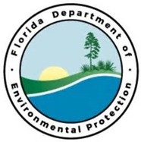
Project Outcomes:

This project would seek to acquire land adjacent to St. Joseph Bay Aquatic Preserve. Coastal wetlands that fronts one of the least affected coastal bay systems in Florida. St. Joseph Bay salt marshes and seagrass provide valuable habitat to fish and invertebrate species. Minimal restoration or enhancement anticipated given the high-quality of the natural communities present
Partners:
FDEP/FCO/CAMA
Funding Required:
$1,000,000
Location:
Gulf County; 29.8002° N, 85.3550° W
Project Timeline:

St. Joseph Bay Priority Shoreline Acquisition
Project Objectives:
Central Panhandle Priority Restoration Projects

