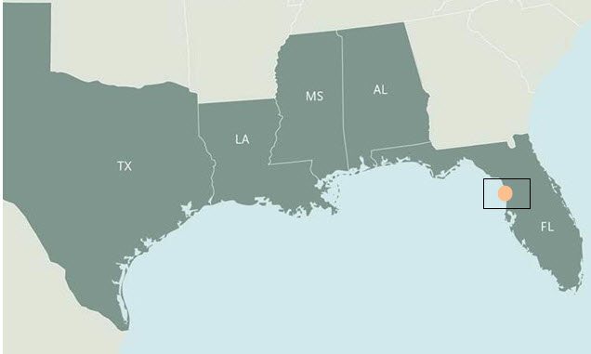
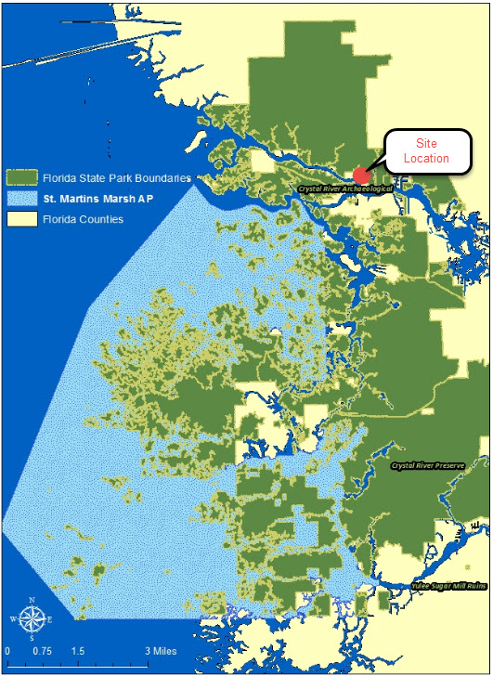
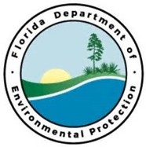
Partners:
Florida Department of Environmental Protection’s Florida Park Service, Florida Public Archaeology Network
Funding Required:
$9,000,000
Location:
3266 North Sailboat Avenue, Crystal River Florida 34428
Project Timeline:
2 Years

Project Outcomes:
St. Martins Marsh Learning Center
Project Objectives:
This project will promote responsible use, educate the public, and allow for the facilitation of research and conservation of the natural and cultural resources within Citrus County, Florida

This project will focus on the construction of an eco-conscious facility that highlights opportunities the public can recreate at their residences. Examples of these ecological improvements include, but are not limited to: the removal of the existing septic system, installation of solar panels, water retention through a rain barrel/gutter system, and removal of harden shorelines and replacement of living shorelines with native vegetation. Additionally, the plans include installation of concrete box culverts for hydrologic restoration and wildlife passages. The project is located on Crystal River Preserve State Park property and will influence the park and Florida Public Archaeology Network.
This area contains some of the most ecologically diverse and pristine habitats in the state of Florida. Currently, there are no public facilities of this nature that provide this type of educational experience to residents and visitors of Citrus County and its adjacent communities. Due to the economic and recreational importance of resources in this area, it is critical to provide the public with an experience that promotes sound stewardship.

Big Bend Priority Restoration Projects

