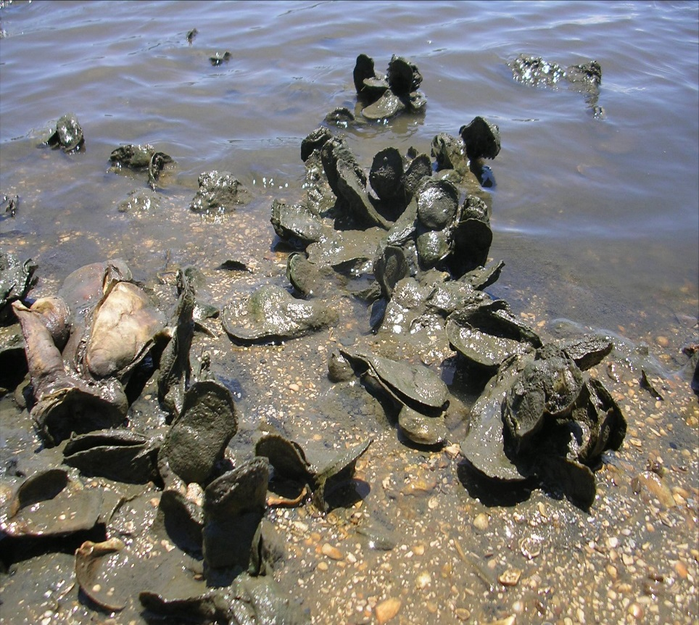
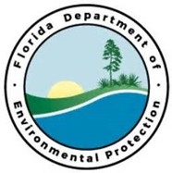
Oyster Reef Restoration East Bay
NWAP Priority Restoration Projects

Project Outcomes:
Partners:
NWFLAP
Funding Required:
$2,000,000
Location:
Santa Rosa; 30.7690° N, 86.9824° W
Project Timeline:
4 Years

Creation of 2 miles of fossilized oyster reefs adjacent to existing project along Garcon Point Peninsula. Restoration of approximately 20 acres of oyster an fish habitat will provide wave attenuation and increased water quality in addition to restoration of historical habitat in Yellow River Marsh Aquatic Preserve.
Project Objectives:

