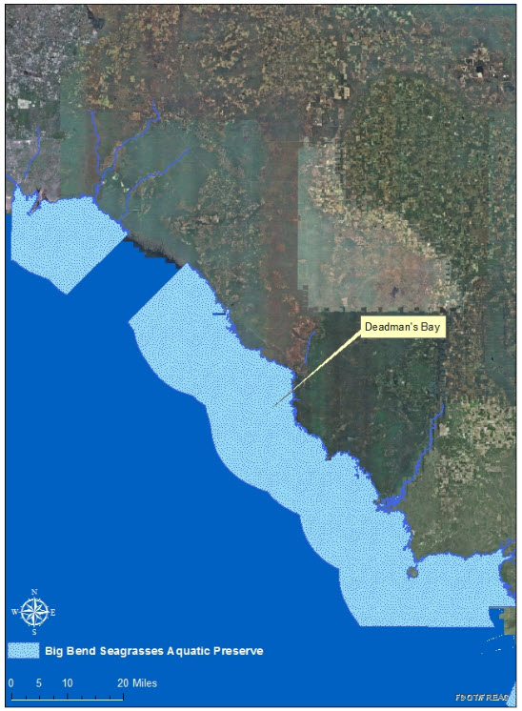
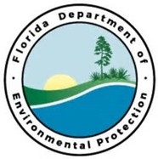

Seagrass beds are considered a vital part of marine and estuarine ecosystems because of their productivity level and sensitivity to water quality changes. Seagrasses provide food, habitat and significant nursery grounds for a myriad of vertebrate and invertebrate species; while maintaining water quality and promoting substrate stabilization. This project will facilitate the assessment, design, engineering and permitting needed to restore damaged seagrass habitat within the Big Bend Seagrasses Aquatic Preserve.

Project Outcomes:
This proposal is the first step in a comprehensive effort to design and implement seagrass restoration within Big Bend Seagrasses Aquatic Preserve to enhance and preserve the unique ecological structure of this area. Healthy seagrass meadows are one the world’s most biodiverse and productive ecosystems that support a magnitude of commercial and recreational species at varying stages of life. Additional benefits include: substrate and sediment stabilization and nutrient absorption; decreased wave energy reducing shoreline impacts; and habitat improvement. Phase I includes pre-restoration site assessment, project design and engineering, and necessary permitting for the Deadman’s Bay project area in Dixie and Taylor Counties.
This project will stabilize and restore critical seagrass habitat in the second largest contiguous seagrass bed on the Gulf coast of Florida; which supports one of the most stable population of bay scallops in the state of Florida. Furthermore, this project will aid in the protection of coastal habitats and cultural resources. The project area is located entirely within the Big Bend Seagrasses Aquatic Preserve boundaries and influences acquisition and management investments from the Gulf Environmental Benefit Fund.

Partners:
Funding Required:
$2,000,000
Location:
Big Bend Seagrasses Aquatic Preserve; Dixie and Taylor County
Project Timeline:
2 Years

Seagrasses Aquatic Preserve
Seagrass Restoration – Phase I
Project Objectives:
Big Bend Priority Restoration Projects

