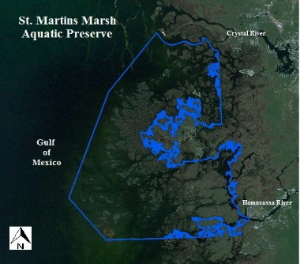
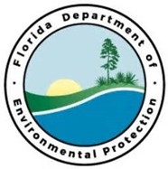
Seagrass beds are considered a vital part of marine and estuarine ecosystems because of their level of productivity and sensitivity to water quality changes. Seagrasses provide food, habitat and nursery significant nursery habitat for a myriad of vertebrate and invertebrate species; while maintaining water quality and promoting substrate stabilization. This project will facilitate the assessment, design, engineering and permitting needed to restore damaged seagrass habitat with the St. Martins Marsh Aquatic Preserve.

This project will facilitate the assessment, design, engineering and permitting needed to restore damaged seagrass habitat with the St. Martins Marsh Aquatic Preserve.

St. Martins Marsh Aquatic Preserve Seagrass Restoration – Phase I
Partners:
Funding Required:
$2,000,000
Location:
St. Martins March Aquatic Preserve, Citrus County
Project Timeline:
2 Years

Project Outcomes:
This proposal is the first step in a comprehensive effort to design and implement seagrass restoration within St. Martins Marsh Aquatic Preserve to enhance and conserve the unique ecological structure of this area. Healthy seagrass meadows are one of the world’s most biodiverse and productive ecosystems that support a magnitude of commercial and recreational species at varying stages of life. Additional benefits include: substrate and sediment stabilization and nutrient absorption; decreased wave energy reducing shoreline impacts; and habitat improvement. Phase I includes pre-restoration site assessment, project design and engineering, and necessary permitting for the entire St. Martins Marsh Aquatic Preserve project area.

This project will stabilize and restore critical seagrass habitat in the Crystal Bay and St. Martins Keys area; which supports one of the most stable population of bay scallops in the state of Florida. Furthermore, this project will aid in the protection of coastal habitats and cultural resources. The project area is located entirely within the St. Martins Marsh Aquatic Preserve boundaries and influences acquisition and management investments from the Gulf Environmental Benefit Fund.

Project Objectives:
Big Bend Priority Restoration Projects

