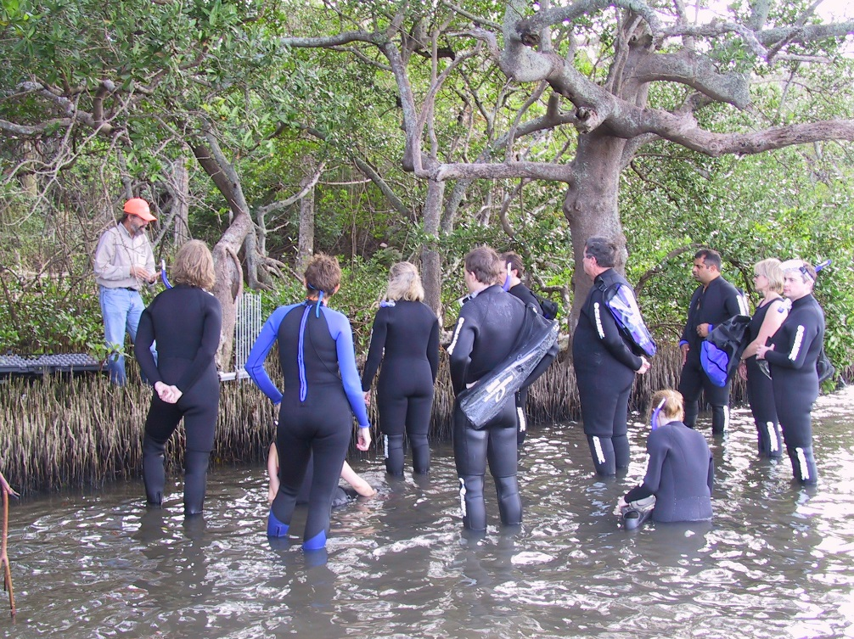
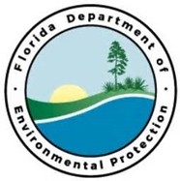
Project Outcomes:
Pinellas Island Habitat Restoration
Tampa Bay Priority Restoration Projects

The amount requested is for two half-time positions to plan and track the restoration and to coordinate the activities of the volunteer groups for a period of three years. The two positions, rather than one full-time one, are for safety in the field.

The Tampa Bay Aquatic Preserves program has been very successful in forming partnerships with a variety of local and out-of-state universities and organizations that supply an increasing number of volunteers. Because of these partnerships, TBAP can restore and maintain native vegetation on very important habitat islands in the Pinellas County and Boca Ciega Bay Aquatic Preserves. Unfortunately, staff limitations have begun to limit the program’s ability to accept and coordinate further expansion of this program.
Partners:
USF, Eckerd College, St. Petersburg College, Ohio State University, University of NC, Louisiana State University
Funding Required:
$10,000,000
Location:
Pinellas County; 28.0154° N, 82.8268° W
Project Timeline:
TBD

Project Objectives:

