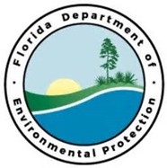
D R A F T

Tampa Bay Priority Restoration Projects

Partners:
Tampa Port Authority, Hillsborough County
Funding Required:
$400,000
Location:
Hillsborough County; 27.9904° N, 82.3018° W
Project Timeline:

Project Outcomes:

Remove concrete removal from the old Goat Island Bridge from the Little Manatee River, and remove part of the old bridge approach from the island to restore flow capacity in the river.
Goat Island Bridge Debris Removal
Project Objectives:

