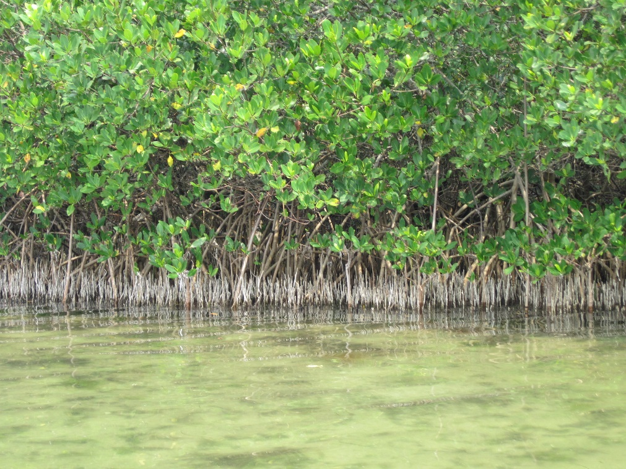
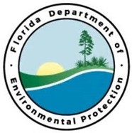
Tampa Bay Priority Restoration Projects

Improvements to Wetlands along Bishop Harbor

Replacing small culverts under Bishop Harbor Road with large box culverts or concrete span bridges will reduce tidal flushing restrictions, allow otters and other wildlife to pass under the road, and, if large enough, could allow paddling access.
Partners:
DRP
Funding Required:
$1,000,000
Location:
Manatee County; 27.4799° N, 82.3452° W
Project Timeline:

Project Outcomes:
Project Objectives:

