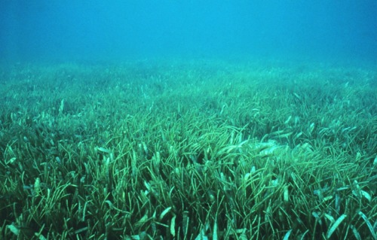
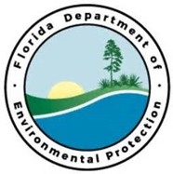
D R A F T

Lignumvitae Key Seagrass Restoration
FL Keys Priority Restoration Projects

Project Outcome:

Partners:
FDEP/FCO, Florida Park Service (TBD), Florida Audubon (TBD)
Funding Required:
$1,000,000
Location:
Monroe County; 24.5557° N, 81.7826° W
Project Timeline:

Project Objectives:
Restore seagrass scars in vulnerable shallow seagrass areas throughout the Lignumvitae Key Aquatic Preserve/State Park with a combination of damage assessment, topographic restoration and bird stake installation, pre/post-restoration monitoring, and activities aimed at modifying boater behavior (education, channel marking, etc.).

