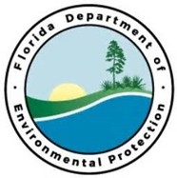
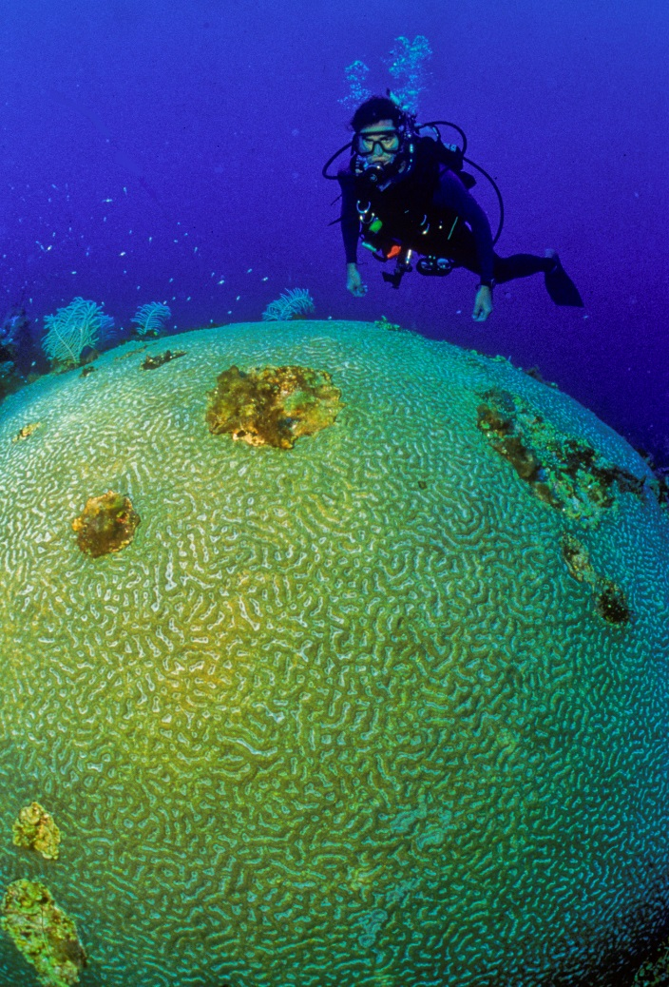
D R A F T

Florida Keys Water Quality and Coral Reef Restoration Restoration
FL Keys Priority Restoration Projects

Project Objectives:
Partners:
Monroe County
Funding Required:
$50,000,000
Location:
Monroe County; 24.5557° N, 81.7826° W
Project Timeline:
TBD

Coral reefs around the world are seriously threatened by direct and indirect human actions. The 1998 Reefs at Risk study found that almost 60% of the world’s coral reefs are potentially threatened by human activity, including coastal development, destructive and over-fishing practices, overexploitation of resources, marine pollution and runoff from inland deforestation and farming. Over the last two decades, coral reefs have experienced an unprecedented loss of live coral cover due to human-caused and natural threats
The U.S. Coral Reef Task Force has identified a reduction in land-based sources of pollution and active restoration of coral reefs as essential actions necessary to enhance community resiliency of coral reefs. In the Florida Keys, the joint EPA/FDEP/NOAA Water Quality Protection Program (WQPP) has directed extensive effort to reduce nutrient sources and enhance water quality. However, the WQPP partners now recognize that the next action should be the restoration of the canal systems.

Project Outcome:
Healthy coral reefs require good water quality to grow, remain viable, and provide ecosystem benefits. Both land-based and sea-based pollution can threaten reef resources by harming sensitive species, altering species compositions, disrupting critical ecological functions (e.g., photosynthesis), and impeding the normal growth and settlement of stony corals and other benthic invertebrates. Reef systems are impacted by a variety of pollutants, including sediments, nutrients, chemical contaminants, marine debris, and invasive species. Pollution enters reef ecosystems in many ways, ranging from specific point-source discharges such as sewage pipes and vessels, to more diffuse sources such as runoff associated with agriculture, coastal development, and road construction. Reef degradation is even greater in areas where the loss of wetlands or other associated habitats has reduced the system's natural ability to filter nutrients and other pollutants before reaching the reefs. Although there is wide variation among the sources, characteristics, and impacts of pollution in U.S. jurisdictions, significant reductions or potential elimination of much of the pollution could be accomplished by full implementation of existing State and Federal regulations and voluntary programs.

