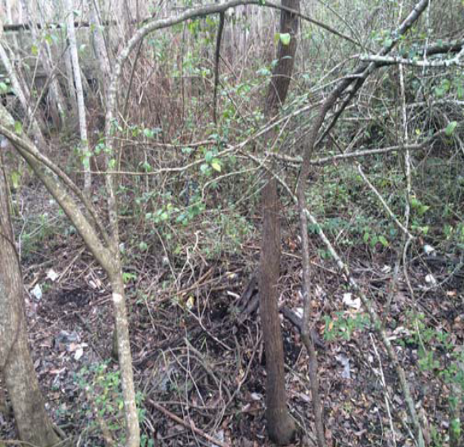
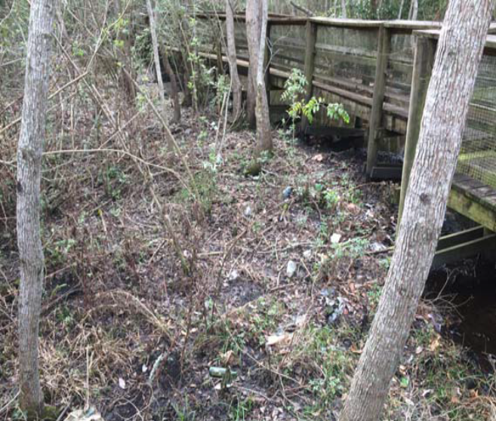

Figure 1: Large amounts of trash deposited along the stream channel floodplain

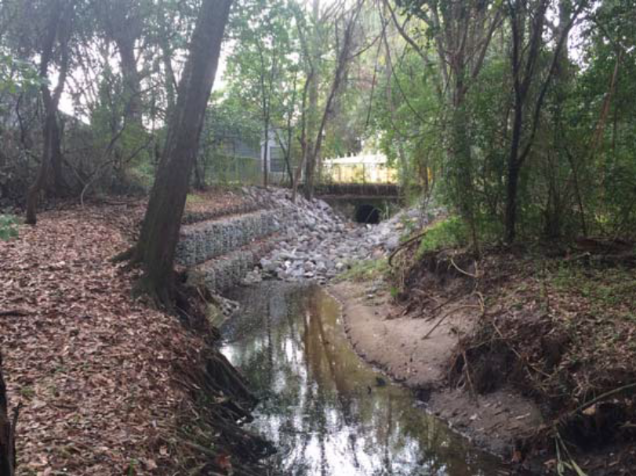
Downstream streambank erosion
Figure 2: Evidence of streambank erosion

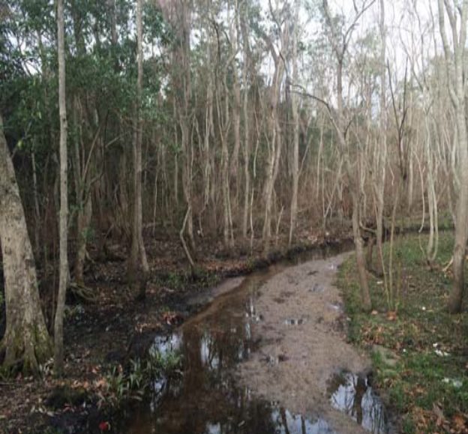
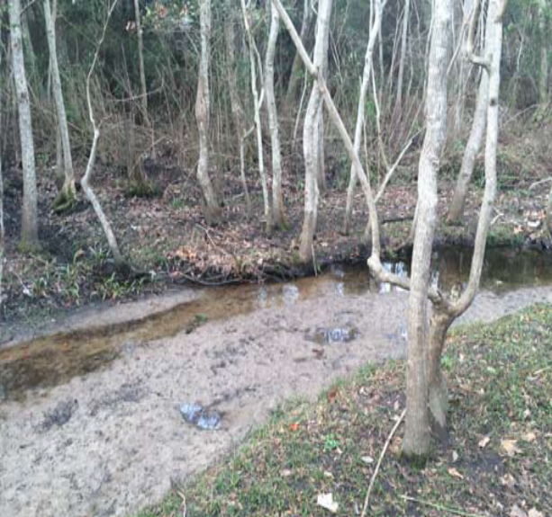
Large side-channel depositional bar
Large side-channel depositional bar

Figure 3: Large side-channel depositional bars

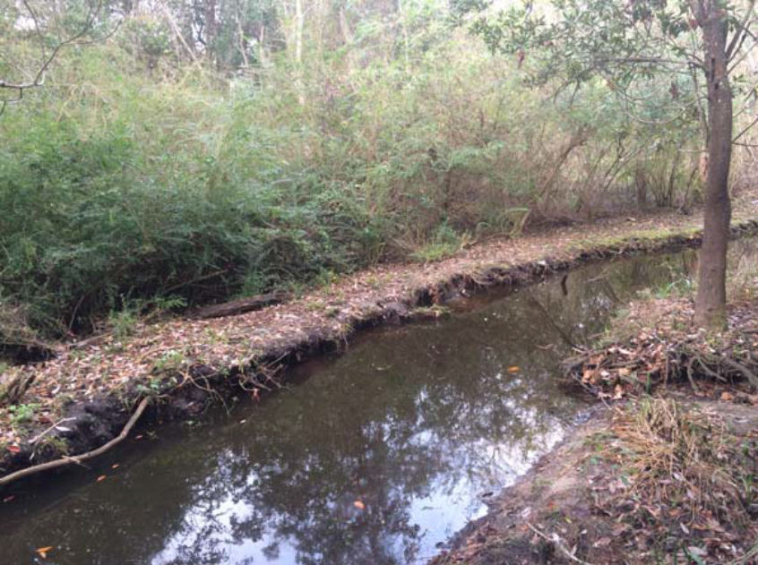

Chinese Privet

Figure 4: Dense monocultural thicket of Chinese Privet

