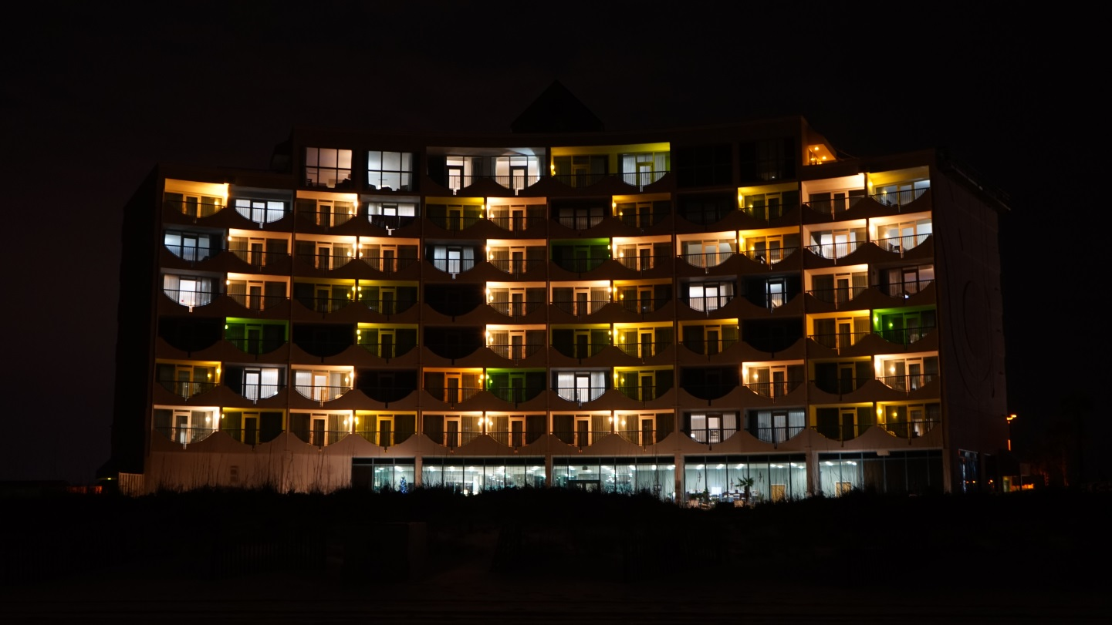
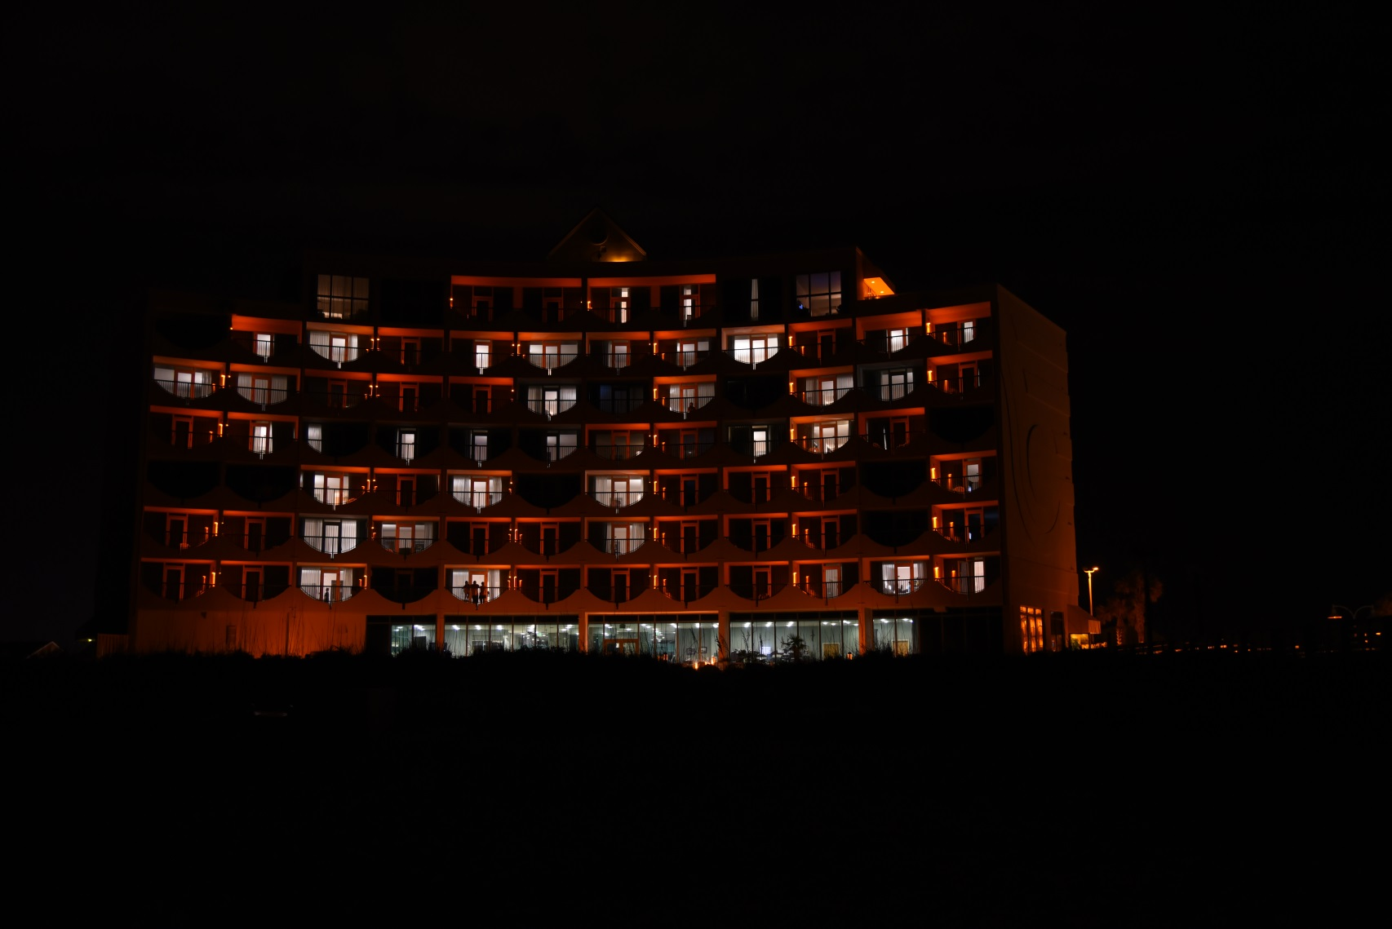
Before and after photo documentation
These properties were recently completed by Sea Turtle Conservancy as part of its current GEBF grant in the Florida Panhandle.
Figure 1: Holiday Inn Express on Pensacola Beach in Escambia County, Florida. Because this property is a hotel, STC installed turtle friendly fixtures with integrated amber LED bulbs so guests could not remove the bulbs.

Pool area at Holiday Inn Express (After only)
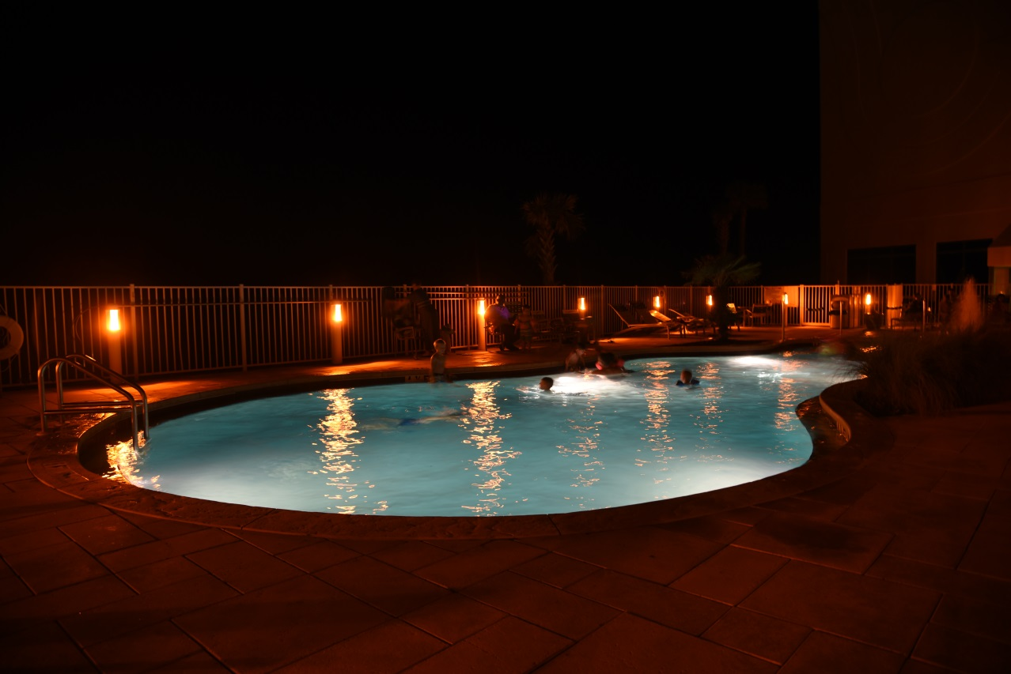

Treasure Island Condominiums
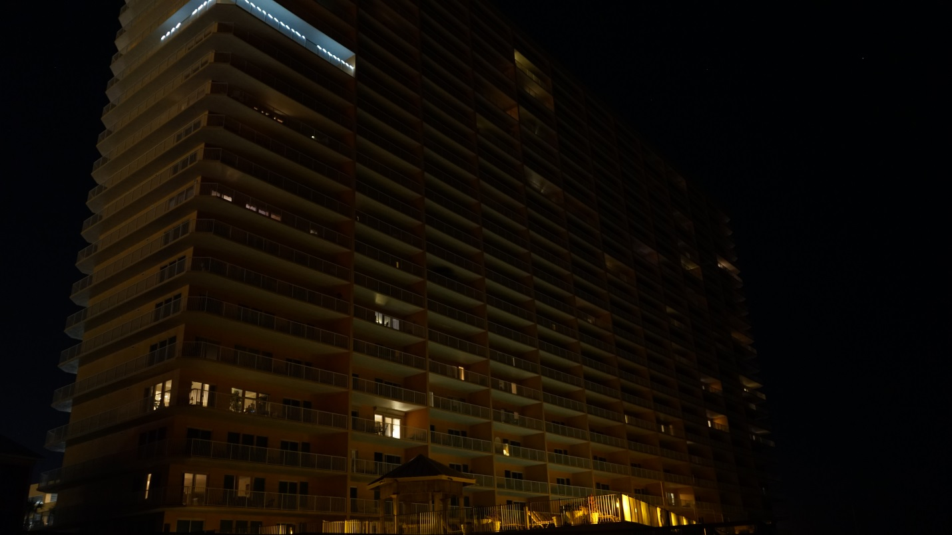
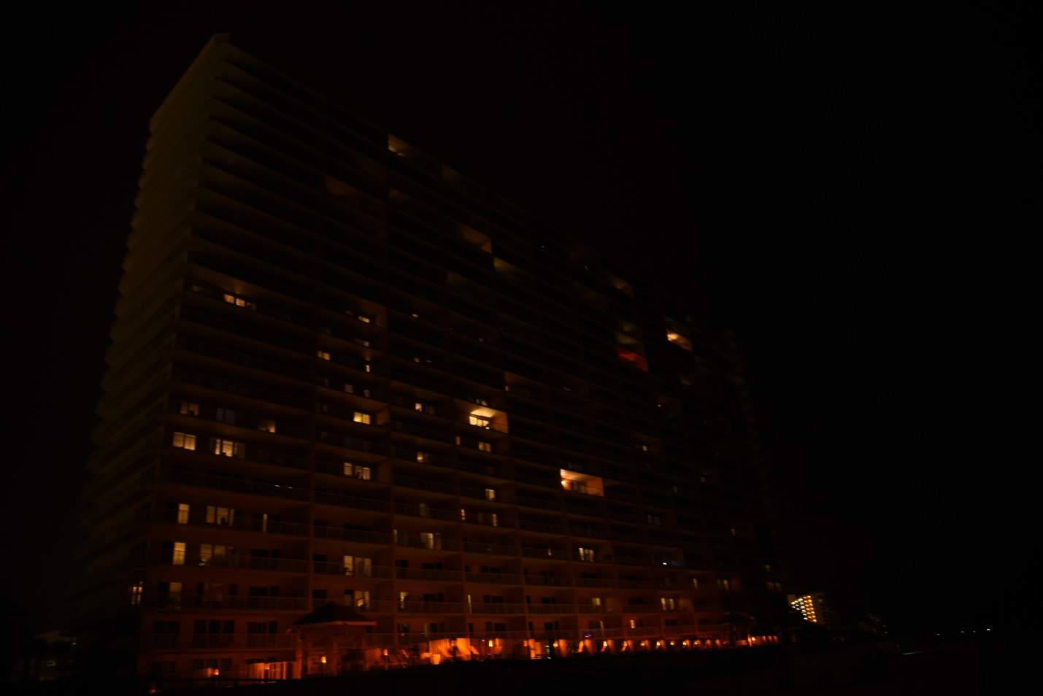
Figure 2: Treasure Island Condominiums in Panama City Beach, Bay County. STC replaced the white pool lights at this property with higher quality shielded bollards with amber LED bulbs.

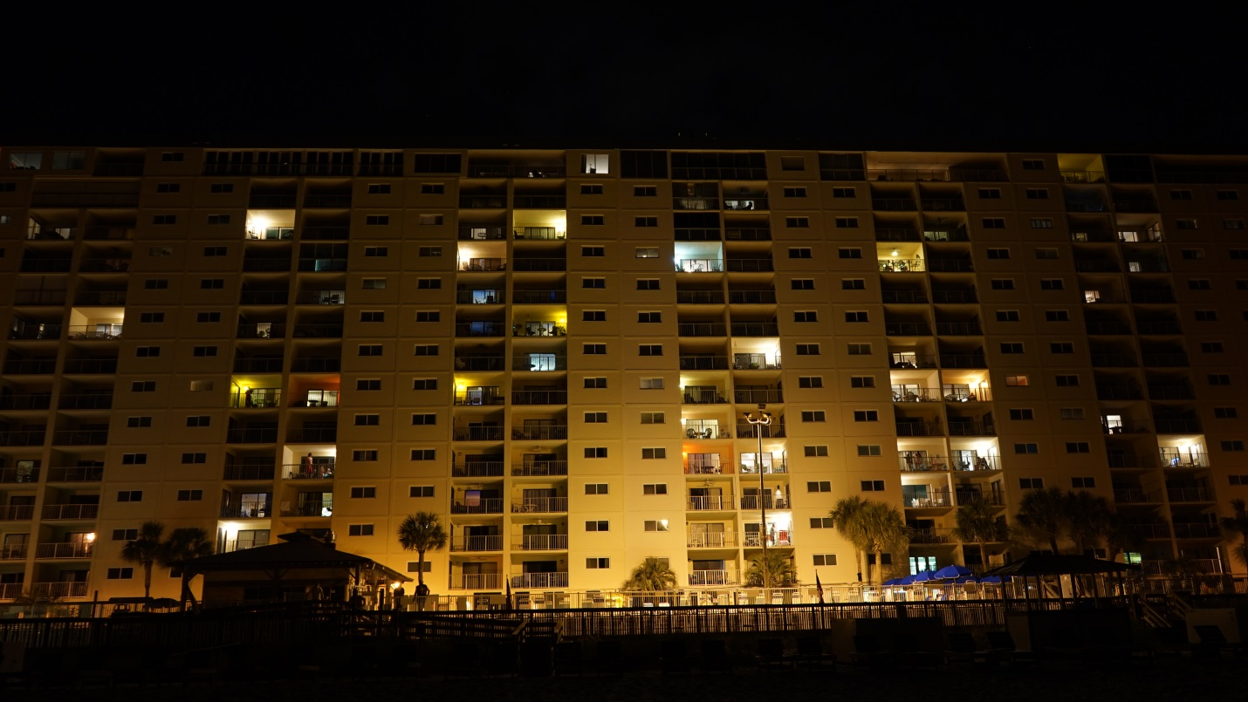
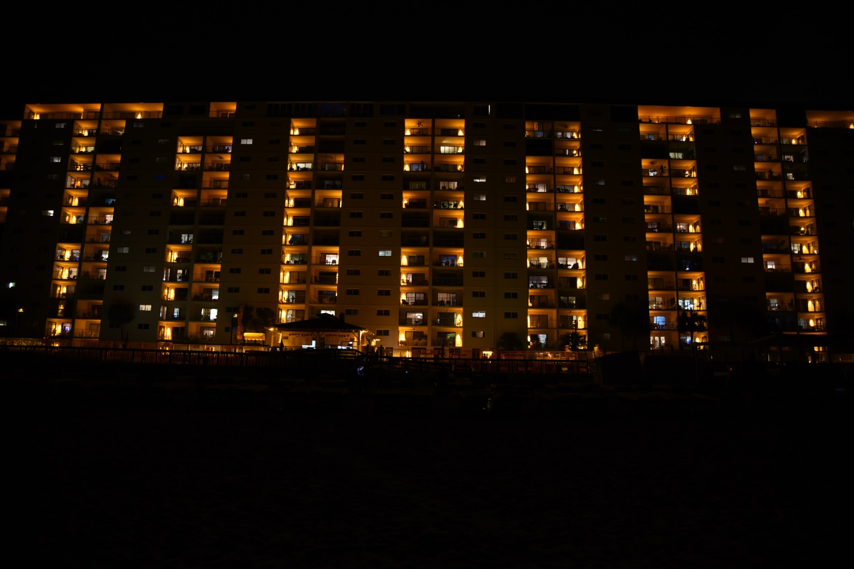
Regency Towers Condominiums
Figure 3: Regency Towers Condominiums in Panama City Beach in Bay County, Florida. STC lowered, shielded and replaced the bulbs in the poolside pole lights, which greatly reduced the amount of light emitted by the pole lights onto the property.

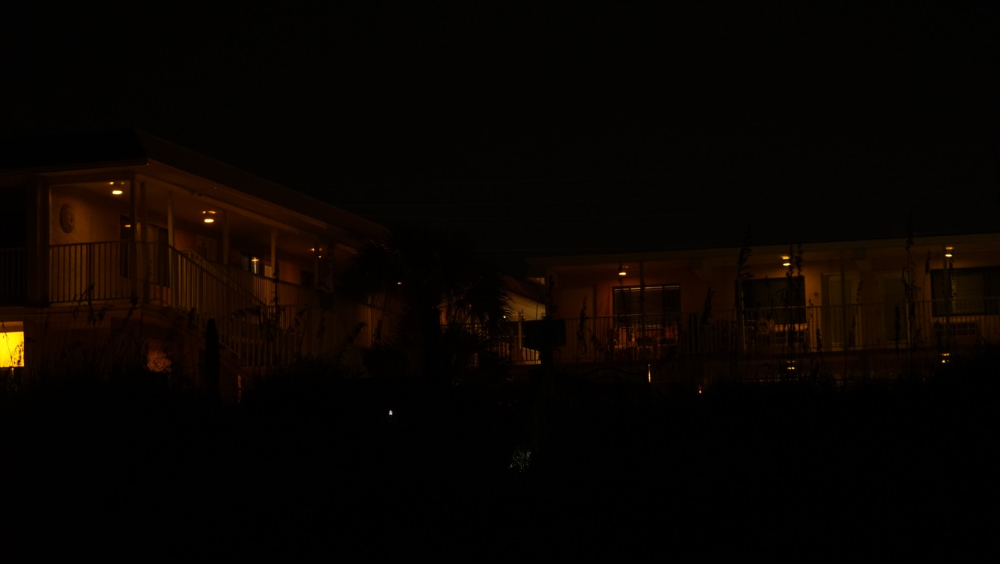
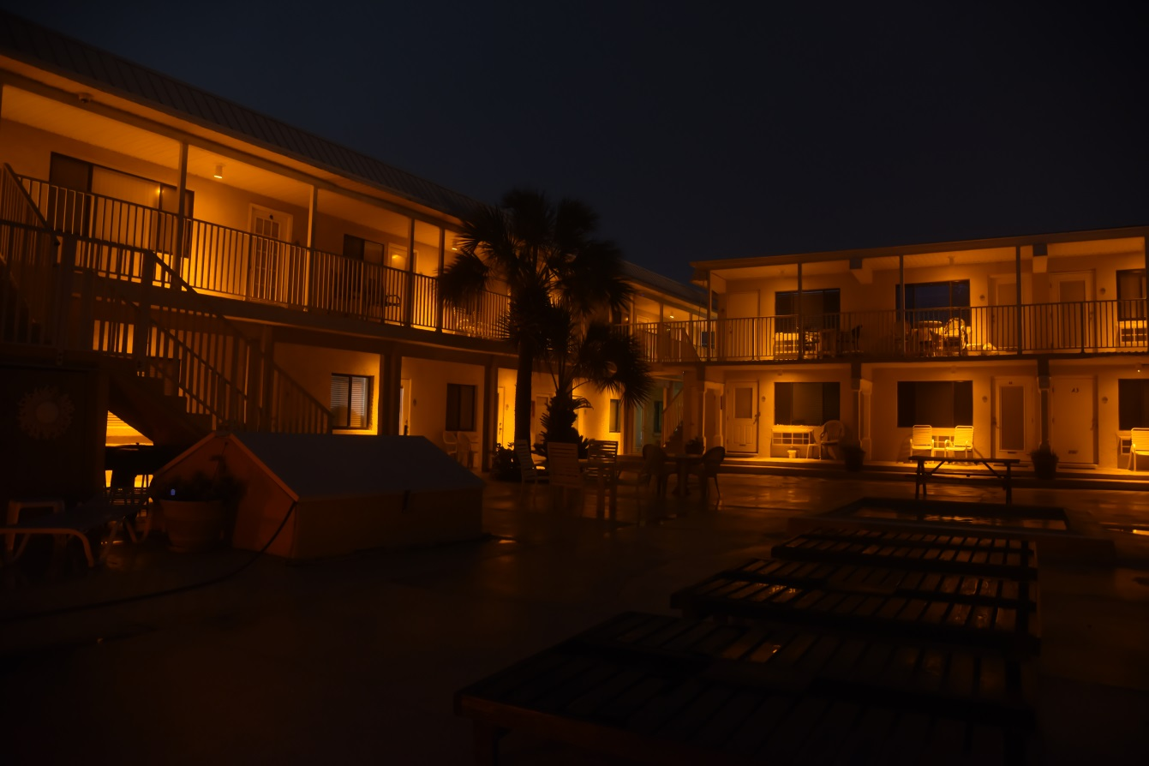
Sting Ray By The Sea Condominium
Figure 4: Sting Ray By The Sea Condominiums, Panama City Beach, Bay County. This small condominium is an example that sometimes when STC retrofits a property it can be brighter and more attractive than it was before.

Lighting Workshops for Code Enforcement, Builders and Planners
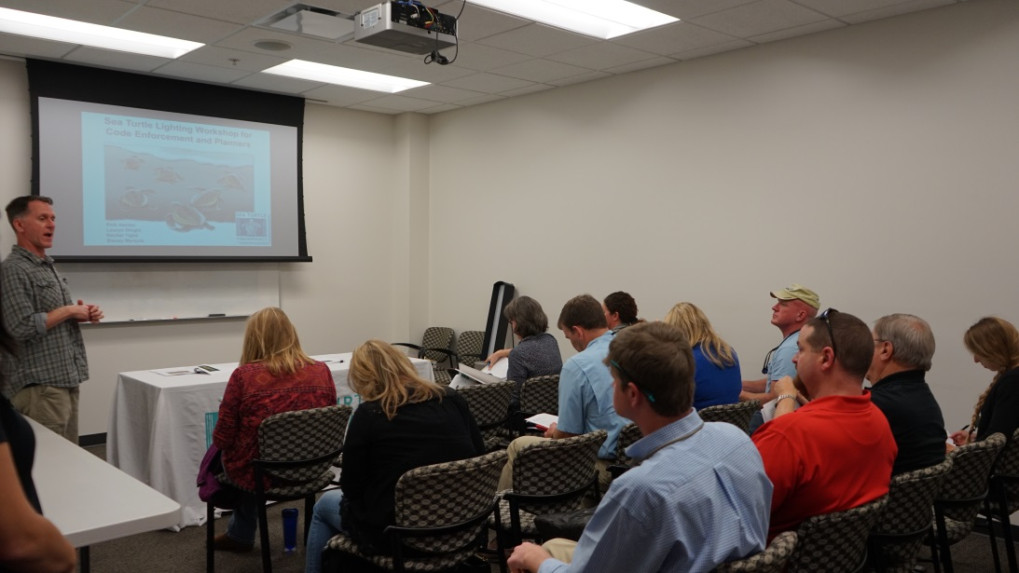
Figure 5: Lighting Project Manager Rick Herren presents STC’s lighting workshop to around 20 code enforcement officials in Escambia County in January 2017.

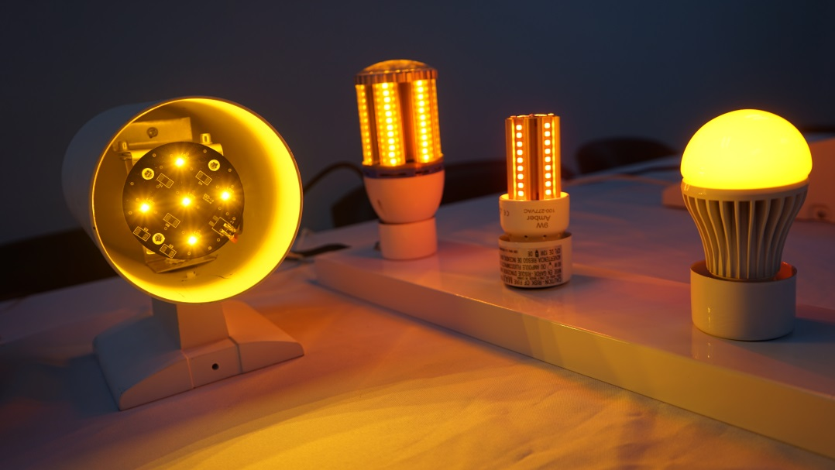
Figure 6: STC worked with a Panhandle-based lighting distributor to create a traveling sea turtle lighting display. The display allows for workshop attendees to see what sea turtle friendly fixtures and bulbs look like in person.

