EXECUTIVE SUMMARY: Artificial Reef Creation Project – Franklin County
Coastline Environmental Materials (CEM) is seeking $6,510,000, for the creation of an expansive artificial reef system, in Florida waters, off Franklin County, Florida. Specifics of the project: 30,000 tons of limestone rip-rap will be mined and hauled from Jefferson County; to a shoreline staging area in Gulf County; the limestone rip-rap will be loaded onto flat-deck barges; then barged from the Gulf County staging area to a permitted offshore site in Franklin County and planted. The individual volume of limestone rip-rap will be between 500 lbs. (1/4 ton) and 6,000 lbs. (3 tons). The total volume of 30,000 tons, will be planted on 5-6 acres of submerged land, depending on orientation following deployment, within the permitted site. The entire project will be completed at a rate of $217 per ton.
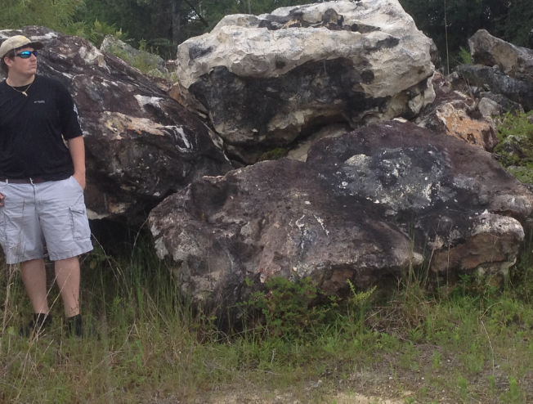
Figure 1: Example of type, size and shape of artificial reef substrate (limestone rip-rap)
The new artificial reef system will be constructed within a permitted site approximately 8 Nautical Miles (NM), south-southeast, from Government Cut, off Franklin County, Florida. The permitted site is 1 NM x 1 NM in area and encompasses approximately 847 acres of sand bottom in State of Florida waters, with an average depth of 43 feet. This regional asset (submerged state land) would be enhanced significantly and become a productive biome, almost immediately and would continue being a productive fishery habitat for the long term.
Due to fishery losses, both actual and perceived, following the Deep-Water Horizon event, there already existed serious short- and long-term economic consequences for the fishery dependent community of Franklin County (City of Apalachicola). Recently, Northwest Florida’s productive coastal waters were directly impacted in 2018 by Hurricane Michael. This hurricane adversely affected Florida’s productive Northwest Gulf Coast through extreme environmental, meteorological and hydrological conditions and resulted in net losses of existing offshore reefs in Franklin County. Losses included depletion and debilitation of fisheries resources which have both short- and long-term effects. Effects include loss of fisheries stocks, disruption of recruitment, loss of reefal integrities and loss of reefal ecology. Further, prior to Hurricane Michael, the total number of artificial reefs in Franklin County was already well below the state average in both density and tonnage compared to all Florida counties currently participating in artificial reef construction.
Distance: 8.14 Nautical Miles
Bearing: 166.66 Degrees
Artificial reefs provide additional critical habitat that increases the environmental carrying capacity and eventually, the abundance and biomass of reef fishes. Artificial reef systems provide additional food; increase feeding efficiency; provide shelter from predation; and provide recruitment habitat for settling individuals that would otherwise have been lost to the population. Additionally, and indirectly, fishes moving to artificial reefs create vacated space in the natural environment; allowing replacement from outside the system (Matthews, 1985). It is well documented that, following an artificial reefs creation, rapid colonization rates (within days to months); high fish densities and high catch rates occur. Moreover, fish densities, biomass and catch rates are higher on artificial reefs than natural reefs. Unproductive substrate, such as sand, is turned into a highly productive biome, with the creation of an artificial reef system.
In a presentation at the 2015 Artificial Reef Summit, Bill Huth, utilized Regional Economic Models, Inc (REMI) to enumerate the economic benefits of artificial reefs to the State of Florida. Results from the modeling indicated that fishing and diving activity on Florida artificial reefs provides 39,118 jobs for Floridians; generates $3.1 billion of economic output; accrues $1.3 billion in income to Floridians; produces $250 million in state revenues for Florida and endows reef users with a use value or consumer surplus of over $700 million. flseagrant.ifas.ufl.edu/artificialreefs/Huth.pdf.
The economic recovery, diversification and enhancement of the disproportionately affected County of Franklin, and the City of Apalachicola, specifically, through the creation of the proposed, large-scale, artificial reef can be demonstrated through the results of a study in 1998 by Bell, et. al. The purpose of the study was to assess the economic impact, user valuation and benefit-to-cost ratio associated with artificial reefs located in Bay, Escambia, Okaloosa, Santa Rosa and Walton Counties. During the study period, a total of $414 million in expenditures were associated with artificial reef usage in these five counties. The expenditures supported 8,136 jobs and $84 million in wages and salaries. Of the total expenditures, $359 million and $55 million were attributed to visitors and residents, respectively. Of the five counties in the study, Walton County is comparable with Franklin County, as both counties had a similar number of artificial reefs at the time of the study. The study concluded that of the total $414 million in expenditures, five percent (5%) of the total $414 million (or $20,700,000) in expenditures, during the study period, were associated with Walton County. This value indicates a very high, positive return to the cost of artificial reef projects implemented in Walton County and can reasonably be expected as a similar value to be gained in Franklin County (City of Apalachicola) and may also add value for the adjacent counties of Gulf and Wakulla.
Fishing and diving are very popular recreational activities in Franklin County and the adjacent Counties of Gulf and Wakulla and are key to the economic productivity of the area. The following positive impacts to the local economy of the City of Apalachicola and Franklin County, after the construction of a large-scale artificial reef are primary and secondary, in nature. Primary benefits would be to guide and recreational fishermen, charter captains as well as recreational divers (SCUBA). Additional primary benefits would be increased revenue at local sporting good, bait, grocery and hardware stores; marinas and gas stations; and local hotels and vacation rental homes. Secondary benefits would include those employed by the entities mentioned and their families, through increases in household income as well as overall job growth in these sectors. This restoration project would definitively enhance the economic recovery of the City of Apalachicola as well as Franklin County, in both the short and the long term and would be a sustainable asset over time and ensure future economic activity. Additionally, this project would provide some diversification to a community that has depended heavily on an oyster-harvesting-based economy; of which, has severely declined in recent years.
The proposed project is “shovel ready” and could be implemented following the first distribution of funds from Triumph Gulf Coast.

Literature Cited
Adams, C., Lindberg, B., and Stevely, J. (2006). The Economic Benefits Associated with Florida’s Artificial Reefs. UF IFAS/EDIS Report.
Bell, F.W. et al. 1998. Economic impact and importance of artificial reefs in northwest Florida. Office of Fisheries Management and Assistance Services, Florida Department of Environmental Administration, Tallahassee, Florida.
Florida Fish and Wildlife Conservation Commission [Jan. 2018]. Artificial Reef Deployment Data. Division of Marine Fisheries Management, Tallahassee, Florida. Data found on the following website: http://myfwc.com/conservation/saltwater/artifical-reefs
Hazen and Sawyer. Swett, R.A., Larkin, S., Adams, C., Hodges, A.W., and Stevens, J.D. (2010). A Socioeconomic Analysis of Artificial Reef Patronage for Six Southwest Florida Counties. Florida Fish and Wildlife Commission, Tallahassee, FL.
Johns, G., Leeworthy, V.R., Bell, F.W., and Bonn, M.A. (2001). Socioeconomic Study of Reefs in Southeast Florida.
Matthews, K. R. 1985. Species similarity and movement of fishes on natural and artificial reefs in Monterey Bay, California. Bull. Mar. Sci. 37:252-270.

