Enhancing Recreational Opportunities off West Florida through High Resolution Mapping, Ecological Characterization and Human Use Assessment of Artificial Reefs
Steven Murawski, Chris Stallings, University of South Florida, College of Marine Science (USF-CMS)
Chad Lembke, University of South Florida, College of Marine Science, Center for Ocean Technology (USF-COT)
Luiz Barbieri, Keith Mille, Florida Fish and Wildlife Research Institute (FWRI)
David Mann, Loggerhead Instruments, Sarasota, Florida

Project Context:

As part of the settlement of the Natural Resource Damage Assessment (NRDA) stemming from the Deepwater Horizon oil spill, the Florida Trustee Implementation Group (TIG) is currently accepting project ideas for resource restoration activities in four thematic areas, including:
“Provide and Enhance Recreational Opportunities (Programmatic Restoration Plan Sections 5.5.14, 5.D.8): provides recreational opportunities through infrastructure, access and education. Given the important link between healthy natural resources and recreation, restoring habitats and improving water quality will also provide human use benefits”.
This proposal is directly responsive to theme 4 of the TIG and the broader Programmatic Restoration Plan upon which it is based.

Project Summary:

Artificial reefs (ARs) are ubiquitous in nearshore waters off the Florida coast. The Florida Fish and Wildlife Research Institute (FWRI) maintains an active database presently including over 3,000 known AR features (Figure 1, http://myfwc.com/conservation/saltwater/artificial-reefs/nrda/ ). These features are composed of a wide variety of materials, including construction debris, sunken vessels, and vehicles, among other items (Figure 2). Because of their availability to small boat fishers and sport divers, ARs are the focus of intensive but variable sport fishing and sport diving activities. Particularly around population centers, ARs are heavily visited and used.

This project is intended to enhance recreational fishing opportunities and the quality of the recreational fishing and sport diving experience by distributing high-resolution bathymetric maps of selected ARs to resource users (e.g., Figure 2), focusing on two large areas off the West Florida Coast (Figure 1). The project will also assess the quality of fish habitat associated with these ARs, evaluate fish density and species composition, and estimate the degree of human use. Additionally, through outreach and interactions with recreational fishers and divers, the project will assess user satisfaction, fish catch, and maintain two-way communication with users to strategize methods to enhance the quality of their recreational experiences.
The proposed project will systematically map and characterize ARs in two large areas of the West Florida shelf (Figure 1). Area 1 off the Florida Panhandle, consists of the coastal areas directly impacted by stranded oil from the Deepwater Horizon incident (note shading of oil extent in Figure 1). The ARs in this region are distributed both in Florida territorial waters (<9.5 miles from the coast) and in federal waters. This region was chosen for inclusion in the project since the ARs there were likely affected by Deepwater Horizon, and would be most vulnerable from a future oil spill in the region, should it occur. Area 2, centered off Pinellas and other counties off Central Florida (Figure 1) was chosen because it was likely much less affected by Deepwater Horizon, and because the ARs there are heavily used by fishers and divers. Focusing on these two areas will allow contrasting oil-affected and oil-free ARs, and comparisons of the effects of human use of the sites within and between each area.
The proposed project will consist of a series of six linked tasks:
- Map known artificial reefs in two broad areas of the west Florida coast
Each site in both of the identified assessment areas (Figure 1) will be mapped at very high (<0.5 meter) resolution using multibeam sonar. Depending on the physical size of these sites, mapping may take a dozen or more so passes with the ship-borne sonar. Using Caris® acoustic image processing software, false color images of the bathymetry will be produced and georeferenced (e.g., Figure 2). The project will primarily use the new research vessel R/V William T. Hogarth (Figure 3), operated by the Florida Institute of Oceanography (FIO). This advanced-technology vessel will have integrated multibeam mapping and associated navigation and dynamic positioning capabilities. Having detailed maps of important ARs in these regions represents an important inventory of each site should an oil spill or other natural disaster occur in the future, thereby allowing relatively simple and rapid damage assessments.
- Use C-BASS towed video platform to characterize the fish species, density, and size composition, as well as the condition of each AR (e.g., degree of encrusting by benthic communities) as well as invertebrate community attributes.
The Camera-Based Assessment Survey System (C-BASS) (Figure 4) consists of a towed array of six high- and medium-resolution video cameras and additional oceanographic sensors. The system can be precisely towed 2-3 meters above bottom features such as ARs to provide assessment-quality imagery of living resources and geological/human made features comprising ARs. Forward-looking camera systems include stereoscopic capability allowing precise sizing of fishes and other objects viewed in the imagery. The video will be used to assess habitat quality attributes such as the percent coral cover, percent sponge and other invertebrate cover, degree of encrusting of AR features and species identification of attached marine plants and animals. Additionally, the C-BASS imagery will be used to assess the species composition, density (numbers per unit area) and the size composition of near-bottom dwelling species associated with each AR. These data will be important in assessing the relative “health” and the productivity of each assessed feature. Using fishing and diving effort assessments (see items 3-5 below) of the AR features, the quality of biological communities will be associated with visitation and recreational catch of each. It is hypothesized that more heavily utilized ARs will have diminished habitat quality and resource productivity. These assessments will set a baseline for future assessment efforts that may allow assessment of changes in these attributes over time, and associated with natural or man-made disasters.
- Conduct aerial surveillance flights and/or small boat-based visual assessments to document use by fishers and sport divers, identifying them by Florida registration numbers for further contact
In order to assess the relative use of individual AR features rapidly, we will employ overflights and possibly boat-based surveys to enumerate vessels anchored in the vicinity of these features. Using fixed-wing or helicopter platforms (and perhaps Unmanned Aerial Systems) as well as vessels, the number, size and vessel hull numbers of each boat in the vicinity of the ARs can be assessed. From these data, we can determine if fishing tackle is being deployed and if a diver’s flag is deployed. While these represent a snapshot in time, doing so on high visitation days (e.g., weekends or during red snapper open season) will allow efficient assessment of the relative use rates. Periodic assessments using overflight/boat-based sampling will be used to estimate total annual use (depending on the number of such assessments conducted and the error variance calculated for each site).
An important additional benefit of these assessments is the collection of identifiers associated with individual vessels (Florida hull registration numbers). Working with FWRI, we will develop a database of users of individual ARs for use in contact surveys (item 5 below).
- Deploy passive acoustic recorders at selected reefs to continuously document patterns of boat use, and occupancy of individual reef sites in order to assess the degree of reef utilization
While overflights/boat assessments will give a precise assessment of visitation, by whom, on surveyed days, alternative technologies can be deployed to monitor some of them continuously. Using passive acoustic sensors that record sounds in the range of vessel engine noise, we will assess visitation at selected AR sites to allow cumulative assessment of use over several months at a time. Units will be deployed at representative ARs to better assess the daily visitation, temporal patterns and the number of vessels anchoring vs. transiting each assessed AR feature. Using the acoustic data and overflights, we will calculate overall visitation of ARs in each region on an annual basis. While it is not possible to determine what activity each vessel may be engaging in (e.g., fishing, diving, other recreation), the overflight/boat-based surveys data will allow partitioning of the acoustic data into proportional activities.
- Survey divers and fishers occupying individual reefs to assess degree of satisfaction with the recreational experience, catch rates and species caught/observed, and other social/economic data
Using the identities of recreational fishers and sport divers determined from overflight/boat data, we will develop mail-based survey instruments to assess user satisfaction and engage resource users on how to enhance recreational experiences associated with assessed ARs. We intend to send to each identified vessel registrant the high resolution image of the AR being used. Additionally, we will develop a survey instrument that elicits the type of use (fishing or diving), species taken, degree of repetitive use and overall satisfaction with the recreational experience. These data can be used to assess the relative productivity of each AR feature as well as the degree of health from the user’s perspective. We will engage users in an active dialog about ways to enhance the recreational experience (e.g., educational materials, identifying rarely visited features, etc.).
- Develop web-based outreach products, and outreach activities with fishing/diving clubs, bait and tackle stores, dive shops and the public.
Project personnel will develop web-based products including maps, imagery and resource assessments for outreach to organized resource use groups, commercial vendors, and the public. Making these information products widely available to the public will allow fishers to better plan their future activities and hopefully maximize the recreational fishing and diving experiences of their vessel trips.
As part of a separate marine mapping project funded by the National Fish and Wildlife Foundation (NFWF), several shallow-water ARs at the entrance to Tampa Bay were surveyed with multibeam sonar as a proof of concept (e.g., Figure 2). These images have proved to be highly popular with sport fishers and divers, many of whom have expressed interest in having additional imagery available for other popular ARs. These images can improve the quality of the recreational experience in several ways. First, relatively inexperienced fishers can rapidly locate high-relief bottom features where fishing is most successful, thereby enhancing catch rates of both catch-and-release, and catch-and-keep fishing. Second, fishers and divers are often not aware of the variety of habitat features associated with an AR site, the high-resolution images and this knowledge enhances the fishing and diving experience. Last, greater knowledge of the extent and productivity of all the AR features in a region may act to disperse fishing and diving effort to currently less visited ARs, thereby increasing local wildlife abundance at heavily visited sites. For these reasons, we believe that a systematic program of AR assessment using the techniques outlined above will significantly enhance the recreational fishing and diving experience off the West Florida coast.
This project differs from a currently funded project being undertaken by FWRI with funding from “early restoration” efforts under NRDA. In that project, new AR sites are being constructed and monitored for three years to assess habitat use by fishes and human use following construction establishment. Our project will monitor existing sites that have a long history of use by the fishing and sport diving communities.
Project Duration and Approximate Costs:
The project outlined above is expected to run for three years (2020-2022) and cost approximately $4.5 million. Major costs for the project include ship time aboard FIO ships R/V Weatherbird II and R/V William T. Hogarth, as well as aircraft/small boat time for use assessments. Additionally, labor for processing imagery, conducting ecological assessments of ARs, and outreach and coordination are the other major cost drivers.

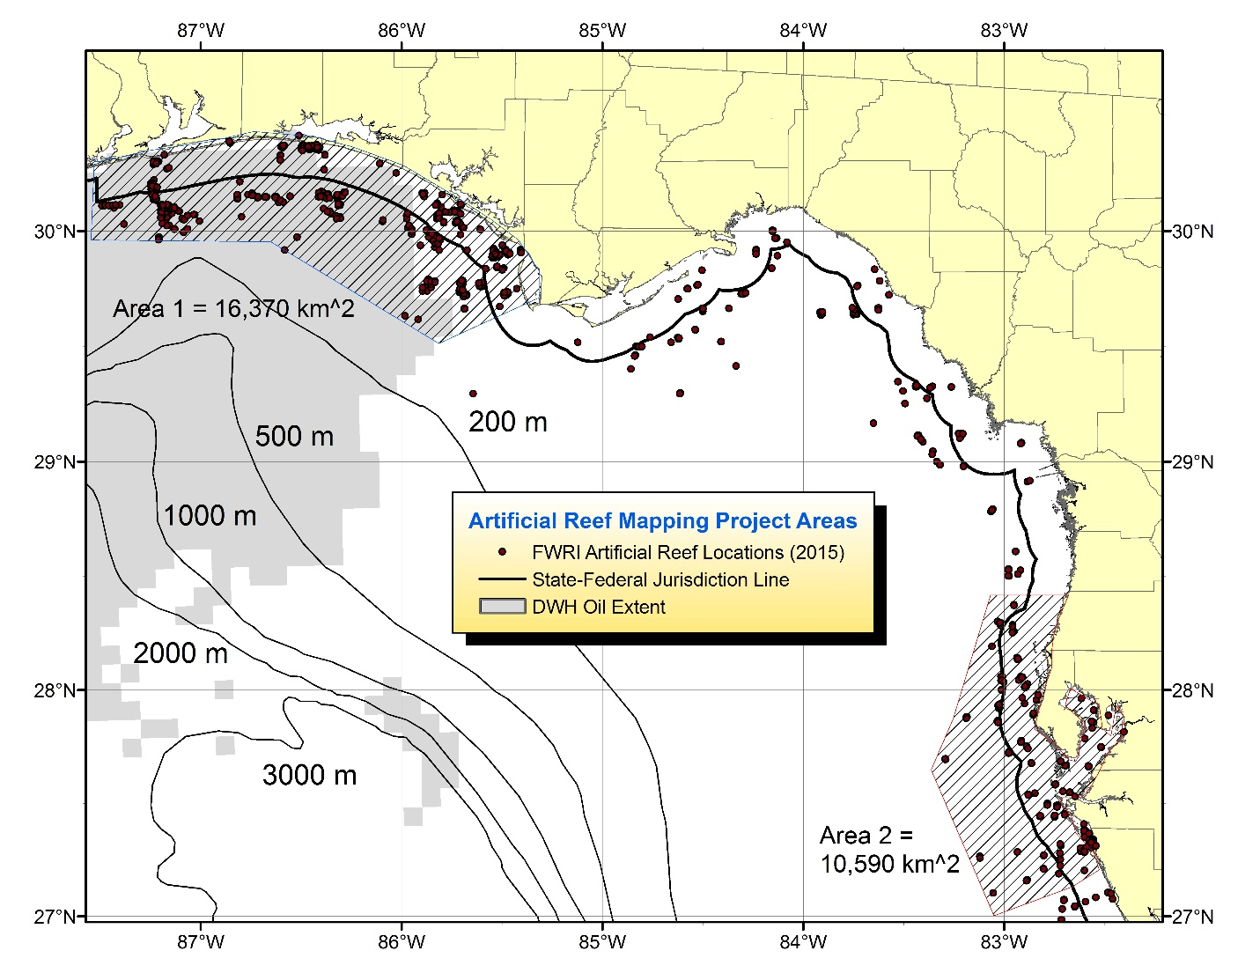
Figure 1. Artificial reef features (dots) included in the FWRI database as of 2015. The two hatched areas are the focal areas of this proposal. Relative surface oil density (gray shaded areas) is from the Deepwater Horizon oil spill in 2010.
Figure 2. Example high resolution composite multibeam map of the St. Pete Beach Artificial reef, located 5 nautical miles west of the Passe-a-Grille inlet at the north entrance to Tampa Bay. Scale is in meters. Water depth is 10 meters (30 feet). https://www.pinellascounty.org/reef/pdf/st-pete-beach.pdf . The map above was made using a Reson 7125 multibeam sonar unit aboard the R/V Bellows in 2016. At the center of the image are visible 10 surplus Army tanks. At the upper right is a sunken 200’ barge. Construction debris from the Skyway Bridge and Corey causeway rebuilds is distributed throughout the site. The reef supports intensive fishing for a variety of species including groupers, grunts, king and Spanish mackerel and cobia. Sport divers use the site as well.

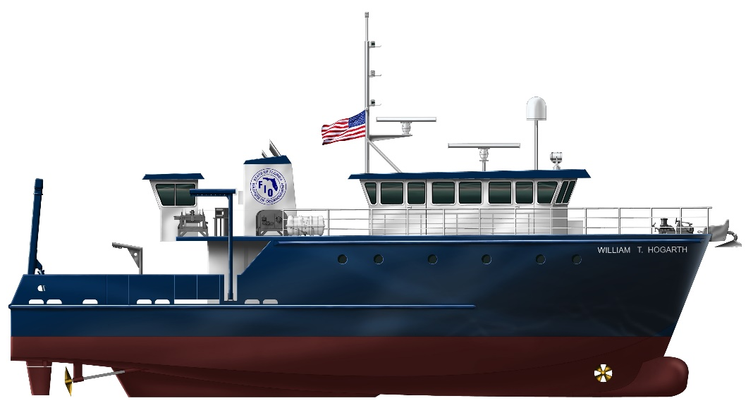
Figure 3. Rendering of the research vessel William T. Hogarth, now under construction. The 78’ vessel has a 6’ draft and will support advanced technologies allowing multibeam mapping and towed video sampling. The vessel will be operated by FIO and launched in May 2017.

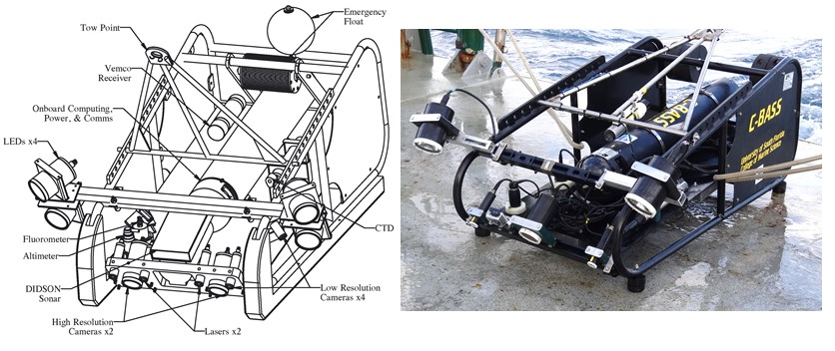
Figure 4. A towed video camera array used for classifying habitat and enumerating fish and invertebrate species associated with the sea bottom. This system, termed Camera-Based Assessment Survey System (C-BASS) was developed in previous projects funded by NOAA and NFWF.

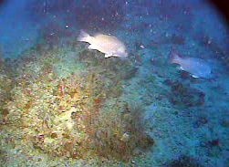
Figure 5. Image of gray snapper on the West Florida shelf as taken from the C=BASS towed video system.

