Best practices/ conceptual illustration from google search. Needs public input. Concept and design not final for Baars Park.
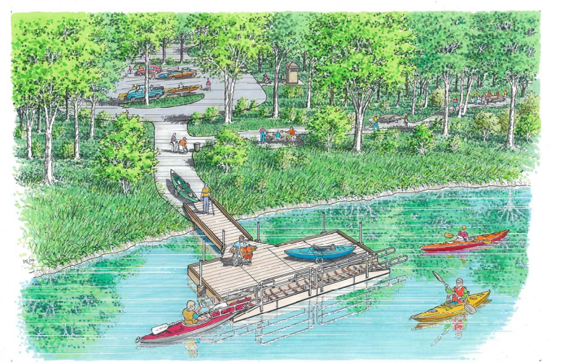
CONCEPT ONLY

