In many ways remote sensing with unmanned aircraft systems (UAS) is creating revolutionary changes affecting precise measures for micro-elevation measurement, virtual object development and topographical mapping. [1-4]. Principle sensors for this type of work are digital cameras and LIDAR. Using digital cameras, and applying advanced photogrammetric techniques, makes it possible to rapidly create 3D point clouds over wide areas. Photogrammetry is the art and science of obtaining useful information from the environment by processing imagery and then applying exacting measures that can provide 3D details [5]. The inherent mobility, and aerial perspective provided by UAS-borne LIDAR, enables precise measurements of features that were previously impossible to access (e.g., remote oyster reefs and mangrove tree stands). LIDAR derived data points rapidly provide ultra-dense and accurate 3D point clouds. In both cases 3D point clouds serve as vertices for triangle meshes. These triangle meshes are foundational for creating virtual objects
Remote sensing using LIDAR can provide a true representation of the topography at macro and micro levels. Data are transformed into digital surface models (DSM) and digital terrain models (DTM). These models can provide accurate representations of all objects located in a given area, associated elevations and determination of the bare earth underlying the objects (see Figure 1) [6].

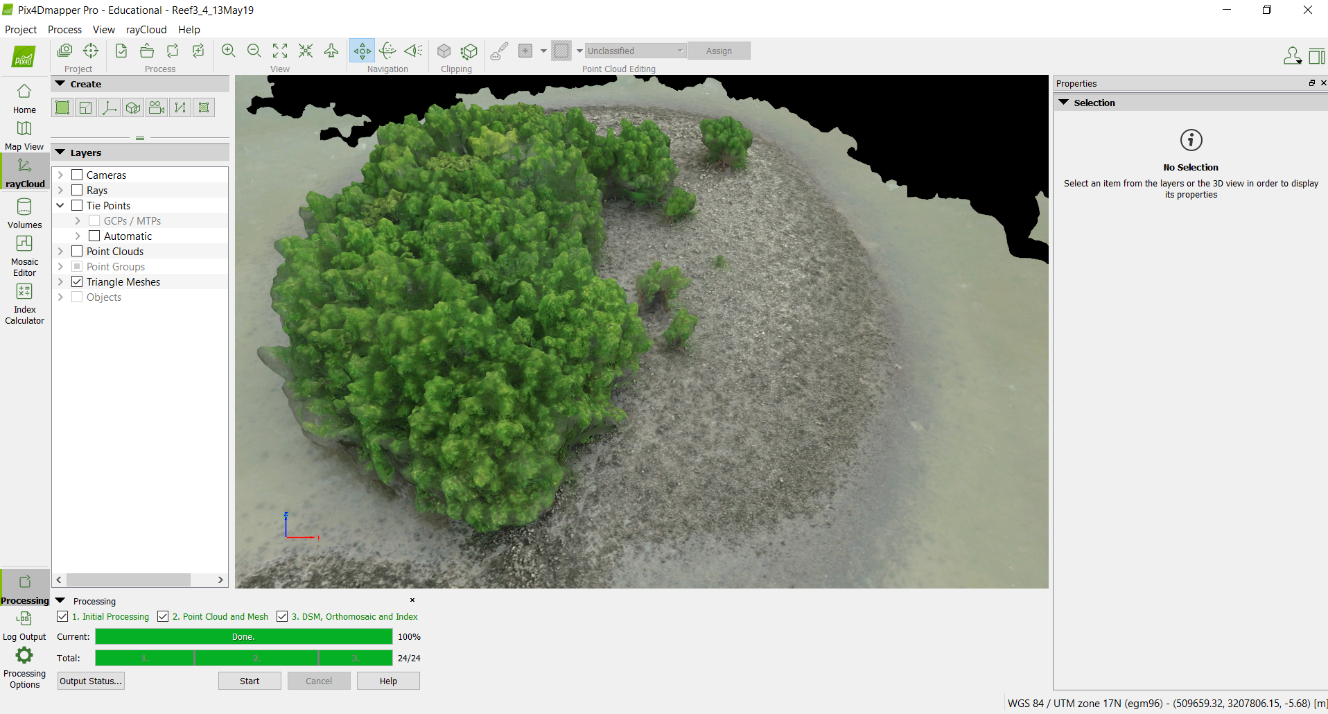
Fig. 1 Virtual Reconstruction of Oyster Reef from UAS Gather Data -2019

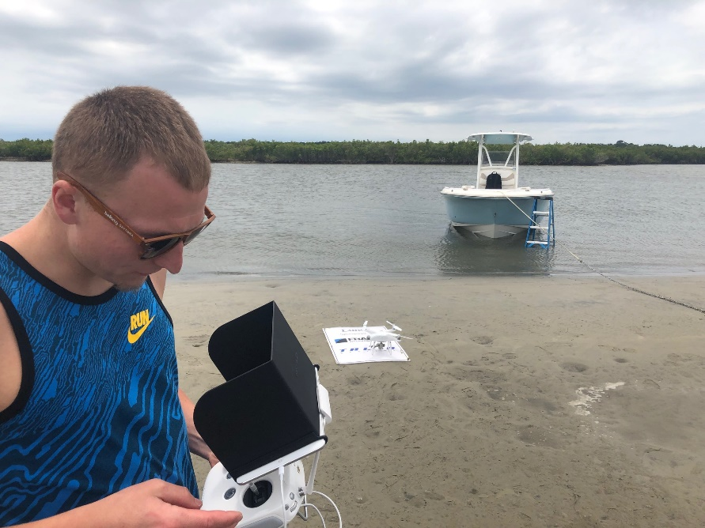

Fig. 2 UAS Operations in the Coastal Environment for Remote Sensing

Coastal settings are complex environments for data collection (see Figure 2). However, these complexties provide a rich base of data for 3D point cloud development. Spatial resolution defines the level of detail depicted in an image. Techniques that combine digital imagery and data from LIDAR can improve object extraction from 3D point clouds by up to 25% [7]. While rapidly flying above chosen areas UAS-borne digital cameras can readily discern 3D features for objects that are as small as 24mm. LIDAR can provide even higher levels of detail, as needed, to fill data needs. In total measurements of great detail can occur allowing modeling of objects ranging from vegetation, human constructed objects, nests and oyster reefs.
The combined sensing capabilities of aerial digital cameras and LIDAR can serve as a source of data to build 3D virtual objects for true measurements and geometries.

[1] Macchiarella, N. D., Robbins, J.M. & Cashdollar, D.J. (2019). Rapid Virtual Object Development using Photogrammetric Imagery Obtained with Small Unmanned Aircraft Systems-Applications for Disaster Assessment and Cultural Heritage Preservation. Proceedings of the AIAA Modeling and Simulation Technologies Conference, AIAA SciTech Forum (AIAA 2019-1974). doi.org/10.2514/6.2019-1974
[2] Achille, C., Adami, A., Chiarini, S., Cremonesi, S., Fassi, F., Fregonese, L., and Taffurelli, L. "UAV-based photogrammetry and integrated technologies for architectural applications--methodological strategies for the after-quake survey of vertical structures in Mantua (Italy)," Sensors Vol. 15, No. 2, 2015, pp. 15520-13339.
doi: 10.3390/s150715520
[3] García-Gago, J., González-Aguilera, D., Gómez-Lahoz, J., and José-Alonso, J. I. S. "A Photogrammetric and Computer Vision-Based Approach for Automated 3D Architectural Modeling and Its Typological Analysis," Remote Sensing Vol. 6, 2014, pp. 5671-5691.
doi: 10.3390/rs6065671
[4] Vacca, G., Sacco, A., and Dessì, A. "The Use of Nadir and Oblique UAV Images for Building Knowledge," International Journal of Geo-Information Vol. 6, No. 12, 2017, pp. 393.
doi: 10.3390/ijgi6120393
[5] Jensen, J. R. Remote Sensing of the Environment. Upper Saddle River, NJ: Prentice Hall, 2007.
[6]Beumier, C. and Idrissa, M. Digital terrain models derived from digital surface model uniform regions in urban areas, International Journal of Remote Sensing, Vol. 37, No. 15, 2016. pp. 3477-3493,
doi: 10.1080/01431161.2016.1182666
[7] Weng, Q. “Remote sensing of impervious surfaces in the urban areas: Requirements, methods, and trends,” Remote Sensing of Environment, Vol. 117, 2012, pp. 1-49

